Disassembly guide: Nespresso Essenza Mini
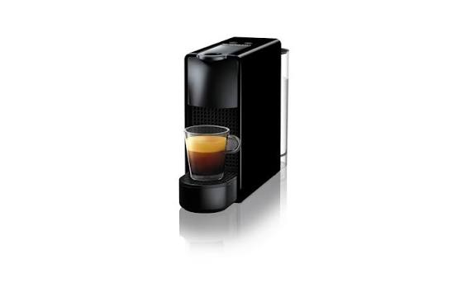

Validation warnings
[ERROR] Nodes [1430123016080] have an unrecognized type and cannot be interpreted in the disassembly grammar.

Bill of materials
Component | Weight | Material | Color
Water Tank | 150.0 g | 9 | —
Drip Tray & Grid | 100.0 g | 1 | —
Capsule Bin | 80.0 g | 1 | —
Oval-head Security Screws (x4) | 10.0 g | 9 | —
Side Panels (Left & Right) | 400.0 g | 1 | —
Brewing Chamber (Capsule slot) | 300.0 g | 1 | —
Top Lever / Handle | 150.0 g | 9 | —
Silicone Tubing & Wiring | 230.0 g | 9 | —
Motherboard (PCB) | 80.0 g | 9 | —
Water Pump (19-bar) | 350.0 g | 4 | —
Thermoblock (Heater) | 450.0 g | 2 | —

Step 1: Manually detach the drip tray, water tank, and pull out the used capsule bin. No tools required
Input: Nespresso Essenza Mini
Outputs: Water Tank, Drip Tray & Grid, Capsule Bin
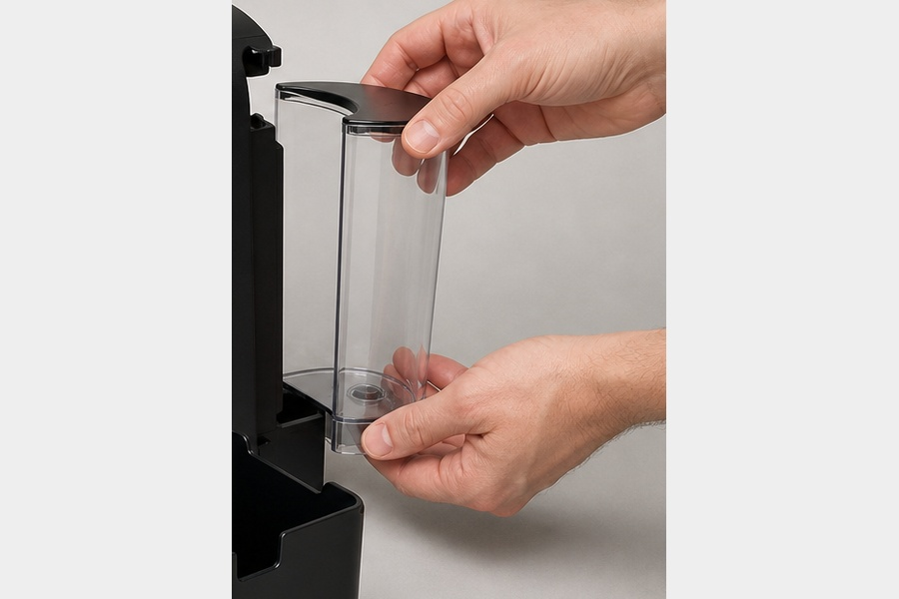
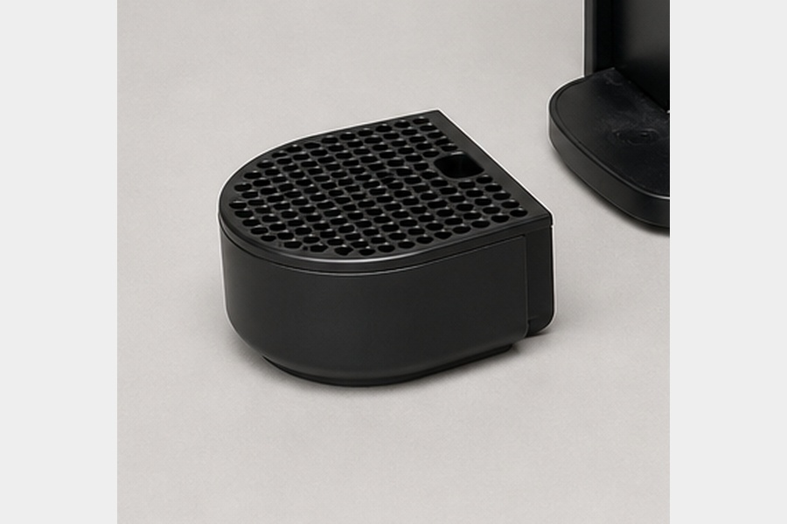
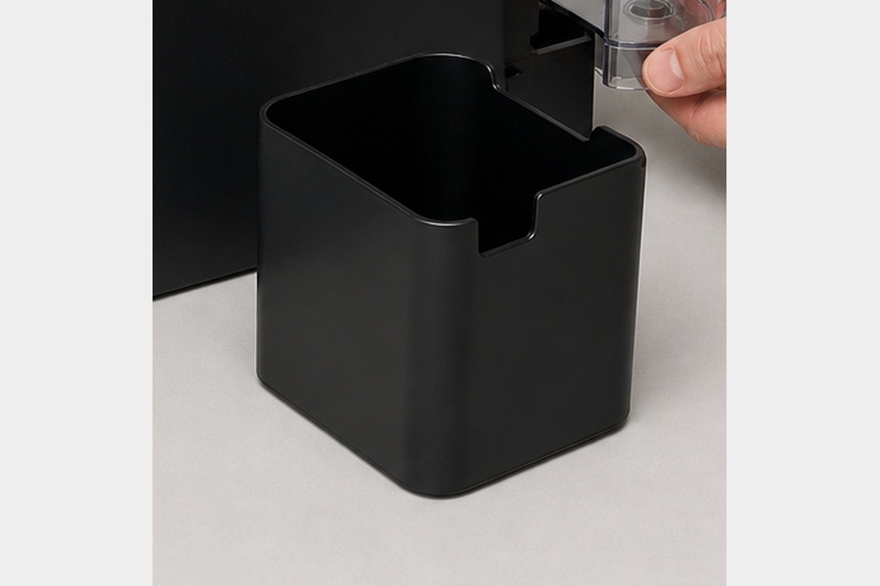
Continue with: Main Housing

Step 2: Remove the 4 proprietary oval-head screws at the bottom of the machine
Input: Main Housing
- Release Bottom Clips
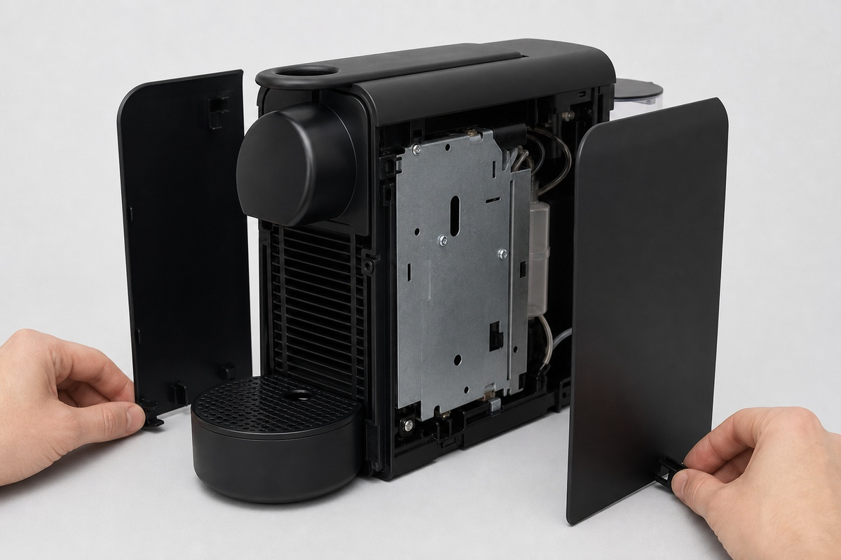
Outputs: Oval-head Security Screws (x4), Side Panels (Left & Right)
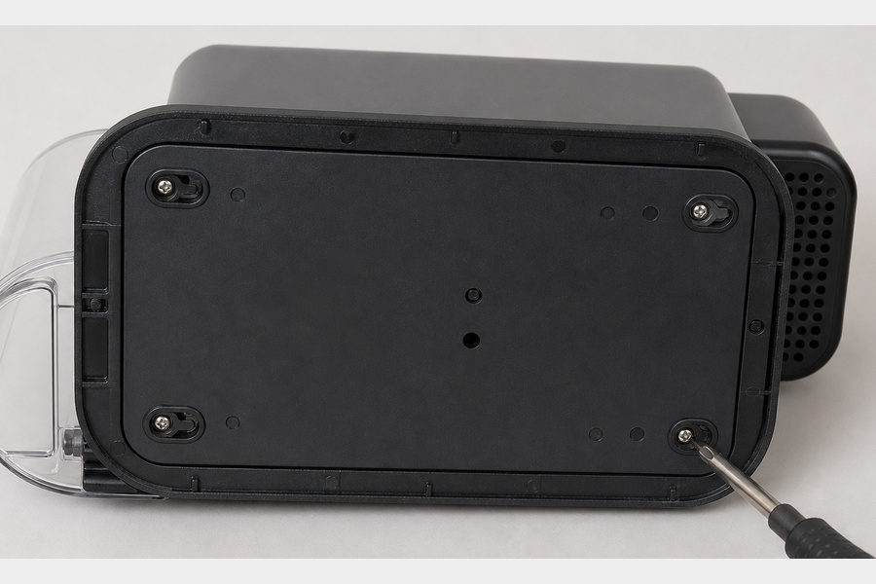
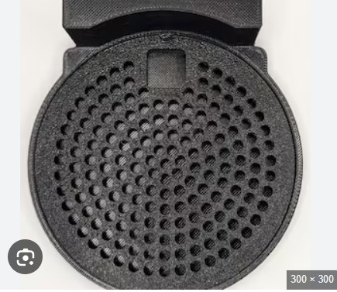
Continue with: Internal Chassis (Core)

Step 3: Unscrew the top lever mechanism and carefully detach the brewing chamber from the water lines
Input: Internal Chassis (Core)
Outputs: Brewing Chamber (Capsule slot), Top Lever / Handle
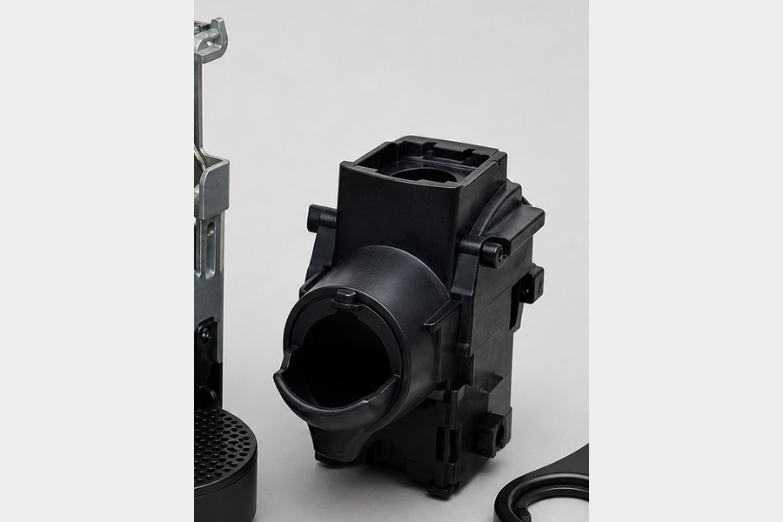
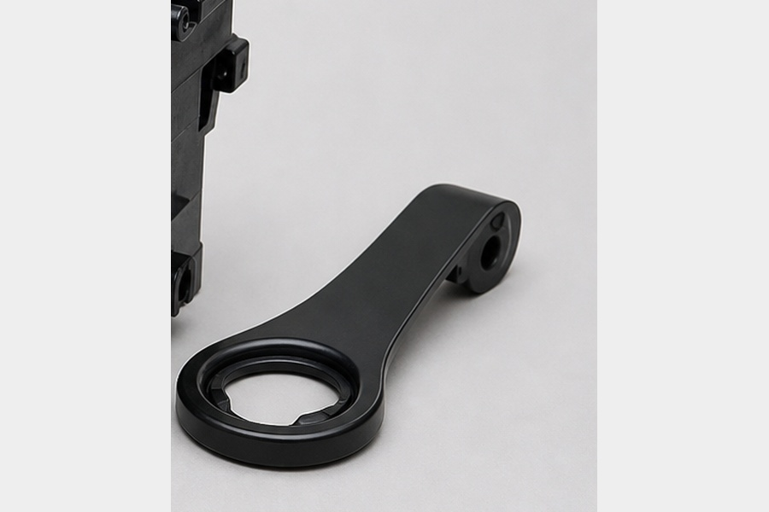
Continue with: Lower Engine Core

Step 4: Unplug the wiring harness from the motherboard, pull out the water pump, and detach the thermoblock heater
Input: Lower Engine Core
Outputs: Silicone Tubing & Wiring, Motherboard (PCB), Water Pump (19-bar), Thermoblock (Heater)
