**Name: Mai Nguyễn Anh Thư - 17110082**

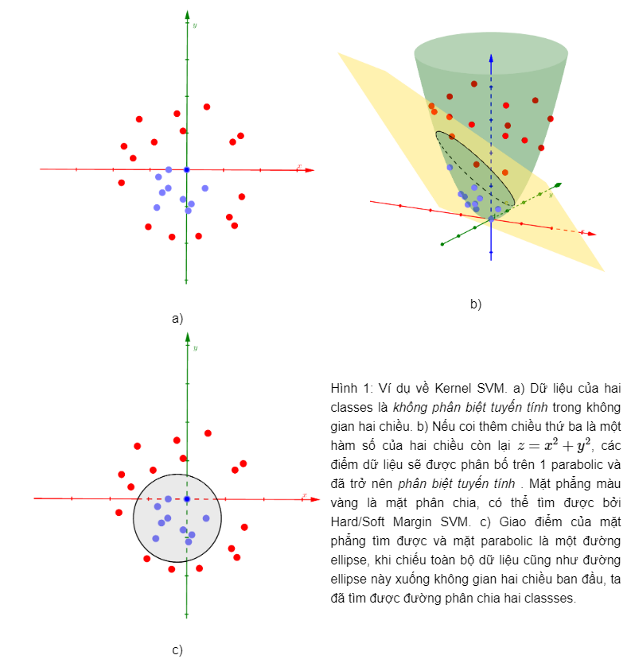

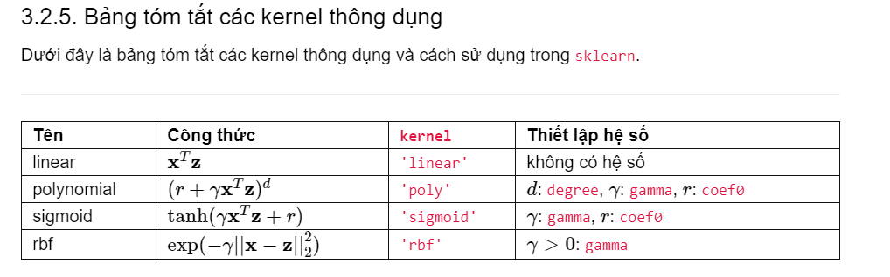

**Interpolation and extrapolation in machine learning**

Extrapolation is an estimation of a value based on extending a known sequence of values or facts beyond the area that is certainly known. In a general sense, to extrapolate is to infer something that is not explicitly stated from existing information.

Interpolation is an estimation of a value within two known values in a sequence of values. Polynomial interpolation is a method of estimating values between known data points. When graphical data contains a gap, but data is available on either side of the gap or at a few specific points within the gap, interpolation allows us to estimate the values within the gap.

Example:

