**Xpath:**

**Relative**

1.Single attribute

//tagname[@att=’value’]

2.Multiple attribute

//tagname[][]

3.Using contains method(Partial matching)

//tagname[contains(@att,’value’)]

4.Using text() method (exact matching)

//tagname[text()=’value’]

5.Using starts-with(Partial matching)

//tagname[starts-with(@att,’value’)]

6.following(2 is the target)

//tagname1[@att=’’]/following::tagname2

7.peceding(1 is the target)

//tagname1[@att=’’]/preceding::tagname2

Note:

// it will search through out the page and / it will search next after

We can navigate(transverse) using “/”

Combination of absolute and relative xpath is used to transvese

**CSS:**

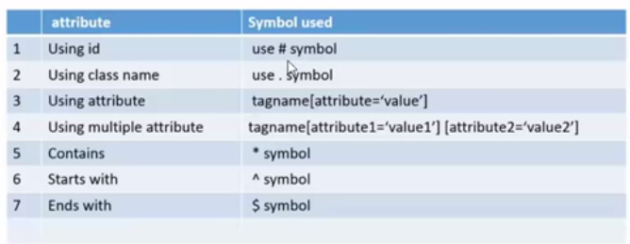

**Note:**

**CSS is faster than xpath**

**CSS will not change based on the browser(Xpath will often fail in IE )**

**Don’t use class.Its will not be unique**

1.Single attribute

tagname[attribute=’value’]

2.Multiple attribute

tagname[attribute1=’value1’][attribute2=’value2’]

3.Using ID(#)

tagname#value

4.Using Class(.)

tagname.value

5.Using contains method(Partial matching)

tagname[attribute*=’value’]

6.Using starts-with(Partial matching)

tagname[attribute^=’value’]

6.Using ends-with(Partial matching)

tagname[attribute$=’value’]