Charts
Naive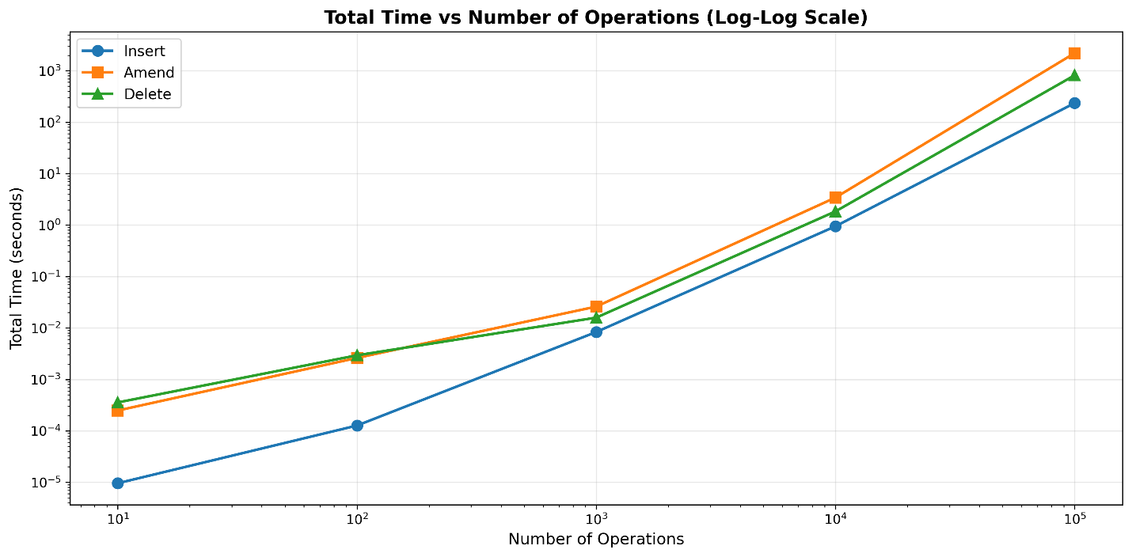
Optimized operations – heap
Here is a comparison where we can see that the optimized version runs orders of magnitude faster
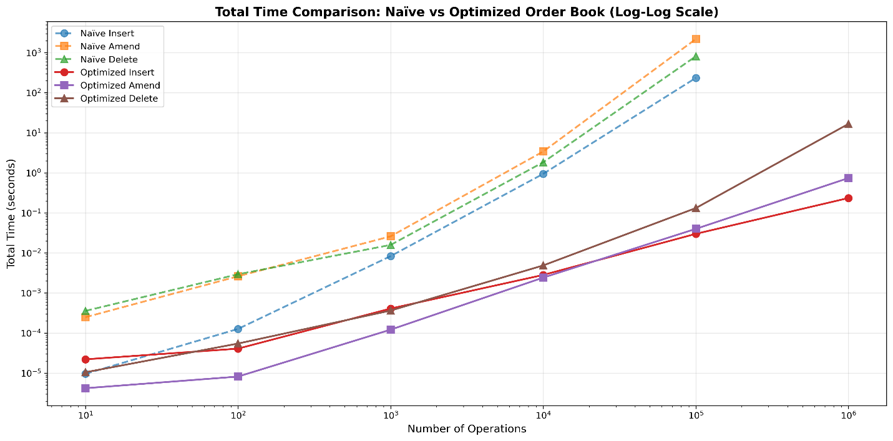

I chose to use a heap to track the best bid and ask prices. This allows us to maintain the ordering on insertions for add, amend, and delete in log(n) complexity. The naïve version breaks down after around 1000 operations, becoming unusably slow. For some of the larger values of n, the runtime was too large, so I had to omit those results.
Operation | Naïve Complexity | Optimized Complexity
add_order | O(n log n) | O(log n)
amend_order | O(n log n) | O(1)
delete_order | O(n log n) | O(log n)
lookup_order | O(n) | O(1)
get_orders_at_price | O(n) | O(1)
get_best_bid/ask | O(1) | O(1)

In terms of the observed scaling behavior, we can look at the plots above and this information:
Naïve:
INSERT Scaling Analysis:
From To Size Increase Time Increase Scaling Factor
0 10 100 10.0x 13.24x 1.32x
1 100 1000 10.0x 65.73x 6.57x
2 1000 10000 10.0x 113.63x 11.36x
3 10000 100000 10.0x 248.47x 24.85x

================================================================================

AMEND Scaling Analysis:
From To Size Increase Time Increase Scaling Factor
0 10 100 10.0x 10.53x 1.05x
1 100 1000 10.0x 9.95x 0.99x
2 1000 10000 10.0x 131.48x 13.15x
3 10000 100000 10.0x 643.60x 64.36x

================================================================================

DELETE Scaling Analysis:
From To Size Increase Time Increase Scaling Factor
0 10 100 10.0x 8.24x 0.82x
1 100 1000 10.0x 5.40x 0.54x
2 1000 10000 10.0x 116.07x 11.61x
3 10000 100000 10.0x 443.19x 44.32x

Optimized:
INSERT Scaling Analysis:
From To Size Increase Time Increase Scaling Factor
0 10 100 10.0x 1.85x 0.19x
1 100 1000 10.0x 10.02x 1.00x
2 1000 10000 10.0x 6.91x 0.69x
3 10000 100000 10.0x 10.62x 1.06x
4 100000 1000000 10.0x 7.84x 0.78x

================================================================================

AMEND Scaling Analysis:
From To Size Increase Time Increase Scaling Factor
0 10 100 10.0x 1.95x 0.20x
1 100 1000 10.0x 14.85x 1.49x
2 1000 10000 10.0x 19.95x 2.00x
3 10000 100000 10.0x 16.50x 1.65x
4 100000 1000000 10.0x 18.55x 1.86x

================================================================================

DELETE Scaling Analysis:
From To Size Increase Time Increase Scaling Factor
0 10 100 10.0x 5.22x 0.52x
1 100 1000 10.0x 6.67x 0.67x
2 1000 10000 10.0x 13.39x 1.34x
3 10000 100000 10.0x 27.08x 2.71x
4 100000 1000000 10.0x 126.38x 12.64x

The optimized implementation achieves dramatic performance improvements through strategic data structure choices that eliminate the expensive operations plaguing the naïve version. The most critical optimization is replacing the O(n log n) full list sorting after every modification with targeted data structures that maintain order efficiently. For order ID lookups, the naïve implementation uses linear search through lists requiring O(n) time to scan through all orders, while the optimized version employs a dictionary (`orders_by_id`) providing O(1) hash table lookups.
Similarly, price level queries transform from O(n) to O(1) dictionary access through `bids_by_price` and `asks_by_price` structures that map prices directly to their order lists. Insert operations see the most improvement, dropping from O(n log n) to O(log n) by using heaps with bisect insertion instead of sorting entire lists after each addition. Amend operations achieve even greater gains, moving from O(n log n) to O(1) because the optimized version uses dictionary lookup and requires no re-sorting since price remains unchanged. Delete operations improve from O(n log n) to O(log n) amortized through dictionary lookups, efficient list removal, and lazy heap cleanup that defers expensive restructuring until necessary.
Best bid/ask retrieval maintains O(1) access while avoiding the hidden O(n log n) sorting cost of the naïve approach through heap-based priority queues with lazy deletion. The key techniques enabling these improvements include hash tables for O(1) lookups, heaps for efficient priority maintenance, avoiding full re-sorts by maintaining only sorted price lists rather than complete order lists, and lazy deletion that amortizes cleanup costs. These optimizations enable us to easily handle millions of orders without waiting days.

