Stack Overflow Clone - Screenshot Evidence

Login Page
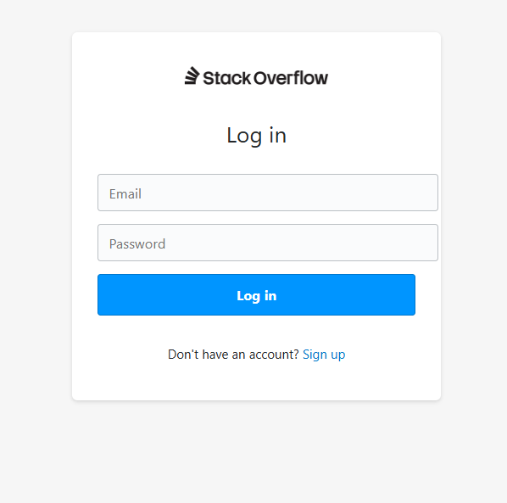
Figure: Login Page

Registration Page
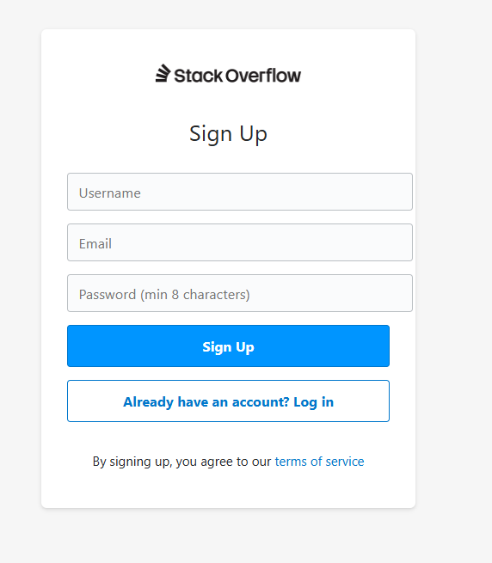
Figure: Registration Page

Home Dashboard
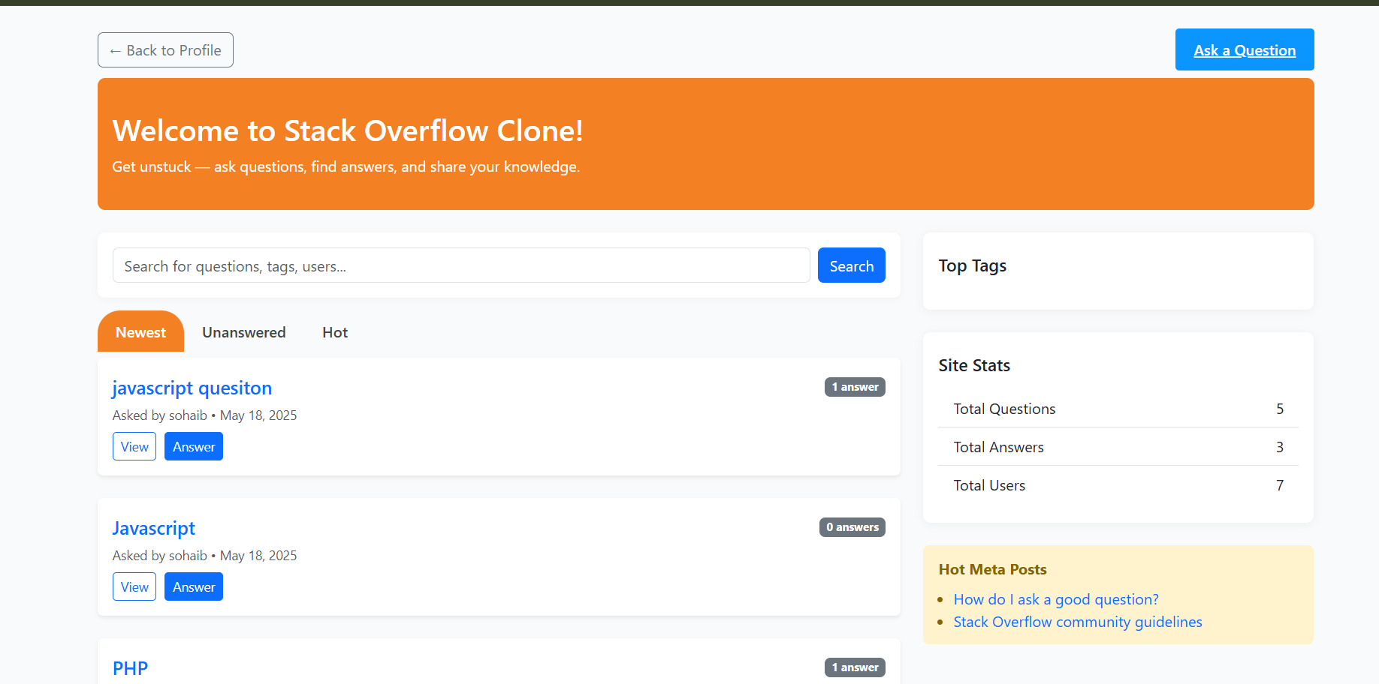
Figure: Home Dashboard

Ask Question Module
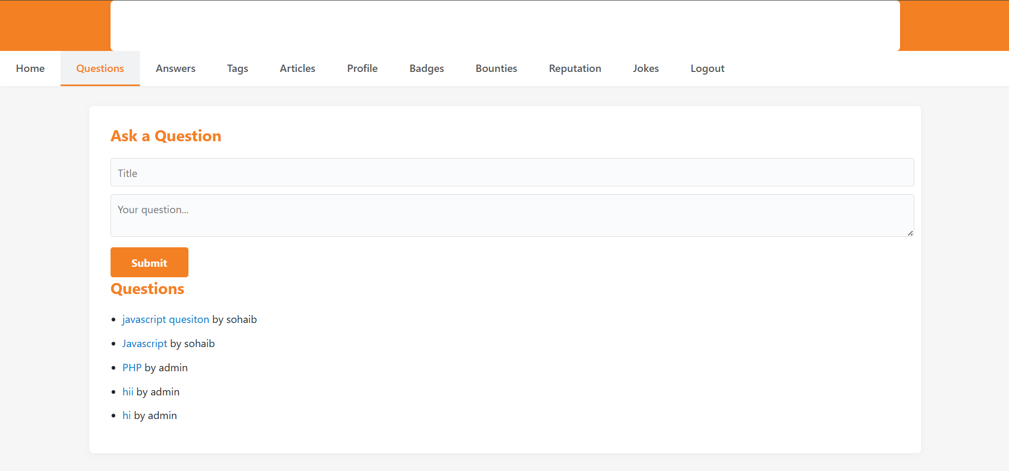
Figure: Ask Question Module

User Profile
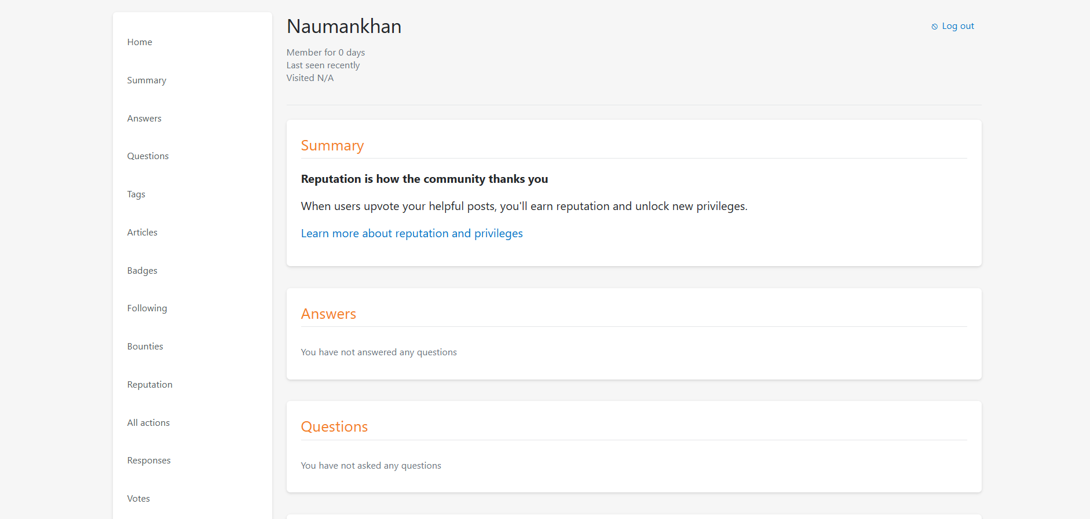
Figure: User Profile

Question View & Answer Module
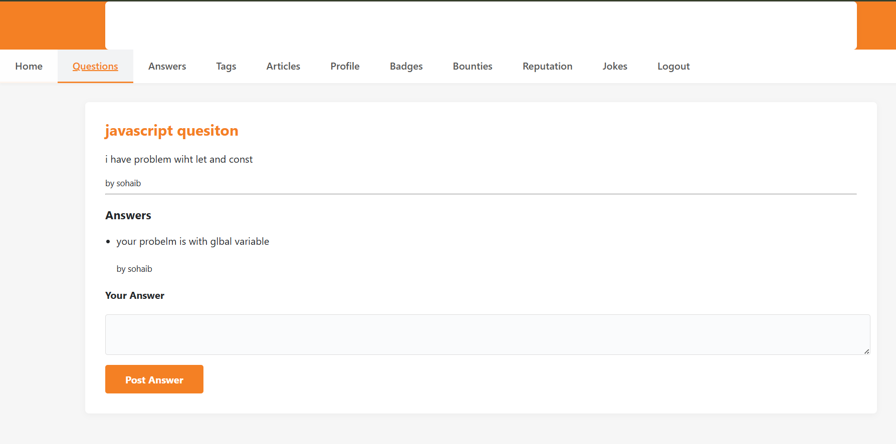
Figure: Question View & Answer Module

Badges Module
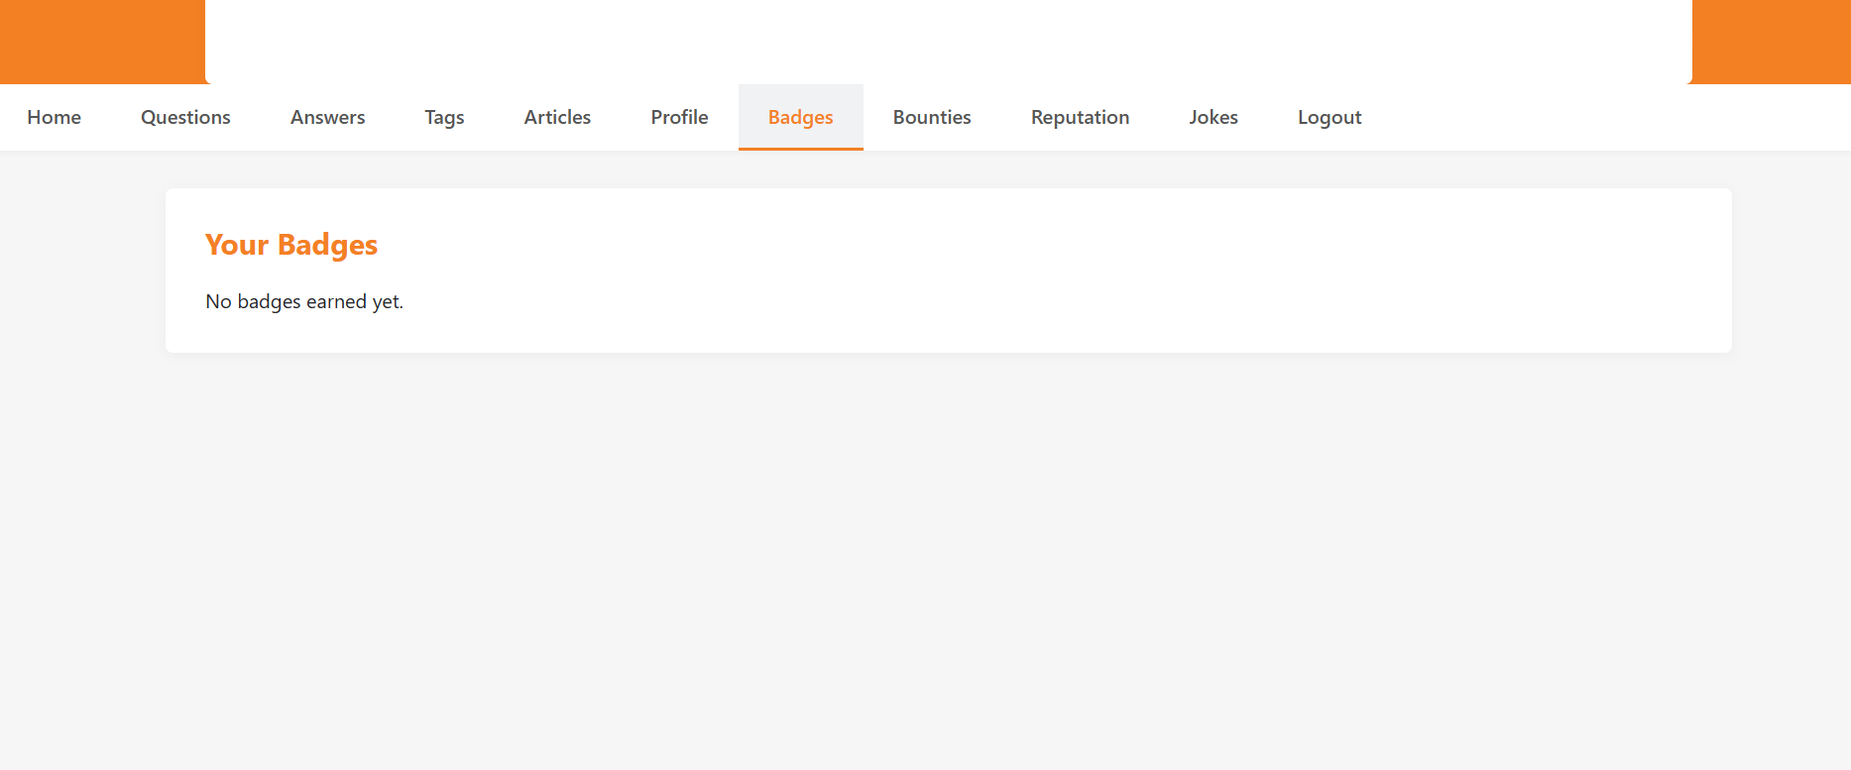
Figure: Badges Module

Reputation Module
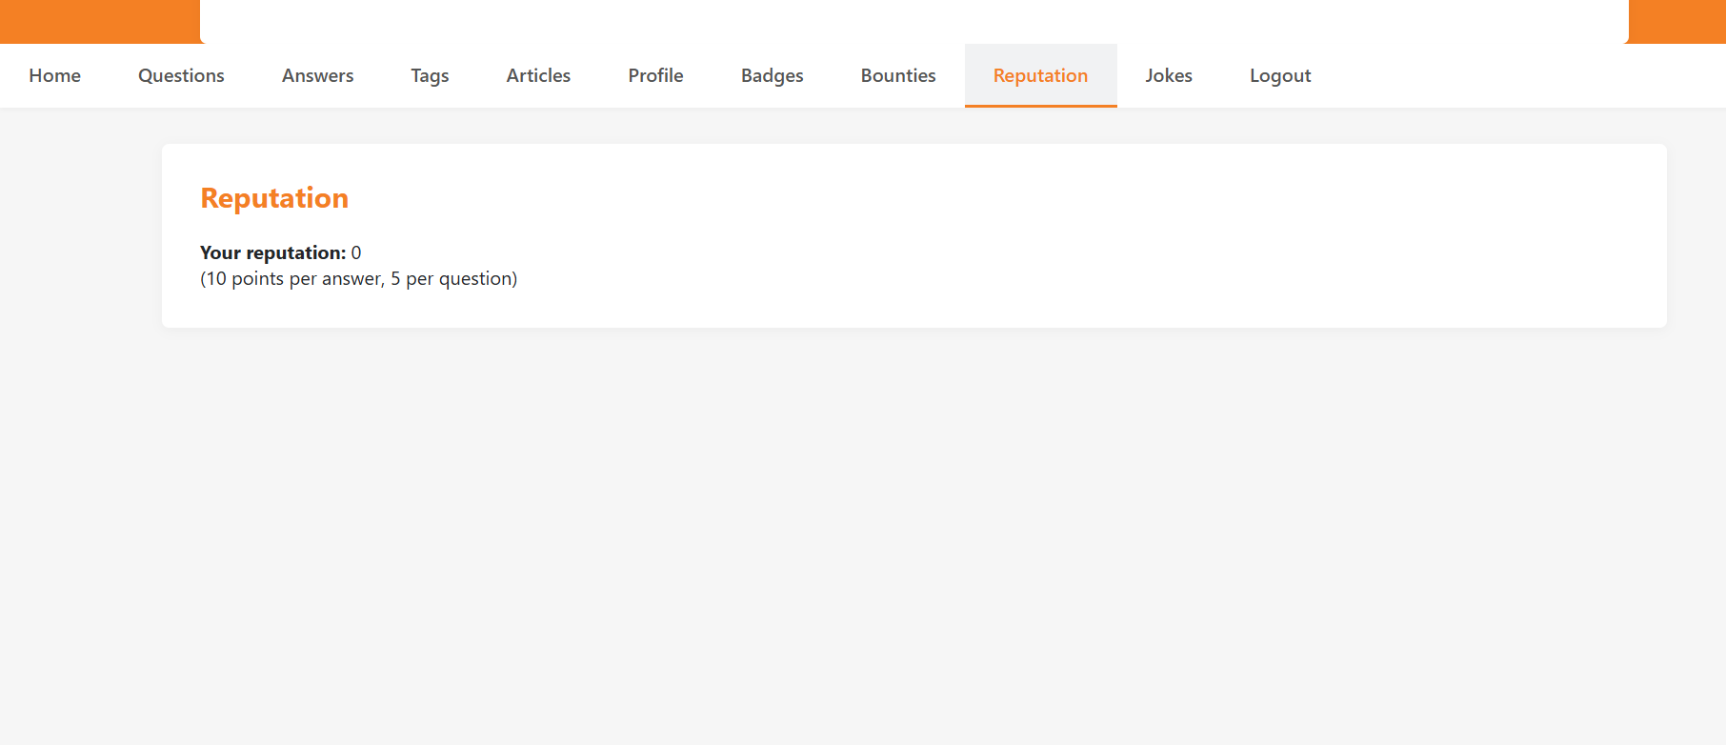
Figure: Reputation Module

Users Table
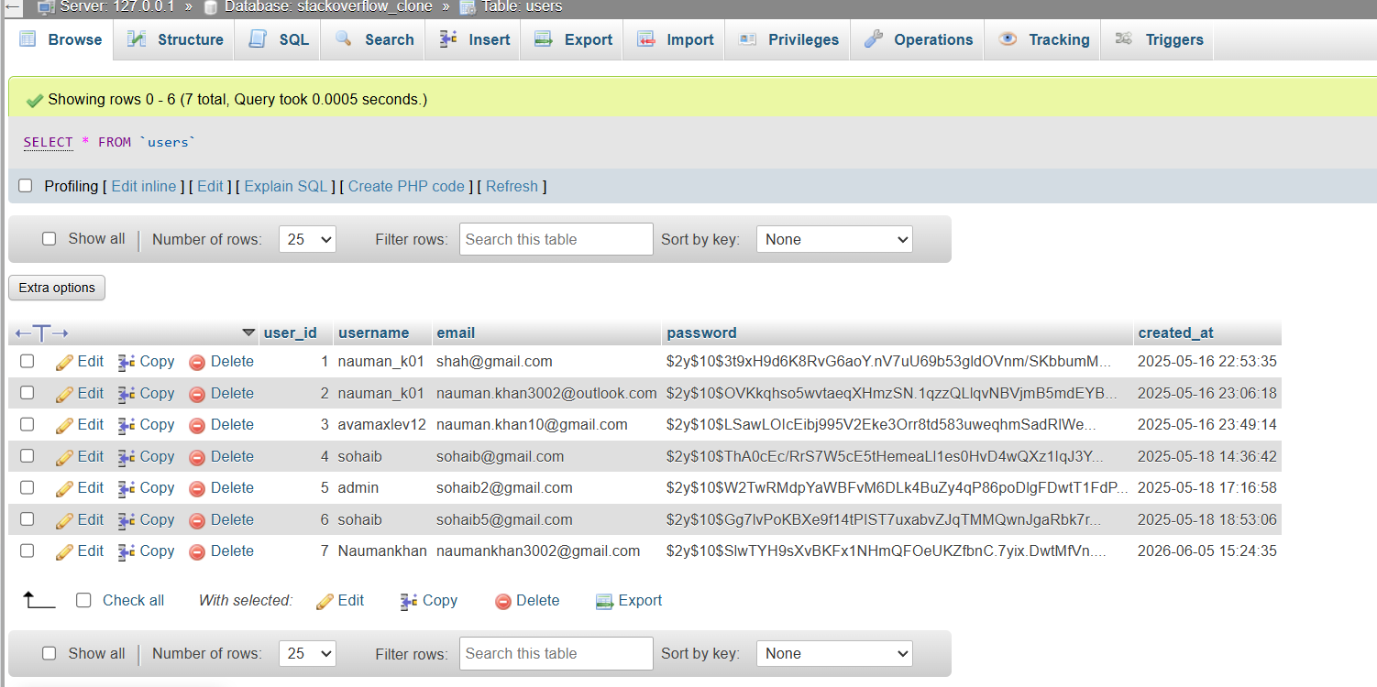
Figure: Users Table

Questions Table
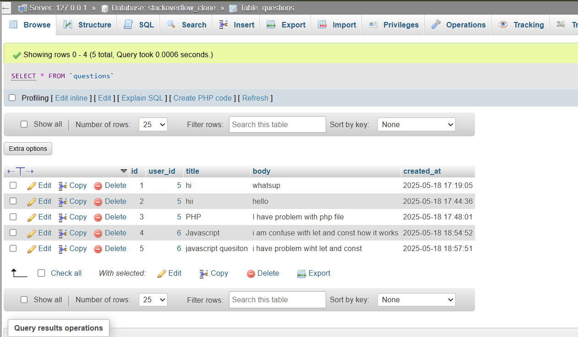
Figure: Questions Table

Answers Table
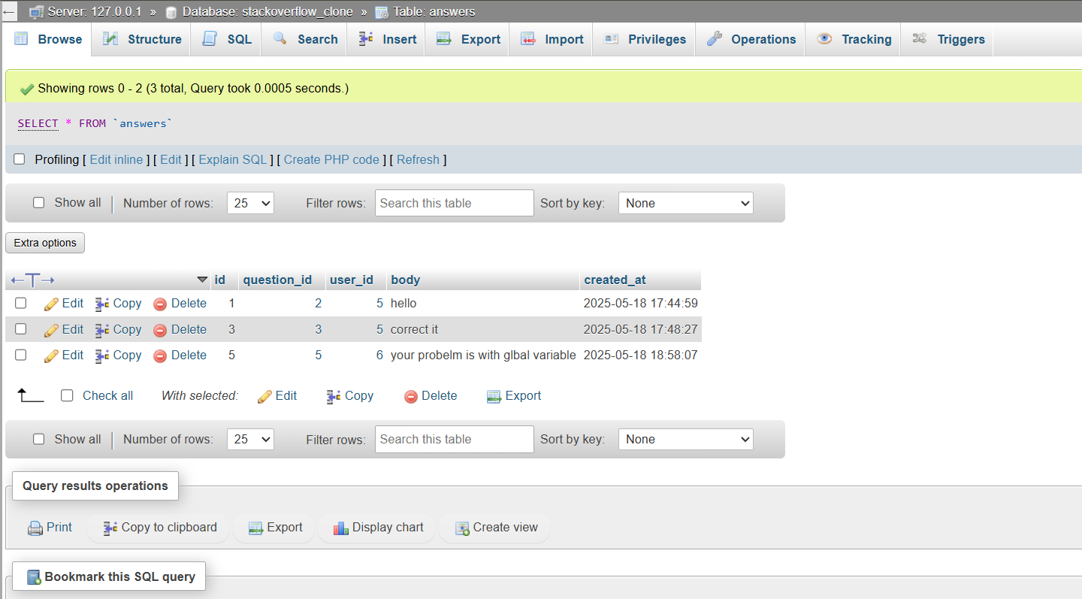
Figure: Answers Table

