**SCM651 Business Analytics**

Team 4:

Mark Misomali Eric Pzena

Mohamad Nayal Bibhuti Timalsina

Homework #2 – Recruiting Advertising Strategy

1. What were the time frames for each marketing campaign? How much was spent on each campaign? What was the effectiveness of previous campaigns? (40%)

|  |  |  |  |  |
| --- | --- | --- | --- | --- |
|  | Whitman.Syr.edu | MBA Marketing iMBA | MBA Marketing – Full Time | Delta |
| Date Start | 2/26/2011 | 4/13/2012 | 10/26/2012 | 9/23/2013 |
| Date End | 8/24/2011 | 10/26/2012 | 7/17/2013 | 11/13/2013 |
| Cost | $37,699.45 | $58,913.03 | $71,307.56 | $10,000 |
| Cost per Click | $4.03 | $14.50 | $16.51 | N/A |
| Sessions | 7079 | 2625 | 4292 | 66 |
| Bounce Rate | 78.39% | 89.22% | 82.53% | 31.82% |
| Cost per Session | $5.32 | $22.44 | $16.61 | $151.52 |

Whitman FT MBA / 59133974

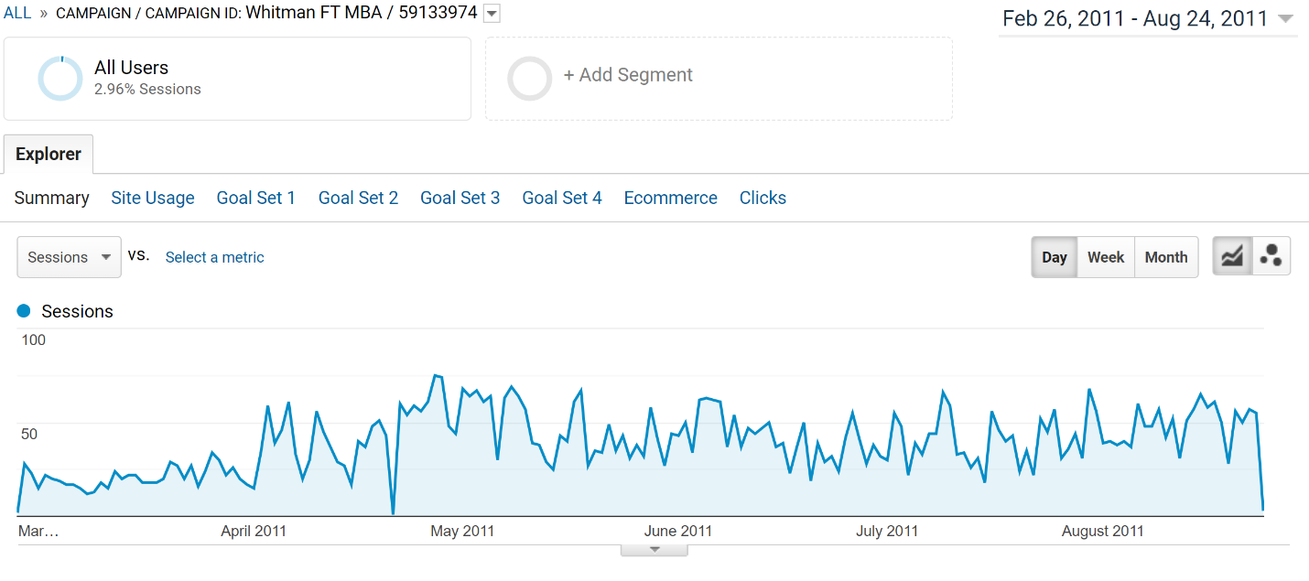

iMBA: Whit MBA / 68555294

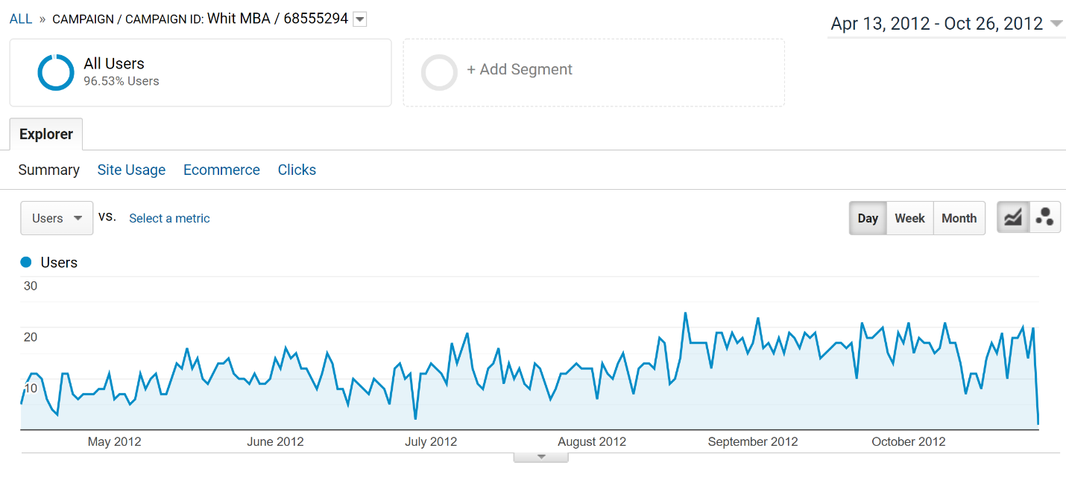

MBA Full Time: Whit MBA / 68555294

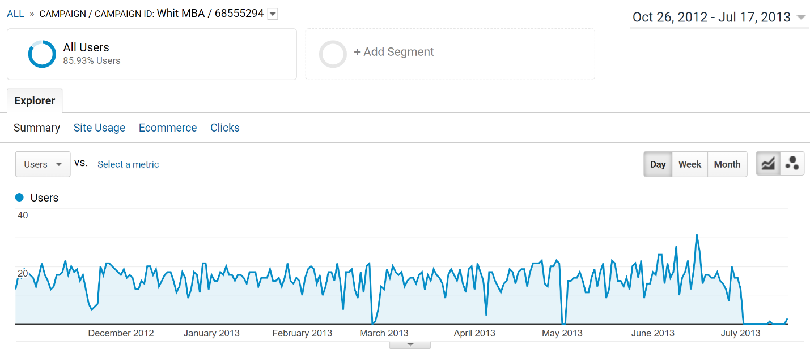

Delta: Sept 2013- May 2014

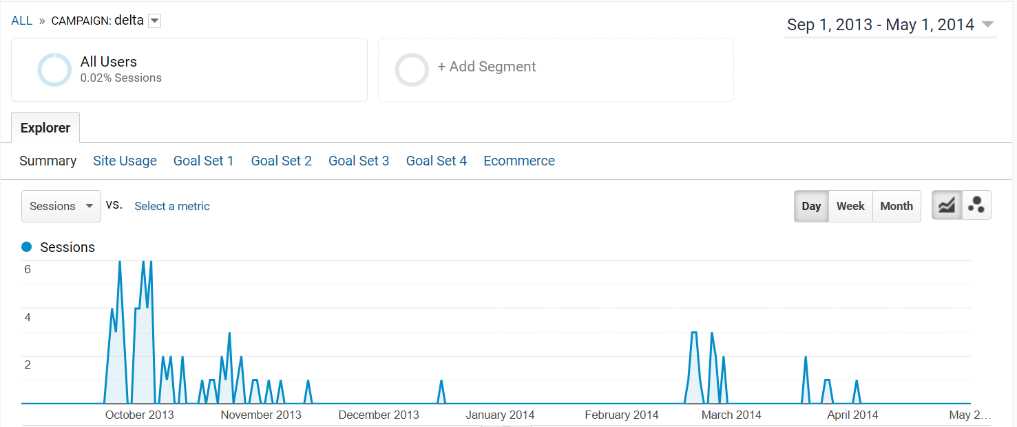

Delta: Sept 2013- Nov 2013

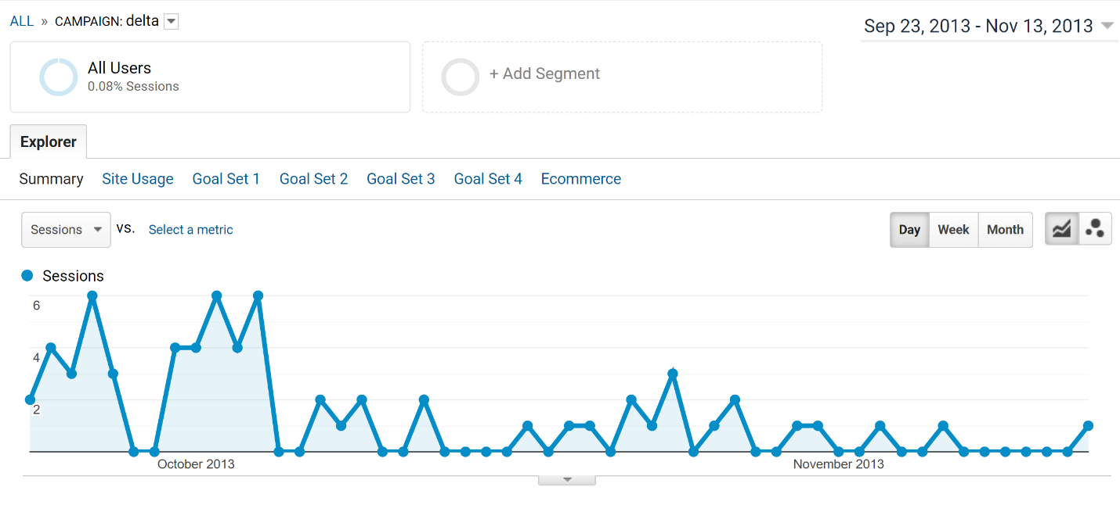

The table shows that Whitman.syr.edu was the most effective campaign because it cost the least and had the lowest cost per click, and the most sessions. This means that people were the most engaged, and the most people were reached for the least amount of money. The Delta campaign did not have a cost per click, but when you divide cost by session, you can see that it cost nearly ten times more for a session than the other campaigns. However, the Delta campaign had the lowest bounce rate, meaning, that although it cost more to get people engaged, that engagement was more meaningful. However, the bounce rate most likely does not make up for the higher price. For our analysis, we limited the date range for the delta campaign from 9/23/2013 to 11/13/2013. Most sessions occurred during this period. The few sessions in 2014 likely took place after the campaign ended.

1. Create a prediction of cost per click and a prediction of advertising cost per student for Google Ads for next year. Use either the prediction technique or Excel’s forecast option. Do not include Delta. If using the forecast option, assume the years below. Number of students recruited from the advertisements is listed below. (10%)
   1. whitman.syr.edu (2011 – 50 students enrolled)
   2. MBA Marketing – iMBA (2012 – 24 students enrolled)
   3. MBA Marketing – Full-time (2013 – 15 students enrolled)

We predict that the cost per click for advertising in 2021 will be $69.87, with a lower confidence bound $61.42 and an upper bound of $78.32. The projected advertising cost per student will be $20,509.80 with a lower confidence bound of $19,912.25 and an upper bound of $21,107.41. It is important to note that this forecast was created from the data about the advertising costs from just three years and used to predict the following eight years. This brings into question the quality of this prediction. More data about the costs from advertising campaigns from the past seven years would improve the reliability of our prediction.

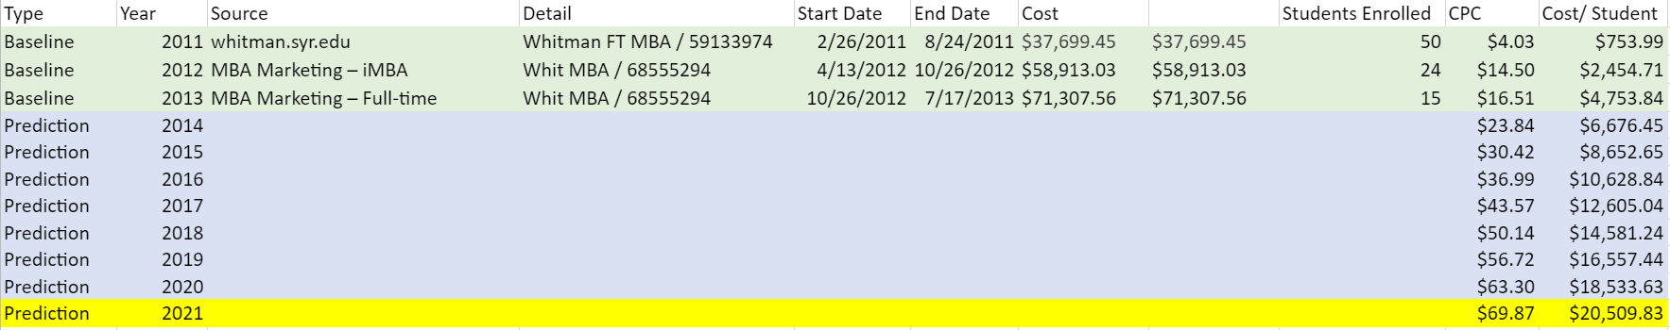

Cost per click:

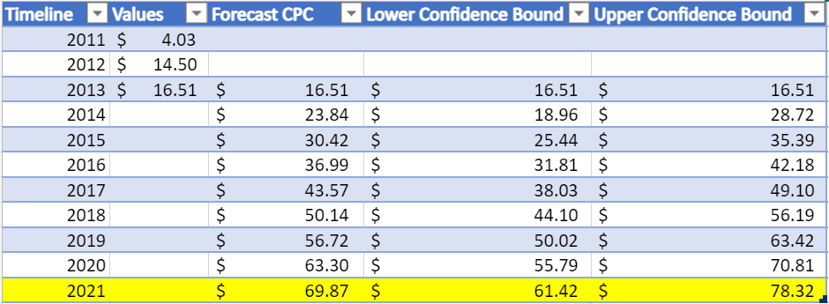

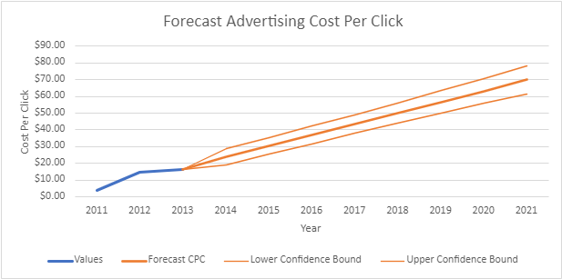

Cost per student:

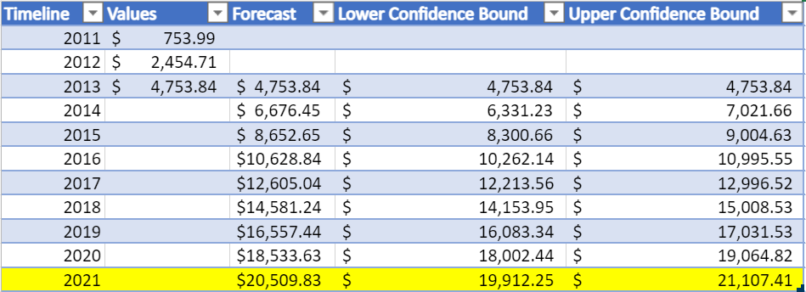

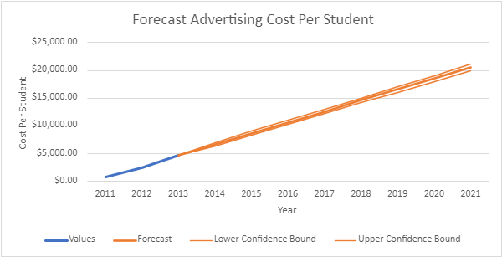

1. Identify the key aspects of a United States campaign for next year (20%)
   1. In which geographic region, states, or cities would you advertise? Why?

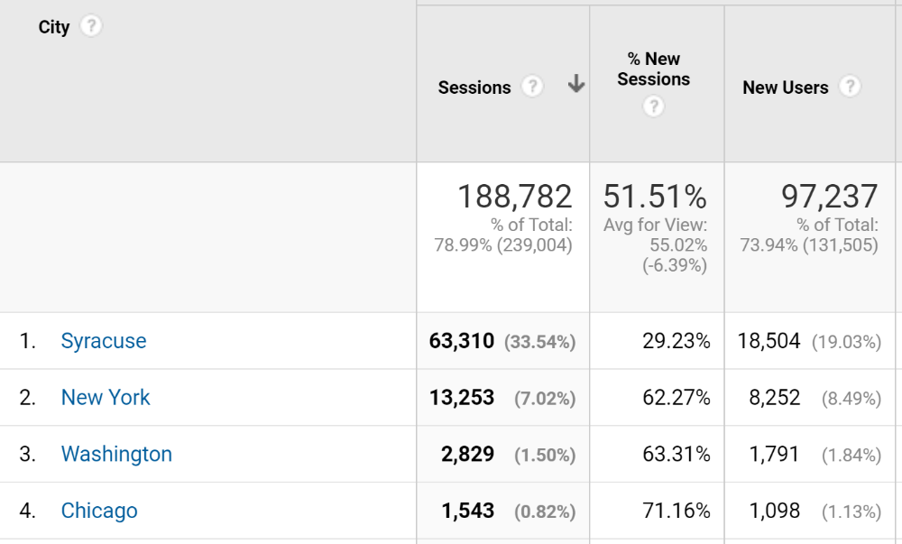

To determine the greatest influx of new users we looked at the time frame of the most successful ad campaign (Whitman.syr.edu - 59133974) between the dates of 2/26/2011 and 8/24/2011. This revealed that most new users are logging in in New York State specifically in the city of Syracuse. New York City, Washington D.C. and Chicago are the next largest sources for new users. Based off this we would focus most of our spending in Syracuse. Our plan is to spend 70% of our $100,000 budget targeted in our top four cities and the remaining $30,000 worth of advertising will not be geographically targeted. This method will ensure our advertising reached people in the cities where they are most likely to respond, while still gaining new site visitors from different geographic regions. Spending in each of our four cities will reflective the percent of sessions in that city relative to total sessions in the top four cities. There were 80,935 sessions in these cities, 78% of these sessions are in Syracuse, 16.4% of these sessions were in New York city, 3.5% of these sessions were in Washington D.C. and 1.9% of sessions were in Chicago. Our targeted $70,000 budget will be split so that $54,600 will be spent in Syracuse, $11,480 will be spent in New York City, $2,450 in Washington D.C., and $1,470 in Chicago.

* 1. What key words would you use? Why?

Over 96% of clicks acquired between 2/26/2011 and 8/24/2011 saw the keyword MBA. Other keywords include “Logtech” and “Top MBA”, but these keywords accounted for a very small portion of clicks so we would use “MBA”.

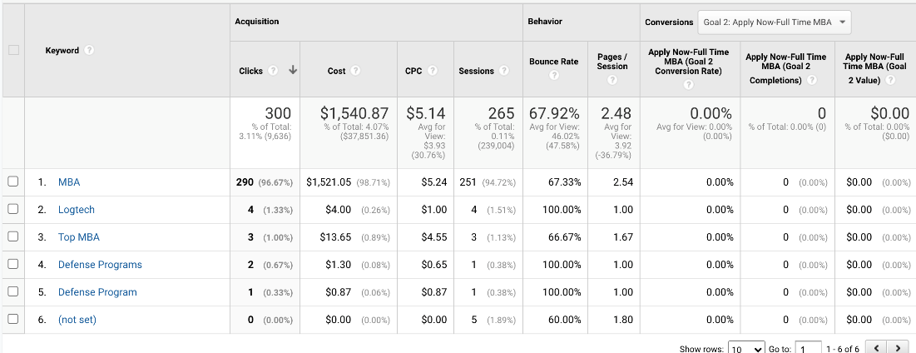

* 1. Which days of the week and what time of day would you advertise? Why?

Using the data from the 2011 campaign we should advertise between 5pm and 11pm on weekdays because we see a significant increase in clicks between 4pm and 5pm then after 11 there is a significant decrease.

The clicks per hour on Saturday and Sunday are more consistent throughout the day.

**Days of week**

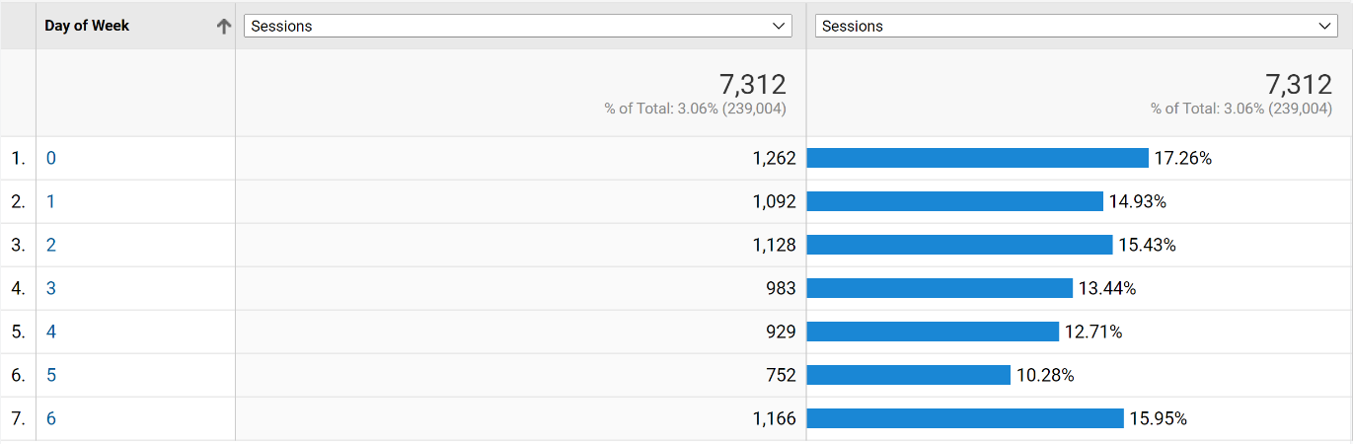

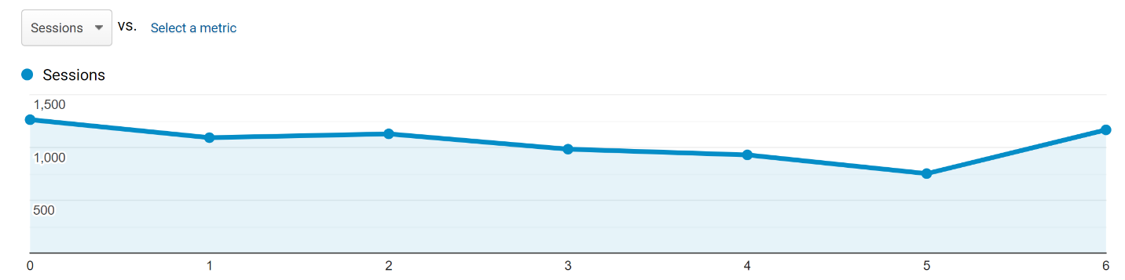

We would spend the $100,000 based on the percentages of people who click on each day. Using the data from the chart above, we would spend $17,260 on Sunday, $14,930 on Monday, $15,430 on Tuesday, $13,440 on Wednesday, $12,710 on Thursday, $10,280 on Friday and $15,950 on Saturday.

**Weekday Chart (Thursday):**

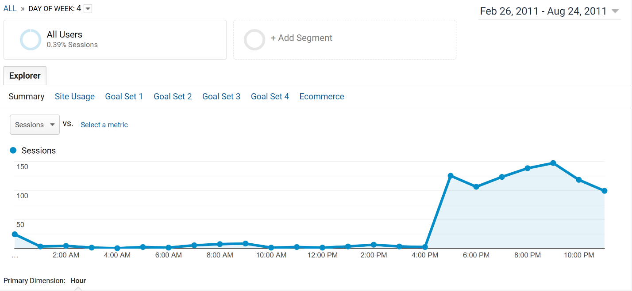

**Weekend Chart (Sunday):**

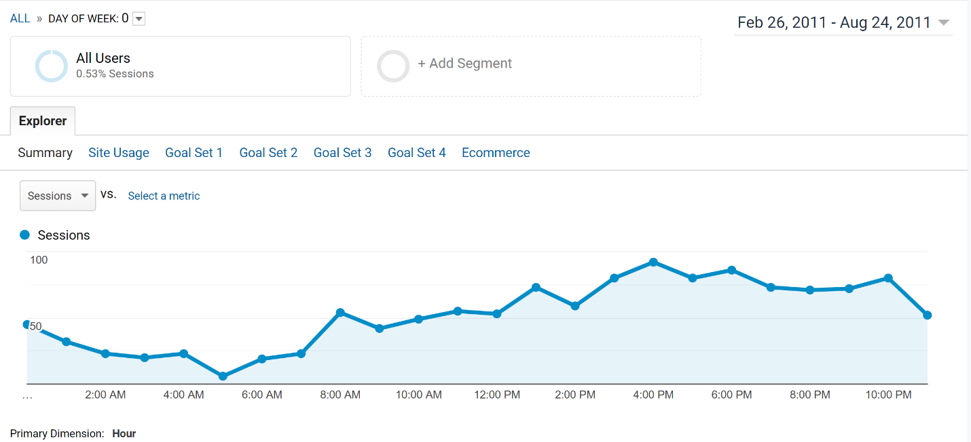

1. How would you measure performance of your decisions after implementation?

We would measure performance by comparing the results of our campaign to the results of previous campaigns. For example, have we improved cost per click? Have sessions per dollar spent gone up? Has the bounce rate gone down? Have the pages viewed per session gone up? Has average duration per session gone up? Has cost per enrolled student gone down? Has google conversion rate gone up? Have we gotten more sessions Syracuse than we have previously?

1. What other factors or considerations are important? What other data would help in developing an Internet advertising strategy, if you could collect it?

The goal of the homework is to recruit the best students. Meaning if there was a way to only advertise to people with high GMAT scores, that data could be advantageous. Another thing to consider in our goal, is do we want to advertise in the places where we are already successful in recruiting students, thereby getting the most students with our money? Or does it make sense to advertise where we are not doing well, because we could bring in people from new places? That could be beneficial in the long term for long term growth but be harder to measure the success of the campaign in the short term. It would also be helpful to have data that shows what percentage of those who responded to our previous campaign ended up enrolling.