8.32

n = 100 (samples of randomly selected pixels)

μ = 225 σ = 20

α = .01

α/2 = .005

Step 1: Two Tail Test

H0 = μ =220 The area sampled is grassland

Ha = μ <> 220 The area samples is not grassland

Step 2:

α = .01

α/2 = .005

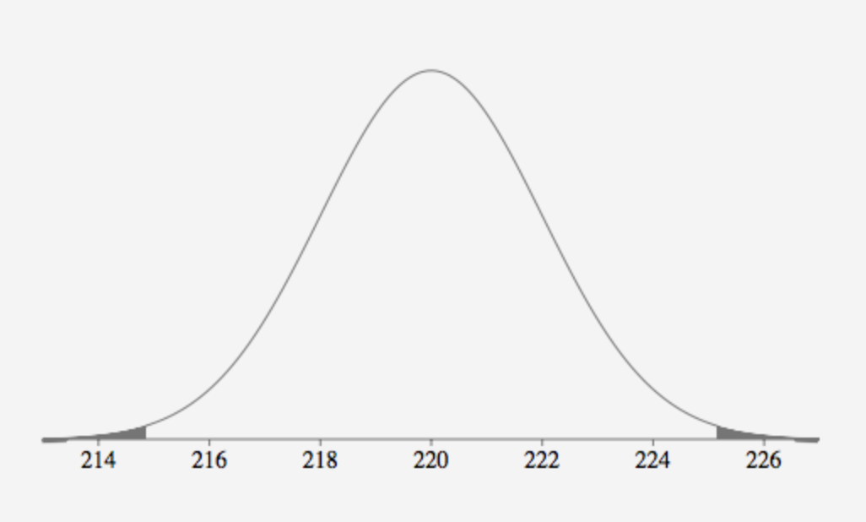

Step 3:

z = x(bar) – 220 / σx (bar)

z = 225 – 220 / (20/√100) = 25 / (20/√100) = 2.5

Step 4:

Rejection region: |z| > α/2 z .005 = 2.576

z < -2.576 or z > 2.576

|z| > α/2 = |2.5| > 2.576

p(z < - 2.5) + p(z > 2.5) = (0.5 – 0.4938) x 2 = 0.0124

Test statistic z =2.5 is less than z .005 = 2.576, we fail to reject H0.

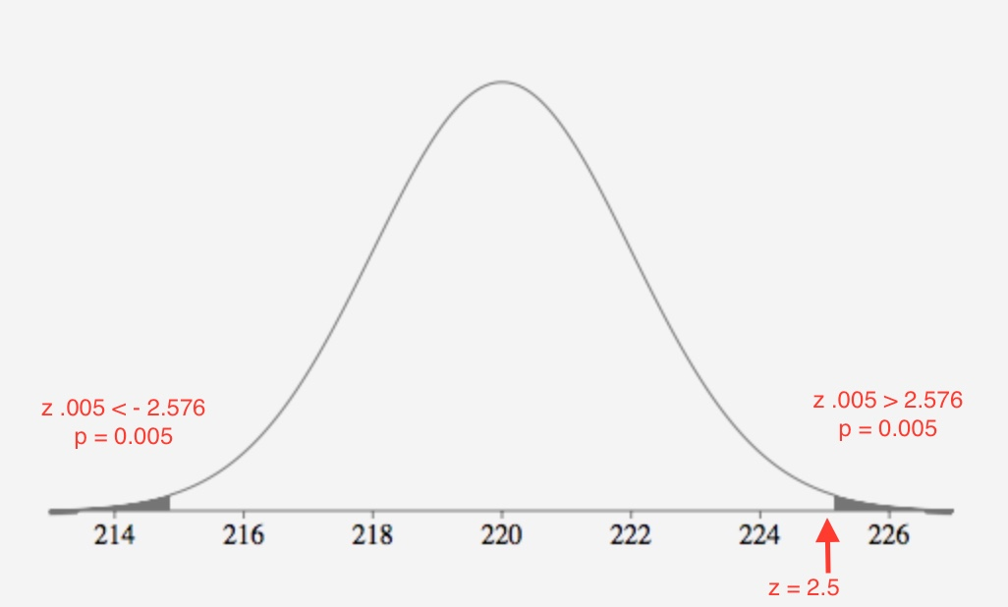

Step 5:

We failed to reject the null hypothesis.

The observed value of the test statistic z= 2.5 is less than z .005 = 2.576 where it does not fall in the rejection region. H0 : μ =220 is not rejected in favor of Ha : μ <> 220. There is insufficient evidence to indicate that the true mean is different from 220 at α = .01. There is insufficient evidence to conclude that the sampled are is not grassland.

8.35

n = 25000 (survey respondents)

μmale = 61340 σ male = 2185

μfemale = 32227 σ female = 932

a.

The value of μmale = 60000 is in between the 95% confidence interval [57050,65631]; therefore the value is not unusual. There is no evidence to reject H0. There is insufficient evidence that the mean salary of all males with post-graduate degrees is different from $60,000.

b. Two tail test

Step 1:

H0 = μ =60000

Ha = μ <> 60000

Step 2:

α = .05

α/2 = .025

Step 3:

x(bar) = 61340

z = x(bar) – 60000 / σx (bar)

z = 61340 – 60000 / 2185 = 0.61

Step 4:

Rejection region: |z| > α/2 z .025 = 1.96

z < -1.96 or z > 1.96

|z| > α/2 = |0.61| > 1.96

Test statistic z =0.61 is less than z .025 = 1.96, we fail to reject H0.

p(z < - 0.61) + p(z > 0.61) = 2 x (0.5 – 0.2291) = 0.5418

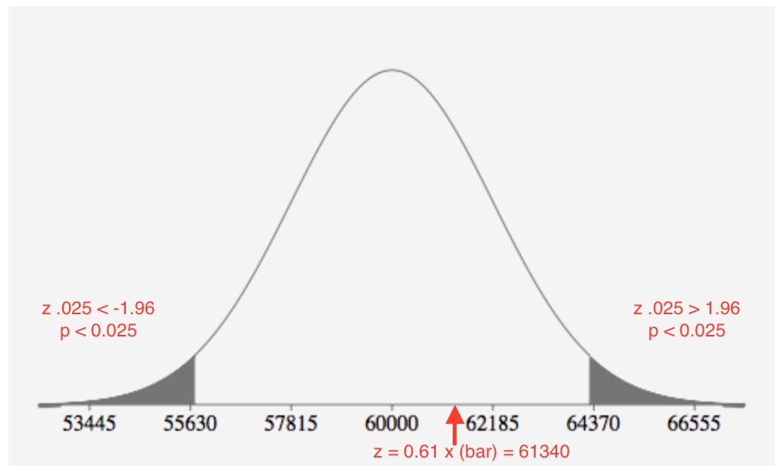

Step 5:

We failed to reject the null hypothesis.

The observed value of the test statistic z =0.61 is less than z .025 = 1.96 where it does not fall in the rejection region. H0 : μ =60000 is not rejected in favor of Ha : μ <> 60000. There is insufficient evidence to indicate the mean salary of all males with post-graduate degree is different from $60,000 at α = .05

c.

The inference from question 8.35 part a and b agree. Both use α = .05.

d.

The value for μfemale = $33,000 is within the 95% confidence interval [30396,34058]; therefore it is not unusual. There is no evidence to reject it. There is no evidence that the mean salary of all females with post-graduate degrees is different from $33,000.

e. Two tail test

Step 1:

H0 = μ =33000

Ha = μ <> 33000

Step 2:

α = .05

α/2 = .025

Step 3:

x(bar) = 32227

z = x(bar) – 33000 / σx (bar)

z = 32227 – 33000 / 932 = -0.829

Step 4:

Rejection region: |z| > α/2 z .025 = 1.96

z < -1.96 or z > 1.96

|z| > α/2 = |0.829| > 1.96

Test statistic z = -0.829 is greater than z .025 = -1.96, we fail to reject H0.

p( z < - 0.83) + p(z > 0.83) = 2 x (0.5 - .2967) = 0.4066

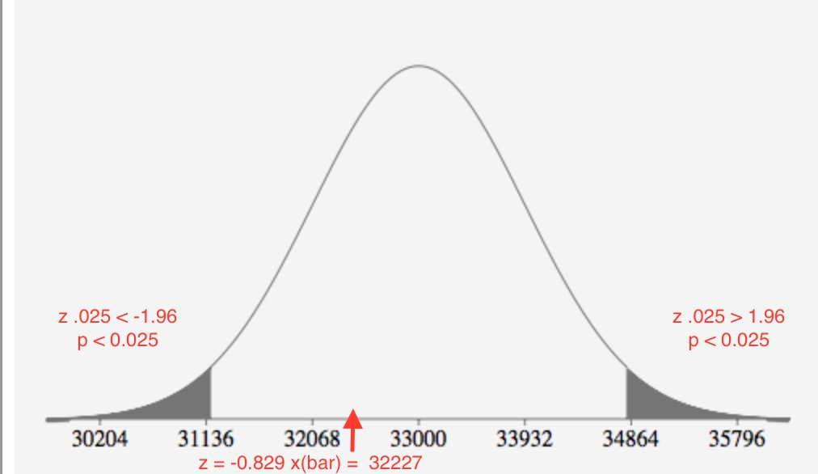

Step 5:

We failed to reject the null hypothesis.

The observed value of the test statistic z = -0.829 is less than z .025 = -1.96 where it does not fall in the rejection region. H0 : μ =33000 is not rejected in favor of Ha : μ <> 33000. There is insufficient evidence to indicate the mean salary of all females with post-graduate degree is different from $33,000 at α = .05

f.

The inference from question 8.35 part d and e agree. Both use α = .05.

**#8.54**

α = .05

n = 72

x(bar) = 1.13 s = 2.21

Step 1: Left tail test (lower)

H0 = μ = 7.5

Ha = μ < 7.5

H0 = μ >=7.5 Chickens more apt to peck white string

Ha = μ < 7.5 Chickens more apt to peck blue string

Step 2:

α = .05

Step 3:

z = x(bar) – 7.5/ σx (bar)

z = 1.13 – 7.5 / (2.21/√72) = -24.457

Step 4:

Rejection region: z < α z .05 = -1.645

z < - 1.645

z = -24.457 < -1.645

Test statistic z = -24.457 is less than z .025 = -1.645, we reject H0.

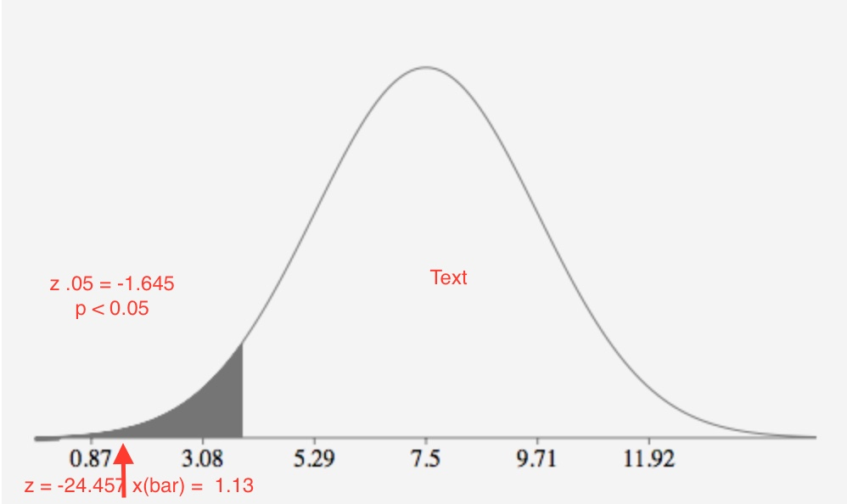

p( z < - 24.457) = 0.0

The observed value of the test statistic z= -24.457 is less than z .05 = -1.645 where it does fall in the rejection region. H0 : μ >=7.5 is rejected in favor of Ha : μ < 7.5. There is sufficient evidence to indicate that chicken are more apt to peck at the blue string at α = .05.

c.

p( z < - 24.457) = 0.0

The p-value is less than 0.001. There is **extremely** **strong** evidence that H0 is false at α = .05.

**#8.56**

μ = 51 n = 50

a.

Step 1: Two tail test

H0 = μ =51

Ha = μ <> 51

s = 7.1

Step 3:

z = x(bar) – 51 / σx (bar)

z = 52.3 – 51 / (7.1/√50) = 1.294

p(z < -1.29) + p(z > 1.29) = 2 x (.5 - .4015) = 0.197

b.

Step 1: Right tail test (upper)

H0 = μ =51

Ha = μ > 51

s = 7.1

Step 3:

z = x(bar) – 51 / σx (bar)

z = 52.3 – 51 / (7.1/√50) = 1.294

p(z > 1.29) = (.5 - .4015) = .0985

c.

Step 1: Two tail test

H0 = μ =51

Ha = μ <> 51

s = 10.4

Step 3:

z = x(bar) – 51 / σx (bar)

z = 52.3 – 51 / (10.4/√50) = 0.883

p(z < -0.88) + p(z > 0.88) = (0.5 - .3106) = 0.3788

d.

part a: z = 52.3 – 51 / (7.1/√50) = 1.294

p(z < -1.29) + p(z > 1.29) = 2 x (.5 - .4015) = 0.197

Any α > 0.197

part b: z = 52.3 – 51 / (7.1/√50) = 1.294

p(z > 1.29) = (.5 - .4015) = 0.0985

Any α > 0.985

part c: z = 52.3 – 51 / (10.4/√50) = 0.883

p(z < -0.88) + p(z > 0.88) = (0.5 - .3106) = 0.3788

Any α > 0.3788

**e.**

p-value = 0.01

α = 0.01 z .01 = 2.326

2.326 = 52.3 – 51 / s /√50 = 2.326 x s/√50 = 52.3 – 51

2.326 x s/√50 = 1.3

s = 1.3 x √50 / 2.326

s = 3.952

For a one tail test any s that is < 3.952 will lead to a p-value <= 0.01

**#8.161**

n = 48

σ = 2.103

a.

Step 1: Left tail test (lower)

H0 = μ =10

Ha = μ < 10

Step 2:

α = .05

z .05 = - 1.645

Rejection region: z < -1.645

Step 3:

x(bar) = 9.292

σ = 2.103

z = x(bar) – 10 / σx (bar)

z = 9.292 – 10 / (2.103/√48) = -2.33

Test statistic z = -2.33 is less than z .05 = -1.645, we reject H0.

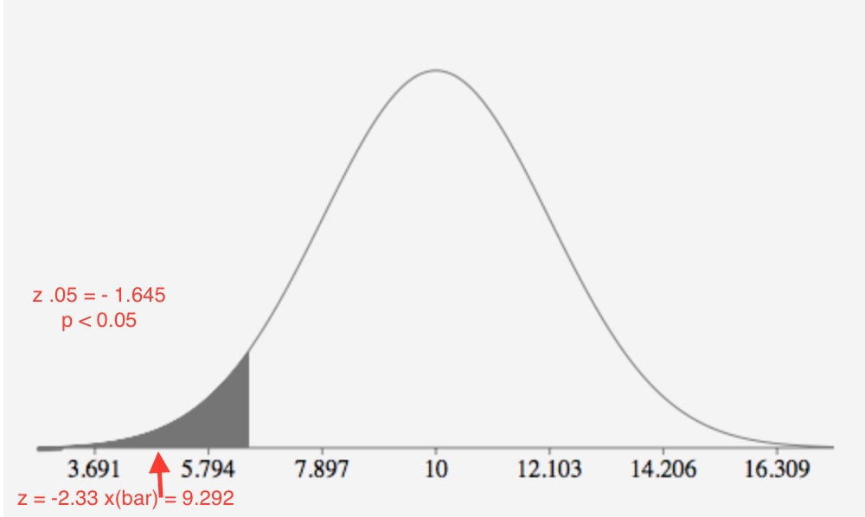

p(z < -2.33) = (0.5 - .3106) = 0.3788

Step 4:

-2.33 < -1.645

The observe value of the test statistics z = -2.33 is less than z .05 = -1.645 falls in the rejection region. H0 : μ =10 is rejected in favor of Ha : μ < 10. There is sufficient evidence to indicated that the true average of inspections is less than 10 at α = .05.

I agree with the potential buyer who doubts the claim that the average inspection is less than 10.

b.

s = 1.2

μ = 9.5

n = 48

z .05 = - 1.645

z .05 = x(bar) – μ / σx (bar)

- 1.645 = x(bar) – 10 / (1.2√48)

- 1.645 x (1.2√48) = x(bar) – 10

x(bar) = 9.7150

z = x(bar) – 10 / σx (bar)

z = 9.715 – 9.5 / (1.2√48)

z = 1.24

p(z < 1.24) = 0.5 + 0.3925 = 0.8925

Probability that x(bar) < 9.715 given μ = 9.5