#8.66

n = 14 – Use the t table

x(bar) = 31.64

StDev = s = 10.49

a.

Step 1: Right (upper) tail test

H0 = μ = 25 The average number of books read by all students that participated in the extensive reading is 25

Ha = μ > 25 The average number of books read by all students that participated in the extensive reading is greater than 25

b.

Step 2:

α = 0.05

*t0.05* = 1.771

degree of freedom = 13

c.

Step 3:

x(bar) = 31.64

t = x(bar) – 25 / s/√n

t = 31.64 – 25 / 10.49/√14

t = 2.368

*t0.05* = 1.771 (shown as T in minitab printout)

t > *t0.05*

Reject the null hypothesis

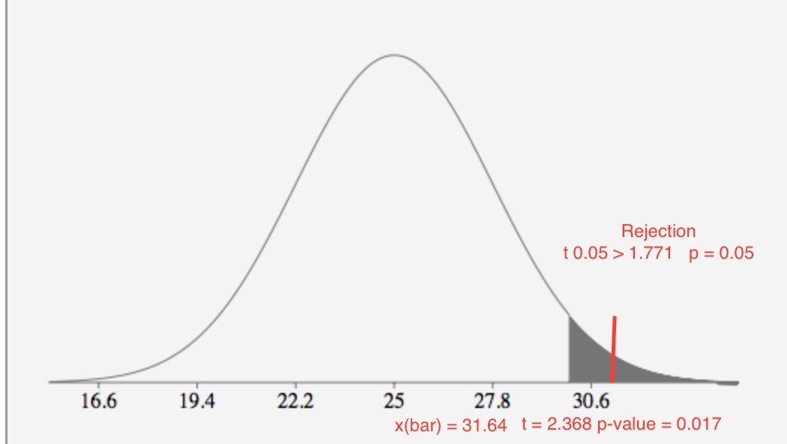

d.

The observed value of the test statistic t = 2.368 is greater than t .05 = 1.771 where it does fall in the rejection region. H0 : μ =25 is rejected in favor of Ha : μ > 25. There is sufficient evidence to indicate that the number of books read by all students who participated in the extensive reading program exceeds 25 at α = .05.

e.

The conditions required 1- random sample from the target population 2 – the population from which the sample is selected has a distribution that is approximately normal.

f.

p-value: 0.017

We have strong evidence that Ho is false.

p( t > - 3.461) = 0.017 0.01 < p-value < 0.025

The p-value is 0.017. There is **strong** evidence that H0 is false at α = 0.05.

#8.74

n = 11 – use t table

Step 1: Two tail test

H0 = μ = 5 Average number of ant species at Mongolian desert sites is 5

Ha = μ ≠ 5 Average number of ant species at Mongolian desert sites differs from 5

Step 2:

α = 0.05

α/2 = 0.025

degree of freedom = 10

*t0.025* = 2.228

Step 3:

x(bar) = 12.818

s = 18.67

t = x(bar) – 5 / s/√n

t = 12.818 – 5 / 18.67/√11

t = 1.3888

Step 4:

Rejection region: | t | < tα/2 t0.025 = 2.228

t < 2.228

p(t > 1.39) = 0.195 (p-value using calculator and MINITAB 0.195) 0.010 < p-value < 0.025

Test statistic t = 1.388 is less than t .025 = 2.228, we fail to reject H0.

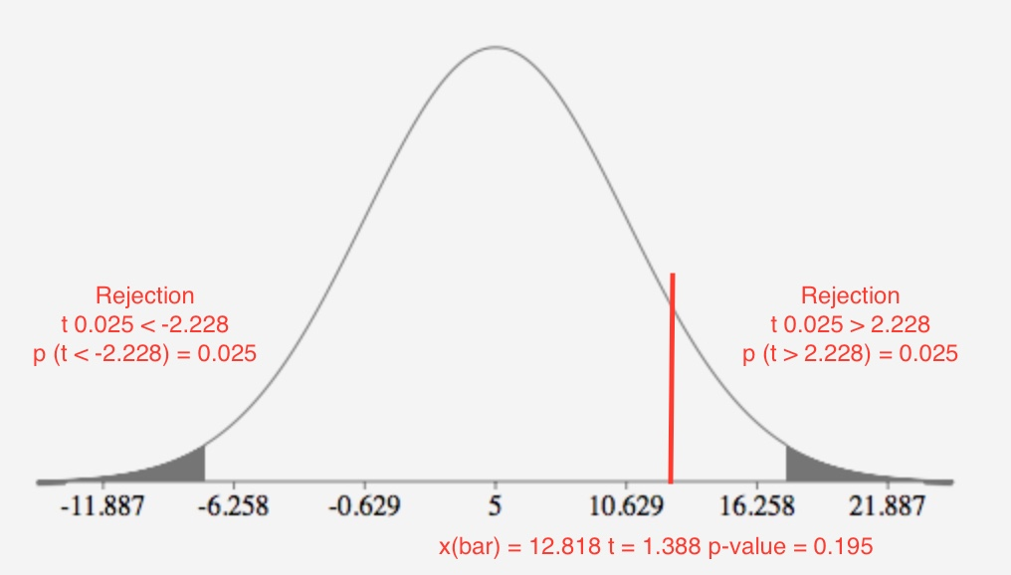

Step 5:

We failed to reject the null hypothesis.

The observed value of the test statistic t = 1.388 is greater than t .025 = 2.28 where it does not fall in the rejection region. H0 : μ = 5 is not rejected in favor of Ha : μ ≠ 5. There is insufficient evidence to indicate that the true mean is different from 5 at α = .05. There is insufficient evidence to conclude that the average number of ant species at Mongolian desert sites differs from 5.

The conditions required 1- random sample from the target population 2 – the population from which the sample is selected has a distribution that is approximately normal.

The conditions required for a valid test are not satisfied.

One-Sample T: AntSpecies

Descriptive Statistics

|  |  |  |  |  |
| --- | --- | --- | --- | --- |
| N | Mean | StDev | SE Mean | 95% CI for μ |
| 11 | 12.82 | 18.68 | 5.63 | (0.27, 25.36) |

*μ: mean of AntSpecies*

Test

|  |  |
| --- | --- |
| Null hypothesis | H₀: μ = 5 |
| Alternative hypothesis | H₁: μ ≠ 5 |

|  |  |
| --- | --- |
| T-Value | P-Value |
| 1.39 | 0.195 |

#8.86

n = 121 – Use z-table

correct = 97

The sample size must be large enough.

n * p0 ≥ 15 121 * .5 = 60.5 ≥ 15

n * q0 ≥ 15 121 * .5 = 60.5 ≥ 15

a. p(hat) = proportion = 97/121 = 0.80

The proportion of the population of students that correctly identified the color of gummy bear based on the flavor is p. If there is no relationship between color and gummy bear flavor, then p = .5. Students have 50% change to guess it right or wrong no matter the flavor.

Step 1: Right (upper) tail test

H0 = p0 = .50 The color and gummy bear flavor are not related

Ha = p0 > .50 The color and gummy bear flavor are related

Step 2:

α = .01

Step 3:

z = p(hat) – p0 / σp(hat)

z = .8 - .5 / √.5 x .5 / 121 = .3 / .0454 = 6.59

Step 4:

Rejection region: | z | < zα z0.01 = 2.326

z > 2.326

p(z > 6.59) ***≤ .5 - .499 ≤ .001*** (p-value using calculator 2.192-35)

Test statistic z = 6.59 is greater than z .01 = 2.326, we reject H0.

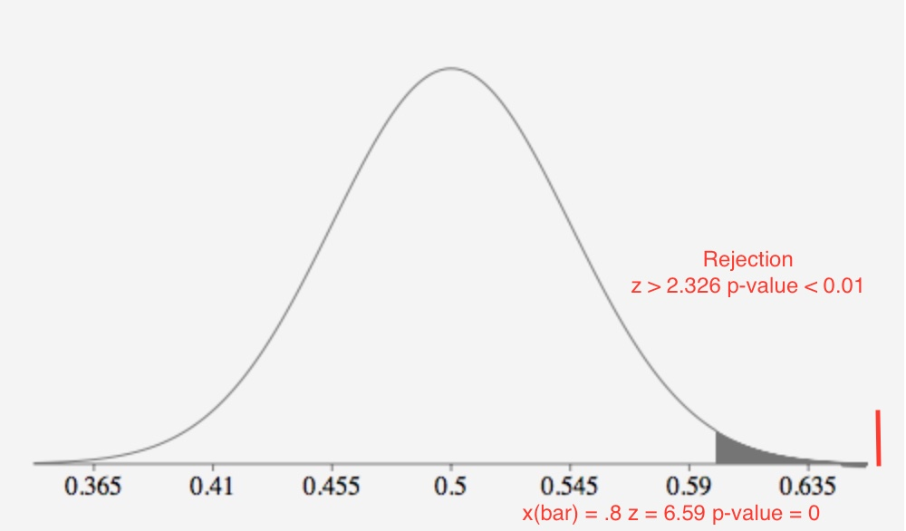

Step 5:

The observed value of the test statistic z = 6.59 is greater than z 0.01 = 2.326 where it does fall in the rejection region. H0 : p = 0.5 is rejected in favor of Ha : p > 0.5. There is sufficient evidence to indicate that the color and gummy bear flavor are related at α = .01.

The p-value is ***≤ .001***. There is **extremely** **strong** evidence that H0 is false at α = .01.

Test and CI for One Proportion

Method

|  |
| --- |
| p: event proportion |
| Exact method is used for this analysis. |

Descriptive Statistics

|  |  |  |  |
| --- | --- | --- | --- |
| N | Event | Sample p | 99% Lower Bound for p |
| 121 | 97 | 0.801653 | 0.703821 |

Test

|  |  |
| --- | --- |
| Null hypothesis | H₀: p = 0.5 |
| Alternative hypothesis | H₁: p > 0.5 |

|  |
| --- |
| P-Value |
| 0.000 |

# 8.141

n = 12 – use t table

x (bar) = 63

s = 17

Step 1: Left (lower) tail test

H0 = μ = 80 True mean score of sleep-deprived subjects is 80

Ha = μ < 80 True mean score of sleep-deprived subjects is less than 80

Step 2:

α = 0.05

degree of freedom = 11

*t0.05* = -1.796

Step 3:

t = x(bar) – 80 / σx (bar)

t = 63 – 80 / (17/√12) = -17 / (17/√12) = -3.461

Step 4:

Rejection region: t < tα t0.05 = -1.796

t < -1.796

p(t < - 3.461) ***0.001 < p-value < 0.005*** (p-value using calculator 0.0026 and 0.003 using MINITAB)

Test statistic t =-3.461 is less than t .05 = -1.796, we reject H0.

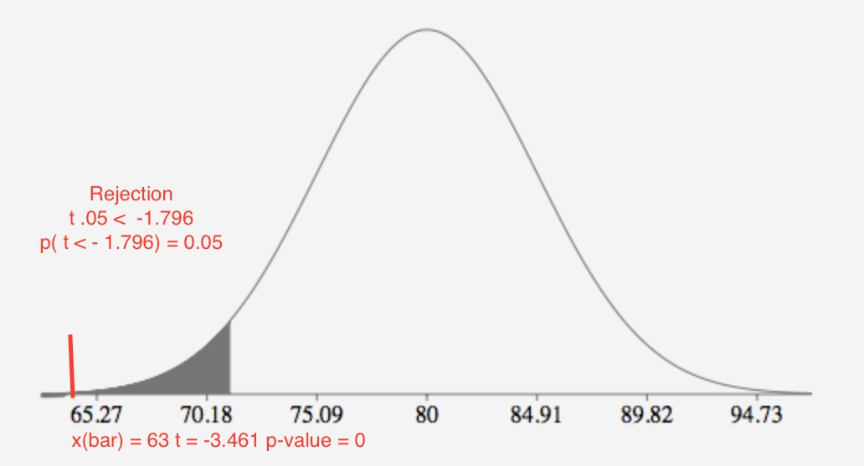

Step 5:

The observed value of the test statistic t = -3.461 is less than t .05 = -1.795 where it does fall in the rejection region. H0 : μ = 80 is rejected in favor of Ha : μ < 80. There is sufficient evidence to indicate that the true mean score of sleep-deprived subjects is less than 80 at α = .05.

p( t < - 3.461) ***≤ .001***

The p-value is ***≤ .001***. There is **extremely** **strong** evidence that H0 is false at α = 0.05.

b.

The conditions required 1) random sample from the target population was selected 2) the population from which the sample is selected has a distribution that is approximately normal.

One-Sample T

Descriptive Statistics

|  |  |  |  |  |
| --- | --- | --- | --- | --- |
| N | Mean | StDev | SE Mean | 95% Upper Bound for μ |
| 12 | 63.00 | 17.00 | 4.91 | 71.81 |

*μ: mean of Sample*

Test

|  |  |
| --- | --- |
| Null hypothesis | H₀: μ = 80 |
| Alternative hypothesis | H₁: μ < 80 |

|  |  |
| --- | --- |
| T-Value | P-Value |
| -3.46 | 0.003 |

#8.145

n = 67

masculinization of face shaped decreased attractiveness of the male face 58 of 67

p (hat) = 58/67 = 0.86567

The proportion of the population of human subject who felt that the masculinization of the face shape decreased attractiveness. If there is no preference for either the unaltered or the morphed male face, then p = .5.

Step 1: Two tail test

p(hat) = 58/67 = .8666

Check the sample size to ensure it is large

np >= 15 33.5 >= 15 nq >= 33.5 >= 15

H0 = p = 0.5 subject did not show a preference for either the unaltered or the morphed male face

Ha = p ≠ 0.5 subject did show a preference for either the unaltered or the morphed male face

Step 3:

z = p(hat) – p0 / √.5 x .5 / 67

z = .866 - .5 / √.5 x .5 / 67

z = 5.99

c.

Step 4

p(z< -5.99) + p(z > 5.99) ***≤ .5 - .499 ≤ .001*** (p-value using calculator 2.154-9)

The p-value reported by researcher in agreement.

d.

Step 2:

α = 0.01

α/2 = 0.005

Step 4:

Rejection region: |z| > α/2 z 0.005 = 2.576

z < -2.576 or z > 2.576

|z| > α/2 = |5.99| > 2.576

p(z < - 5.99) + p(z > 5.99) ***≤ .5 - .499 ≤ .001***

Test statistic z = 5.99 is greater than z 0.005 = 2.576, we reject H0.

Step 5:

The observed value of the test statistic z = 5.99 is greater than z 0.005 = 2.576 where it does fall in the rejection region. H0 : p = 0.5 is rejected in favor of Ha : p ≠ 0.5. There is sufficient evidence to indicate that subjects showed a preference for either the unaltered or morphed face at α = .01.

The p-value is ***≤ .001***. There is **extremely** **strong** evidence that H0 is false at α = .01.

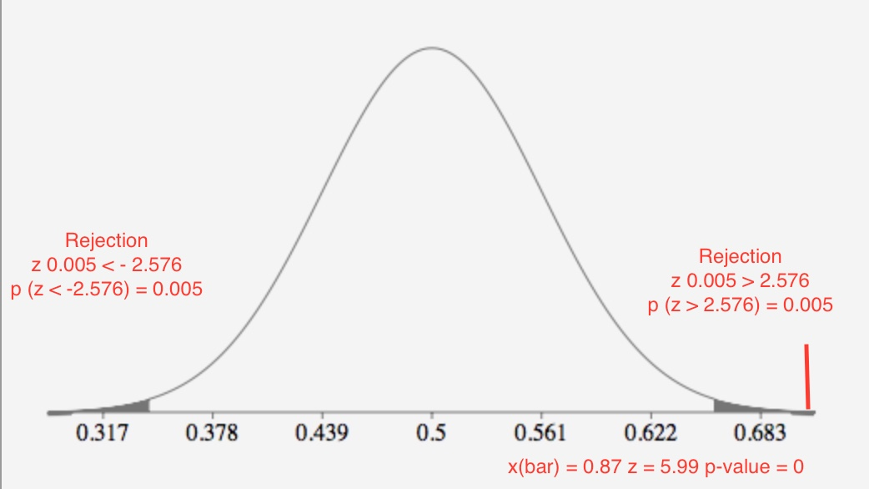

Test and CI for One Proportion

Method

|  |
| --- |
| p: event proportion |
| Exact method is used for this analysis. |

Descriptive Statistics

|  |  |  |  |
| --- | --- | --- | --- |
| N | Event | Sample p | 99% CI for p |
| 67 | 58 | 0.865672 | (0.725473, 0.951443) |

Test

|  |  |
| --- | --- |
| Null hypothesis | H₀: p = 0.5 |
| Alternative hypothesis | H₁: p ≠ 0.5 |

|  |
| --- |
| P-Value |
| 0.000 |