#9.10

Two independent samples

N = 100 from each sample

x(bar)1 = 70

x(bar)2 = 50

variance1 = σ1 = 100

variance2 = σ2 = 64

x(bar)1 - x(bar)2 = 70 – 50 = 20

μ1 is the mean for sample 1

μ2 is the mean for sample 2

1. σ (x(bar)1 - x(bar)2 ) = √ σ1/ n1 + σ2/ n2 = √ 100/100 + 64/100 = 1.28062
2. The sampling distribution of x(bar)1 - x(bar)2 is approximately normal per the Central Limit Theorem. The sample size for x(bar)1 and x(bar)2 is 100 which is greater or equal to 30.

μ1 - μ2 = 5

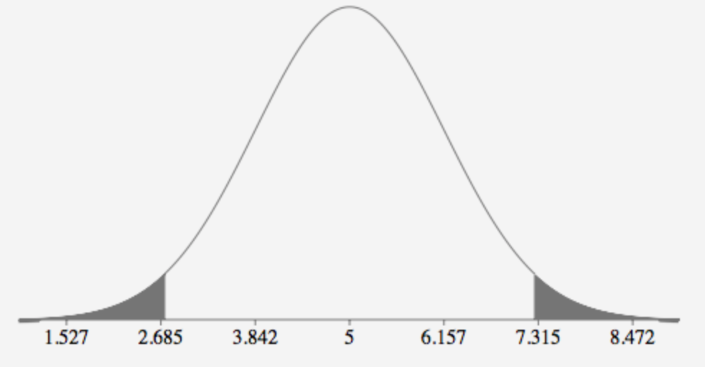

1. α = 0.05

α/2 = 0.025

z .025 = 1.96

z < -1.96 or z > 1.96

1. x(bar)1 - x(bar)1 = 20 appears to contradict the null hypothesis H0 : μ1 - μ2 = 5.
2. H0 : μ1 - μ2 = 5 the difference between the mean for sample 1 and sample 2 is 5
3. Ha : μ1 - μ2 ≠ 5 the difference between the mean for sample 1 and sample 2 is not 5

z = 20 – 5 / 1.2806

z = 11.713

Reject null hypnosis

1. 20 ± 1.96 x 12806 = 20 ± 2.510 = [17.4899, 22.510]

The confidence interval does not contain 5, then it is not possible for the difference between the population means to be 5.

1. The confidence interval gives us a range of values for μ1 - μ2. We use this interval to test the hypothesis. Based on the test, the null hypothesis μ1 - μ2 = 5 is rejected and we can conclude that alternative hypothesis μ1 - μ2 ≠ 5 must be true.

#9.14

independent samples n1= 41 (schizophrenic) n2 = 49

*z.005* = 2.576

1. μ1 is the mean time on the Trail Making Test for schizophrenics subjects

μ2 is the mean time on the Trail Making Test for normal subjects

1. H0 : μ1 - μ2 = 0 the difference between mean time of the Trail Making Test for schizophrenics subjects and the mean time of the Trail Making Test for normal subject is 0

Ha : μ1 - μ2 > 0 mean time of the Trail Making Test for schizophrenics subjects is greater than the mean time of the Trail Making Test for normal subject

1. p-value of 0.001 is less than α = 0.01. We would reject the null hypothesis H0 : μ1 - μ2 = 0 mean time on the Trail Making Test for any p-value less than α = 0.01. We can conclude that alternative hypothesis mean time of the Trail Making Test for schizophrenics subjects is greater than the normal subject for α = 0.01.
2. The true difference in mean between time on the Trail Making Test between schizophrenics and normal subjects is between 22.741 and 61.238 at 95% confidence level.

104.23 – 62.24 ± 2.576 √ 45.45 2/41 + 16.342/49

41.99 ± 2.576 x 7.4720 = 41.99 ± 19.248 = [22.741, 61.238]

#9.16

μ1 is the mean IBI for Muskingum River

μ2 is the mean IBI for Hocking River Basin

1. .035 – .340 ± 1.645 √ 1.046 2/53 + .962/51 = -0.305 ± 1.645 √ 0.0206 + 0.0180 = = -0.305 ± 1.645 x 1.967 = -0.305 ± 0.3236

[-0.6286,0.0186]

We are 90% confident that the mean IBI of Muskingum River is less than Hocking River by .6286 and more by .0186.

H0 : μ1 - μ2 = 0 the difference between the mean IBI for Muskingum River and the mean IBI for Hocking River Basin is 0

Ha : μ1 - μ2 ≠ 0 the difference between the mean IBI for Muskingum River and the mean IBI for Hocking River Basin is not 0

#9.17

1. µ1 = sample 1 mean number of books read by students who participated in the reading program with A

µ2 = sample 2 mean number of books read by students who participated in the reading program with B or C

H0 = µ1 - µ2 = D0

Where D0 = Hypothesized difference between the means

1. (x(bar)1 – x(bar)2 ± tα/2 √ s2p ( 1/ n1 + 1/ n2)

37 – 24.5 ± 2.179 √ 893.5/12 ( 1/8 + 1/ 6)

12.5 ± 10.154 = [2.346,22.654]

1. We are 95% confident that the difference between mean number of books read by student who participated in the reading program who earned an A and those wo earned a B or C is between 2.346 and 22.654
2. Students who participated in the reading program that earned an A appear to read more books than student that earned a B or C.

|  |  |
| --- | --- |
| Stem | Leaf |
| Unit = 10 |  |
| 1 | 6 |
| 2 | 1248 |
| 3 | 449 |
| 4 | 2 |
| 5 | 3 |

x(bar)1 = 37

x(bar)2 = 24.5

tα/2 = 2.179

7 + 7 – 2 = 12

s2p = (8-1) s21 + (6-1) s22 / 8 + 6 – 2 = (8-1) 8.7012+ (6-1) 8.5262 / (8 + 6 – 2) = (8-1) s21 + (6-1) s22 / 8 + 6 - 2

#9.114

x(bar)1 = 39.08

x(bar)2 = 38.79

variance1 = σ1 = 6.732

variance2 = σ2 = 6.942

x(bar)1 - x(bar)2 = 39.08 – 38.79 = 0.29

a.

√ s21/ n11 + s22/ n22 = √6.732 / 127 + 6.942 / 114 = √.77912 = 0.88268

0.29 ± 1.645 x 0.88268 = 0.29 ± .1452 = [-1.162, 1.742]

b.

The value zero is contained in the 90% confidence interval. There is no sufficient evidence to suggest the there is a difference in the perception of service quality at 5-star hotel

c.

σ21 = females n = 114

σ22 = males n = 127

H0 : σ21 = σ22 variance of males and variance of females are equal

Ha : σ21 ≠ σ22 variance of males and variance of females are not equal

F = σ21 / σ22 = 6.942 / 6.732 = 1.0633

Df female = 114 -1 – 113 df male = 127 -1 – 126

α = 0.10

α/2 = 0.05

F .05 = 1.26

Rejection Region

F > 1.26

1.063 < 1.26 The test statistic does not fall within the rejection region. H0 is not rejected in favor of Ha. There is no sufficient evidence to suggest that the variance between males and females guest differ at α = 0.10.