#8.129

The smaller the p-value associated with a test of hypothesis, the stronger is the support for the **alternative** hypothesis. The p-value is the probability of observing the test statistic value that contradict the null hypothesis and supports the alternative. The smaller the p-value the stronger argument to support alternative. The p-value is the weight of evidence.

#8.131

Prior to analyzing the data the H0 (null hypothesis), Ha (alternative hypothesis) and α (confidence level) should be specified. These elements are required to conduct hypothesis test.

# 8.139

a. H0 : p = .45 45% of senior women (over the age of 65) use herbal therapies to prevent or treat health problems

b. H0 : μ = 2.5 senior women (over the age of 65) who use herbal therapies to prevent or treat health problems use an average of 2.5 herbal products

#8.143

n = 21 number of individual suicide bombing by Al Qaeda that occurred against the US – Use t-table

x(bar) = 1.867 attacks

s = 1.195 attacks

a.

Step 1: Two Tail Test

H0 = μ= 2.5 True mean number of suicide bombing for all Al Qaeda attacks against the US is 2.5

Ha = μ ≠ 2.5 True mean number of suicide bombing for all Al Qaeda attacks against the US differs from 2.5

Step 2:

α = 0.1

α/2 = 0.05

degree of freedom = 20

*t0.05* = 1.725

Step 3:

t = 1.867 – 2.5 / (1.195/√21) = -2.46 (same as shown in the MINITAB output)

Step 4:

Rejection region: | t | < tα/2 t 0.05 = 1.725

t < -1.725 or t > 1.725

p(t < - 2.46) = 0.023 (as shown in the MINITAB output) 0.010 < p-value < 0.025

Test statistic t = -2.46 is less than t 0.05 = -1.725, we reject H0.

The p-value = 0.023 is less than α = 0.1, we reject H0.

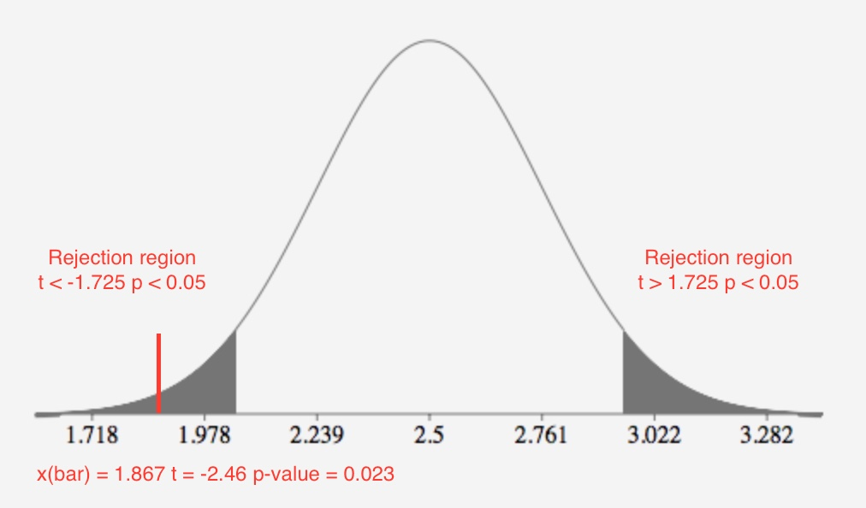

Step 5:

The observed value of the test statistic t = -2.46 is less than t 0.05 = -1.725 where it does fall in the rejection region. H0 : μ = 2.5 is rejected in favor of Ha : μ ≠ 2.5. There is sufficient evidence to indicate that the true mean number of suicide bombing for all AI Qaeda attacks against the US differs from 2.5 at α = 0.1.

p( t < - 3.461) = 0.023 0.010 < p-value < 0.025

The p-value is 0.023. There is **strong** evidence that H0 is false at α = 0.1.

b. The 90% confidence interval is 1.407 to 2.307. The μ = 2.5 is does not fall in the 90% confidence interval. This will lead to reject the hypothesis that the true mean number of suicide bombing for all AI Qaeda attacks against the US is 2.5 and conclude the true mean differs from 2.5 at α = 0.1.

c. The inferences derived from # 8.143 part a and b agree. Both parts used the same confidence level and sample mean and standard deviation. The results are consistent.

d. The conditions required 1) random sample from the target population 2) the population from which the sample is selected has a distribution that is approximately normal.

e.

|  |  |
| --- | --- |
| *Bin* | *Frequency* |
| 1 | 11 |
| 2 | 6 |
| 3 | 1 |
| 4 | 2 |
| 5 | 1 |

The distribution appears to be skewed to the right. The assumption that the sample distribution is approximately normal is not meet.

One-Sample T: Attacks

Descriptive Statistics

|  |  |  |  |  |
| --- | --- | --- | --- | --- |
| N | Mean | StDev | SE Mean | 90% CI for μ |
| 21 | 1.857 | 1.195 | 0.261 | (1.407, 2.307) |

*μ: mean of Attacks*

Test

|  |  |
| --- | --- |
| Null hypothesis | H₀: μ = 2.5 |
| Alternative hypothesis | H₁: μ ≠ 2.5 |

|  |  |
| --- | --- |
| T-Value | P-Value |
| -2.46 | 0.023 |

#8.147

n = 100 number of sample water specimens collected from a tributary of the Han River – Use z-table

x(bar) = 67.8 mpl

s = 14.4 mpl

Step 1: Right (upper) tail test

H0 = μ= 50 mean alkalinity level of water in tributary is 50 milligrams per liter

Ha = μ > 50 mean alkalinity level of water in tributary is greater than 50 milligrams per liter

Step 2:

α = 0.01

Step 3:

z = x(bar) – 50 / σx (bar)

z = 67.8 – 50 / (14.4/√100) = 17 / (14.4/√100) = 12.361

Step 4:

Rejection region: z > zα z 0.01 = 2.326

z > 2.326

12.361 > 2.326

p(z > 12.361) = ***≤ .5 - .499 ≤ .001*** (p-value using calculator 2.192-35)

Test statistic z =12.361 is more than z 0.005 = 2.576, we reject H0.

The p-value = 0 is less than α = 0.01, we reject H0.

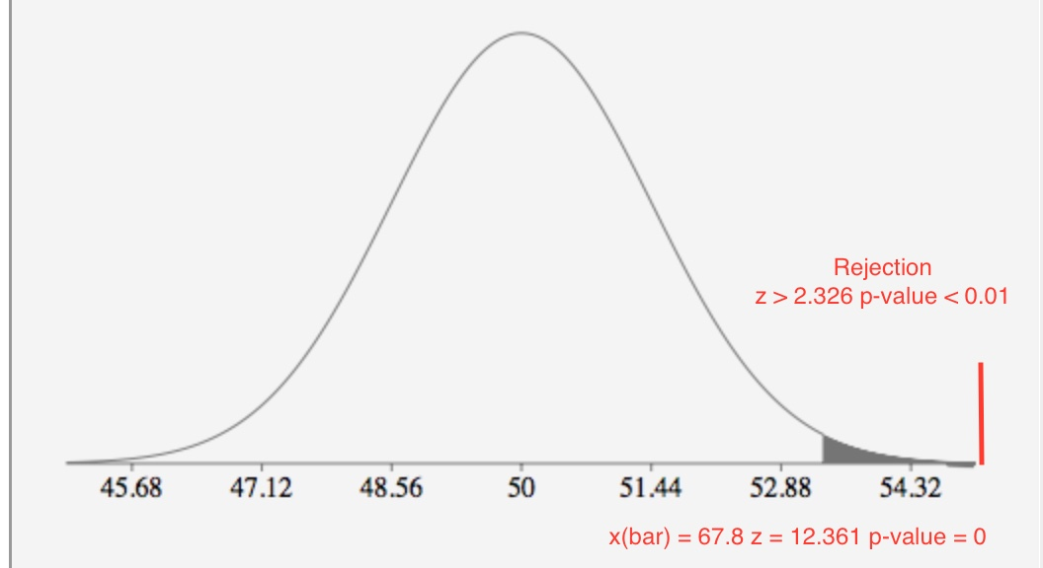

Step 5:

The observed value of the test statistic z = 12.361 is greater than z 0.01 = 2.236 where it does fall in the rejection region. H0 : μ = 50 is rejected in favor of Ha : μ > 50. There is sufficient evidence to indicate that the mean alkalinity level of water in tributary is greater than 50 milligrams per liter at α = 0.01.

p( z < 12.361) = ***≤ .5 - .499 ≤ .001***

The p-value is ***≤ .001***. There is **extremely** **strong** evidence that H0 is false at α = 0.01.

One-Sample Z

Descriptive Statistics

|  |  |  |  |
| --- | --- | --- | --- |
| N | Mean | SE Mean | 99% Lower Bound for μ |
| 100 | 67.80 | 1.44 | 64.45 |

*μ: mean of Sample  
Known standard deviation = 14.4*

Test

|  |  |
| --- | --- |
| Null hypothesis | H₀: μ = 50 |
| Alternative hypothesis | H₁: μ > 50 |

|  |  |
| --- | --- |
| Z-Value | P-Value |
| 12.36 | 0.000 |

#8.149

n = 33 out of 239 POW survivors responded - Use the z-table

x(bar) = 9.00 mean PTSD score

s = 9.32

Step 1: Left (lower) tail test

H0 = μ= 16 true mean PTSD score for all WWII aviator POWS is 16

Ha = μ < 16 true mean PTSD score for all WWII aviator POWS is less than 16

Step 2:

α = 0.1

Step 3:

z = x(bar) – 16 / σx (bar)

z = 9 – 16 / (9.32/√33) = -7 / (9.32/√33) = -4.314

Step 4:

Rejection region: z < zα z 0.1 = -1.282

z < -1.282

-4.314 < -1.282

p(z < -4.314) = ***≤ .5 - .499 ≤ .001*** (p-value using calculator 8.000-6)

Test statistic z =-4.314 is less than z 0.1 = -1.282 we reject H0.

The p-value is less than α = 0.1, we reject H0.

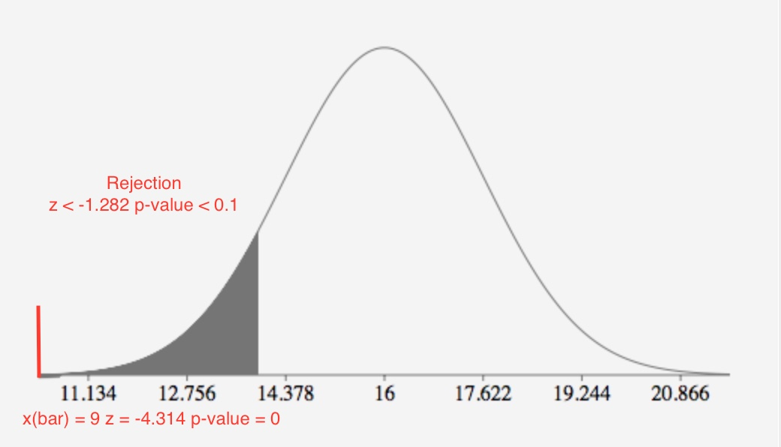

Step 5:

The observed value of the test statistic z = -4.314 is less than z 0.1 = -1.282 where it does fall in the rejection region. H0 : μ = 16 is rejected in favor of Ha : μ < 16. There is sufficient evidence to indicate that the true mean PTSD score for all WWII aviator POWS is less than 16 at α = 0.1.

p( z < - 4.314) ***≤ .5 - .499 ≤ .001***

The p-value is ***≤ .001***. There is **extremely** **strong** evidence that H0 is false at α = 0.1.

One-Sample Z

Descriptive Statistics

|  |  |  |  |
| --- | --- | --- | --- |
| N | Mean | SE Mean | 90% Upper Bound for μ |
| 33 | 9.00 | 1.62 | 11.08 |

*μ: mean of Sample  
Known standard deviation = 9.32*

Test

|  |  |
| --- | --- |
| Null hypothesis | H₀: μ = 16 |
| Alternative hypothesis | H₁: μ < 16 |

|  |  |
| --- | --- |
| Z-Value | P-Value |
| -4.31 | 0.000 |