DA 320 Project 1 M. Blanco

# Project 1

**Part 1**: Read this article: [http://www.lifehack.org/articles/featured/11-free-mind-mappingapplications-web-services.html](http://www.lifehack.org/articles/featured/11-free-mind-mapping-applications-web-services.html)

Evaluate TWO of your favorite applications. Make a chart to compare the advantages and disadvantages of the two you picked with the rest of the applications.

|  |  |  |
| --- | --- | --- |
|  | FreeMap  freemind | bubble.us  bubb |
| Advantages | | |
| Cost |  | Paid version is $4.91/month. Students get a 50% discount. |
| Platform |  |  |
| Tutorial/User Guide | Detailed 65 page user guide and tutorial | Gallery of mind maps |
| Collaboration | None | Share and collaborate mind maps with others |
| Save |  |  |
| Other |  | Color and engaging One click presentation |
| Trial Version | N/A | 30 days |
| Disadvantages | | |
| Collaboration | None | N/A |
| Functionality | N/A | Limited functionality for Free version |
| Training | No training videos for new users | No training videos for new users |

# FreeMind

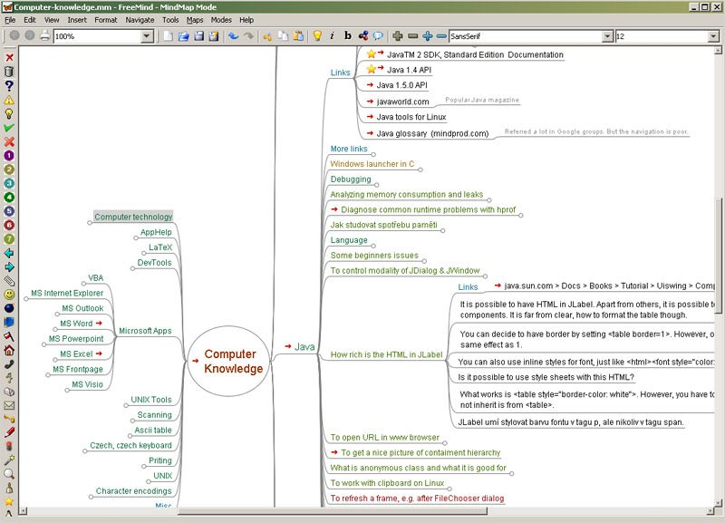

Pros:

Easy to use interface that allows user to start creating charts right away.

Helps user organize thoughts and explore relationships.

Platform independent.

Cons:

Requires software package to install.

Charts are more functional than attractive with limited design and customization options.

The free version only allows three mind maps to be saved.

Lacks the features of their desktop mind map tools such as FreeMind.

Security, availability and reliability.

# Bubble.us

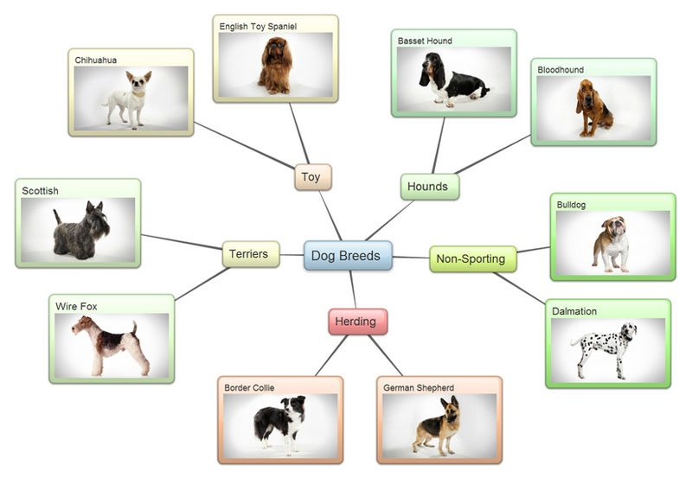

Pros:

Easy to use interface that allows user to start creating charts right away.

Helps user organize thoughts and explore relationships.

No software package to install.

Platform independent.

Cons:

Charts are more functional than attractive with limited design and customization options.

The free version only allows three mind maps to be saved.

Lacks the features of their desktop mind map tools such as FreeMind.

Security, availability and reliability.

Mind maps are public.

Requires internet connection.

Cannot extend usage via plug-ins.

**Part 2:** Choose ONE application to download and/or create an account on one of the mind mapping web offerings sites. Launch the application and go through the tutorials (if applicable). Finally take a print shot of the application home screen

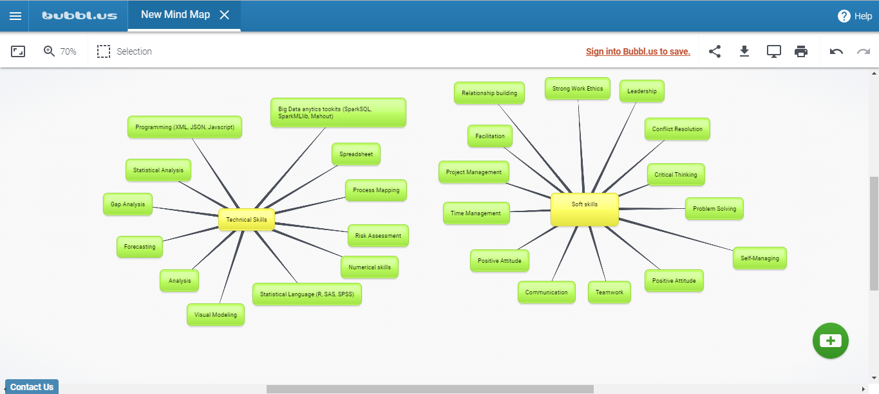

**Part 3:** Save your file as ***DA320_Project1_XXXXX.docx (or .pdf)*** where ***XXXXX*** is the first five letters of your last name, and submit it online.