DA 320 Project 3 M. Blanco

# Project 3

**Part 1**: **Design a relational database to keep track of customer’s ordering information. Make sure you link the key fields clearly. See example below:**

|  |  |  |  |  |  |  |  |  |  |
| --- | --- | --- | --- | --- | --- | --- | --- | --- | --- |
| id | name | phone | level | discount rate | order ID | order date | item | item ID | unit price($) |
| 1 | Jean | 206-123-4567 | prime | 0.05 | 201 | 1/15/2018 | ski | 534 | 105 |
| 2 | Tom | 305-333-6789 | Silver | 0.01 | 202 | 1/15/2018 | camera | 780 | 60 |
| 1 | Jean | 206-123-4567 | prime | 0.05 | 203 | 1/16/2018 | battery | 500 | 15 |
| 3 | Lee | 300-234-3456 | silver | 0.01 | 204 | 1/16/2018 | camera | 780 | 60 |
| 4 | Mat | 239-456-0023 | Gold | 0.02 | 205 | 1/16/2018 | ski | 534 | 105 |

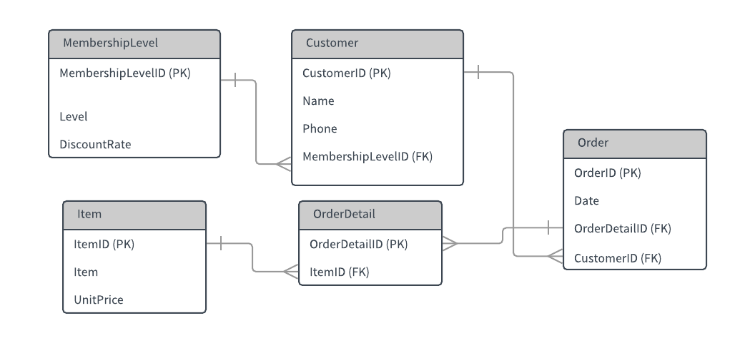

|  |  |  |
| --- | --- | --- |
| MembershipLevel | | |
| **MembershipLevelID (PK)** | **Level** | **DiscountRate** |
| 1 | Prime | 0.05 |
| 2 | Silver | 0.01 |
| 3 | Gold | 0.02 |

|  |  |  |  |
| --- | --- | --- | --- |
| Customer | | | |
| **CustomerID (PK)** | **Name** | **Phone** | **MembershipLevelID (FK)** |
| 1 | Jean | 206-123-4567 | 1 |
| 2 | Tom | 305-333-6789 | 2 |
| 3 | Lee | 300-234-3456 | 2 |
| 4 | Mat | 239-456-0023 | 3 |

|  |  |  |  |
| --- | --- | --- | --- |
| Order | | | |
| **OrderID (PK)** | **Date** | **OrderDetailID (FK)** | **CustomerID (FK)** |
| 201 | 1/15/2018 | 1 | 1 |
| 202 | 1/15/2018 | 2 | 2 |
| 203 | 1/16/2018 | 3 | 1 |
| 204 | 1/16/2018 | 4 | 3 |
| 205 | 1/16/2018 | 5 | 4 |

|  |  |
| --- | --- |
| OrderDetail | |
| **OrderDetailID (PK)** | **ItemID (FK)** |
| 1 | 534 |
| 2 | 780 |
| 3 | 500 |
| 4 | 780 |
| 5 | 534 |

|  |  |  |
| --- | --- | --- |
| Item | | |
| **ItemID (PK)** | **Item** | **Price** |
| 534 | Ski | 105 |
| 780 | Camera | 60 |
| 500 | Battery | 15 |

**Part 2**: Save your file as ***DA320_Project3_XXXXX.docx (or .pdf)*** where ***XXXXX*** is the first five letters of your last name, and submit it online

