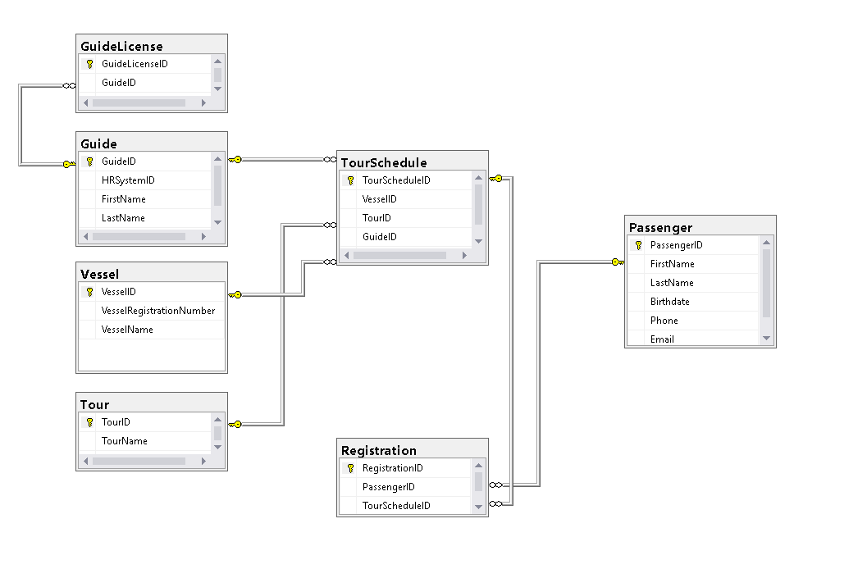

* A vessel ***cannot***be scheduled if it does not exist.

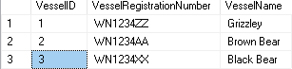

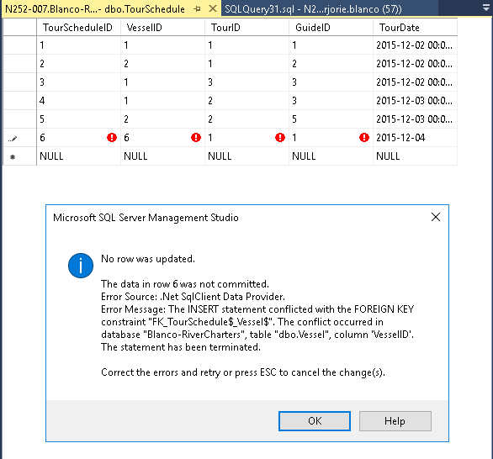

* A vessel ***cannot***be scheduled twice on the same day.

Original:

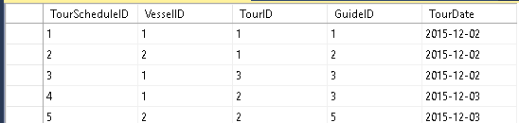

Msg 1505, Level 16, State 1, Line 94

The CREATE UNIQUE INDEX statement terminated because a duplicate key was found for the object name 'dbo.TourSchedule' and the index name 'CK_VESSEL_TOURDATE'. The duplicate key value is (1, 2015-12-02).

Msg 1750, Level 16, State 1, Line 94

Could not create constraint or index. See previous errors.

The statement has been terminated.

Updated:

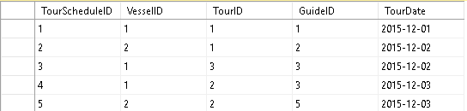

ALTER TABLE dbo.TourSchedule

ADD CONSTRAINT CK_VESSEL_TOURDATE UNIQUE (VesselID, TourDate);

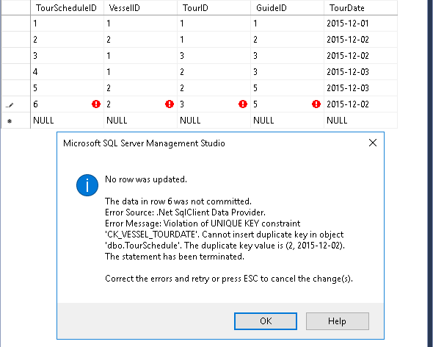

* A guide ***cannot***be scheduled twice on the same day.

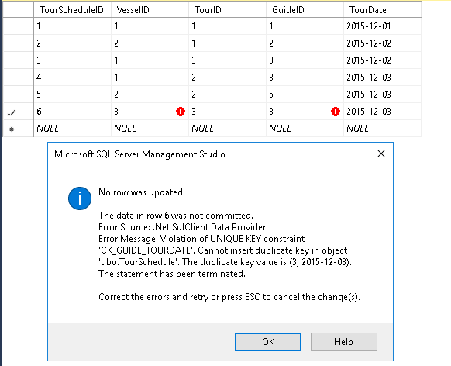

ALTER TABLE dbo.TourSchedule

ADD CONSTRAINT CK_VESSEL_TOURDATE UNIQUE (VesselID, TourDate);

* A tour ***can, yes it can,***be scheduled twice or more on the same day.

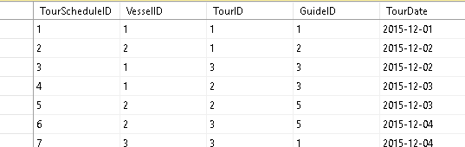

* A tour ***cannot***be scheduled on a date that has occurred in the past.

ALTER TABLE dbo.TourSchedule

ADD CONSTRAINT CK_TourDate_Constraint

CHECK (TourDate >= GETDATE());

Msg 547, Level 16, State 0, Line 80

The ALTER TABLE statement conflicted with the CHECK constraint "CK_TourDate_Constraint". The conflict occurred in database "Blanco-RiverCharters", table "dbo.TourSchedule", column 'TourDate'.

Note: was not able to demonstrate. I am trying to figure the error. I wat to submit what I have so far.

* The expiration date of a guide's license/certificate ***cannot*** be a date that has occurred in the past.

ALTER TABLE dbo.GuideLicense

ADD CONSTRINT CK_IssuedDate_ExpirationDate_Constraint

CHECK (IssuedDate < ExpirationDate);

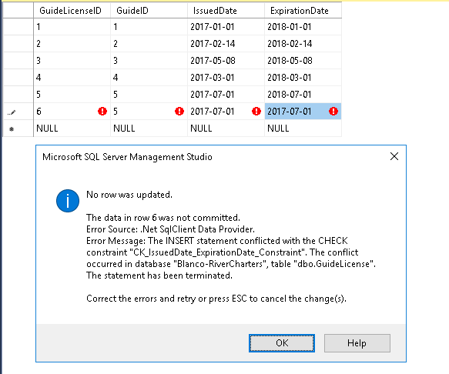

* FK fields ***cannot***be NULL. *(When you demonstrate your contraints [see below] you may demonstrate****not null****constraints via the Explorer pane.  From the SQL Server Explorer pane, expand to display the fields and their constraints, and then take a screen shot of the Explorer pane.)*

