Name: SkillConnectAI
githubUrl : https://github.com/mnbprasadreddy/SkillConnectAI.git
Description
An enterprise-grade AI-powered interview preparation and coding practice platform that enables users to improve technical skills, practice real-time coding challenges, attend AI-driven mock interviews, analyze performance metrics, and receive personalized learning recommendations from a single unified intelligent dashboard.
The platform integrates coding problem solving, AI interview simulation, real-time voice and confidence analysis, performance analytics, adaptive learning roadmaps, contest systems, learning materials, recommendation engines, and AI-generated feedback reports into one complete ecosystem. Users can solve coding problems, participate in mock technical interviews, track skill progression, identify weak topics, and receive intelligent guidance based on their performance and behavioral analysis.
Designed with a futuristic AI SaaS interface, the system combines real-time analytics, Judge0 code execution, Firebase authentication, Neon PostgreSQL data management, Socket.IO live synchronization, and AI-powered evaluation pipelines to simulate real-world technical interview and software engineering preparation environments.

Functional Requirements
Authentication
• Register, login, logout using Firebase Authentication
• Secure JWT token verification and session persistence
• Protected dashboard routes and authentication recovery system
• Email verification and password reset support

User Profile Management
• Create and manage user profiles
• Track coding progress, interview history, and analytics
• Store user skill level, achievements, and learning progress
• Profile synchronization with Neon PostgreSQL database

Problem Library
• Access coding problems by difficulty and topic
• Search and filter problems dynamically
• View problem descriptions, constraints, and examples
• Track solved and unsolved problems
• Pagination support for large problem collections

Coding Workspace
• Real-time code editor with Monaco Editor integration
• Multi-language code execution using Judge0 API
• Run and submit coding solutions
• Hidden and public test case evaluation
• Runtime, memory usage, and execution result tracking

AI Mock Interview System
• AI-powered technical and HR interview simulation
• Real-time interview question generation
• Webcam and microphone integration
• Live interview timer and transcript tracking
• Behavioral and communication analysis during interviews

AI Voice & Confidence Analysis
• Speech-to-text transcription using AI services
• Confidence and nervousness score calculation
• Eye contact and posture analysis
• Filler word detection and fluency analysis
• Real-time biometric analytics dashboard

Performance Analytics
• Topic-wise coding performance tracking
• Accuracy and submission analysis
• Difficulty-based problem-solving statistics
• Weak vs strong topic identification
• Daily and weekly activity visualization charts

AI Recommendation Engine
• Personalized coding problem recommendations
• Adaptive difficulty adjustment system
• Weak topic detection and improvement suggestions
• AI-generated learning paths and practice strategies

Learning Roadmap
• Structured DSA learning progression
• Topic unlocking system based on progress
• Progress percentage tracking
• Continue-learning recommendations

Learning Materials
• Topic-based theory explanations
• Coding examples and practice resources
• AI-assisted concept explanations
• Direct integration with coding practice problems

Contests
• Real-time coding contests and leaderboards
• Contest timers and ranking systems
• Score calculation based on submissions and time
• Live contest performance tracking

Replay & Interview Reports
• Replay past interview sessions
• View interview transcripts and analytics
• AI-generated interview feedback reports
• Communication and technical performance summaries

Notifications & Alerts
• Real-time interview and contest notifications
• Learning progress alerts
• AI recommendation updates
• Verification and authentication alerts

Community System
• Discussion and interaction platform for users
• Share coding experiences and interview tips
• Topic-based discussions and collaboration

Reports & Export
• Export interview and coding analytics reports
• Generate performance summaries
• Download AI-generated feedback reports as PDF

Real-Time Systems
• Socket.IO real-time synchronization
• Live interview analytics updates
• Real-time leaderboard updates
• Dynamic dashboard activity tracking

AI Services
• AI-generated interview questions
• AI behavioral analysis engine
• AI report generation system
• AI recommendation and adaptive learning system

Database & Backend
• PostgreSQL database using Neon
• Prisma ORM for database management
• Express.js backend APIs
• FastAPI AI microservices integration

Security & Validation
• Secure API authentication and token verification
• Protected backend routes
• Request validation and error handling
• Secure database synchronization between Firebase and Neon PostgreSQL

Non-Functional Requirements
• Dashboard and coding workspace should load within 2–3 seconds under normal network conditions
• API response time for authentication, coding submissions, analytics, and AI interview processing should remain under 3 seconds for standard operations
• Platform should support 50+ concurrent active users during coding practice, mock interviews, and contest participation
• Real-time Socket.IO services should maintain low-latency synchronization for live interviews, analytics updates, and contest leaderboards
• Judge0 code execution responses should process efficiently with optimized polling and execution handling
• AI interview analytics and report generation should provide results with minimal processing delay
• The platform should maintain 99.5% uptime for authentication, coding services, and interview systems
• All communication between frontend, backend, AI services, Firebase, and Neon PostgreSQL should be encrypted using HTTPS/TLS protocols

Problem Statement
Students preparing for technical interviews often use multiple separate platforms for coding practice, mock interviews, learning materials, and performance tracking. This makes the preparation process fragmented and difficult to manage.
Existing systems lack personalized feedback, real-time interview analysis, adaptive learning guidance, and unified performance monitoring. Candidates also struggle to identify weak topics, improve communication skills, and simulate real-world interview environments effectively.
SkillConnect AI solves this problem by providing an AI-powered unified platform for coding practice, mock interviews, behavioral analysis, performance analytics, adaptive recommendations, and learning roadmaps in a single intelligent ecosystem.

Proposed Solution
A full-stack AI-powered interview preparation and coding practice platform combining a React + Vite frontend with an Express.js and FastAPI backend that provides coding challenges, AI mock interviews, real-time behavioral analysis, adaptive learning recommendations, performance analytics, and live coding evaluation through Judge0 integration — integrated with Firebase Authentication, Neon PostgreSQL, Prisma ORM, and Socket.IO real-time services to deliver a complete intelligent technical interview preparation ecosystem.
Technologies Used
React.js, Vite, JavaScript, Tailwind CSS, Framer Motion, Monaco Editor, Recharts, Socket.IO Client, Firebase Authentication, Express.js, Node.js, Prisma ORM, PostgreSQL (Neon Database), FastAPI, Python, Judge0 API, Gemini AI API, Socket.IO, JWT Authentication, REST APIs, GitHub, Vercel, Railway, Docker, Axios, React Router DOM, Lucide React, Cloudinary/Firebase Storage.
System Architecture
A three-tier architecture where a React + Vite single-page frontend communicates with an Express.js REST API backend and a FastAPI AI microservice layer. The frontend provides real-time coding practice, AI interview dashboards, analytics visualization, and learning management interfaces, while the backend manages authentication, coding workflows, database operations, recommendation systems, and real-time communication.
The platform integrates Firebase Authentication for secure user management, Neon PostgreSQL with Prisma ORM for structured data storage, Judge0 API for code execution and evaluation, and Socket.IO for live interview analytics, contest updates, and real-time dashboard synchronization. The FastAPI AI service handles voice analysis, confidence detection, AI-generated interview reports, behavioral analytics, and adaptive recommendation processing.
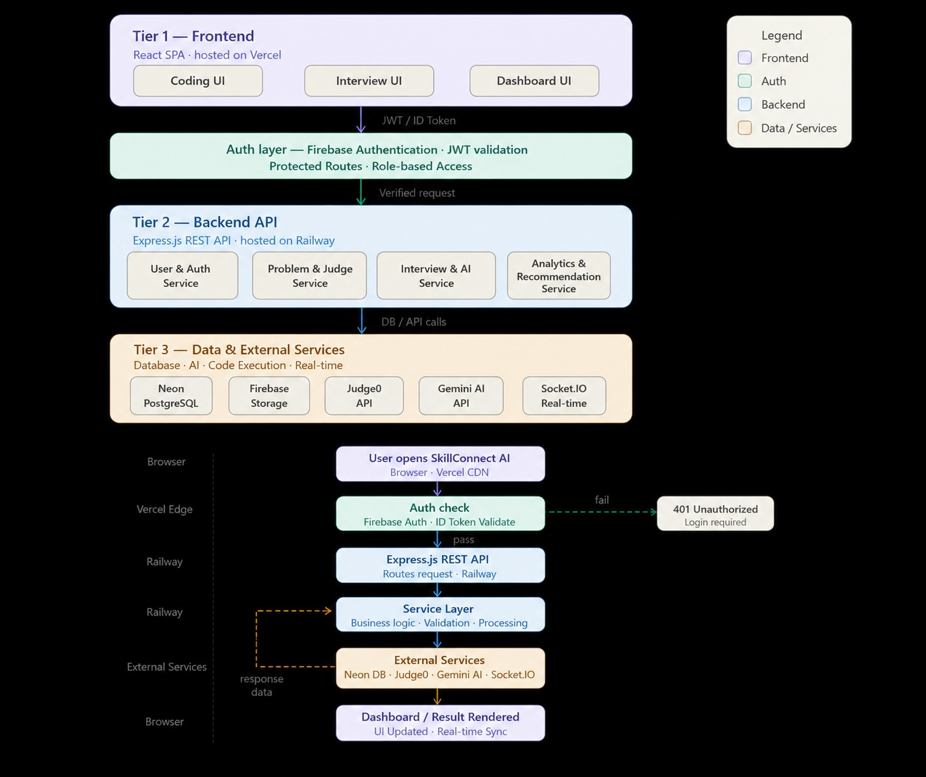

In Scope
AI-powered mock interviews, coding problem solving and evaluation, real-time code execution using Judge0, coding workspace management, adaptive learning recommendations, performance analytics, topic mastery tracking, learning roadmaps, AI-generated interview feedback reports, voice and confidence analysis, real-time interview monitoring, contest and leaderboard systems, user profile management, Firebase authentication, Neon PostgreSQL synchronization, Socket.IO real-time communication, replay and interview history tracking, community interaction modules, notification systems, and PDF-based performance report exports.
Out of Scope
Support for non-technical interview domains outside software engineering, enterprise-level recruitment management systems, mobile application development, offline coding execution environments, blockchain/Web3 integrations, advanced AI model training infrastructure, large-scale multiplayer competitive coding ecosystems, third-party video conferencing platform integrations, and fully automated real-time hiring decision systems.
Future Enhancements
• AI Resume Analysis and ATS Score Evaluation for placement preparation
• Advanced AI Interviewer with dynamic follow-up questioning and emotion-aware interactions
• Real-time collaborative coding interviews with peer and mentor support
• Mobile application support for coding practice and interview participation
• AI-powered coding hints and automated solution optimization suggestions
• Gamified achievement system with badges, streak rewards, and ranking tiers
Conclusion
SkillConnect AI is a well-architected AI-powered interview preparation and coding practice platform that demonstrates strong full-stack engineering, real-time system integration, and intelligent analytics capabilities. The project successfully combines coding assessment, AI mock interviews, behavioral analysis, adaptive learning, and performance tracking into a single unified ecosystem.
Its primary growth challenges involve scaling real-time AI processing for concurrent interview sessions, optimizing large-scale analytics and code execution workloads, strengthening production-grade deployment and security pipelines, and further enhancing the AI recommendation and behavioral analysis systems to compete with advanced technical interview preparation platforms.
projectType: web application

