Miles Carey

Mustapha Brima 11/20/20

MIE 380 Mini Project 3 (Group 18)

Part 1:

The Sharp Company was originally founded in the year 1912 in a small metal workshop in Osaka Japan owned by Tokuji Hayakawa; an inventor and tinkerer whose gadgets and repair jobs would earn him a decent income. Hayakawa would soon create a mechanical pencil, which he dubbed the ‘Ever-Sharp’ pencil, which consisted of “…a retractable graphite lead in a metal rod” (<https://www.referenceforbusiness.com/history2/59/Sharp-Corporation.html#ixzz6eTSiLRhg>). Hayakawa’s creation won patents in Japan as well as in the United States and was soon in great demand as it was both durable and simple. Tokuji Hayakawa would then adopt an assembly line and moved production to a larger factory later on.

Soon after losing not only his ‘Ever Sharp’ pencil factory, but his wife and child as well in 1923 to a devastating earthquake, Hayakawa would begin to develop radios. Though in the early 1920s, the first sets of crystal radios were imported into Japan from the US. However, after three months of studying and experimenting with US crystal radios, Hayakawa developed Japan’s first domestically produced crystal radio when he succeeded in receiving a broadcasting service (which had been programming and broadcasting to a small audience) with his new creation in 1925. This new domestic radio quickly caught the attention and demand and sold so well that Hayakawa’s facilities had to be expanded once again. After the creation of the AC vacuum tube model radio, called the ‘Sharp Dyne’ in 1929, Sharp became the leading Japanese radio manufacturer. The Sharp company expanded greatly soon after and reorganized into a corporation in the year 1935 under the name ‘Hayakawa Electric Industries’. After years of innovation through the 1940s, 1950s, and 1960s, Tokuji Hayakawa stepped down from the daily operations of the company in 1970, and was replaced by Akira Saeki, who oversaw the new corporate identity of the company and would join development efforts of their various products reestablishing Hayakawa Electric Industries as ‘The Sharp Corporation’.

In today’s day and age, the Sharp Corporation is a company headquartered in Sakai, Japan that manufactures products that range from sales telecommunication equipment to electronic and electric application equipment. They manufacture such equipment internationally in countries such as the United States, Japan, China, Europe, to name a few. Today, the company currently offers a wide range of products in different sections of the company such as ‘The Smart homes’ section which offers “…mobile phones, electronic dictionaries, calculators, telephones, network control units, refrigerators, superheated steam ovens, microwave ovens, small cooking appliances”, the ‘Smart Business Solutions’ segment which consists of “…digital multi-function printers, information displays, POS systems, electronic cash registers, commercial projectors” among other products, and also the ‘ IoT Electronics Devices’ segment which specializes in “…camera modules, manufacturing facilities, sensor modules, proximity sensors, dust sensors” as well as other products”. (<https://finance.yahoo.com/quote/SHCAY?p=SHCAY>)

Part 2:

**Transition Rate Matrix using R Studio (located at bottom-left panel of screenshot):**

(Shows either stock staying the same (State 1), a gain In stock (State 2), or a loss in stock (State 3).)

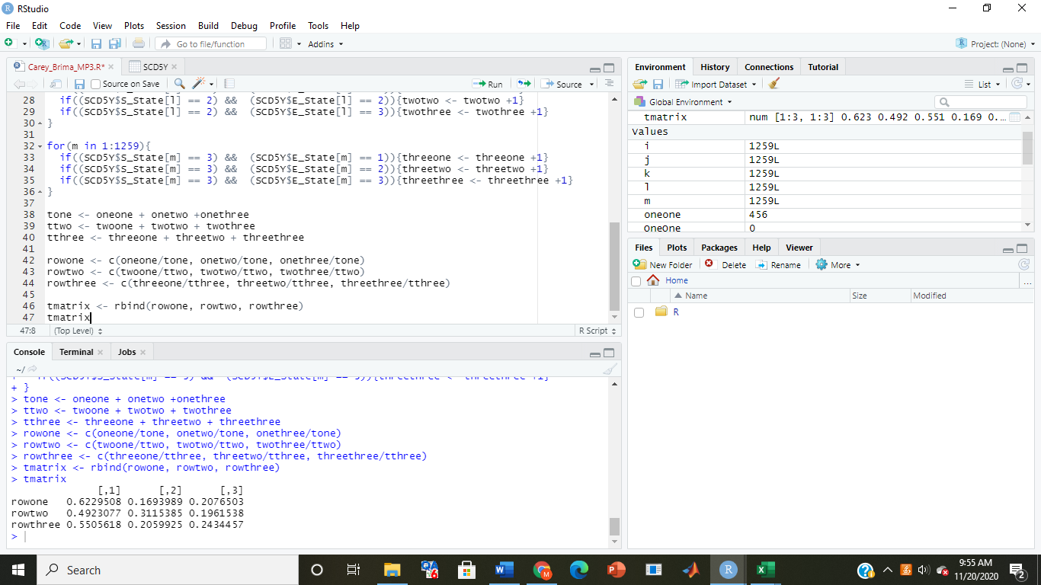

**Steady State probabilities at n years (done in Matlab):**

(Transition rate matrix reaches steady state as n approaches infinity.)

Steady State (with n = 2):

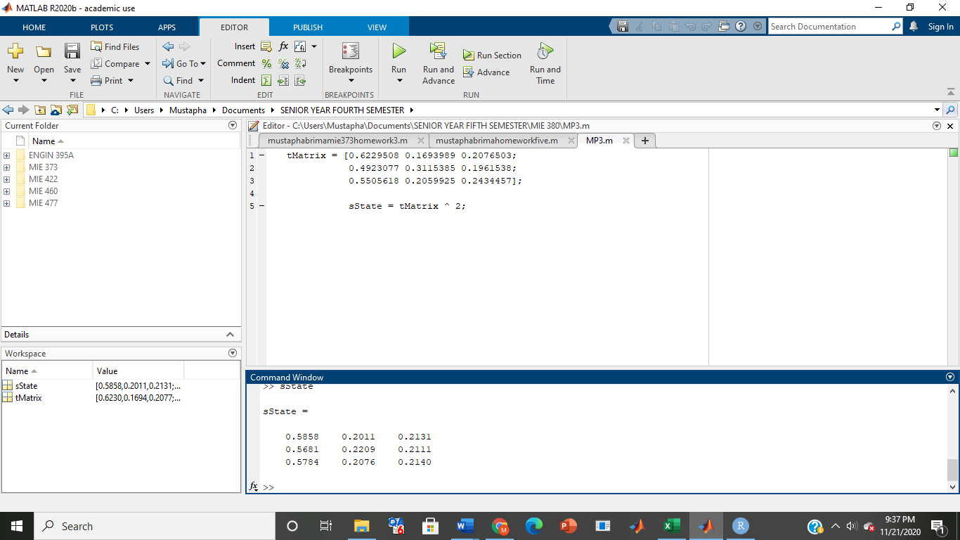

Steady State (with n = 5):

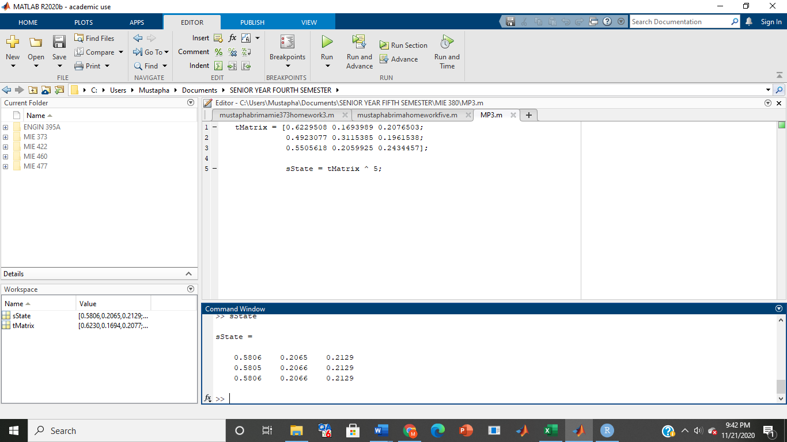

Steady state (with n = 10):

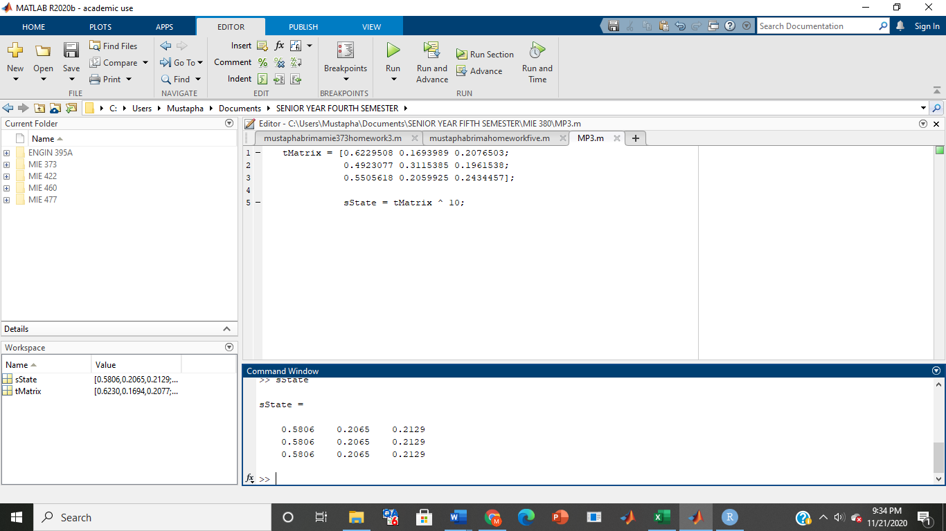

Steady State (with n = 100)

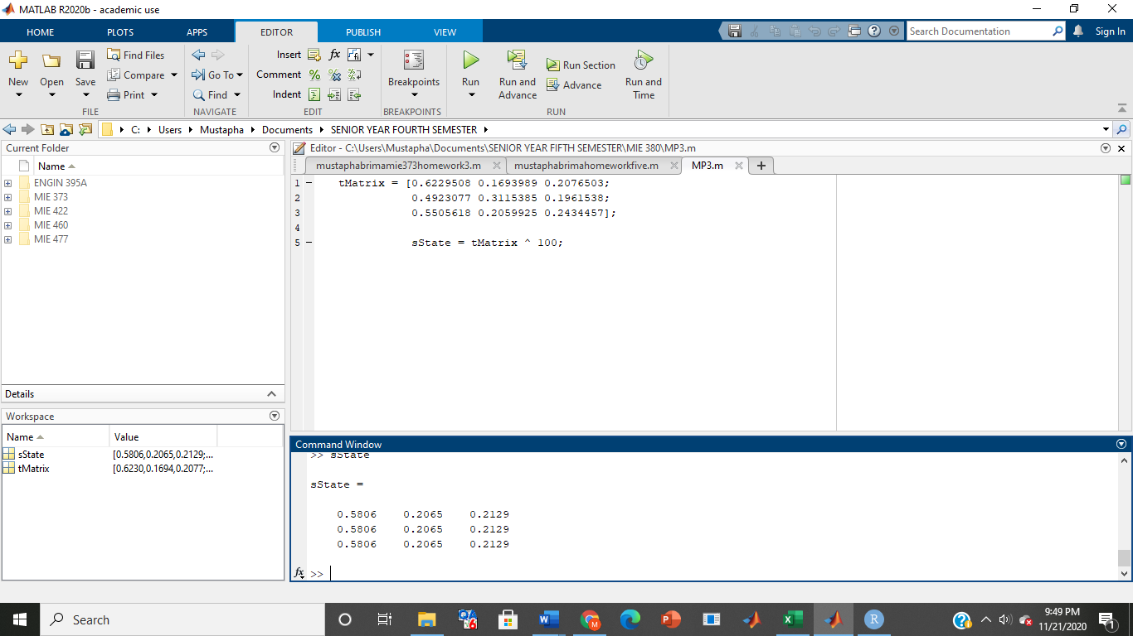

Part 3:

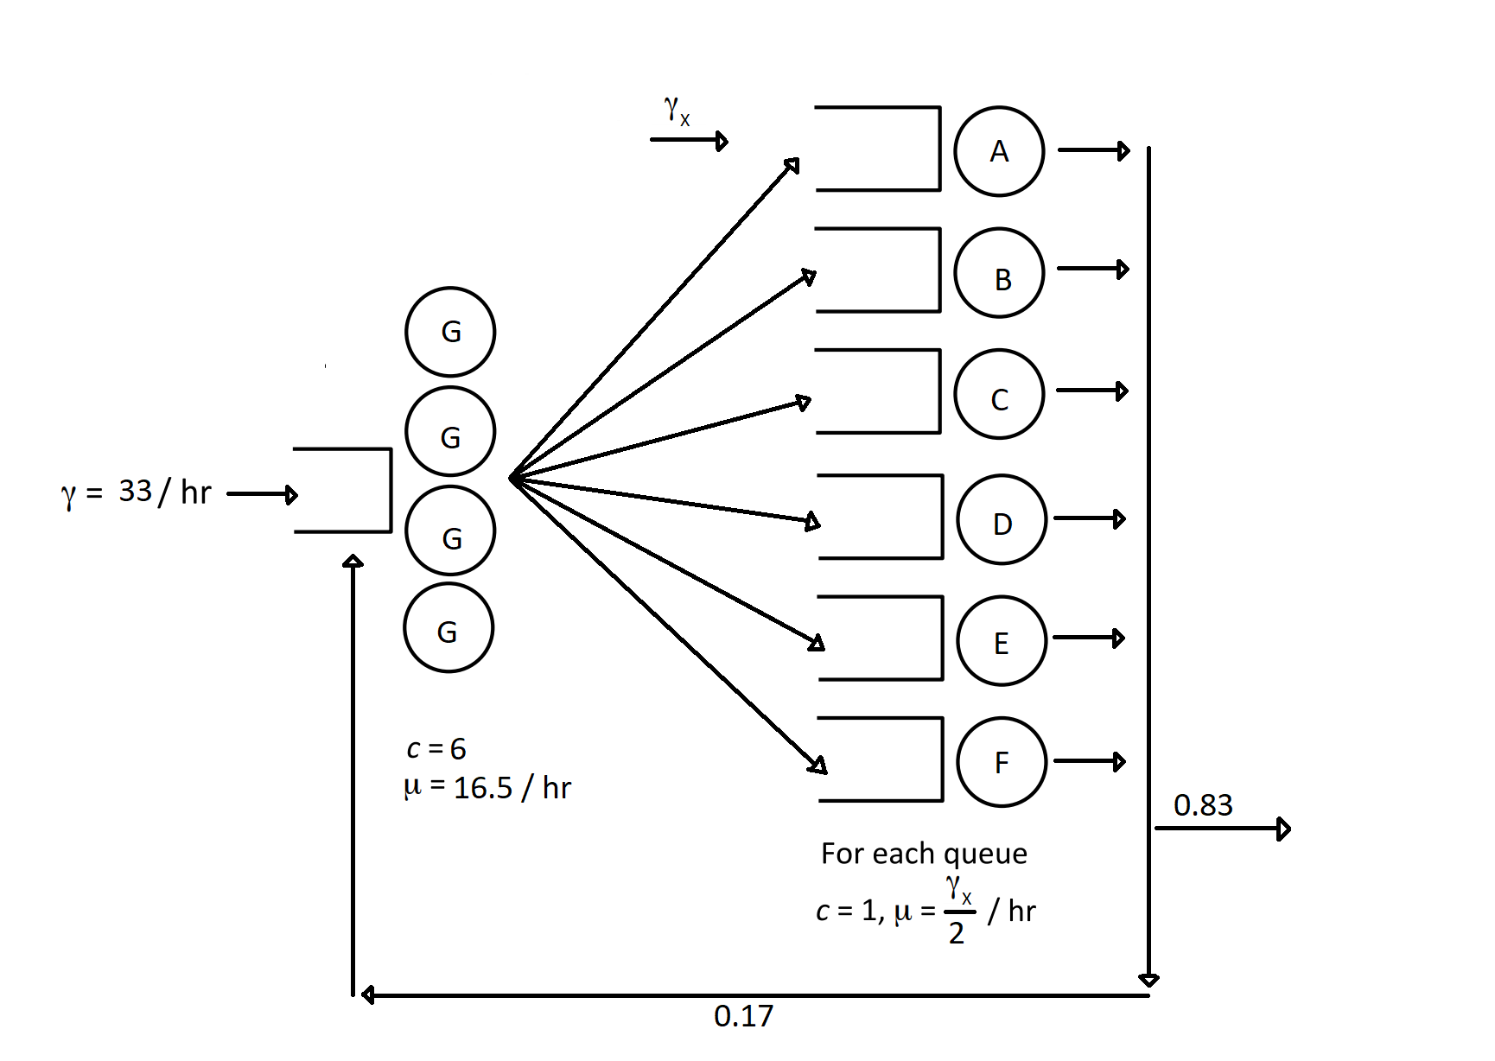

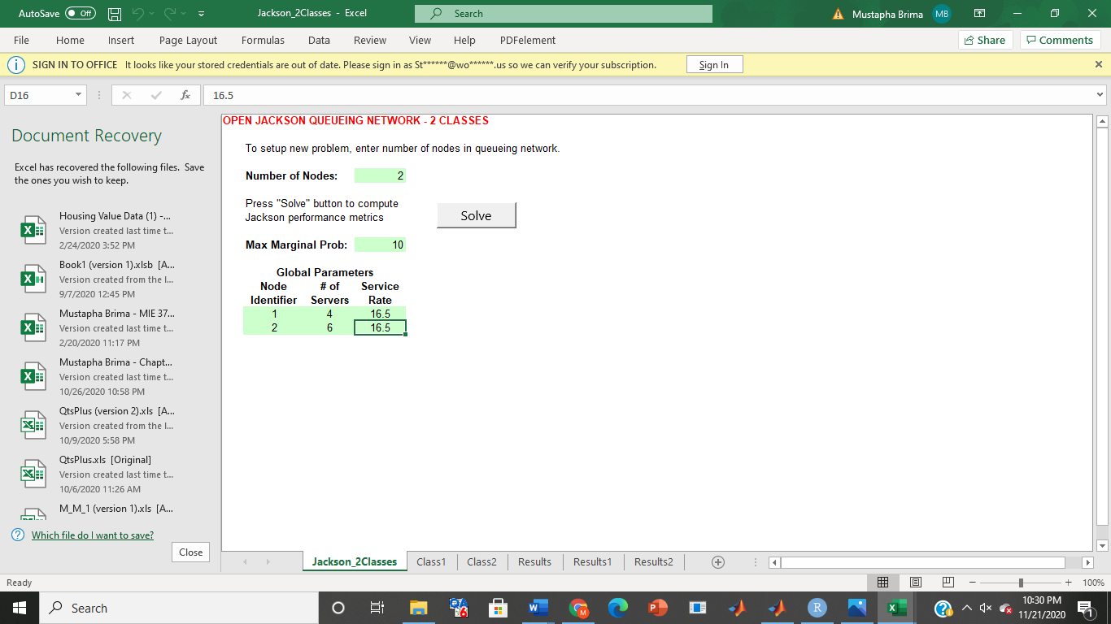

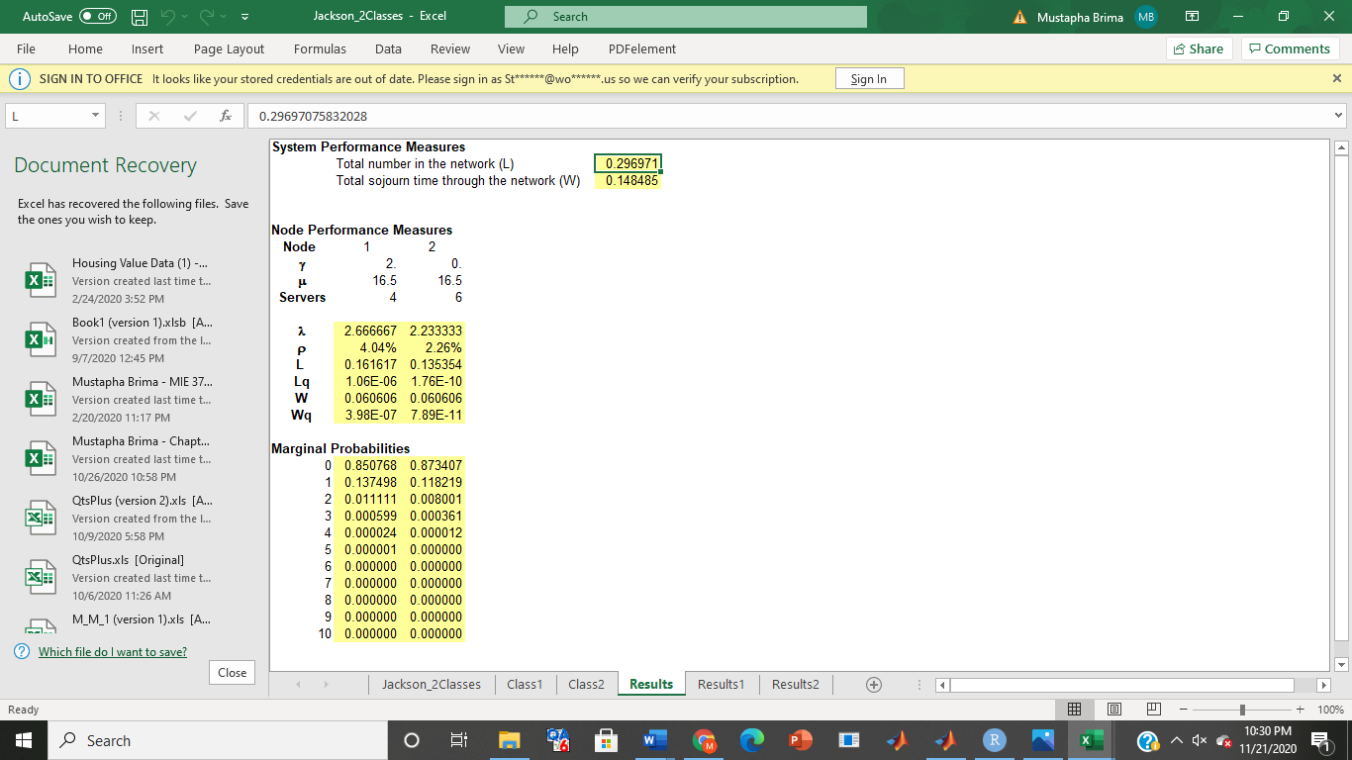

Average number of purchase requests at each account manager (Lq):

L (class 1) = 1.06 * 10^(-6)

L (class 2) = 1.76 * 10^(-10)

Average Time spent in system (W):

W (class 1) = 0.060 hours

W (class 2) = 0.060 hours

References:

“SHARP CORP (SHCAY) Stock Price, News, Quote & History.” *Yahoo! Finance*, Yahoo!, 22 Nov. 2020, finance.yahoo.com/quote/SHCAY?p=SHCAY.

“Sharp Corporation - Company Profile, Information, Business Description, History, Background Information on Sharp Corporation.” *Reference for Business*, www.referenceforbusiness.com/history2/59/Sharp-Corporation.html.