# 1 补充gfs_tool 的命令详解

# 2 Journals

Determine the number of journals for your GFS2 file systems

One journal is required for each node that mounts a GFS2 file system

GFS2 allows you to add journals dynamically at a later point as additional servers mount a file system

Add new journals

# gfs2_jadd -j Number MountPoint

Number

Specifies the number of new journals to be added

MountPoint

Specifies the directory where the GFS2 file system is mounted

# 3 命令

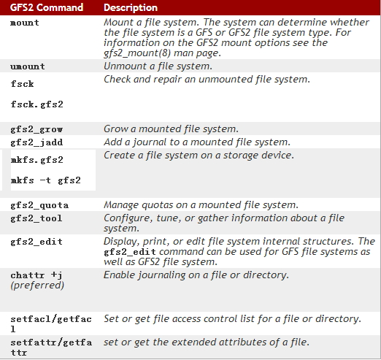

## 如何创建

mkfs.gfs2 -p lock_dlm -t ClusterName:FSName -j NumberJournals BlockDevice

mkfs.gfs2

-j #: 指定日志区域的个数，有几个就能够被几个节点所挂载；

-J #: 指定日志区域的大小，默认为128MB;

-p {lock_dlm|lock_nolock}:

-t <name>: 锁表的名称，格式为clustername:locktablename, clustername为当前节点所在的集群的名称，locktablename要在当前集群惟一；

Required information

Lock manager type

lock_nolock

lock_dlm

Lock file name

ClusterName:FSName

Number of journals

One per cluster node accessing the GFS is required

Extras are useful to have prepared in advance

Size of journals

File system block size

## 如何扩增？

The**gfs2_grow** command is used to expand a GFS2 file system after the device where the file system resides has been expanded

The gfs2_grow command must be run on a mounted file system, but only needs to be run on one node in a cluster

Usage

gfs2_grow MountPoint

MountPoint

Specifies the GFS2 file system to which the actions apply

Examples

gfs2_grow /mygfs2fs

## 如何冻结？

Can suspend write activity to a file system by using the gfs2_tool freeze command

Suspending write activity allows hardware-based device snapshots to be used to capture the file system in a consistent state

The gfs2_tool unfreeze command ends the suspension

Usage

Start Suspension

gfs2_tool freeze MountPoint

End Suspension

gfs2_tool unfreeze MountPoint