**1.1 Abstract**

Hospital Management System is aimed at reducing paper work for a hospital and hence improving its efficiency and speeding up of all process.

In this system we will manage all the information about patients, doctors, diseases by to domains 1. IPD (Internal Patient Department).

Hence, all the related information about a patient is available to doctors, pharmacy, reception staff (for bill processing), etc. Thus this software saves the entire patient’s hassle.

In this system we will create and maintain invoice of the patient including OPD, IPD, and medicine charges.

The system involves paper work in the form of maintaining various files and manuals. Maintaining critical information in the files and manuals is full of risk and a tedious process.

The existing system needs to save his information in the form of excel sheets or Disk Drives. There is no sharing is possible if the data is in the form of paper or Disk drives. It’s a limited system and fewer users friendly. Searching of particular information is very critical it takes lot of time.

**3.1 Functional Model**

This system contain 3 major modules

1. Patient Module: To organize, To search, view patient info.
2. Doctor Module: To organize doctor info. To Delete, Search and view doctor info.
3. Invoice Module: To generate invoice and display invoice info.

**1.2 ER Diagram**

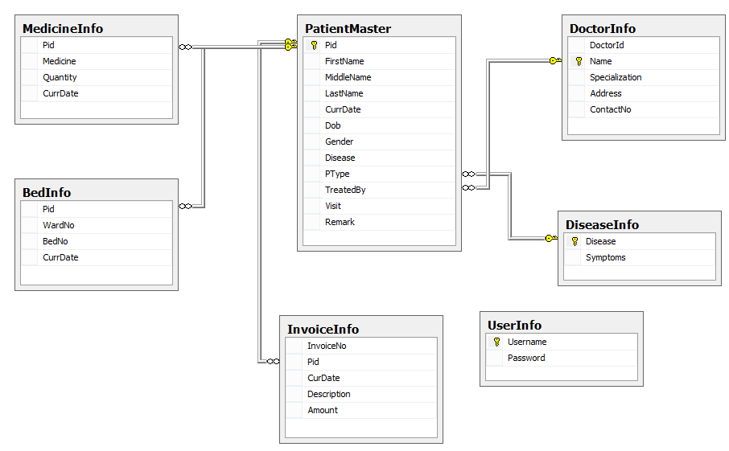

**Note: Please follow below Instruction:**

* 3 tier Architecture Model
* Microsoft coding standards
* Database should be normalized
* Use of SP for all database operations
* Appropriate security measures needs to implement.