Egypt University of Informatics
Faculty of Computer and Information Systems Data Analysis Course

The Marriage Crisis in Egypt:
Gold Prices & Economic Challenges

Presented by:
Mostafa Elnagar - 24-101443
Adham Shams 24-101192
Ahmed Sami 24-101314
Yousef Eslam 24-101303

Date: 08/04/2026
Sample Size: 128 Responses

Introduction
Marriage in Egypt has always carried deep cultural and social significance. However, in recent years, the financial burden of marriage has grown enormously for young Egyptians. Gold prices have surged to historic highs, apartment costs have multiplied, and the overall cost of living continues to rise each year due to persistent inflation and currency devaluation.
This research investigates how rising gold prices and increasing living costs are impacting the marriage plans of young Egyptians, particularly university students and recent graduates. Through a structured survey distributed to 128 respondents, we examined perceptions around the Shabka (gold jewelry given to the bride), housing affordability, and the overall realism of marriage costs for the current generation.

Research Question
How are the rising gold prices and increasing living costs affecting the ability of young Egyptians to get married?

Hypothesis
We hypothesize that the majority of young Egyptians find current marriage costs completely unrealistic, especially for fresh graduates entering a challenging job market. We further predict that most respondents would be open to modifying or simplifying expensive traditions such as the gold Shabka or large wedding receptions in order to make marriage more financially accessible.

Methodology

Population of Interest
The target population is young Egyptians, primarily university students and recent graduates aged 18–28 years. This demographic represents those who are actively contemplating or approaching marriage age and are therefore most directly impacted by the economic pressures under study.

Sampling Method
We employed convenience sampling. The survey was distributed through WhatsApp groups, Instagram stories, and university group chats. While not perfectly representative of all Egyptian demographics, this method allowed rapid collection of 128 responses from our core target age group within a short timeframe.

Bias Identification
    - Selection Bias: Respondents are predominantly urban university students; rural and lower-income perspectives may be underrepresented.
    - Response Bias: Financial topics can prompt socially desirable answers. The survey was kept anonymous to mitigate this.
    - Question Wording: Questions were designed to be neutral and non-leading to avoid steering respondents toward particular answers.
    - Non-response Bias: Approximately 30% of respondents skipped the open-ended questions, limiting qualitative depth.

Survey Questions
- How soon do you plan to get married after graduation?
- Do you think the current cost of marriage in Egypt is realistic for a fresh graduate?
- What do you think is the biggest financial barrier to getting married today?
- Would you accept replacing the gold Shabka with a cheaper alternative (e.g., silver)?
- What do you think is a reasonable Shabka today (given current gold prices)?
- What would you be willing to do to afford marriage costs? (Multi-select)
- Do you think rising marriage costs are causing people to marry later?
- Have rising marriage costs personally affected your plans?
- Does the rising cost of gold and housing make you feel anxious about your future marriage plans?
- Have you heard of or personally experienced a delayed/canceled engagement due to costs?
- What marriage traditions do you think should be reconsidered? (Open-ended)
- How much money do you think is realistically needed to get married in Egypt today? (Open-ended)

Analysis & Visualizations

Marriage Timeline (Q1)
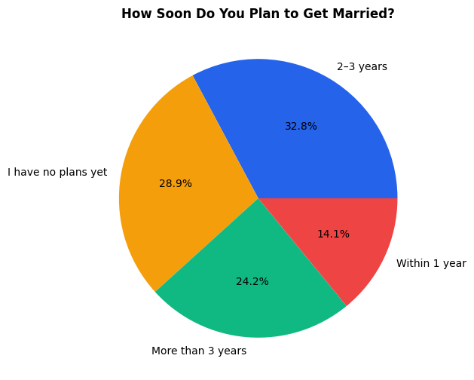

The largest group of respondents (42, or 32.8%) plans to marry within 2–3 years, while 37 (28.9%) say they have no plans yet. Only 18 respondents (14.1%) plan to marry within 1 year, suggesting that most young Egyptians are delaying the decision. This pattern already hints that financial pressure is pushing marriage further into the future, as the urgency to marry soon is lower than cultural norms might suggest for this age group.

Realism of Marriage Costs (Q2)
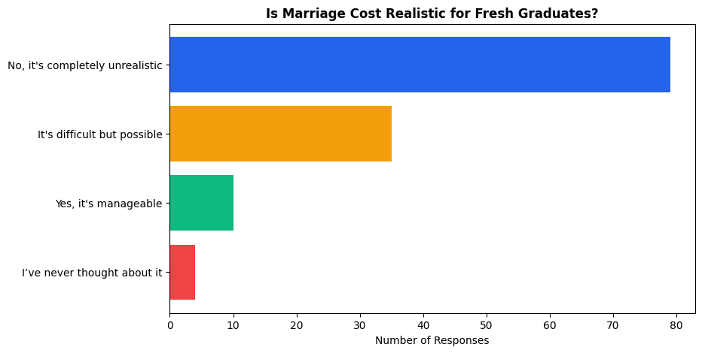

A strong majority of respondents (79 out of 128, or 61.7%) consider current marriage costs completely unrealistic for fresh graduates. An additional 35 (27.3%) find it difficult but possible, and only 10 (7.8%) consider it manageable. This result strongly supports our hypothesis and establishes the core problem: young Egyptians largely view the cost of marriage as out of reach on a starting salary.

Biggest Financial Barrier (Q3)
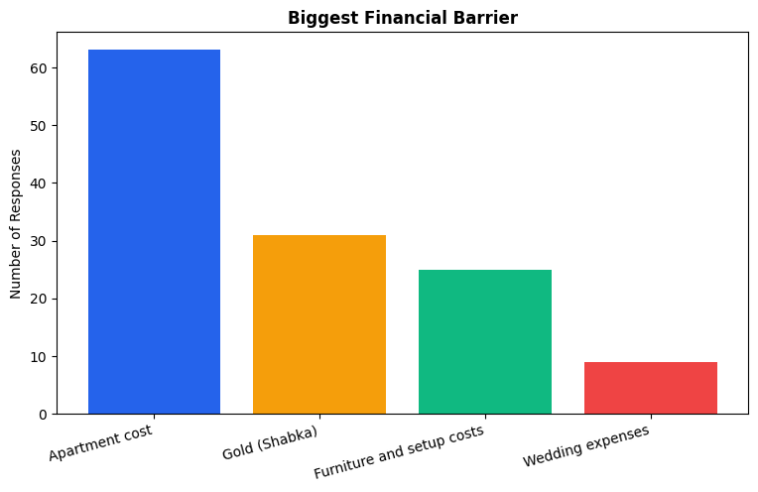

Apartment cost is the single biggest barrier, cited by 63 respondents (49.2%), followed by gold (Shabka) at 31 (24.2%), furniture and setup costs at 25 (19.5%), and wedding expenses at 9 (7.0%). This finding reframes the narrative: while gold prices receive significant media attention, housing is actually the primary obstacle. Any policy or cultural shift aimed at easing marriage costs must prioritize the housing crisis first.

Replacing the Gold Shabka (Q4)
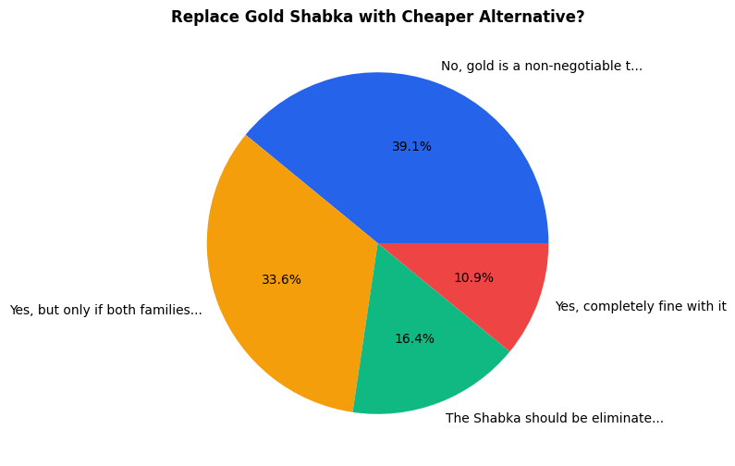

While 50 people (39.1%) still view gold as a non-negotiable tradition, the combined total of those open to some form of change reaches 78 respondents (60.9%). This includes 43 who would accept an alternative if both families agree, 21 who want to eliminate the Shabka entirely, and 14 who are completely comfortable with an alternative. The data shows tradition is strong but the majority is open to pragmatic change.

Reasonable Shabka Amount (Q5)
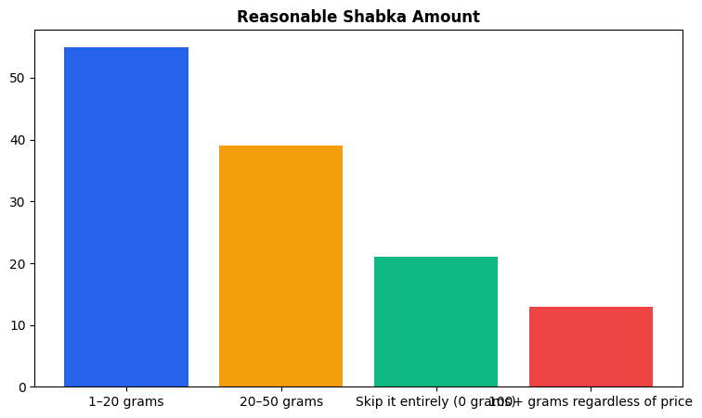

The majority of respondents prefer a modest Shabka: 55 (43.0%) chose 1–20 grams and
39 (30.5%) chose 20–50 grams. Twenty-one respondents (16.4%) favor skipping it entirely, while only 13 (10.2%) insist on 100+ grams regardless of price. This indicates a clear shift in expectations toward affordability, with most people willing to accept significantly less gold than what was typical in previous generations.

What Respondents Are Willing to Do (Q6)
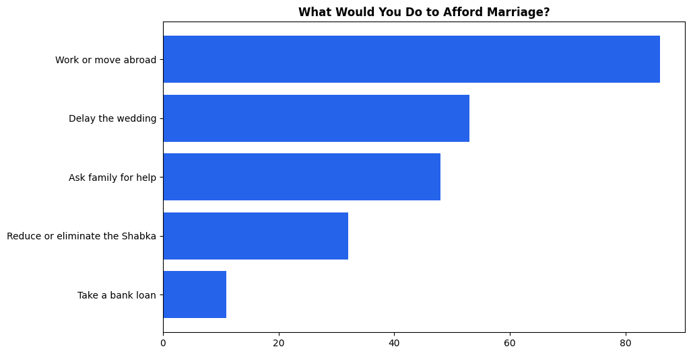

"Work or move abroad" was by far the most selected option with 86 total selections across the multi-select question, reflecting a deep sense that domestic economic conditions are insufficient for building a life. Delaying the wedding (selected by many in combination) and asking family for help were also common strategies. The prevalence of emigration as a perceived solution speaks to the severity of the economic situation and the lack of confidence in local income prospects.

Do Costs Cause Delayed Marriage? (Q7)
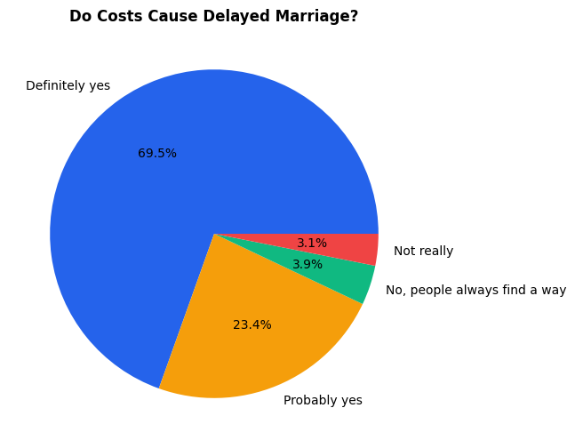

This is the most decisive finding of the survey: 89 respondents (69.5%) said definitely yes, and 30 (23.4%) said probably yes. This means 93.0% of respondents believe rising costs are causing people to marry later. Only 9 respondents expressed any skepticism. The near-universal agreement on this point indicates that delayed marriage is not a perception
— it is an observable social phenomenon being experienced across the respondent group.

Personal Impact (Q8)
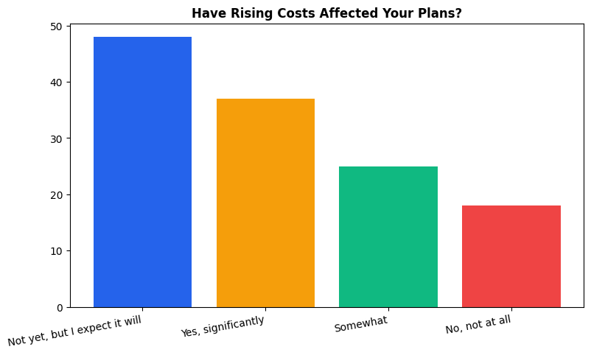

When asked about personal impact, 48 respondents (37.5%) said costs have not yet affected them but they expect they will, while 37 (28.9%) report being significantly affected already. An additional 25 (19.5%) are somewhat affected. Only 18 (14.1%) say they are not affected at all. Taken together, 85.9% of respondents feel economic pressure around marriage either now or in the foreseeable future, making this a near-universal personal concern and not merely an abstract societal issue.

Anxiety About Future Marriage (Q9)
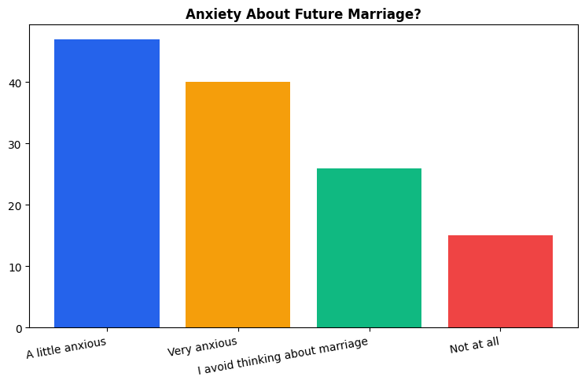

Forty-seven respondents (36.7%) feel a little anxious about marriage costs, and 40 (31.3%) feel very anxious. Twenty-six (20.3%) actively avoid thinking about marriage altogether, which may itself be a manifestation of anxiety. Only 15 (11.7%) report no anxiety at all. The high rate of avoidance is particularly notable: for over one-fifth of the sample, the topic of marriage costs is psychologically distressing enough to be blocked out.

Delayed or Canceled Engagements (Q10)
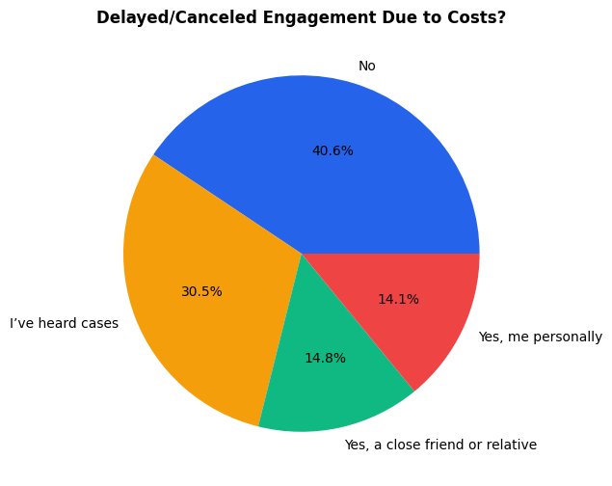

The data confirms that delayed or canceled engagements due to financial costs are real and widespread. Thirty-nine respondents (30.5%) have heard of such cases, 19 (14.8%) know a close friend or relative personally affected, and 18 (14.1%) have experienced it themselves. Only 52 (40.6%) have no direct exposure to this phenomenon. This means that nearly 60% of the sample have some firsthand or secondhand experience with engagement delays caused by economic pressure.

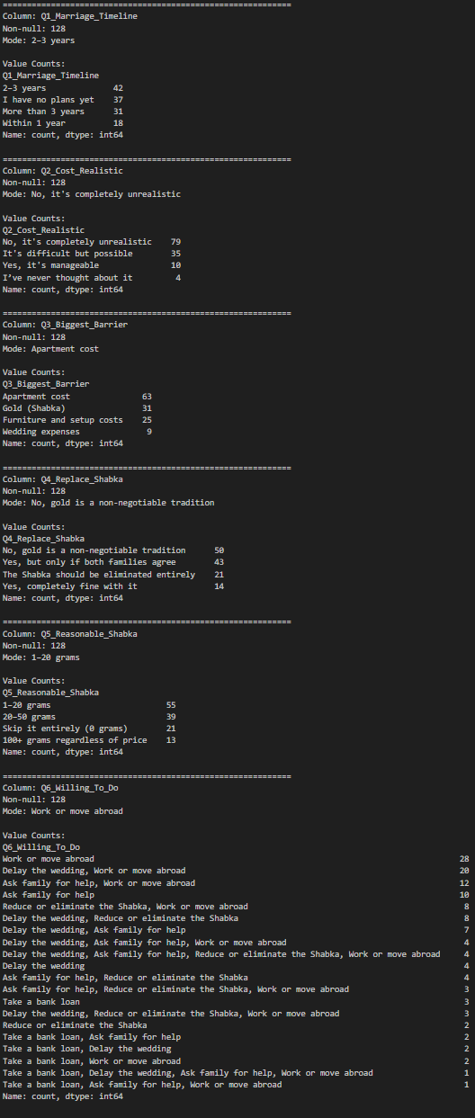
Descriptive Statistics Summary
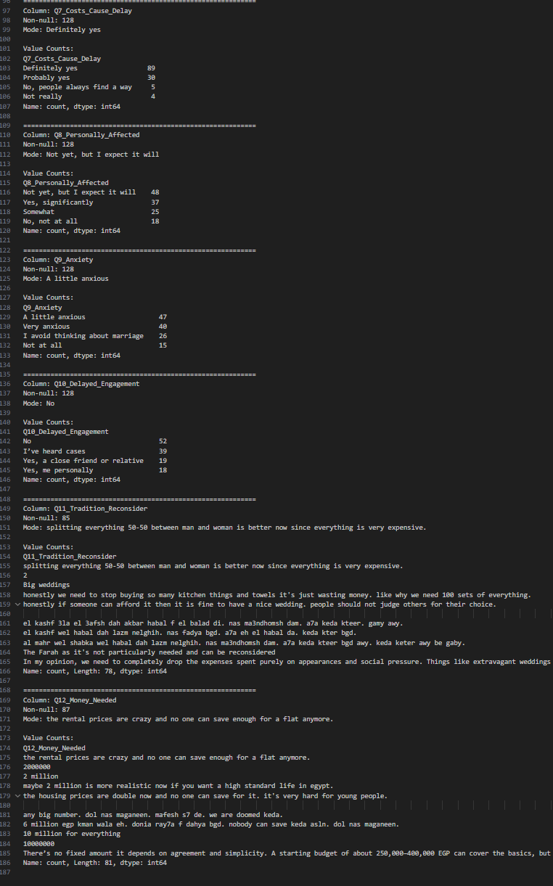

Since all ten closed-ended survey questions use categorical (nominal or ordinal) scales, the mode is the appropriate measure of central tendency. The summary table above presents the most common answer for each question along with its frequency. The overall pattern is consistent: respondents view marriage costs as unrealistic, housing as the main barrier, and economic pressure as a real force delaying marriage plans for the current generation.

Conclusion
Our hypothesis was largely confirmed by the data. 61.7% of respondents consider marriage costs completely unrealistic for fresh graduates, and 93.0% agree that these costs are causing people to delay marriage. While the cultural significance of the gold Shabka remains strong (39.1% still view it as non-negotiable), the majority of respondents are open to smaller or alternative forms, and most prefer a Shabka of 20 grams or less.
Contrary to the popular narrative that gold is the primary obstacle, housing emerged as the biggest financial barrier, cited by nearly half the sample. The open-ended responses further revealed a desire to simplify weddings, reduce the mahr, and eliminate excessive purchases of household items. Many respondents view working or moving abroad as the only realistic path to affording marriage — a sentiment that speaks to broader economic anxieties beyond just the marriage question.
Overall, the data confirms that the marriage crisis in Egypt is a multi-dimensional issue driven by housing costs, inflation, gold prices, and rigid cultural expectations. Addressing it will require both economic reform and a gradual cultural evolution toward more affordable marriage practices.

Critical Reflection
- The sample is predominantly urban university students, which limits generalizability to rural or lower-income populations of Egypt.
- Approximately 30–35% of respondents skipped the two open-ended questions (Q11 and Q12). Several of those who did respond submitted joke or irrelevant answers, which were removed during data cleaning.
- The survey was distributed exclusively online, meaning it excludes Egyptians without reliable internet access — a potentially significant demographic.
- No demographic variables such as gender, exact age, or income level were collected, which restricts deeper cross-tabulation analysis.
- Despite these limitations, the strong consistency of responses across 10 independent questions gives confidence that the identified trends are real and meaningful within the sampled population.

