# Section 3: Viewing generated reports

## Original Hippocampus of Study 1:

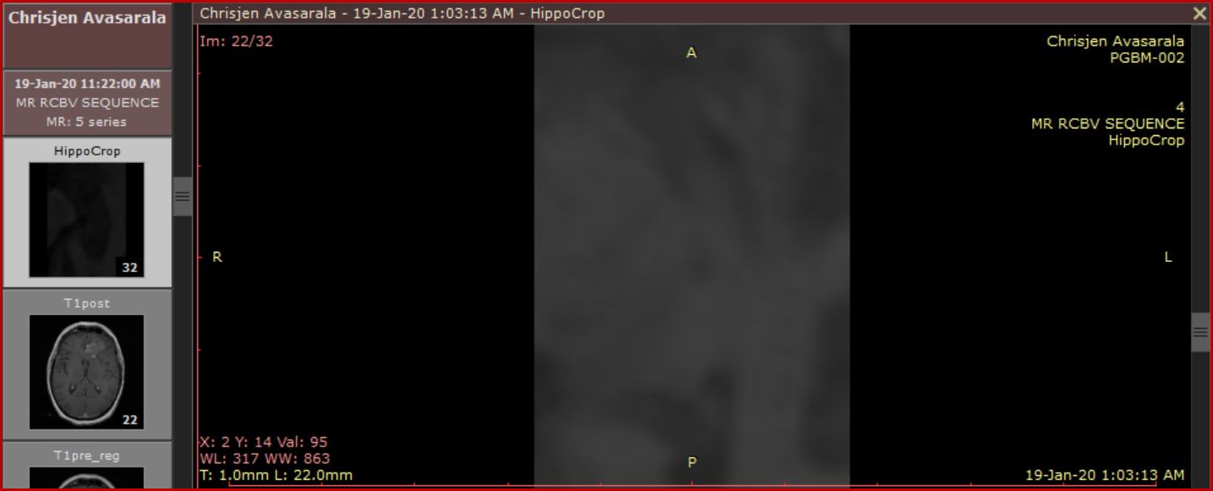

## Report of Hippocampus of Study 1:

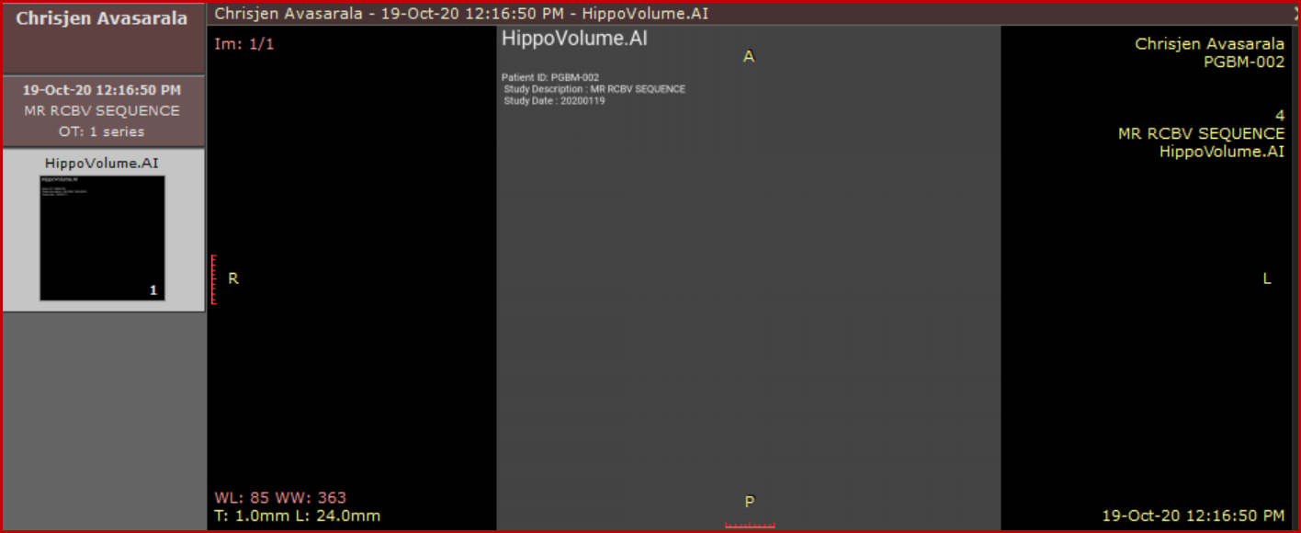

## Original Hippocampus of Study 2:

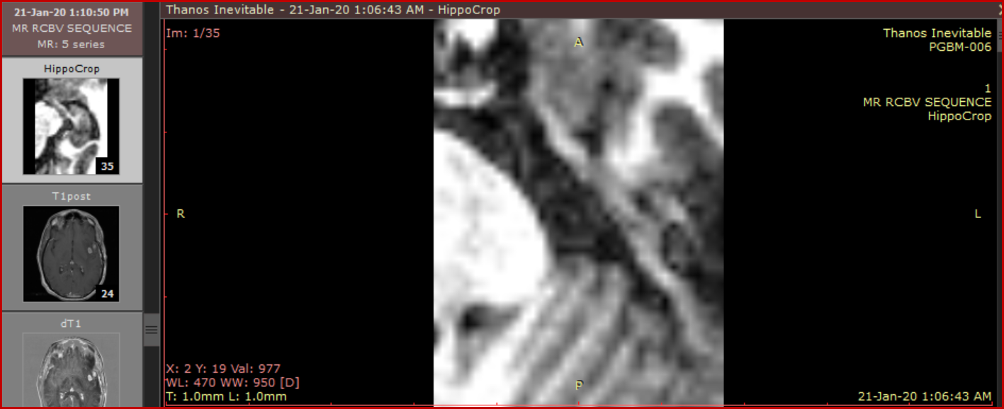

## Report of Hippocampus of Study 2:

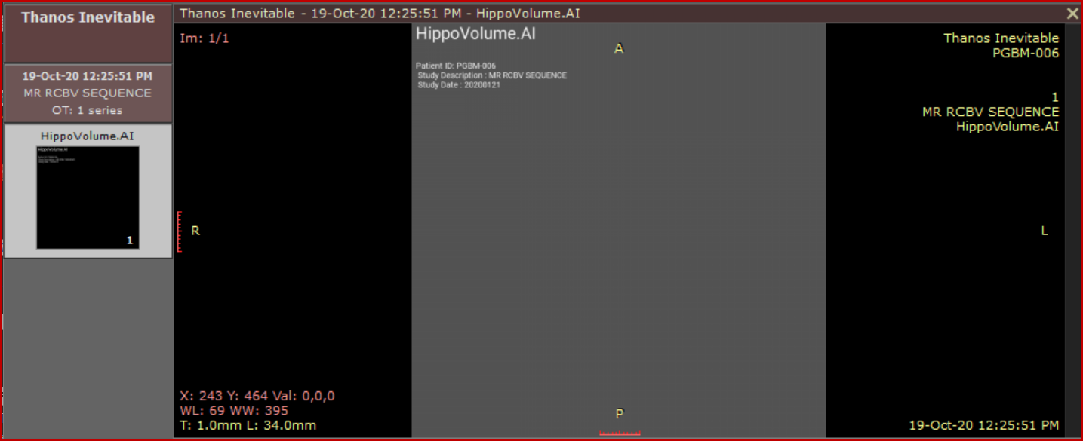

## Original Hippocampus of Study 3:

## Report of Hippocampus of Study 3: