Objectives
Pre-programmed Automated Drone
Students | Felipe Soares, Marcos Negreira | Fall
Students | Felipe Soares, Marcos Negreira | 2015
Advisors | Dr. Bassem Alhalabi | 2015
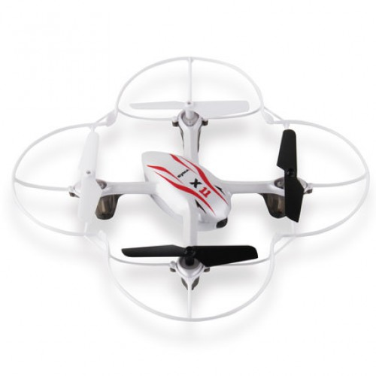

Our project intends on controlling a small quadcopter using the micro controller MSP430, to take off autonomously and fly a selected pre-programmed pattern and land back on its base.

General Description
The base of the drone will take pre-flight measurements and adjust the flight plan according to the room’s dimensions. Due to the weight restrictions on the drone itself, all sensors will be only on the base and the micro controller will operate the drone via remote control.
The selected drone is an off-the shelf self-stabilizing drone measuring just under 6 x 6 in, which makes it desirable for indoor flight.
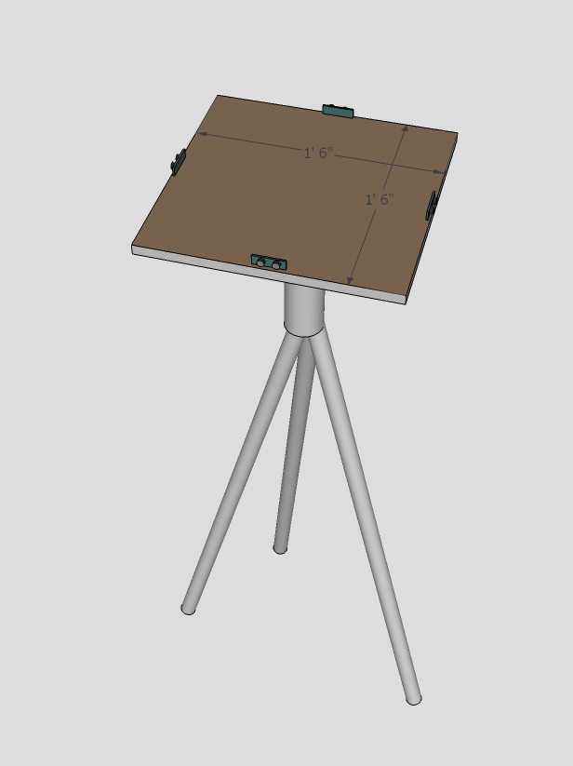
Measurements are taken by multiple ultra-sonic distance sensors placed on the base, the flight plan will adjust in proportion to the room’s dimensions.

