MZUMBE UNIVERSITY


FACULITY OF SOCIAL SCIENCE AND TECHNOLOGY

PRACTICAL TRAINING REPORT

STUDENT NAME : MUHAMED S. BAKARI
REGISTRATION NUMBER : 14322018/T.20
PROGRAMME : BSC. ITS2
PRACTICAL TRAINING YEAR : 2021/2022
ORGANIZATION NAME : TEMEKE MUNICIPAL COUNCIL
TRAINING OFFICER NAME : REGINA SAGINI
ACADEMIC SUPERVISOR’S NAME : DR PATRICK KIHOZA

EXECUTIVE SUMMARY
This report shows the activities I did during my practical training at TEMEKE MUNICIPAL COUNCIL for 8 weeks from 09th August, 2022 to 30th September 2022.
This report composed of five chapters , chapter one is all about the introduction party which explains about the background of organisation, various functions of the , mission and vision of the university, the whole structure and review of the university.
In chapter two, it explains task performed and lesson learned during the whole period of the field work. Chapter two will explain clearly every duty taken and lessons learnt from the activity performed.
Chapter three will give a literature review of the task I performed during the fieldwork. It will include scientific theories which reflect the relevance of the task I performed as it is update with accordance to my studies.
Chapter four will give the interpretation and analysis of what I have learned. It will give a clear picture to what I have acquired from the field work. Also, it won’t leave behind what I luck, that is what skill I still don’t have as per this field work.
Finally, is chapter five which will give the conclusion and the recommendations, this chapter will explain more on what should be improved in computing science training programs and what feedback may try to help the host organization to improve more further.

ACKNOWLEDGMENT
First of all, I would like to bring my thanks to ALL MIGHT GOD that he has been merciful to me by insuring guidance, health and opportunity to accomplish my field practical training at Temeke Municipal Council as a part of my academic progress at MZUMBE UNIVERSITY much thanks and glory to him.
Secondly, my sincere appreciations should go to the MZUMBE UNIVERSITY Morogoro Campus to insure and prepare all facilities for me to conduct my field practical training
Moreover, I bring my most sincere acknowledgement to my supervisors DR. KIHOZA PATRICK who is my MU supervisor, who gave us the original back –up during my report writing) together with my industrial supervisor Information Communication and technology Officers Mrs REGINA SAGINI and ZAINABU SAGINI for her readiness to support me in each step I took in my carrier during field period;
Furthermore, I like to express my special thanks to Management of Temeke Municipal Council and entire Staff, as they played great role during my eight week of field training at Temeke Municipal Council from them I learnt a lot from their various activities and jobs experience, much thanks to them.
I cannot forget to give special thanks to all my fellow students whom we worked together and helped each other as a team by exchanging ideas and skills to the assigned tasks during the entire practical training period at the field station.

TABLE OF CONTENTS
EXECUTIVE SUMMARY i
ACKNOWLEDGMENT ii
LIST OF FIGURES v
ABBREVIATIONS AND ACRONYMS vi
CHAPTER ONE 1
BACKGROUND OF THE ORGANIZATION 1
1.0 INTRODUCTION 1
1.1 Overview of the Company/Organization 1
1.1.1 Organization profile 1
1.1.2 Historical Background 1
1.1.3 ORGANIZATION VISION AND MISSION AND CORE VALUES. 2
1.1.4 ORGANIZATION STRUCTURE 3
1.2 PRIMARY FUNCTIONS OF THE ORGANIZATION 4
CHAPTER TWO 6
TASK PERFORMED AND LESSONS LEARNT 6
2.1 Introduction 6
2.2 Task Assigned and Performed 6
2.3 Results of the Proposed Solution 8
2.4 Lesson learnt 8
2.5 Lessons learned 14
CHAPTER THREE 16
INTERPRETATION AND ANALYSIS 16
3.1 Improvement of existing skills 16
3.2 New skills acquired 16
CHAPTER FOUR 17
GAPS IN SKILLS AND TECHNOLOGY 17
4.1 Gap in skills 17
4.2 Gap technology 17
CHAPTER FIVE 18
CONCLUSION AND RECOMMENDATIONS 18
5.1 Conclussion 18
5.2 Reccomanditions 19
REFERENCES 20

LIST OF FIGURES
Figure 1.1: Temeke Municipal Organization Structure 3
Figure 2.1 Problem trouble shooting 7
Figure 2.2 Upgrade to window 10 9
Figure 2.3 Download the Windows 10 Media Creation Tool 10
Figure 2.4 Run the Windows 10 Media Creation Tool 10
Figure 2.5 Windows 10 installation 11
Figure 2.6 ShowingRJ45 and modulor connector 12
Figure 2.7 Internet Troubleshooting 13
Figure 2.8 Printer configuration display 14

ABBREVIATIONS AND ACRONYMS
DICT - Department of information and communication technology
ICT - Information and Communication Technology
IDM - Institute of Development and Management
IT - Information technology
MU - Mzumbe University
OS - Operating system
PC - Personal Computer
RAM - Random access memory
ROM - Read only memory
TMC - Temeke Municipal council
LAN – Local Area Network
UTP - Unshielded twisted pair
STP - Shielded twisted pair
RJ – Registered jack

CHAPTER ONE

BACKGROUND OF THE ORGANIZATION

1.0 INTRODUCTION
This chapter explains the organization in general including the name, physical location, historical background, vision, mission and the main functions of the organization.
  - Overview of the Company/Organization
    - Organization profile
Temeke Municipal Council is located in the south of Dar es Salaam City, bordered by the Coast Region in the South, Ilala Municipality in the north and west while in the east it stretches by the coastal line of the Indian Ocean and Kigamboni Municipal Council. It covers an area of 240square km² with a coastal line of 5km length and lies between 39º12' - 39º33' east and 6º48' -7º33' south. Temeke Municipal Council is located from Dar es Salaam opposite with the national stadium to the junction of Mandela road and national stadium.

    - Historical Background
Temeke Municipal Council was established on 10th November, 1999 under the Local Government (Urban) Authorities Act. 1982 No. 8 section 8 and 9. Temeke Municipal is the one of municipal councils of Dar es Salaam city at Tanzania, other municipalities are Kinondoni, Ilala, Ubungo and Kigamboni. Temeke is lies in the southern part of Dar-es-salaam Region, it consist of two (2) divisions, (Mbagala and Chang’ombe), thirty (23) wards and and 142 Sub wards/Mitaa. Before that time Dar es Salaam City and Coast Region constituted a single region known as Coast Region Later on, the region was further subdivided into two Regions namely Coast region and Dar es Salaam region.

    - ORGANIZATION VISION AND MISSION AND CORE VALUES.
VISION
A Council with high quality social services. To have a well-developed population with better livelihood.
MISSION
To convey high quality services effectively and efficiently. Temeke Municipal Council is committed to provide sustainable quality social economic services to its population throughout good governance and effective use of resources at all level
CORE VALUES
TMC is committed to adhere to the following core values: Poverty reduction Good governance (democracy, equity, rule of law, transparency, accountability) Effective and efficient delivery of quality services.

    - ORGANIZATION STRUCTURE
TEMEKE MUNICIPAL ORGANIZATION STRUCTURE
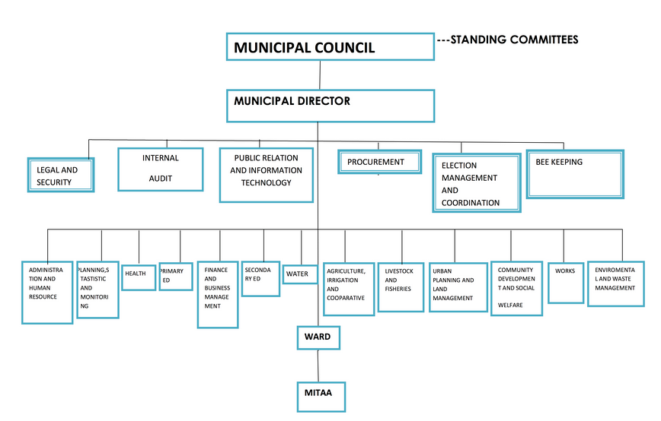

Figure 1.1: Temeke Municipal Organization Structure

  - PRIMARY FUNCTIONS OF THE ORGANIZATION
- Support - To enable employees to make the most effective use of IT resources, the IT Officer provides various forms of user support. After installing new software or network facilities, Officer provides training so that employees can quickly make productive use of the new resources. Example of support offered is the TAMISEMI.
- Network - The IT Officer develops and operates a network to support effective communication and collaboration with the employees in the organization. Increasingly, Officer deploying the latest Internet Protocol networks with the capability to carry all voice, data, video and Internet traffic on a single network. IP Also provide other network supports such as router configurations and internet troubleshooting.
- Business - Provide business support by offering license to people with qualified attachments such as membership ID cards (NIDA) and house rent contracts and other business related contracts.
- Providing loans of 10% percentage to those who needs loans of ten people.
- To ensure the implementation of nation and local laws, policies and regulations.
- To provide sustainable good services in a participatory and good governance in order to eradicate poverty.
- To maintain and promote peace and good governance within its boundaries.
- To improve social welfare and economic development to all people in her boundaries.
- Regarding the National policy of the village and council, to improve and maintain social welfare and areas under its authority.
- According to Act. No. 7 of 1983 sub section III the basic function under lived are: -
- To maintain peace, tranquility and good governance.
- To strongly develop social and economic welfare to the community in the district.
- Delegate political, financial and administrative authority to the subordinate organs under local authority such as Wards, Villages and Hamlet level.
- Develop community participation democratically in decision to all issues/matters related to their locality.
- Build up self-reliant mechanism to continuously finding sources of finance/income that will lead to provision of sustainable services, financial accountability to the community and civil serval

CHAPTER TWO

TASK PERFORMED AND LESSONS LEARNT

2.1 Introduction
Under this chapter all activities performed at Temeke Municipal Council Discussed.
During the whole period of the field at TMC, we were assigned projects in groups, the project was mainly about well working in IT activities especially maintainance of networking activities such that network cables termination and computer maintenance performed in various organization offices.

2.2 Task Assigned and Performed
COMPUTER MAINTAINANCE AND REPAIR
Computer maintenance and troubleshooting around organization offices like UTUMISHI and MASIJARA
by the way, Computer troubleshooting is a process of identifying and fixing issues with your hardware, software or connectivity using a computer. also, computer troubleshooting, is a form of problem solving, often applied to repair failed products or processes on a machine or a system. The following are steps followed during computer troubleshooting as;
- Identify the problem, the first thing you need to be aware of when troubleshooting a problem is that the symptoms are not the problem. So, in order to know the problem, you should ask the user of the computer.
- Establish a theory of probable cause, once you have identified the base problem that is causing the symptoms you will establish a list of probable causes. So use you technical knowledge to prioritize that list.
- Test probable cause theory to determine actual cause, once you have established your theory of probable cause you should take a moment to consider whether or not you can troubleshoot the issue on your own.
- Establish an action plan and execute the plan.
- Verify full system functionality
During practical training I was assigned to troubleshoot computers. This is the process of reviewing, diagnosing and identifying operational or technical problems within a computer. It aims to resolve physical and/or logical problems and issues within a computing hardware, i.e. to solve poor performance of a computer problem
Some processes within hardware troubleshooting include:
- Cleaning dusts from RAM and Video carts slot/ports and from cooling fan.
- Removing repairing and replacing hard disk or video/graphic card.
- Removing, repairing and replacing faulty RAM,
- Software related hardware problems such as device driver update or installation.
- Tightening cable and jumpers on motherboard and/or components.
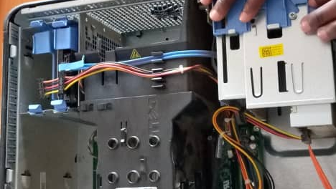

Figure 2.1 Problem trouble shooting
The suggested solution was to upgrade RAM and hard drive so as to increase performance of computer since the speed of computer was very slow
- Functional Requirement
- RAM is the computer memory used to hold current programs and data that are in use
- For a computer to have high speed in operating the program RAM should be large enough from 4GB to above
- The size of RAM is the vital thing to consider when computer seems to be slow
- Hard drive should have more than 250 GB

2.3 Results of the Proposed Solution
By performing computer maintenance computer performance increased and user were able to deploy work with computer since there was no delay of executing the programs.

2.4 Lesson learnt
During practical field I learnt various lessons which have increased capability and thinking ability in various life problems such as
- Importance of team working,as we work in our team during field practical we work as a team so due to this we have are different completion activities in short period of time.
OPERATING SYSTEM INSTALLATION
Operating system is a program that acts as an intermediary between a user of a computer and the computer hardware. Also is software which makes a computer to actually work, also enable all the programs we use.
Task assigned
Installation of operating system on these computers in defferent offices around organization that louching windows 7 and installing windows10 instead, S as well as upgrading those desktop computers running older versions to the lattest ones,

Requirements;
In the process of windows installation, there are some requirements that we were supposed to have which are
- USB drive
- Windows 10 disk image.

. The following are the steps that can be followed during installation of operating system in different computers.
Step 1: Upgrade to window 10
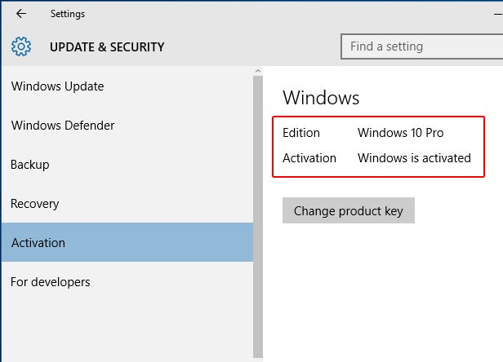

Figure 2.2 Upgrade to window 10
You can’t perform a clean installation of Windows 10 until you’ve performed an upgrade installation and activated the operating system. This done, confirm that Windows 10 has been activated by going to Start > Settings > Update & security > Activation. Look in the right of the window and you should see Activation: Windows is activated. If you don’t see this, you must not proceed and you’ll need to wait until Windows 10 activates.
Step 2: Download the Windows 10 Media Creation Tool
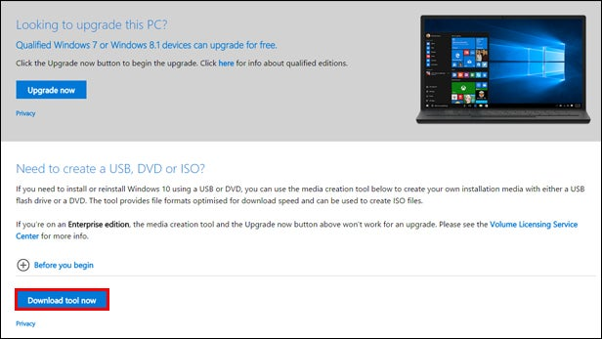

Figure 2.3 Download the Windows 10 Media Creation Tool

Step 3: Run the Windows 10 Media Creation Tool
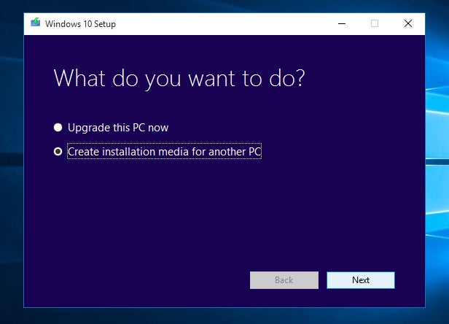

Figure 2.4 Run the Windows 10 Media Creation Tool
Step 4: Choose Your Windows 10 Version
Step 5: Choose a Storage Device-Select the device you’re going to use for the Windows 10 installation USB flash drive. Click Next. Select the USB flash drive, or a folder on your PC, to store the Windows 10 setup files. Click Next. Else you can boot using the USB flash drive.
During practical training I was assigned to install operating system, window 7 and windows 10 latest version to various TMC computers and supposed to install all associated application software such as Microsoft Office 2013, Microsoft Office 2019, Driver pack solution 2017 latest, Adobe reader for PDF documents, Mozilla Firefox and Google chrome browsers. Operating system installation was done by bootable flashes using booting software, Rufus version 3 late
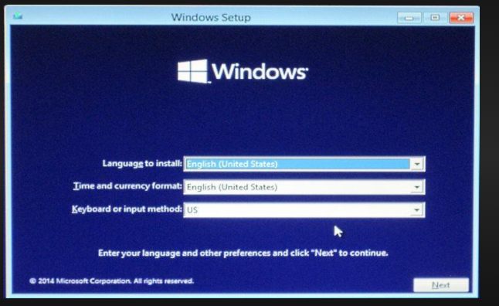

Figure 2.5 Windows 10 installation
NETWORK CABLE TERMINATION
is the connection of the wire or fiber to a device, such as equipment, panels or a wall outlet, which allows for connecting the cable to other cables or device,
Requirements ware;
- RJ45
- Ethernet cable
- Climping tool
- Cutter

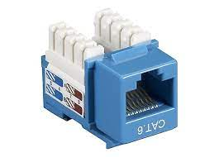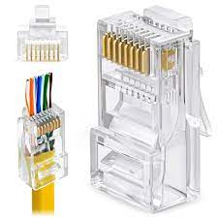

Figure 2.6 showingRJ45 and modulor connector

Internet Troubleshooting
On internet Troubleshooting I have learnt on how to fix the Ethernet cable and how to wire a Crossover Ethernet cable and plug it into RJ-45. There are some steps to follow on how to wire a Crossover Ethernet cable and plug it into RJ-45. Such steps are
- First-Switch the green-white wire
- Second-after the green-white wire followed by Solid-Green wire
- Third-Followed by orange-white wire
- Fourth-Followed by Solid-Blue wire
- Fifth-Followed by blue-white wire
- Sixth-Followed by Solid-Orange wire
- Seventh-Followed by purple-white wire
- Lastly-Finish by Solid-Purple
The diagram below shows more details on how to correctly arrange Ethernet wire
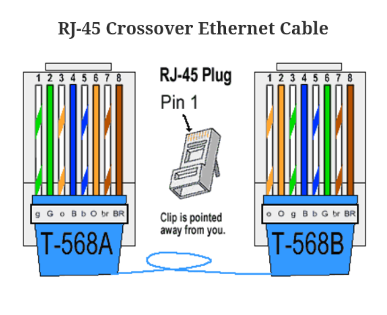

Figure 2.2 Internet Troubleshooting
PRINTER CONFIGURATION
Printer configuration and troubleshooting in different offices which were in need of that help so that to soften the offices tasks. PRINTER TROUBLESHOOTING
Also involve hardware repair which means to rectify, to fix the problem in the hardware. It may also include replacement of a component that is faulty; it is the essential part of troubleshooting.
Actually, during my field attachment also, I did many troubleshooting one of it was troubleshooting printer and fixing printer problem for example printer drivers are up-to-date and that has enough paper and ink or toner to print.
Generally, I was considering the following step to troubleshoot and fix the problem.
- Turning off and on the printer
- Unplug the printer and plug it back in.
- Check printer print queue by look for the printer icon in the system tray and DoubleClick it.
- The printer queue shows the status of each object as well as the general status of printer.
- Making sure that use the printer Offline is not selected.
- I ensure that Use printer Offline is not checked.
- But sometimes printing while printer is turned off can cause Window to set printer to work offline and that can cause stall jobs sent later.
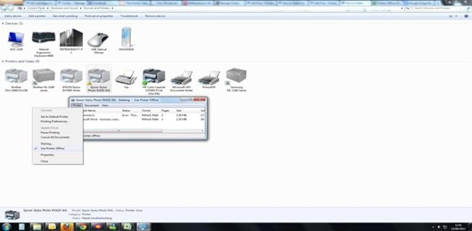

Figure 2.8 Printer configuration display

2.5 Lessons learned
- Practical training programs help to increase interdisciplinary knowledge. It helps me to learn the practical implementation of theoretical knowledge in any discipline, and enables a deeper learning experience.
- Troubleshoot hp PC with window 10 pro.
- Reset the Password of the desktop computer without deletes data.
- Fixing the bad system config in windows 10.
- Troubleshoot HP laser jet Pro CM1415fn color MFP and found out that black toner was only 10% and replaced it with a new one and it became 100%.
- Internet troubleshooting on phone and desktop computer.
- Installation of Kaspersky antivirus on desktop computer.
- Provide technical IT support in a certain gathering/ meeting.
- Through practical training, I get to know how organization operates and what standard procedures must be followed in the real working environment. Practical training addresses organization problem and helps me enhance the knowledge that makes me an organization ready professional.
- Develops my interpersonal skills.
- Various architecture on solving tough problems
- To be patient when solving hard and tough problems
- Importance of respecting time during working time
- And importance of discipline and respecting others ideals

CHAPTER THREE

INTERPRETATION AND ANALYSIS

3.1 Improvement of existing skills
During field session we acquired various skills which have increased capability to maintain, and keeping computers and other electronic devices in a good and conducive manner that may be used for a long and saving cost of purchasing new devices continuously
Also, through training different student, it has led to arise of expertise which increases efficiency and famous of the organization all over the word through various IT projects declared online

3.2 New skills acquired
There are various new skills that I learnt during the field training period. The following are the new skills learnt.
- Termination of ethernet cables.
- Computer maintenance and repair
- Troubleshooting network problems.
- Troubleshooting printer problems.
- Application of softw
- Changing BIOS setup for a PC failed to boot
- Computer troubleshooting
- Activating window

CHAPTER FOUR

GAPS IN SKILLS AND TECHNOLOGY

4.1 Gap in skills
Directorate lacks some IT field that would easily many activities such as effective networking media and updated programmable system, The scarcity of resources such as flash, toolkit, case and USB, was also a big challenge, during working time, field members were to settle for a while to wait for a person to complete the task so that another can use the resource acquired, this leads to many tasks not complete at a time

4.2 Gap technology
- Network instability; whenever there is a power cut brought about by TANESCO, generally resulted into network instability due to the fact that organisation do not have enough countermeasures in place. When I say countermeasures I mean generators, they do not act quickly enough especially in UTUMISHI and MASIJARA offices. This results into delay of tasks to be performed in offices.
- Outdated computer equipment; the current desktop computers are very outdated. They require a lot of accessories and a lot of cabling for it to be complete. The computers need to be updated and get with the times.aslo insufficient networking tool kits.
- Lack of access for better learning; during the whole field period we missed direct access to interact with the organization IT system to improve our experience in IT systems and web programming

CHAPTER FIVE

CONCLUSION AND RECOMMENDATIONS

5.1 Conclusion
To wind up this report, much appreciation goes to Temeke Municipal Council . For accepting my request to conduct field study at the TMC organisation. I experience many things and study many things, feel comfortably to ask where there is a problem and much cooperation, they gave me during all the time.
Last but not least important issue is that, it is very important for organizations and other institutions not to be reluctant to accept students to do their practical training due to unknown reasons, also to tolerate all situation concerning academic matter shown by the student, for the case that we are still learning, they should not treat the student equally as other workers to the company or organization.

5.2 Recommendations
Despite the fact that the practical training provides skills, the students may not get all the necessary skills. Therefore, I recommend that there should be a plan and a timetable for training students on a specific subject for the aim of implanting the necessary skills to students. In addition to that I recommend that students should be asked about the skills they wish to have and the plan should also base on students’ interest.
. Other recommendations are:
- Assigned tasks should be within student’s level of coverage
- Supervisors should give clear explanations and guidelines about the task so that students perform the confidently and in time.
- Among those 7 weeks of field practical training, at least the first 2 weeks should be used for learning and making things clear about the tasks to be done so as to accomplishment of assigned tasks could be easy.
- Assigned tasks should not rely on a single field of study since ICT covers a wide range of fields such as networking, programming, database management, web design, etc.
- All required tools and resources to complete a specific task should be available in satisfactory amount so that to accomplish the assigned tasks effectively, efficiently and in time.
- Supervisors should know the area of interest of different students so as to enable students to work fully and tackle those tasks accordingly.

REFERENCES
WEBSITES
www.temekemc.go.tz
https://www.cnet.com/how-to/how-to-make-your-own-ethernet-cable/
http://i.i.cbsi.com/cnwk.1d/i/tim/2011/08/03/Crimped-connector.jpg
BOOKS
Ericsson Telecom AB, (1996). AXE Operation & Maintenance Platform, (Third edition), Stockholm Sweden.
- 21st November 2021

