ABAPSpace
ABAP NAMESPACE REFACTORING

MANUAL

TABLE OF CONTENTS
LIST OF FIGURES II
TABLE DIRECTORY III
LIST OF ABBREVIATIONS IV
1. INTRO 1
2. ENHANCED OBJECT POLICY 1
2.1 ABAP OBJECT IDENTIFIER 1
3. REPLACEMENT 2
3.1 WITH OBJECT POLICY 2
3.2 WITHOUT OBJECT POLICY 2
3.3 SUPPLEMENT 2
4. PRESET 3
5. USER MANUAL 7
5.1 PREREQUISITES 7
5.2 RUN ABAPSpace 7
5.3 USE ABAPSpace 7
LIST OF REFERENCES 10

LIST OF FIGURES
Illustration 1: ABAPSpace - start screen 8
Illustration 2: ABAPSpace - edit screen 9

TABLE DIRECTORY
Table 1: ABAP object identifier 1
Table 2: Preset XML Schema 3

LIST OF ABBREVIATIONS

INTRO
ABAPSpace is a Java tool for namespace refactoring.

ENHANCED OBJECT POLICY
The enhanced object policy expects an object name as follows:

<NAMESPACE><OBJECT_IDENTIFIER><OBJECT_NAME>

ABAP OBJECT IDENTIFIER
Specific checks based on specific ABAP objects can only be made, if an object was recognized as such. The detection is only performed on the basis of source files, without the SAP system. To enable such checks, the object name must indicate what the object type is.

Therefore, the following object identifier are required:

ABAP Object | Object Identifier | Maximum Length | Description
Package | PA | 30
Class | CL | 30 | Abbreviation is SAP default
Interface | IF | 30 | Abbreviation is SAP default
Exception Class | CX | 30 | Abbreviation is SAP default
Program | PR | 40
Include | IN | 40
Function Group | FG | 26
Function Module | FM | 30
DB Table | TA | 16
DB View | VW | 16
Table Type | TT | 30
Structure | ST | 30
Data Element | DA | 30
Domain | DO | 30
Message Class | MC | 20
Table 1: ABAP object identifier

There are already standard identifiers like classes (CL) or interfaces (IF). Further ones are defined on this basis.

REPLACEMENT

WITH OBJECT POLICY

<NAMESPACE_NEW><OBJECT_IDENTIFIER><SUPPLEMENT><OBJECT_NAME>

WITHOUT OBJECT POLICY

<NAMESPACE_NEW><SUPPLEMENT><OBJECT_NAME>

SUPPLEMENT
The supplement is a specific prefix to group objects. For example, objects belong to a specific development package or project.

PRESET
All settings of ABAPSpace are stored in a preset XML file (file suffix: *.xpx).
The following XML schema defines the preset file:

Table 2: Preset XML Schema
001  002  003  004  005  006  007  008  009  010  011  012  013  014  015  016  017  018  019  020  021  022  023  024  025  026  027  028  029  030  031  032  033  034  035  036  037  038  039  040  041  042  043  044  045  046  047  048  049  050  051  052  053  054  055  056  057 |  | <?xml version="1.0" encoding="UTF-8"?>  <xsd:schema xmlns:xsd="http://www.w3.org/2001/XMLSchema"  targetNamespace="http://www.abapspace.com/Preset" xmlns:tns="http://www.abapspace.com/Preset"  elementFormDefault="qualified">  <xsd:element name="objectNameIdent">  <xsd:simpleType>  <xsd:restriction base="xsd:string">  <xsd:minLength value="1" />  </xsd:restriction>  </xsd:simpleType>  </xsd:element>  <xsd:element name="preIdent">  <xsd:simpleType>  <xsd:restriction base="xsd:string">  <xsd:minLength value="0" />  </xsd:restriction>  </xsd:simpleType>  </xsd:element>  <xsd:element name="postIdent">  <xsd:simpleType>  <xsd:restriction base="xsd:string">  <xsd:minLength value="0" />  </xsd:restriction>  </xsd:simpleType>  </xsd:element>  <xsd:complexType name="objectTypeGen" mixed="true">  <xsd:sequence>  <xsd:element ref="tns:preIdent" minOccurs="0" maxOccurs="1"></xsd:element>  <xsd:element name="objectIdent" minOccurs="1" maxOccurs="1">  <xsd:simpleType>  <xsd:restriction base="xsd:normalizedString">  <xsd:minLength value="1" />  </xsd:restriction>  </xsd:simpleType>  </xsd:element>  <xsd:element ref="tns:objectNameIdent" minOccurs="1"  maxOccurs="1"></xsd:element>  <xsd:element ref="tns:postIdent" minOccurs="0" maxOccurs="1"></xsd:element>  <xsd:element name="nameMaxLength" minOccurs="1"  maxOccurs="1">  <xsd:simpleType>  <xsd:restriction base="xsd:int">  <xsd:minInclusive value="0" />  </xsd:restriction>  </xsd:simpleType>  </xsd:element>  </xsd:sequence>  </xsd:complexType>  <xsd:element name="preset">  <xsd:complexType>  <xsd:sequence>  <xsd:element name="description" minOccurs="1" maxOccurs="1">  <xsd:simpleType>  <xsd:restriction base="xsd:normalizedString">  <xsd:minLength value="1" />  <xsd:maxLength value="200" />  </xsd:restriction>  </xsd:simpleType>  </xsd:element>  <xsd:element name="refactorSourceDir" type="xsd:normalizedString"  minOccurs="1" maxOccurs="1"></xsd:element>  <xsd:element name="refactorTargetDir" type="xsd:normalizedString"  minOccurs="1" maxOccurs="1"></xsd:element>  <xsd:element name="fileStructure" minOccurs="1"  maxOccurs="1">  <xsd:complexType>  <xsd:sequence>  <xsd:element name="update" type="xsd:boolean"  minOccurs="1" maxOccurs="1"></xsd:element>  <xsd:element name="namespacePlaceholder" type="xsd:normalizedString"  minOccurs="1" maxOccurs="1"></xsd:element>  <xsd:element name="namespaceReplacement" type="xsd:normalizedString"  minOccurs="1" maxOccurs="1"></xsd:element>  </xsd:sequence>  </xsd:complexType>  </xsd:element>  <xsd:element name="checkNameMaxLength" type="xsd:boolean"  minOccurs="1" maxOccurs="1"></xsd:element>  <xsd:element name="namespaceNew" type="xsd:normalizedString"  minOccurs="1" maxOccurs="1"></xsd:element>  <xsd:element name="supplement" type="xsd:normalizedString"  minOccurs="0" maxOccurs="1"></xsd:element>  <xsd:element name="namespaceOldList" minOccurs="1"  maxOccurs="1">  <xsd:complexType>  <xsd:sequence>  <xsd:element name="namespaceOld" minOccurs="1"  maxOccurs="unbounded">  <xsd:complexType>  <xsd:sequence>  <xsd:element name="objectPolicy" type="xsd:boolean"  minOccurs="0" maxOccurs="1" />  <xsd:element name="namespaceOld" type="xsd:normalizedString"  minOccurs="1" maxOccurs="1" />  </xsd:sequence>  </xsd:complexType>  </xsd:element>  </xsd:sequence>  </xsd:complexType>  </xsd:element>  <xsd:element name="objectPolicyGeneral" minOccurs="0"  maxOccurs="1">  <xsd:complexType>  <xsd:sequence>  <xsd:element ref="tns:preIdent" minOccurs="0"  maxOccurs="1"></xsd:element>  <xsd:element ref="tns:objectNameIdent" minOccurs="1"  maxOccurs="1"></xsd:element>  <xsd:element ref="tns:postIdent" minOccurs="0"  maxOccurs="1"></xsd:element>  </xsd:sequence>  </xsd:complexType>  </xsd:element>  <xsd:element name="objectPolicy" minOccurs="0"  maxOccurs="1">  <xsd:complexType>  <xsd:sequence>  <xsd:element name="objectPackage" minOccurs="0"  maxOccurs="1" type="tns:objectTypeGen"></xsd:element>  <xsd:element name="objectClass" minOccurs="0"  maxOccurs="1" type="tns:objectTypeGen"></xsd:element>  <xsd:element name="objectInterface" minOccurs="0"  maxOccurs="1" type="tns:objectTypeGen"></xsd:element>  <xsd:element name="objectExceptionClass" minOccurs="0"  maxOccurs="1" type="tns:objectTypeGen"></xsd:element>  <xsd:element name="objectProgram" minOccurs="0"  maxOccurs="1" type="tns:objectTypeGen"></xsd:element>  <xsd:element name="objectInclude" minOccurs="0"  maxOccurs="1" type="tns:objectTypeGen"></xsd:element>  <xsd:element name="objectFunctionGroup" minOccurs="0"  maxOccurs="1" type="tns:objectTypeGen"></xsd:element>  <xsd:element name="objectFunctionModule" minOccurs="0"  maxOccurs="1" type="tns:objectTypeGen"></xsd:element>  <xsd:element name="objectDatabaseTable" minOccurs="0"  maxOccurs="1" type="tns:objectTypeGen"></xsd:element>  <xsd:element name="objectDatabaseView" minOccurs="0"  maxOccurs="1" type="tns:objectTypeGen"></xsd:element>  <xsd:element name="objectTableType" minOccurs="0"  maxOccurs="1" type="tns:objectTypeGen"></xsd:element>  <xsd:element name="objectStructure" minOccurs="0"  maxOccurs="1" type="tns:objectTypeGen"></xsd:element>  <xsd:element name="objectDataElement" minOccurs="0"  maxOccurs="1" type="tns:objectTypeGen"></xsd:element>  <xsd:element name="objectDomain" minOccurs="0"  maxOccurs="1" type="tns:objectTypeGen"></xsd:element>  <xsd:element name="objectMessageClass" minOccurs="0"  maxOccurs="1" type="tns:objectTypeGen"></xsd:element>  </xsd:sequence>  </xsd:complexType>  </xsd:element>  <xsd:element name="keywordsExclude" minOccurs="0"  maxOccurs="1">  <xsd:complexType>  <xsd:sequence>  <xsd:element name="keyword" minOccurs="0" maxOccurs="unbounded"  type="xsd:normalizedString">  </xsd:element>  </xsd:sequence>  </xsd:complexType>  </xsd:element>  </xsd:sequence>  </xsd:complexType>  </xsd:element>  </xsd:schema>

USER MANUAL

PREREQUISITES

Runtime environment. You have to install the Java Runtime Environment (>= Version 8).

Setup. All settings of ABAPSpace are stored in a Preset XML file. An example file can be found under:

- abapspace/bin/preset

RUN ABAPSpace
Go to the following ABAPSpace directory

- abapspace/bin

and run a start script:

- abapspace → Linux
- abapspace.bat → Windows

USE ABAPSpace

Start screen. If ABAPSpace has been started, the following screen appears (Illustration 1):

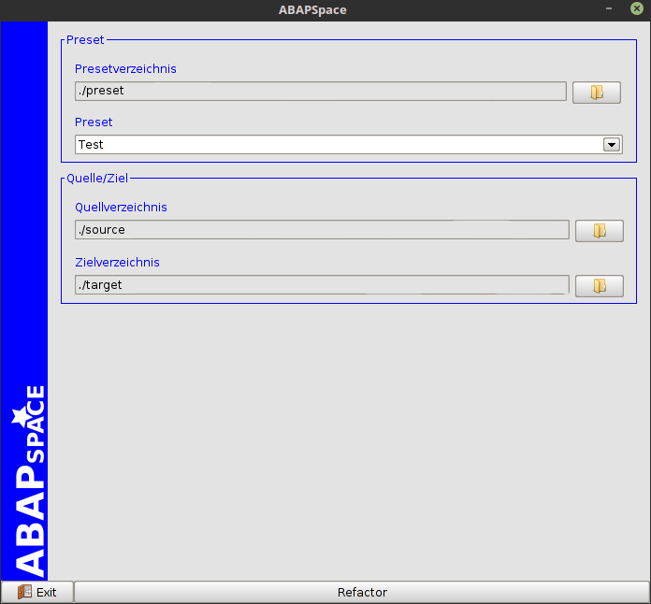
Illustration 1: ABAPSpace - start screen
Preset section. Its possible to select a separate preset directory.
The standard preset directory is:

- abapspace/bin/preset

A preset can be selected via the combobox.

Source/Target section. Here you can change the source and target directory. Target and source directory can be specified as default in the preset file.

Button Refactor. Starts the refactor process based on the selected preset file. The following actions are performed:

- Determines the objects based on the source files
- Checks the maximum object name length (only if the enhanced object policy is used and activated)
- calls the edit screen (below)
- Runs the namespace adaptation. All source files are copied to the target directory. The source files remain untouched.

Button Exit. Closes the application.

Edit screen. Its possible to change the found object names before the changes are made (Illustration 2).

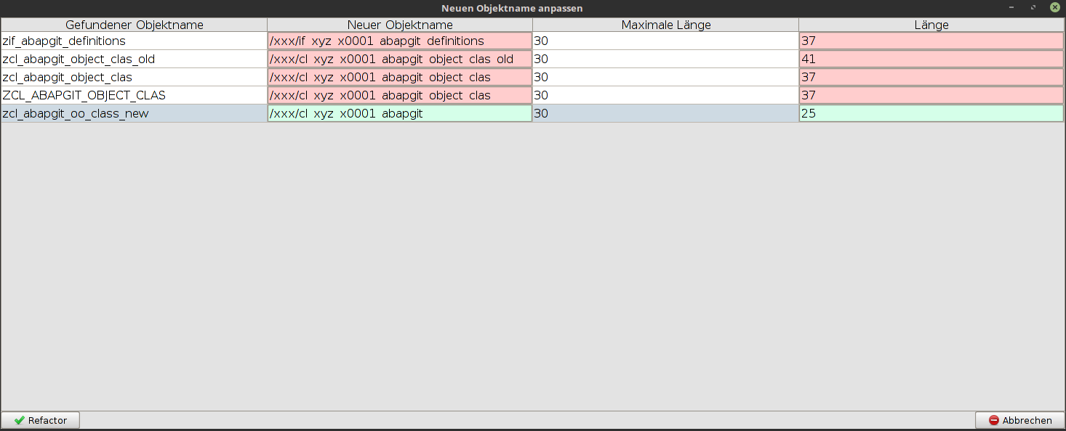
Illustration 2: ABAPSpace - edit screen
If the enhanced object policy is used, you can see which object names have exceeded the maximum length.

When you're done with changes, click refactor or cancel.

LIST OF REFERENCES

