**INTRODUCTION**

**INTERPRETATION OF THE TASK**

The task for this project is to create a micro-site named “Good Food Mood”.

The website is aimed ad working professionals with little time to do research about food.

**RESEARCH AND ANALYSIS**

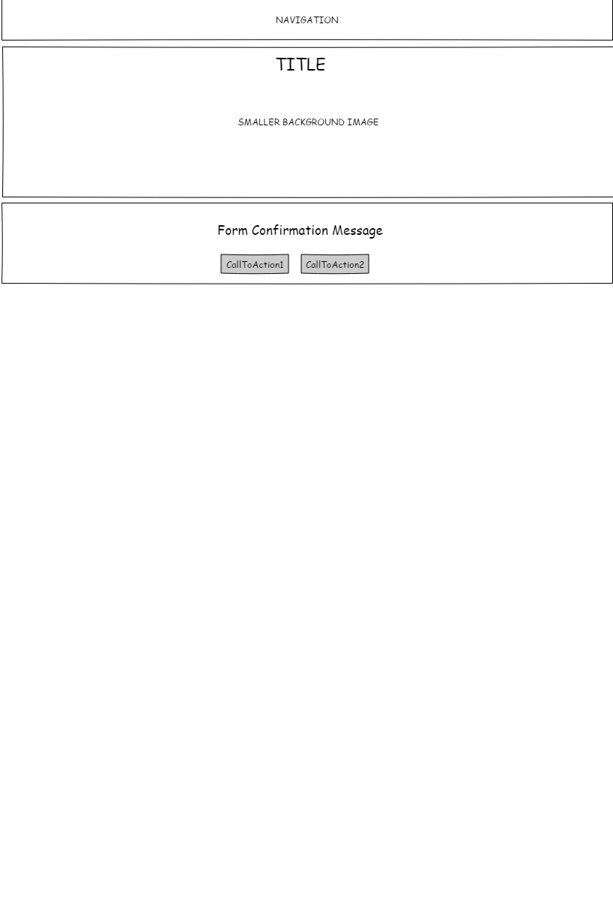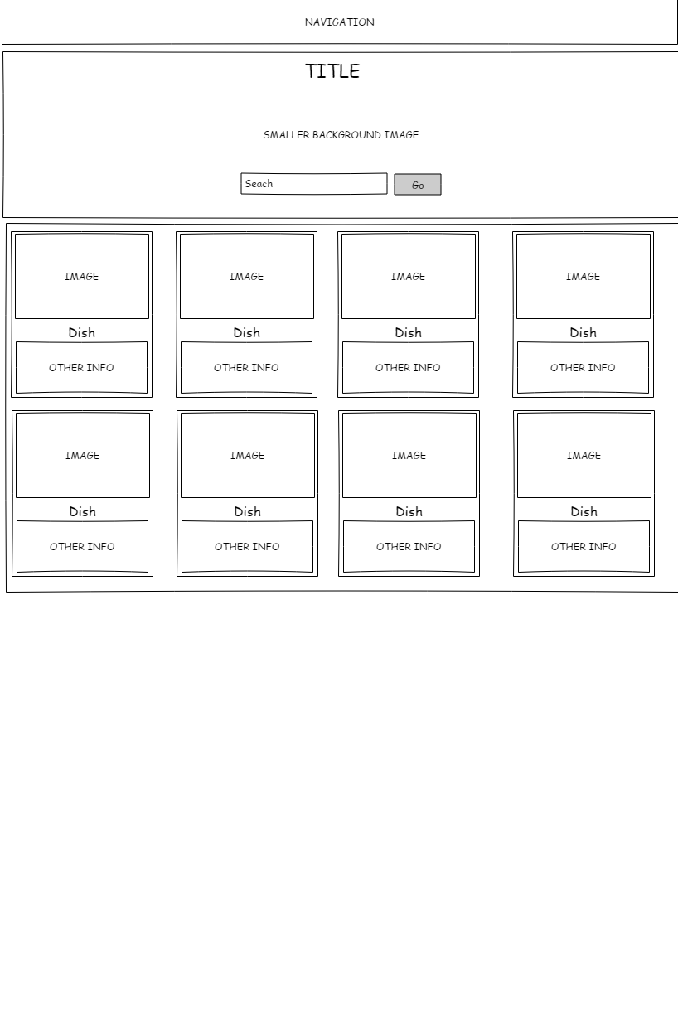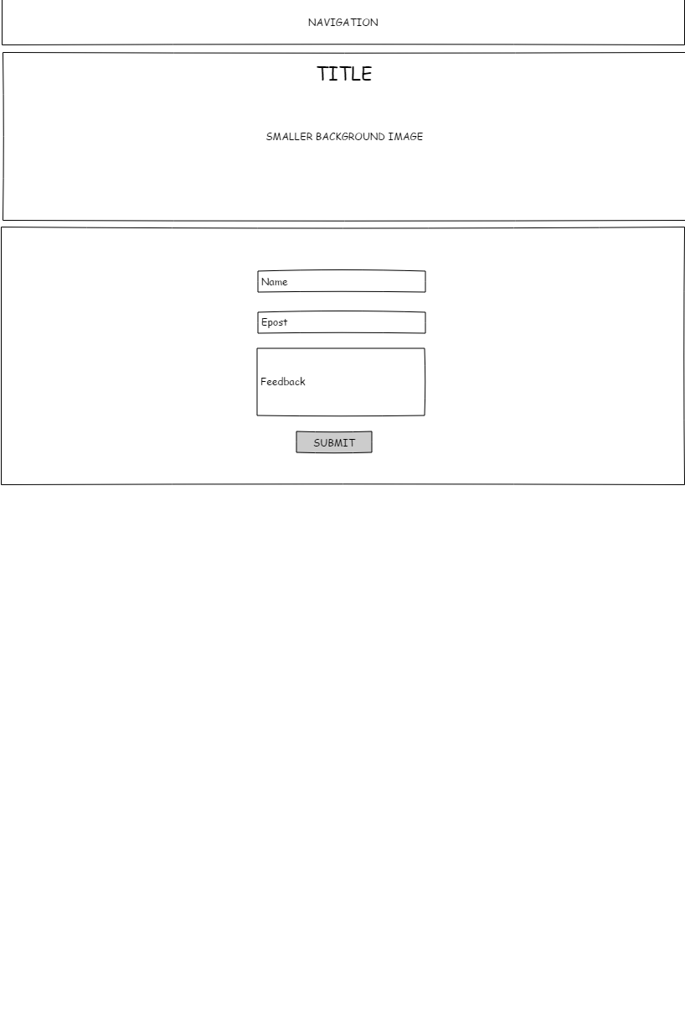**SKETCHES – SCANNED IDEA DEVELOPMENT AND DIGITAL SKETCHES**

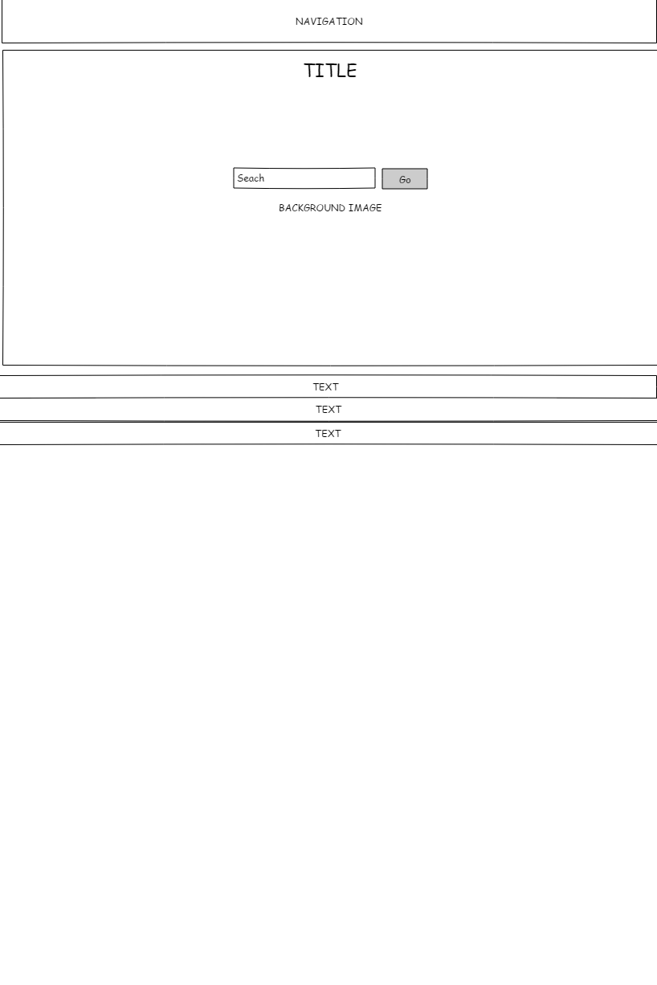

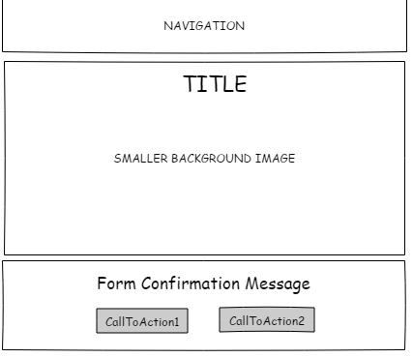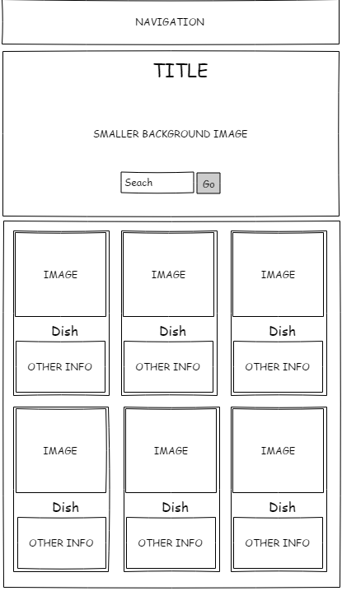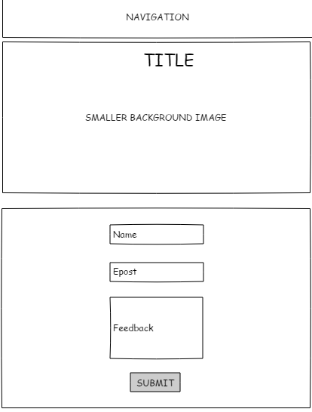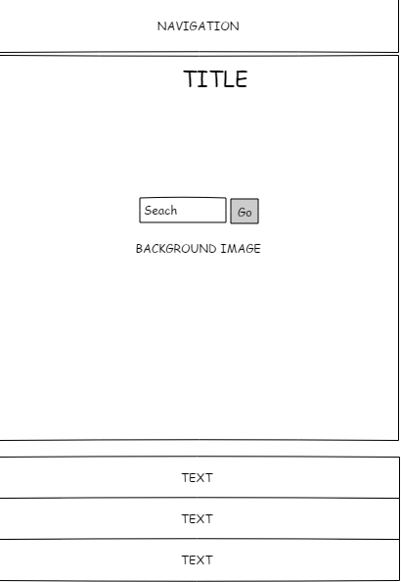

**Planning**

**FUNCTIONAL SPEC/GANT CHART**

When planning the development of the website I started out by making a Gantt chart of the process, having a Gantt chart is a great way of making it easier to plan the development. And when the functional spec is also completed it gives a lot of information to the developers about what the website should do for the user. The functional spec also gives the developers some deadlines for content that should be completed at a certain time.

**TARGET AUDIENCE**

Finding the target audience and writing a personae for this project was not extremely difficult, as a lot of the information was in the task description of the project. The description allowed me to just fill in the blanks after doing some research about the existing information.

**WORK PROCESS**

Some changes were made from the sketches to the final product. Most noteworthy is probably the addition of a footer in the website, which contains the link to the website that hosts the API.

**SEO &** **WCAG**

I built the website to comply with the WCAG guidelines as much as possible, for example I used sections and headers to tell browsers what content to expect and did not use a lot of div tags that tell the browser just about nothing.

Regarding SEO, I used meta tags to tell the search engines what the website is about. The meta tags related to SEO I ended up using were “description” and “keywords”. Both of these tags are important to make it easier for the search engines to help them tell what the content of the website is.

**DESIGN PRINCIPLES**

I choose to use bright colors to guide the user’s eyes at the relevant information.

Objects that lie next to each other will belong together, and I also used changed colors on both these elements when one of the elements would get a new color. An example of this is on the contact for where I would use red colors on input-boxes and on the “error”-text when the form had an issue with the data. I also used red colors on the “(*)”, this is so that it tells the user why an error has occurred with the for, and it is also a commonly used sign when an input is required (and not optional).

There is also a design principle that says that we read websites like a capitalized “F”, and therefore it was important to have most of the information in this format.

**STYLE/GENRE**

I choose a very similar design for the website both for the desktop and mobile website. The most noteworthy change is that the mobile version uses a 1 column layout on the search-page, while the desktop version uses a 3-column layout depending on the width of the screen.

**TYPOGRAPHY**

For the typography I choose a font that was easy to read and says that the website is professional. After a lot of looking around at Google Fonts I found a font that matched my criteria of the desired font. After finding the font I also used the same font-family for the rest of the website.

The Font I ended up using for the title is “Work Sans”, a “Sans Serif” font.

**COLOURS**

When deciding what colors to use I ended up using a variation of colors. I used green (and dark green) background on the buttons having call-to-action motive, and I used a quite dark blue background color on some of the text contents and on the footer. Instead of using two blue colors as well, I ended up choosing a lover opacity of the colors instead (I used opacity on both blue colors as the main one was just a bit too dark).

For the forms I also used colors to give feedback to the user about what the status of the for was. I used red colors for elements that had some issue with the entered data, and green colors for the elements that had no issues with the entered data.

**COMPOSITION, LAYOUT, GRID AND OTHER ELEMENTS**

The layout of the website is a bit complicated. For the mobile version I choose a 1 column layout for the smaller devices and a 3-column layout for the larger devices on the search page, on the rest of the pages I choose a 1 column layout. On the desktop version I choose a 3-column layout for the search page, on the rest of the pages I used the same layout as the mobile version (1 column layout).

I also played around with breadcrumbs but realized early in the development that it would not make much of a difference seeing hove the deepest page on the website was only 1 level (the search page and the contact-success page).

**INTERFACE AND JAVASCRIPT**

For the navigation of the website I choose to have not very many navigational links, just Home and Contact. This is simply because I am using a lot of other navigational elements on the website, and these elements use persuasion to guide the user to the correct page. It also helps the users if there are anyone not sure about where to go. Also, having just two quite large navigation elements helps the mobile users as I had no need to make vertical buttons. Lastly I included some helpful tips to help the users with the search functionality, this way if the user sees the tips before searching it will be easier from the start and if the user sees the tips after some time, it will make the user more willing to respond positively to the website as the tips helped in some way on a later visit.

There is not a whole lot of difficult programming made in JavaScript, it just consists of form evaluation (using RegEX) and the asynchronous fetch-command to get content from the API. I thought about using an experimental feature in the URL-object in JavaScript to fetch the URL-parameter, but opted not to do so, as it does not seem to be any way of using a failsafe when using it. My solution (with the .split method) work just as well, especially when the URL has only one parameter.

**SUMMARY AND EVALUATION**

The rollout of the website went quite smoothly. After fixing a small amount of the bugs found when testing the website (both with chrome-developer-tools and with physical devices) I uploaded the website to the correct website path.

I am quite happy with the finished project, I am especially pleased with the image I found which gives the website a calmer look.

**SOURCES AND REFERENCES**

GitHub: <https://github.com/mnervik/Good-Food-Mood>

Website: <http://mathiasnervik.no/pe_gfm>

API: <https://developer.edamam.com/edamam-docs-recipe-api>

Banner Image: <https://www.pexels.com/photo/board-bread-breakfast-bunch-349610/>

Adobe Color: <https://color.adobe.com/nb/Fo%CC%88da-scandinavian-food-branding-and-packaging-by-michael-morton-color-theme-10993430/>

Search Icon <https://icons8.com/icon/59878/search>