SIxO Software Download

The operating software of the SIxO is stored in flash memory. This is a step by step instruction how to change it. The old software contained in the flash memory will be overwritten by the new one.

Be sure to save your settings. Usually the SIxO has one settings screen. Write down the settings like the wheel size. If the software versions are not too different the settings will be kept. Otherwise you have to enter them manually after the download.

What you need:
- A download cable.
- A Jumper if not already present inside the SIxO (see below for a description).
- A Power supply (see below).
- A personal computer with Windows 98. Other operating systems may work but the download software seems to have a few problems in other environments.
- The download program flashsta.exe.
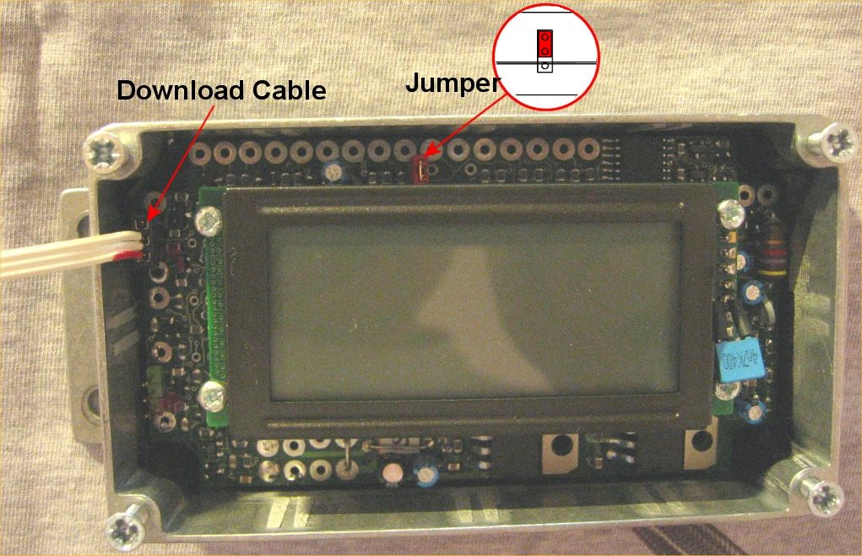
- The new software SIxO.mot.

The download cable is a special serial cable designed for the SIxO. On one end there is a SubD connector which connects to the COM port of a personal computer. On the other end there is a standard 3 pin header which connects to the SIxO.

A Jumper is a small electronic component. Its just an electrical bridge used to short two electrical contacts like a switch. This tells the SIxO to go into download mode. There is a 3 pin header inside the SIxO above the display. If the jumper is plugged onto the outer two contacts near the edge of the board the SIxO is in download mode.

The SIxO must be connected to a power supply. The easiest way is to leave it where it is: on the motorbike. There is no need to disconnect anything.
Otherwise refer to the pinning of the SIxO SubD connector at the end of the cable coming out of the case. Connect +12V from a benchtop power supply to the right pins. No other connections are required.

1. Write down settings like the wheel size.
Set jumper to download position (outer two pins).
Connect download cable to SIxO. Align the red markers of the cable and the the board.
Connect download cable to COM1 of a personal computer.
Turn on SIxO.
Turn on PC and start Windows 98.

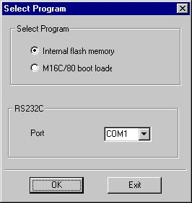
2. Start flashsta.exe.
Select internal flash memory and COM1.
Click OK.
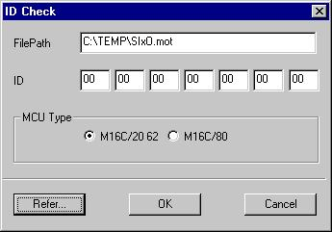
3. Enter the path to the software
Enter the ID if needed.
Select M16C/20 62
Click OK.
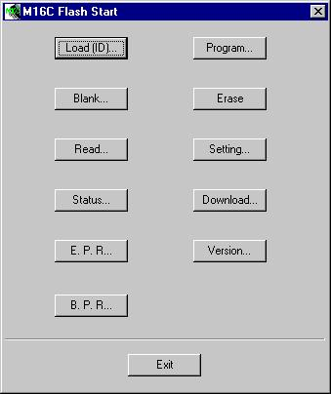
4. The main screen opens.

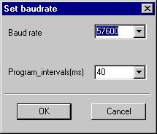
5. Click Setting
Select 57600 Baud and 40ms
Click OK
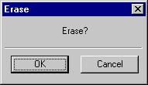
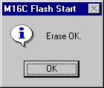
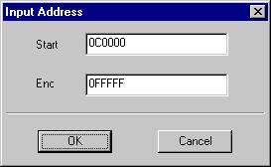
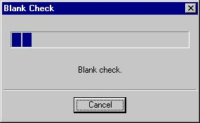
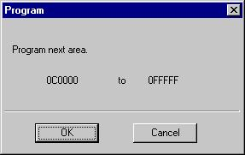
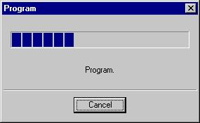
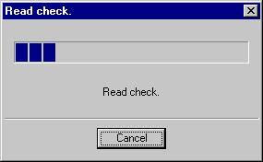
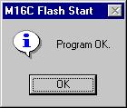
6. Click Erase on the main screen.
Confirm with OK.
7. Click B.P.R. on the main screen
Confirm with OK.
8. Click OK.

10. Turn off power.
Detach download cable.
Set jumper to the normal position or remove jumper completely.

9. Click OK and then Exit on the main screen

11. Turn on power.
Check if the new Software is working and if the settings like the wheelsize are still correct. If not enter them.
12. Enjoy :-)

