Connecting the SIxO to the Motorbike

Standard Connector for DC

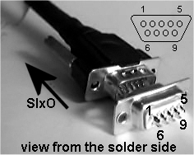
The SixO is connected to the motorbike via a Sub-D connector with 9 pins: plug/male at the SIxO, jack/female at the bike. The pinning is given in the picture on the left. Usually there are also pin numbers printed on the connectors.

Pin Number | Function | Connect to
1 | engine speed (RPM) | primary side ignition coil
2 | power supply | +12V (batterie plus)
3 | button Up | key Up
4 | button Down | key Down
5 | button Reset/Enter | key Reset/Enter
6 | power supply and ground return | ground (batterie minus)
7 | speed and distance | wheel contact
8 | internaly connected to GPIO0 | no connection
9 | internaly connected to GPIO1 | no connection

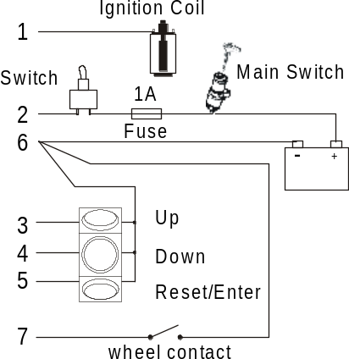
Typically there are two tabs at the primary side of an ignition coil. One is fixed to +12V or ground. The SIxO is connected to the other one that is driven for every ignition. If you are not sure which one to use just try it out. Connecting the wrong tab to the SIxO does not do any damage.

A 1A fuse in the power supply to the SIxO is a good idea. The switch is optional but you may want to turn off the SIxO even with the main switch on.

