SIxO Operation Manual

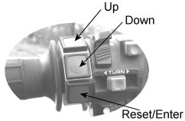
General Concept

The SixO is operated with only three buttons. These buttons perform several functions dependent on the context you are in. In general the topmost button moves or counts up, the middle button moves or counts down and the button at the bottom resets or enters a value. Two Buttons may be pressed simultaneously to perform special functions. The SixO also distinguishes between short and long keystrokes. The recognition of a long keystroke is visually confimed by a LED flash.

Switching between Screens

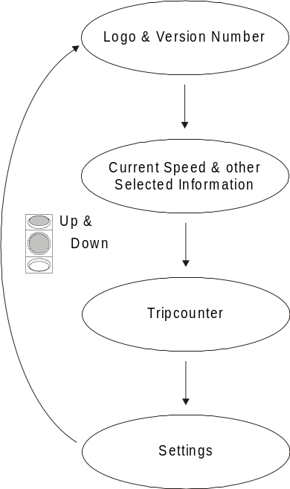
Pressing Up and Down simultaneously switches cyclicly through the different screens.
At power up the last screen you have been in is displayed.



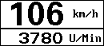
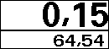

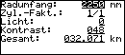

Logo and Version Number

This screen displays the SixO logo and information about your specific SIxO model. You will find the software version number in the lower right corner. When asking for support have this information ready.

Current Speed and other Selected Information
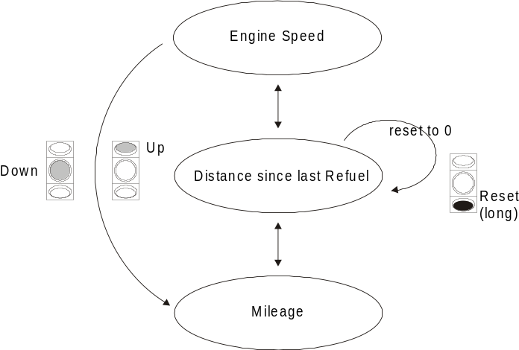
The screen displays the current speed in the bigger top area. The Information displayed in the lower area can be selected by pressing the movement keys.

The distance since last refuel is reset to 0 by a long keystroke on the Reset button.

The mileage is preset in the settings screen.

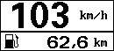

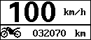

Tripcounter

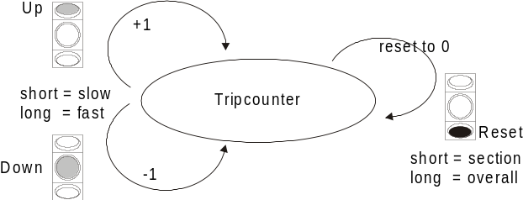
This is a distance counter especially designed for roadbook tours. It displays the section counter in the bigger top area and the overall distance in the lower area.

A short stroke on the Reset button resets the section to 0.
A long stroke on the Reset button resets the overall distance to 0.

Additionally the overall distance can be altered by pressing Up or Down. A short stroke increases or decreases the least significiant digit. Holding down the button alters the counter continually with increasing speed.

Settings

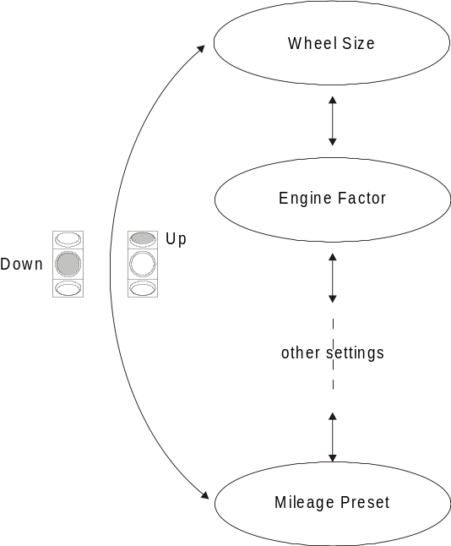
The settings screen allows to configure your SIxO and adapt it to your motorbike. Up/Down moves between entries. Enter selects the editing mode for the current entry. A value is altered one digit at a time. When in editing mode Enter cyclicly moves from digit to digit and Up/Down alters it. A long stroke on the Enter button leaves the editing mode and saves the whole value. The recognition of a long keystroke is visually confimed by a LED flash.
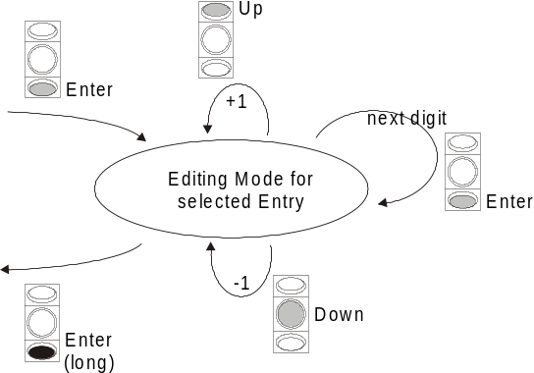

Radumfang (Wheel Size)

The wheel size (circumference) is entered in mm. Place a mark on the wheel and a corrsponding mark on the ground where the wheel touches the ground. Move your motorbike forward until the mark again touches the ground. Measure the distance between the two marks. This is your wheel size. You can measure more than one wheel turn to increase accuracy.
Check that the correct speed is displayed when driving. With a wrong wheel size a wrong speed is displayed!

Zylinder Factor (Engine Factor)
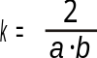
To calculate the revolutions per minute the SIxO needs to know what type of engine is present. The engine factor k is given as a nominator/ denominator pair. It is more clear if k is expressed by other, more descriptive variables:

a is the number of cylinders driven by one ignition coil and
b is the number of sparks per 2 revolutions (1 or 2).

Examples: The Husqvarna or Husaberg 4 stroke engine has one cylinder driven by one ignition
coil, so a = 1.
On 2 revolutions there are 2 sparks (one of the sparks does not lead to ignition). So
b = 2.
Altogether k = 1 and therefore can be expressed by nominator/dominator = 1/1.
(You may enter nominator/dominator = 2/2. It has the same effect)

The Transalp has two cylinders. Each cylinder is driven by its own ignition coil. Therefore a = 1.
The Transalp also simply generates 2 sparks on 2 revolutions. So b = 2.
Again we end up with k = 1.

A Volkswagen T4 has a 5-cylinder engine. These 5 cylinders are driven by one igniton
coil: a = 5.
Theres only one spark on 2 revolutions.
So b = 1 and k = 2/5 = nominator/denominator.

You know your number of cylinders for sure and if you do not know the number of coils you can look it up. However the number of sparks is not obvious. Since there are only two possibilities and the engine speed changes by a factor of two with b = 1 or 2 you simply can try it out. If yor engine speed is much too high or much too low try to alter b.

Licht (Backlight)
Turns the Backlight on (1) or off (0). Remember to turn it off at daylight for prolonged backlight live.

Kontrast
Changes the contrast of the display. Valid values are 0..199. Higher values = more contrast.
The contrast of the SIxO is temperature compensated. Once set to a certain level the display contrast should only change under extreme temperatures.

Mileage Preset
Here you can preset the mileage of your motorbike. The mileage is displayed on the second screen together with the current speed if selected.

