Controller Platinen

Panda Board
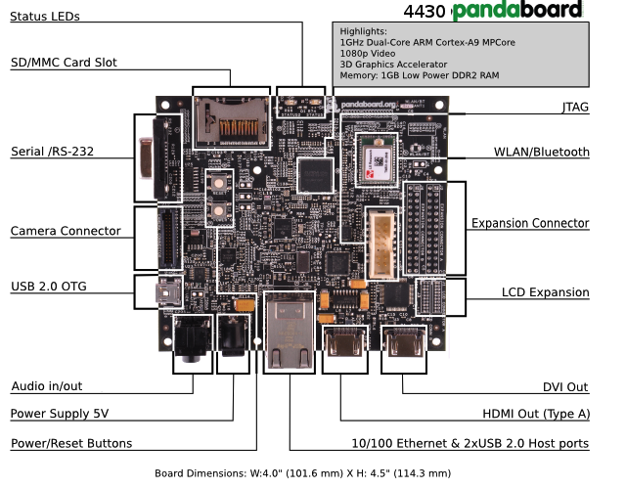
http://pandaboard.org/sites/default/files/board_setup_v3.png

I2C-Bus:
J3 Pin 23 und J3 Pin 24

SPI-Bus:
J3 diverse Pins

ADC:
<nicht verfügbar ?>

IO:
<nicht verfügbar ?>

Extension Connector:
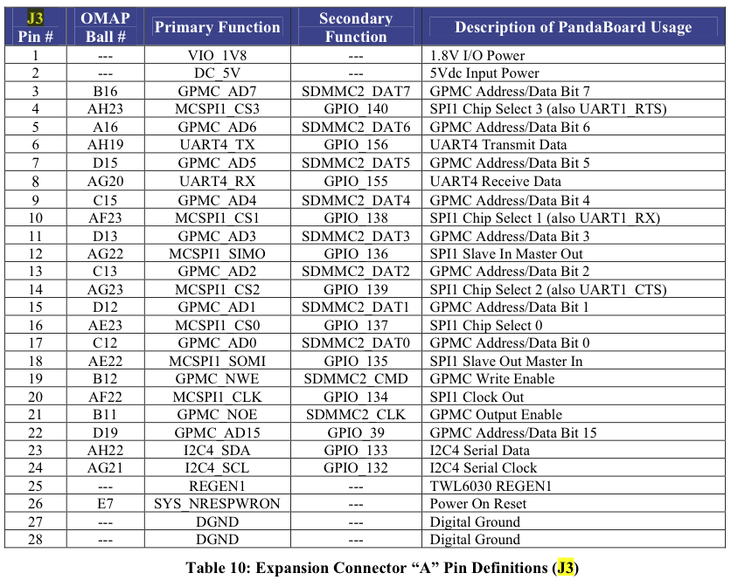
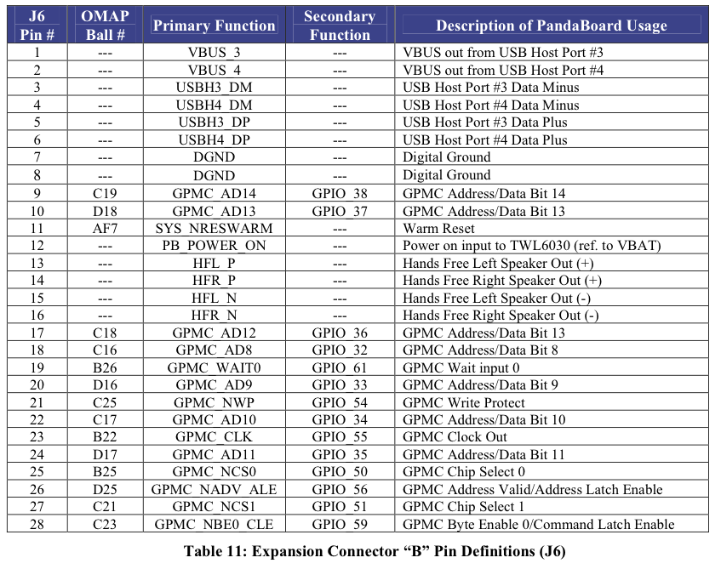
Friendly ARM Mini 2440

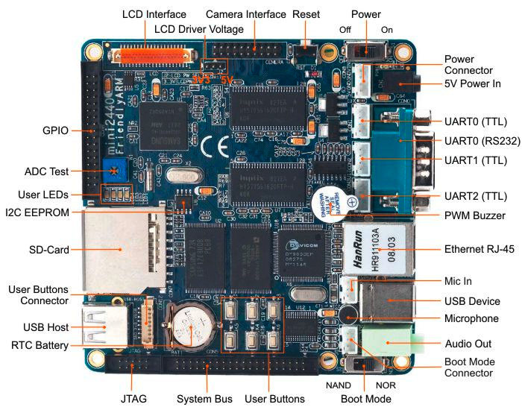
http://www.friendlyarm.net/sites/products/mini2440_3.jpg

http://elk.informatik.fh-augsburg.de/pub/elinux-abgaben/ss11/Schwarz/Studienarbeit_final/studienarbeit.html

http://www.mikrocontroller.net/articles/Micro2440#Connector_.2F_GPIO_Belegung

Quellcode siehe: /Users/min/Develop/Heizungsregelung/linux-2.6.32.2
→ http://open-nandra.com/2010/09/friendly-arm-2440-and-sca3000-accelerometer/

I2C-Bus:
GPIO: Pin 29 und Pin 30

SPI-Bus: → http://www.friendlyarm.net/forum/topic/2456
GPIO: Pin 25 bis Pin 28

ADC:
GPIO: 8x 10Bit, allerdings Touchscreen belegt schon 4 Kanäle, Pin 5-8

IO:
GPIO: 8x Pin 9 ff.

GPIO

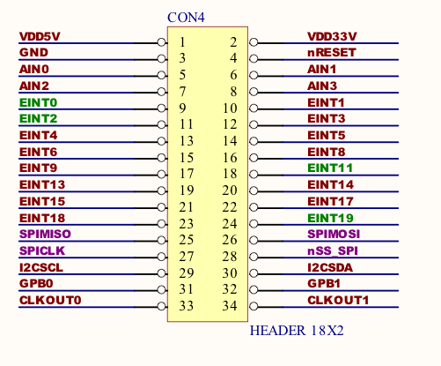

Raspberry Pi
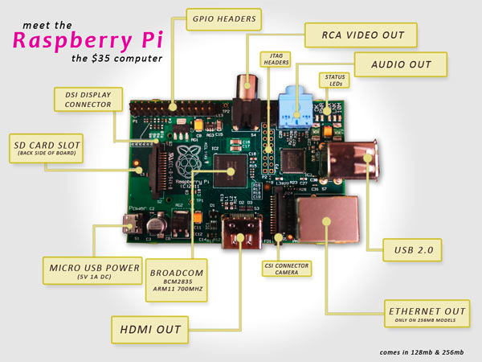
sPin 1

http://cdn01.androidauthority.com/wp-content/uploads/2012/10/raspberrypi.jpg

http://elinux.org/RPi_Low-level_peripherals

http://www.amazon.de/dp/3868994106/ref=asc_df_386899410611280948?smid=A3JWKAKR8XB7XF&tag=hydra0d-21&linkCode=asn&creative=22494&creativeASIN=3868994106&hvpos=1o2&hvexid=&hvnetw=g&hvrand=2869201011132470666&hvpone=&hvptwo=&hvqmt=

http://elinux.org/RPi_BCM2835_GPIOs

I2C-Bus:
GPIO: siehe Pinbelegung

SPI-Bus:
GPIO: siehe Pinbelegung

ADC:
<nicht verfügbar>

IO:
GPIO: 8x siehe Pinbelegung

UART:
GPIO: siehe Pinbelegung
GPIO
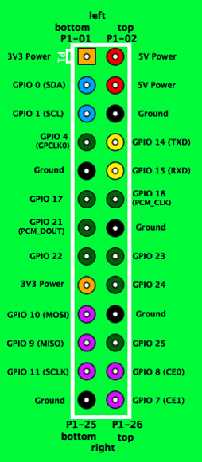
http://elinux.org/File:GPIOs.png

http://www.raspberrypi-spy.co.uk/2012/06/simple-guide-to-the-rpi-gpio-header-and-pins/

http://lavalink.com/wp-content/uploads/2012/04/raspberry-pi-serial_sm.jpg

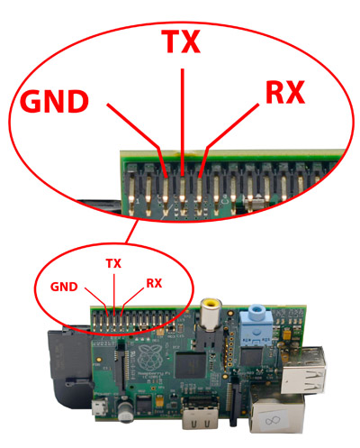
Header Pinout, top row:
Pin Number | Pin Name Rev1 | Pin Name Rev2 | Hardware Notes | Alt 0 Function | Other Alternative Functions
P1-02 | 5V0 | 5V0 | Supply through input poly fuse
P1-04 | 5V0 | 5V0 | Supply through input poly fuse
P1-06 | GND | GND
P1-08 | GPIO 14 | GPIO 14 | Boot to Alt 0 -> | UART0_TXD | ALT5 = UART1_TXD
P1-10 | GPIO 15 | GPIO 15 | Boot to Alt 0 -> | UART0_RXD | ALT5 = UART1_RXD
P1-12 | GPIO 18 | GPIO 18 |  |  | ALT4 SPI1_CE0_N ALT5 = PWM0
P1-14 | GND | GND
P1-16 | GPIO23 | GPIO23 |  |  | ALT3 = SD1_CMD ALT4 = ARM_RTCK
P1-18 | GPIO24 | GPIO24 |  |  | ALT3 = SD1_DATA0 ALT4 = ARM_TDO
P1-20 | GND | GND
P1-22 | GPIO25 | GPIO25 |  |  | ALT4 = ARM_TCK
P1-24 | GPIO08 | GPIO08 |  | SPI0_CE0_N
P1-26 | GPIO07 | GPIO07 |  | SPI0_CE1_N
Header Pinout, bottom row:
Pin Number | Pin Name Rev1 | Pin Name Rev2 | Hardware Notes | Alt 0 Function | Other Alternative Functions
P1-01 | 3.3 V | 3.3 V | 50 mA max (01 & 17)
P1-03 | GPIO 0 | GPIO 2 | 1K8 pull up resistor | I2C0_SDA | I2C0_SDA / I2C1_SDA
P1-05 | GPIO 1 | GPIO 3 | 1K8 pull up resistor | I2C0_SCL | I2C0_SCL / I2C1_SCL
P1-07 | GPIO 4 | GPIO 4 |  |  | GPCLK0
P1-09 | GND | GND
P1-11 | GPIO17 | GPIO17 |  |  | ALT3 = UART0_RTS, ALT5 = UART1_RTS
P1-13 | GPIO21 | GPIO27 |  | PCM_DIN | ALT5 = GPCLK1
P1-15 | GPIO22 | GPIO22 |  |  | ALT3 = SD1_CLK ALT4 = ARM_TRST
P1-17 | 3.3 V | 3.3 V | 50 mA max (01 & 17)
P1-19 | GPIO10 | GPIO10 |  | SPI0_MOSI
P1-21 | GPIO9 | GPIO9 |  | SPI0_MISO
P1-23 | GPIO11 | GPIO11 |  | SPI0_SCLK
P1-25 | GND | GND

Colour legend
+5 V
+3.3 V
Ground, 0V
UART
GPIO
SPI
I²C

