Understanding probability
Table of Contents

Understanding probability
Let’s roll a die…
sample(x = 1:6, size = 5, replace = FALSE)
## [1] 6 3 1 5 2
sample(x = 1:6, size = 20, replace = TRUE)
## [1] 1 2 6 1 4 3 2 6 6 1 5 2 1 2 5 1 6 6 1 1
sample(x = 1:6, size = 20, replace = TRUE) # you get different numbers
## [1] 2 2 2 2 5 3 4 6 4 2 6 1 3 5 5 6 5 5 4 5
sample(x = 1:6, size = 20, replace = TRUE) # again
## [1] 4 4 5 2 2 4 2 3 1 6 1 3 2 6 3 6 6 2 3 5
How often do you get a 6?
RollDie <- function(n) sample(1:6, n, replace = TRUE)
d1 <- RollDie(n = 50)
sum(d1 == 6)
## [1] 10
sum(d1 == 6)/50
## [1] 0.2
We can plot a relative histogram using:
hist(d1)
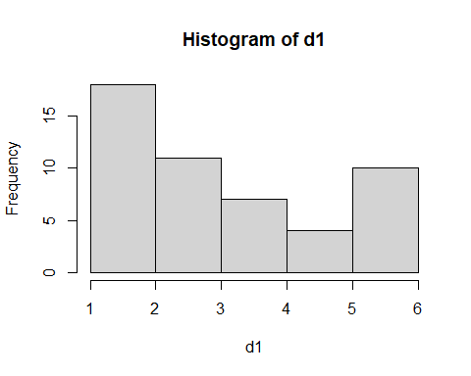
hist(d1, probability = TRUE, breaks = seq(0.5,6.5,1))
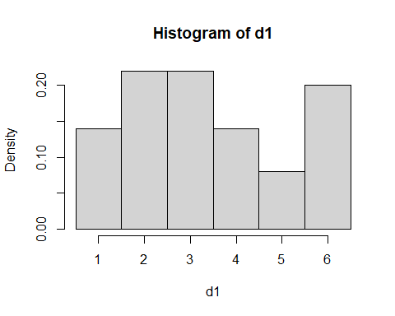
Let’s simulate 500 rolls:
sims <- vector("list", 500)
probs <- vector("numeric", 500)
for (n in 1:500) {
sims[[n]] <- RollDie(n)
probs[n] <- sum(sims[[n]] == 6)/n
}
plot(probs)
abline(h=1/6)
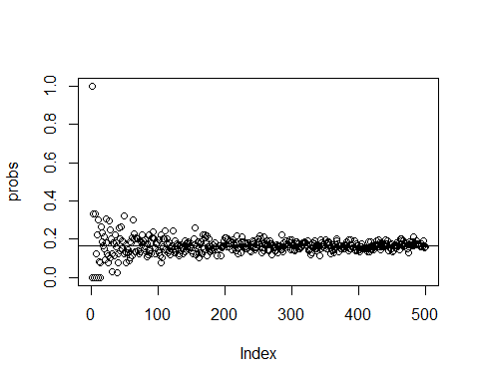
Please remember that our definition of probability is ‘long-run relative frequency’.
If we repeat an experiment (like flipping a coin or rolling a dice) a large number of times and tabulate the outcomes, the relative frequencies will ‘converge’ to the probabilities of each outcome.
This is the basic principles of Monte Carlo Simulations - Monte Carlo Simulation means using a computer to repeatedly carry out a random experiment and keeping track of the outcomes. That’s what we just did!! (http://ditraglia.com/Econ103Public/Rtutorials/Rtutorial4.html#introduction)
The probability of obtaining a 6 is a marginal probability. “The interesting thing about a marginal probability is that the term sounds complicated, but it’s actually the probability that we are most familiar with. Basically anytime you are in interested in a single event irrespective of any other event (i.e. “marginalizing the other event”), then it is a marginal probability. For instance, the probability of a coin flip giving a head is considered a marginal probability because we aren’t considering any other events.” (http://tinyheero.github.io/2016/03/20/basic-prob.html)
sample(x=c("testa","croce"), size = 5, replace = TRUE)
## [1] "croce" "croce" "croce" "testa" "testa"
E.g. what is the probability of capturing an adult snow vole?
Now we can roll two dice:
sample(1:6, size = 1, replace = TRUE)
## [1] 5
sample(1:6, size = 1, replace = TRUE)
## [1] 3
How often do we get the same number if we roll 2 dice?
roll1 = NULL #This initializes our variable - i.e. it creates a spot in memory for it. We need to do this for any vector, table, matrix, dataframe, but not for single numbers
roll2 = NULL
for (i in 1:100) {
roll1[i] = RollDie(1)
roll2[i] = RollDie(1)
}
# We can ask how many doubles we came up with:
sum(roll1 == roll2)
## [1] 16
# relative frequency
sum(roll1 == roll2)/100
## [1] 0.16
roll1 <- vector("list", 500)
roll2 <- vector("list", 500)
probs <- vector("numeric", 500)
for (n in 1:500) {
roll1[[n]] <- RollDie(n)
roll2[[n]] <- RollDie(n)
probs[n] <- sum(roll1[[n]] == roll2[[n]])/n
}
plot(probs)
abline(h=1/6)
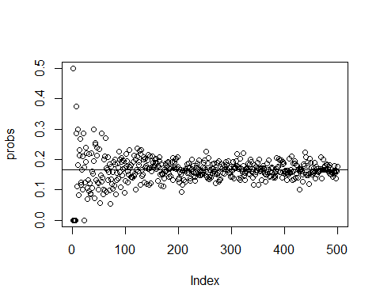
Now we can ask for the sum of the two rolls:
n = 500
roll1 = NULL #This initializes our variable - i.e. it creates a spot in memory for it. We need to do this for any vector, table, matrix, dataframe, but not for single numbers
roll2 = NULL
for (i in 1:n) {
roll1[i] = RollDie(1)
roll2[i] = RollDie(1)
}
hist((roll1 + roll2), density = 100, breaks = 1:12, prob = T)
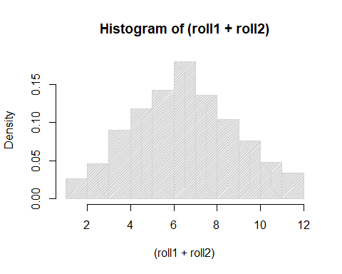
barplot(table(roll1 + roll2), main = "2 Dice Sum, 100 Rolls") #this works better for this case
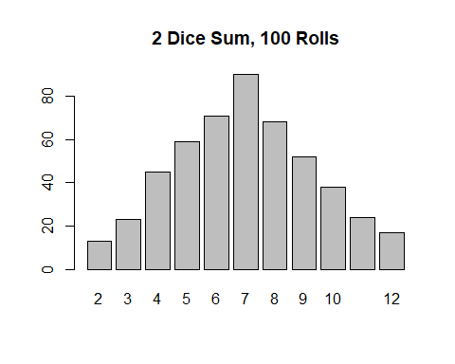
rolls <- roll1 + roll2
sum(rolls == 7)
## [1] 90
sum(rolls == 7)/n
## [1] 0.18

Joint probability
Joint probability: probability of the joint occurrence of two independent events. i.e., the probability of two different events occurring at the same time. If two events (A and B) are independent, then P(A and B) = P(A) * P(B).
Again, we roll 2 dice.
How often do we get a 6 in both rolls?
n = 1500
roll1 = NULL #This initializes our variable - i.e. it creates a spot in memory for it. We need to do this for any vector, table, matrix, dataframe, but not for single numbers
roll2 = NULL
for (i in 1:n) {
roll1[i] = RollDie(1)
roll2[i] = RollDie(1)
}
# We can ask how many times this happen:
sum(roll1 == 6 & roll2 == 6)
## [1] 43
# the relative frequency is:
sum(roll1 == 6 & roll2 == 6)/n
## [1] 0.02866667
Repeat the previous code, changing n (50, 100, 200, 500). Find the relative frequencies.
Compare with:
(1/6)*(1/6)
## [1] 0.02777778
E.g. you caught a snow vole: what is the probability that it is an adult and that it is female? The joint probability can be calculated by taking the proportion of times a specific combination of age and sex occurs, divided by the total number of age-sex classes combinations (but see below for this specific example - joint distribution of conditionally dependent variables).

Mutually exclusive events
If two events (A and B) are mutually exclusive, then P(A and B) = P(A) + P(B).
When you roll a die, you can roll a 5 OR a 6 (the odds are 1 out of 6 for each event) and the sum of either event happening is the sum of both probabilities:
P(rolling a 5 or rolling a 6) = P(rolling a 5) + P(rolling a 6)
P(rolling a 5 or rolling a 6) = 1/6 + 1/6 = 2/6 = 1/3.
Think about the previous example of rolling 2 dice. We asked how many times we got the same number from them:
P(rolling a 1 and rolling a 1) = 1/6 * 1/6 = 0.02777778
P(rolling a 2 and rolling a 2) = 1/6 * 1/6 = 0.02777778
P(rolling a 3 and rolling a 3) = 1/6 * 1/6 = 0.02777778
P(rolling a 4 and rolling a 4) = 1/6 * 1/6 = 0.02777778
P(rolling a 5 and rolling a 5) = 1/6 * 1/6 = 0.02777778
P(rolling a 6 and rolling a 6) = 1/6 * 1/6 = 0.02777778
These events are mutually exclusive, we can not get 1 in both rolls and 2 in both rolls. Try to sum up these probabilities:
0.02777778+0.02777778+0.02777778+0.02777778+0.02777778+0.02777778
## [1] 0.1666667
# or
0.02777778*6
## [1] 0.1666667

Conditional probability
A conditional probability is the probability of an event X occurring when a secondary event Y is true. Mathematically, it is represented as P(X | Y). This is read as “probability of X given/conditioned on Y”.

Think about biological data…
http://tinyheero.github.io/2016/03/20/basic-prob.html
What is the probability of capturing an adult snow vole? (marginal)
What is the probability of capturing a female snow vole? (marginal)
What is the probability of capturing a female adult snow vole? (joint)
What is the probability of capturing a female, given that it is an adult? (conditional)
y <- read.csv("data/captures.csv",sep=";")
y <- na.omit(y[,c("age", "sex")])
The marginal probability of capturing an adult snow vole is:
library(dplyr)
##
## Caricamento pacchetto: 'dplyr'
## I seguenti oggetti sono mascherati da 'package:stats':
##
## filter, lag
## I seguenti oggetti sono mascherati da 'package:base':
##
## intersect, setdiff, setequal, union
age.marginal.df <-
y %>%
group_by(age) %>%
summarise(n = n()) %>%
ungroup() %>%
mutate(prop = n/sum(n))
age.marginal.df
## # A tibble: 2 × 3
## age n prop
## <chr> <int> <dbl>
## 1 A 79 0.849
## 2 G 14 0.151
And the probability of capturing a female snow vole is:
sex.marginal.df <-
y %>%
group_by(sex) %>%
summarise(n = n()) %>%
ungroup() %>%
mutate(prop = n/sum(n))
sex.marginal.df
## # A tibble: 2 × 3
## sex n prop
## <chr> <int> <dbl>
## 1 F 33 0.355
## 2 M 60 0.645
Joint probabilities can be calculated by taking the proportion of times a specific sex-age combination occurs, divided by total number of all sex-age combinations (i.e. frequency):
joint.df <-
y %>%
group_by(age, sex) %>%
summarise(n = n()) %>%
ungroup() %>%
mutate(prop = n/sum(n))
## `summarise()` has regrouped the output.
## ℹ Summaries were computed grouped by age and sex.
## ℹ Output is grouped by age.
## ℹ Use `summarise(.groups = "drop_last")` to silence this message.
## ℹ Use `summarise(.by = c(age, sex))` for per-operation grouping
## (`?dplyr::dplyr_by`) instead.
joint.df
## # A tibble: 4 × 4
## age sex n prop
## <chr> <chr> <int> <dbl>
## 1 A F 32 0.344
## 2 A M 47 0.505
## 3 G F 1 0.0108
## 4 G M 13 0.140
What is the probability of capturing a female, given that it is an adult? (conditional)
joint.prob <-
joint.df %>%
filter(age == "A", sex == "F") %>%
.$prop
joint.prob
## [1] 0.344086
marg.prob <-
age.marginal.df %>%
filter(age == "A") %>%
.$prop
marg.prob
## [1] 0.8494624
cond.prob <- joint.prob/marg.prob
cond.prob
## [1] 0.4050633
i.e. 32 adult females out of a total of 79 adults.
Please note that if variables are not conditionally independent, their joint distribution is not equal to P(A)P(B), but rather by P(B)P(A | B). Check this by multiplying the conditional probability obtained here by the marginal probability of being an adult (B). Compare with the joint.df table.

