Snow Vole Captures - ggplot2
Table of Contents

Dataset: Snow Vole Captures (Chionomys nivalis)
captures <- read.csv("data/captures.csv", sep=";")
library("ggplot2")
Objective: Use the ggplot2 package to explore the morphological traits and population structure of the snow vole.
Task 1: Weight vs. Foot Length (Scatter Plot). Investigate if heavier individuals have longer feet.
t1 = ggplot(captures, aes(x = weight_g, y = footlength_mm, color = sex)) + geom_point(na.rm = TRUE) + geom_smooth(se=FALSE, method = "lm", na.rm = TRUE) + ggtitle("Relationship Between Weight and Foot Length") + xlab("Weight [g]") + ylab("Foot Length [mm]")
ggsave("output/weight_footlength_scatter.png", t1)
## Saving 5 x 4 in image
## `geom_smooth()` using formula = 'y ~ x'
t1
## `geom_smooth()` using formula = 'y ~ x'
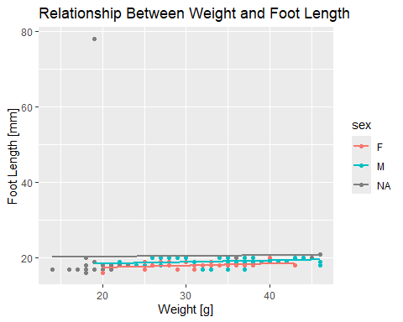
The data shows no positive relationship between the foot length and the weight of the captured Snow Voles, this goes for males and females both.
Task 2: Weight Distribution (Histogram). Analyze how weight is distributed across the population.
t2 = ggplot(captures, aes(x = weight_g)) + geom_histogram(na.rm = TRUE, binwidth = 2) + facet_wrap("session", scale = "free_y") + ggtitle("Weight Distribution In Each Capture Session") + xlab("Weight [g]") + ylab("Frequency")
ggsave("output/weight_hist.png", t2)
## Saving 5 x 4 in image
t2
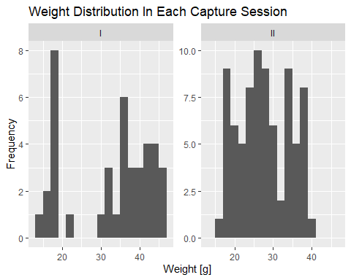
Task 3: Comparing Sex and Age (Boxplot). Check for sexual dimorphism or differences between adults and juveniles.
t3 = ggplot(captures, aes(x = age, y = weight_g, fill = sex)) + geom_boxplot(na.rm = TRUE) + ggtitle("Sexual Dimorphism Across Age Groups") + xlab("Age") + ylab("Weight [g]")
ggsave("output/weight_age_box.png", t3)
## Saving 5 x 4 in image
t3
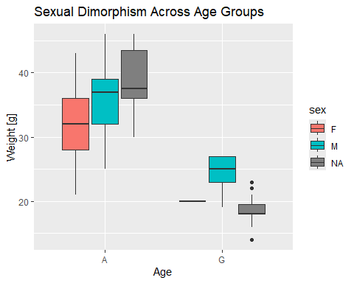
The heaviest group is the one for adult males. Some outliers in the juvenile group, also interesting the fact that there’s only one confirmed juvenile female captured.

