SWE20001 – Development Project 1: Tools and Practices

Pass Task <2.1P>

Duy Phuong Nguyen (101204984)

Lab: Friday 2:30pm

Tutor: Huai Liu

Team number: 3

Henry Tran 102075482

Edward Knight 102700043

Duy Phuong Nguyen 101204984

Christian Ilott 102169762

This report summarises my contributions to the teamwork in Week <2> as well as the tasks I have performed during this week:

**Activity 2.1. Team formation and To Do process:**

During this team activity, I have done the following to contribute to the To Do process our team carried out:

* First, sign up and install Git to my computer
* Then setup the git by checking version, input username and email address

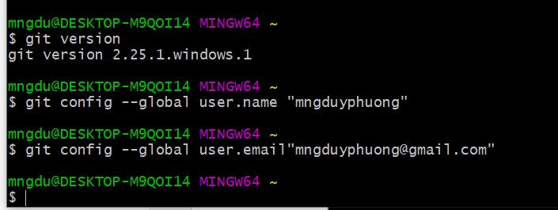

* Our team had a little discussion and assigned roles for everyone:
  + The team’s leader is Edward Knight
  + UI Coder is Henry Tran
  + Game Developer 1 is Duy Phuong Nguyen
  + Game Developer 2 is Christian Ilot
* The team’s leader added me to the project so I can see the QuickSnap repo

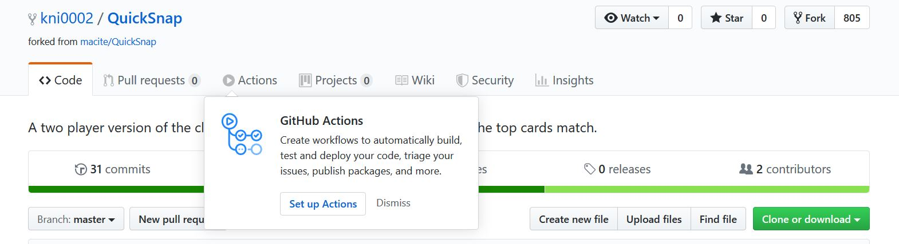

* Added the HTTPS clone url form GitHub to my terminal

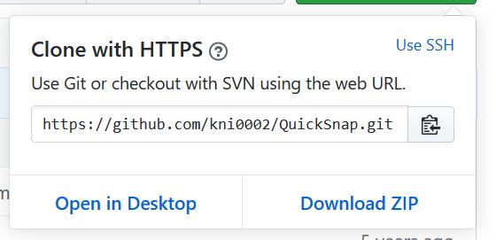

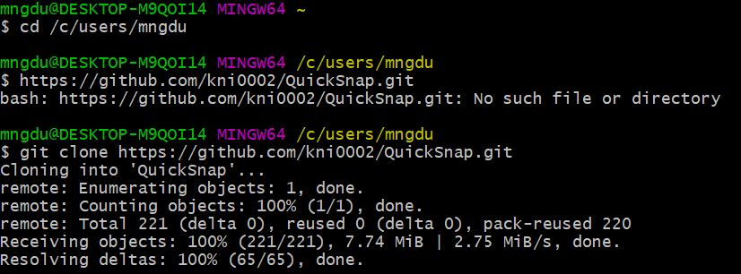

* Testing the project and trying to run the game

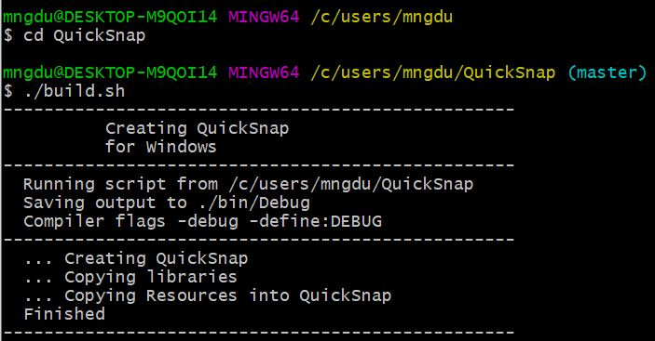

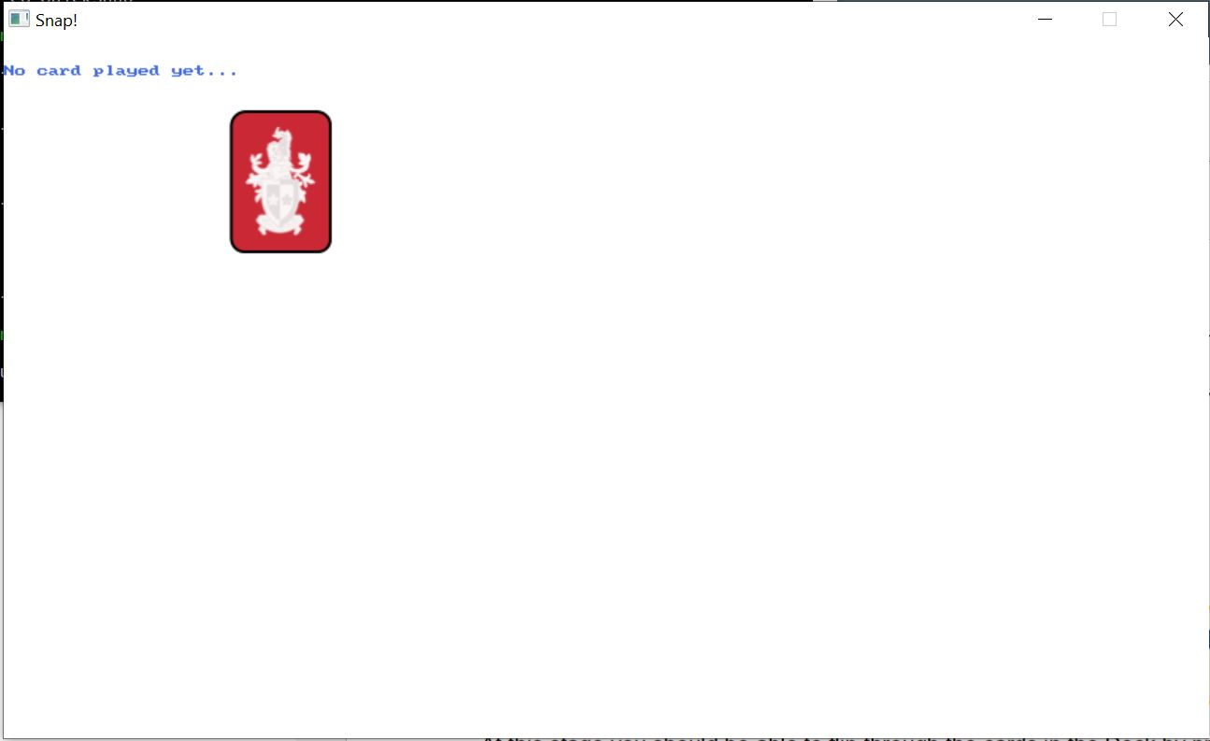

* I started to work on my own part: Improving the game with auto-flipping cards. The first step is creating a new branch and name it add-automatic-card-flip

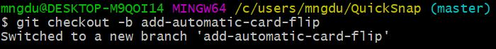

* Create Game Timer in Snap.cs file

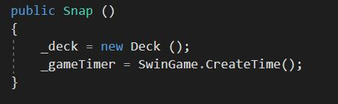

* Update Start method

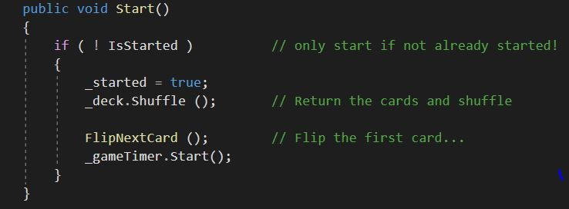

* Set up the Update method to check the time

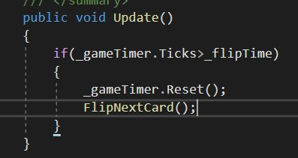

* Update HandleUserInput method in SnapGame.cs so user can press spacebar to start the game

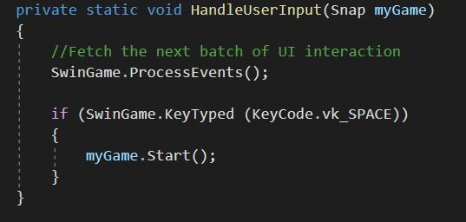

* Update PlayerHit method

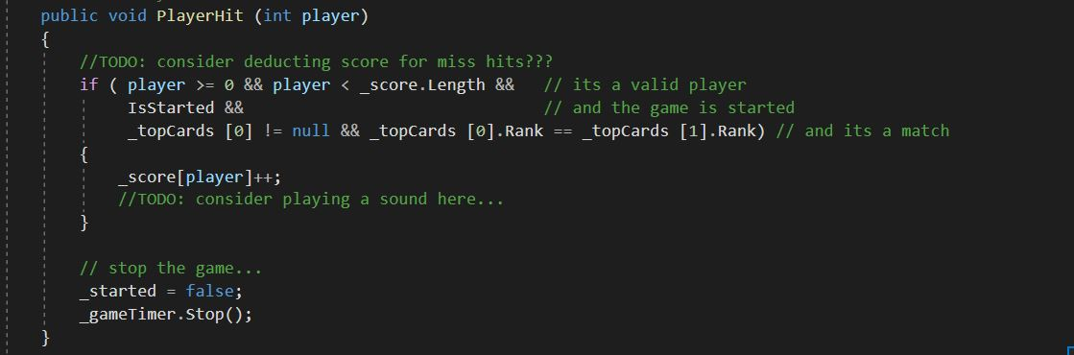

* All of my works then push to the sever by using the command in Git

git push -u origin add-automatic-card-flip

Below is the proof of my contributions and Network demonstration

* The middle user is me with a purple profile picture

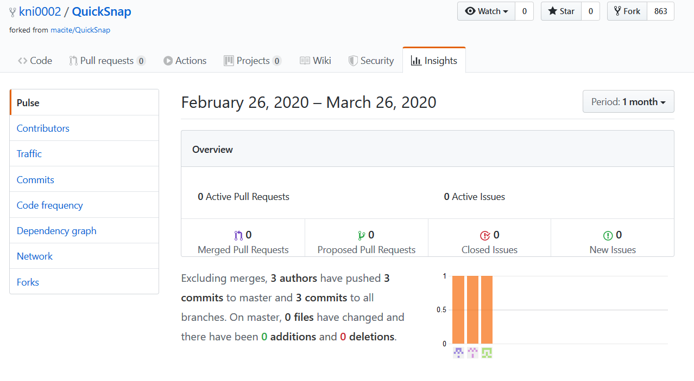

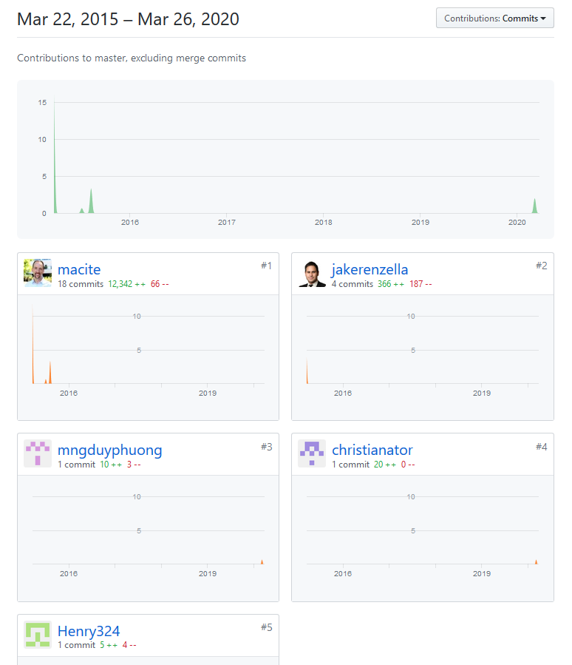

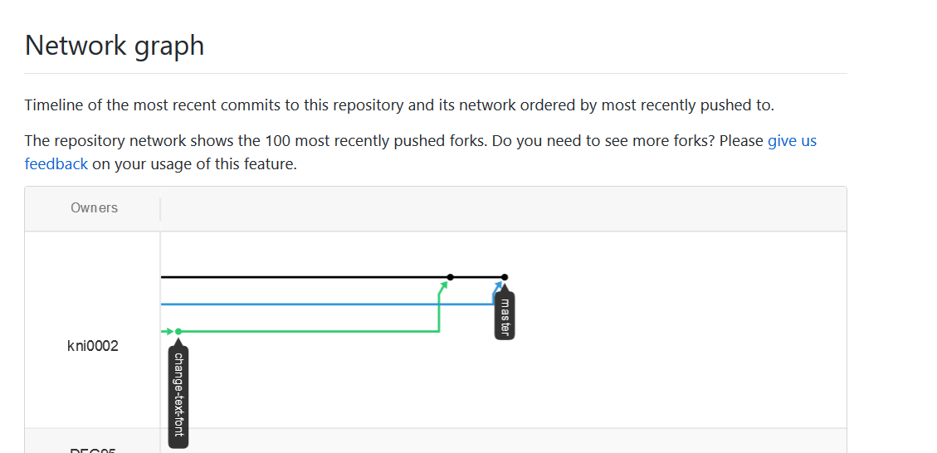

|  |  |  |
| --- | --- | --- |
| Command | Description | Screenshot |
| git –version | Check the current version of gitbash |  |
| git config -global user.name  git config –global user.email | Setup Git username and email |  |
| git clone /path/…/… | Clone the file from GitHub online sever to local computer |  |
| git checkout -b <name> | Create a new branch |  |
| ./build.sh  ./run.sh | Build and run the project |  |
| git status  git diff | Check the status and differences |  |
| Git push -u origin <name> | Push your changes to the sever |  |

Diagram of the process

