SWE20001 – Development Project 1: Tools and Practices

Credit Task <2.2>

Duy Phuong Nguyen (101204984)

Lab: Friday 2:30pm

Tutor: Huai Liu

Team number: 3

Henry Tran 102075482

Edward Knight 102700043

Duy Phuong Nguyen 101204984

Christian Ilott 102169762

**Merge Conflict**

1. **What is merge conflict? How can it occur??**

Version control system is a great tool for project development because different people can work in the same project. The system will control changes and managing the changes from different contributors. However, conflict will happen when two people are trying to modify the same line in same file

Merge conflict causes fails to start the merge and Git fails during the merge. Git cannot recognise what is wrong what is correct in that situation and it will affect the people who are trying to conduct the merge. Git will mark the conflict and we need to solve it before merging the pull request.

**For example/ Demo:**

Master create a new file called: merge.txt

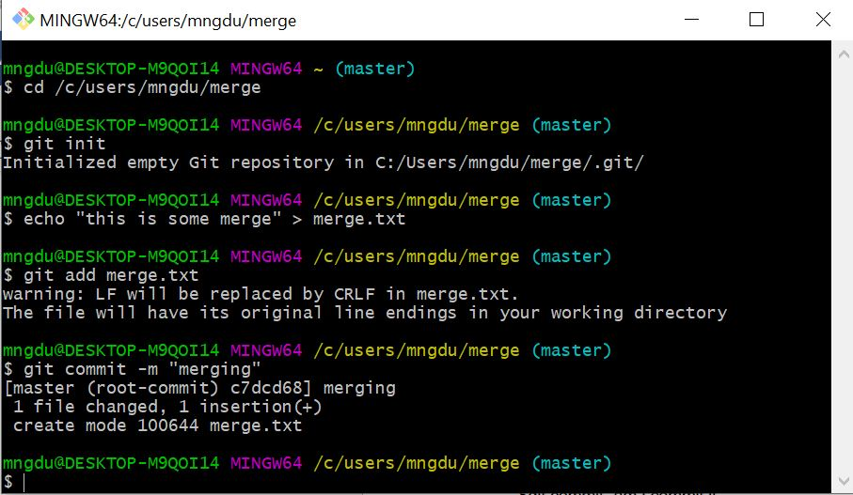

Then another developer trying to edit something in this file

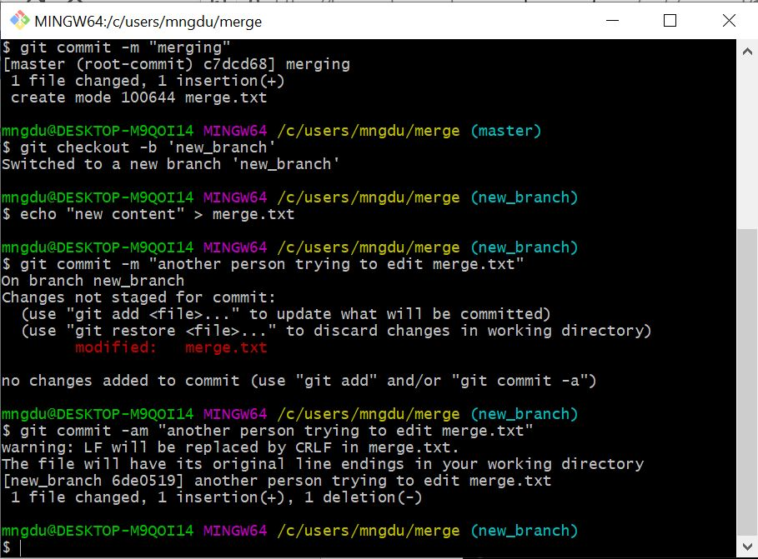

We switch back to master and edit the same file. The system will tell you there is a conflict in content.

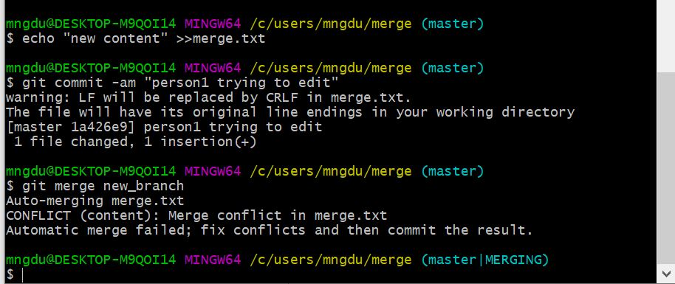

When we trying to merge the file, system will pop-up message and can’t merge until we solve the problem.

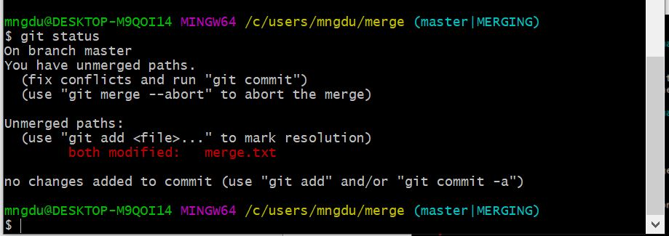

1. **How to solve merge conflict**

There are two way you can solve the conflict: edit the file or using the command line to delete the one branch with few lines of coding.

1. Editing the file which causes the conflict

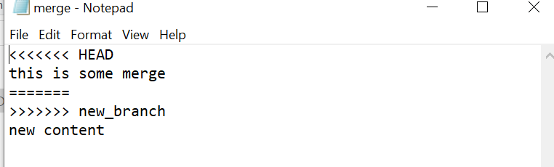

When you delete new_branch content, Git will allow you to merge

1. Deleting the file that another person is working on

This method maybe causes some problem to another person because we have to decide which one to delete.

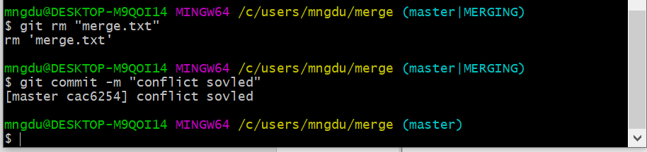

1. **What should not be done and why**

We should not let another person working on the same file while they don’t know where their part is. It causes conflict and make loss in the file.

Each team member should not work without reminding others because it make the situation becomes complicated when they have to delete a file which others just uploaded