SWE20001 – Development Project 1: Tools and Practices

Pass Task <4.1>

Duy Phuong Nguyen (101204984)

Lab: Friday 2:30pm

Tutor: Huai Liu

Team number: 3

Henry Tran 102075482

Edward Knight 102700043

Duy Phuong Nguyen 101204984

Christian Ilott 102169762

This report summarises my contributions to the teamwork in Week <4> as well as the tasks I have performed during this week:

1. **Task decisions**

In this week, one of our team members didn’t show up so each of us had to do more works. There are 8 tasks in total so me and Edward got 3 tasks each and Henry, who is the team leader got 2 tasks

* D2: Which team member will create Toggl team project and invite other member (using email address)?
* D3: Which team member is responsible for adding the VB.Net code base to the project GitHub?
* D5: Which team member is responsible for researching a suitable coding standard to be used for this project?

1. **Create Toogl team project and invite other member**

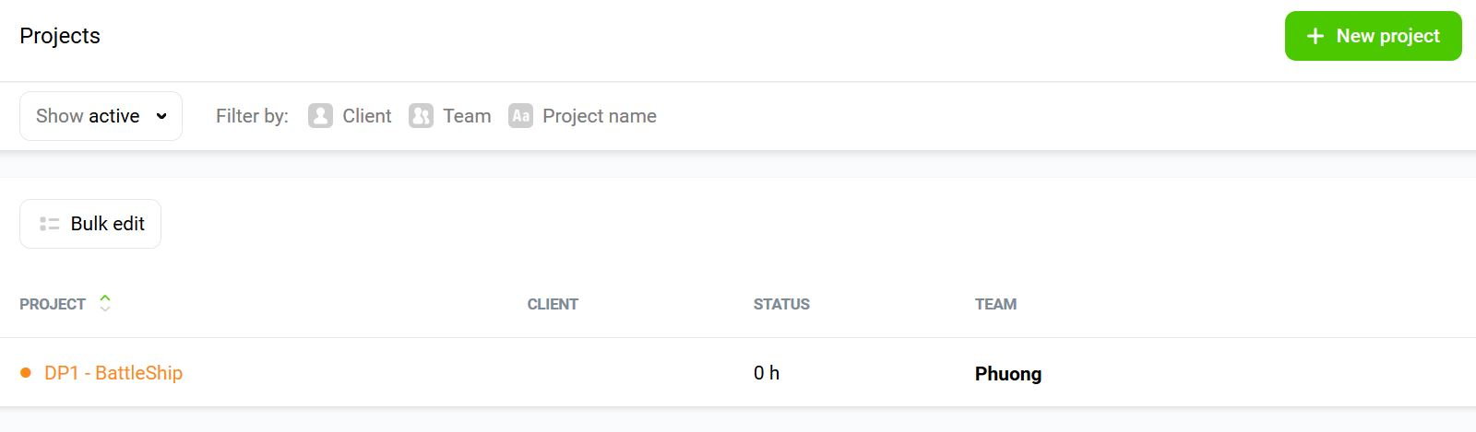

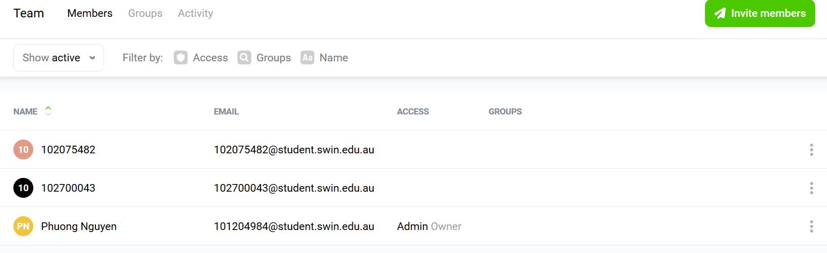

1. **Adding VB.Net code base to project GitHub**

I’m used some basic skills I learned from Lab 2 to upload the data code base to GitHub with Git Bash.

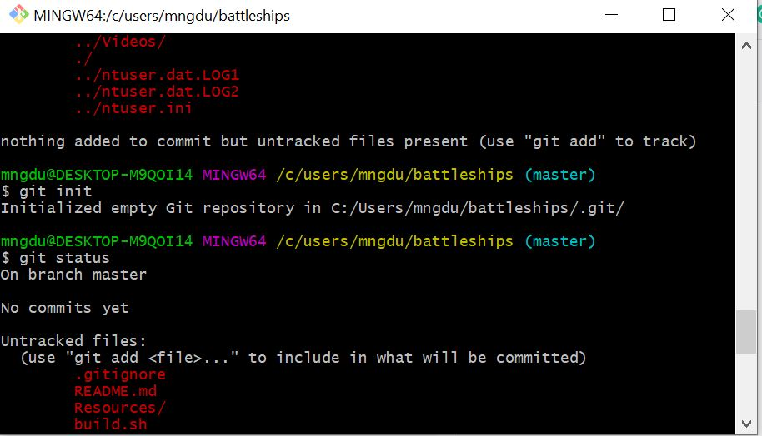

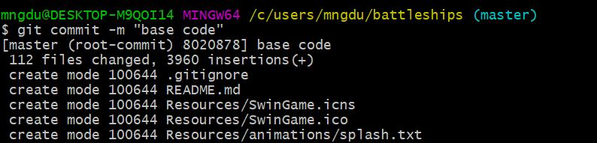

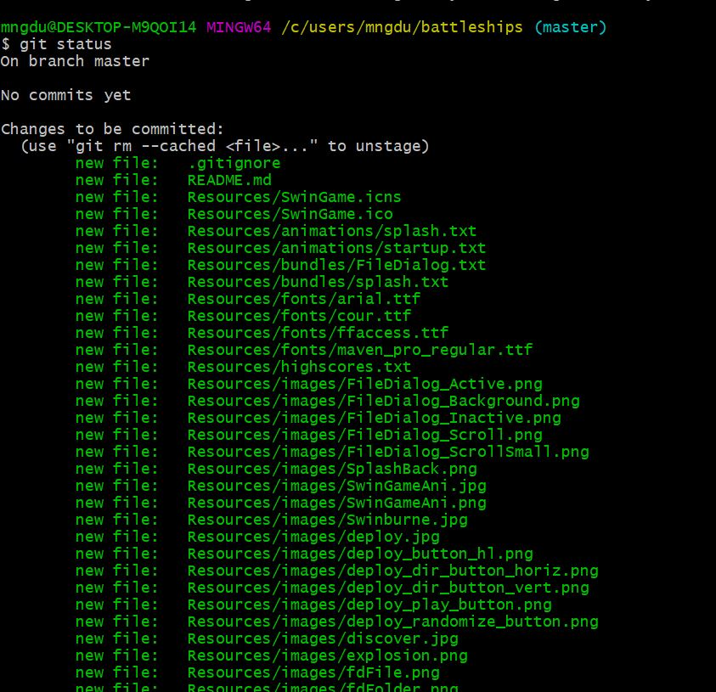

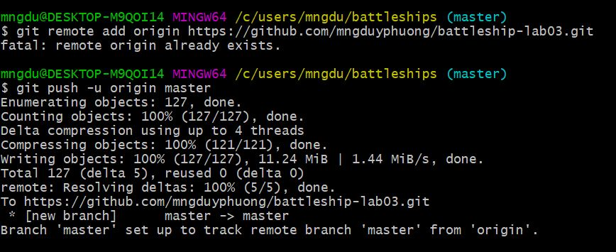

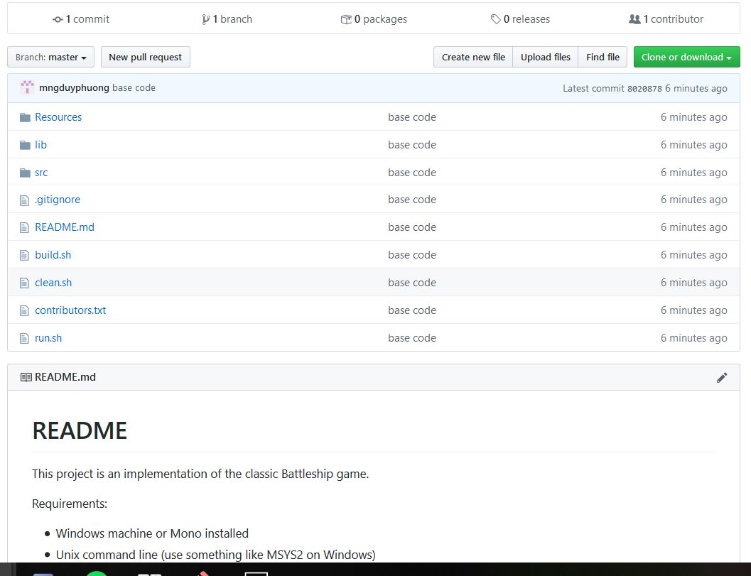

1. **Researching coding standard for C# project and updating the wiki**

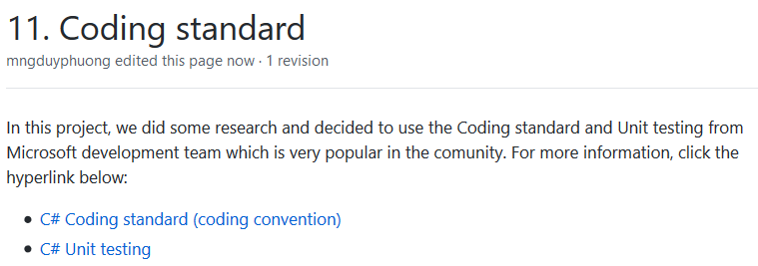

**GitHub URL:** [**https://github.com/mngduyphuong/battleship-lab03**](https://github.com/mngduyphuong/battleship-lab03)