SWE20001 – Development Project 1: Tools and Practices

Pass Task <x>

Duy Phuong Nguyen (101204984)

Lab: Friday 2:30pm

Tutor: Huai Liu

Team number: 3

Henry Tran 102075482

Edward Knight 102700043

Duy Phuong Nguyen 101204984

# Task decision

For week 6, we have 2nd iteration for our battleship project. I’m the team leader for group 3 this week. We completed the tasks together during the meeting. Below is my contribution for this week activity:

* “What could be improved in the next iteration”.
* Checked our group source code with Mono app, which is posted in week 6 modules.
* Mentioned all the errors in our code from last week iteration.
* Finalize the group report and upload it to doubtfire.

# Contribution

1. “What could be improved in the next iteration”: I suggested an idea to use Trello and Toggle to track the progress of task completion in “Process Retrospective” part.

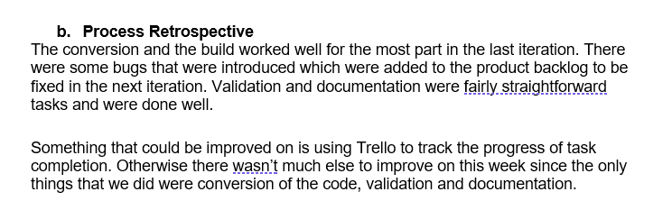

1. Checked our group source code with Mono app, which is posted in week 6 modules.
   1. Download the Mono windows from week 6 modules

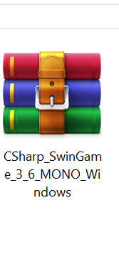

* 1. Follow the guide from week 6 lecture and implant our group C# code to the project

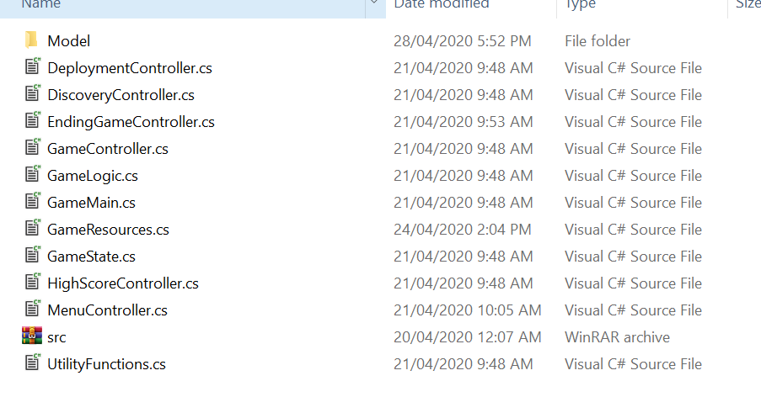

* 1. Tried to use build.sh to build the project

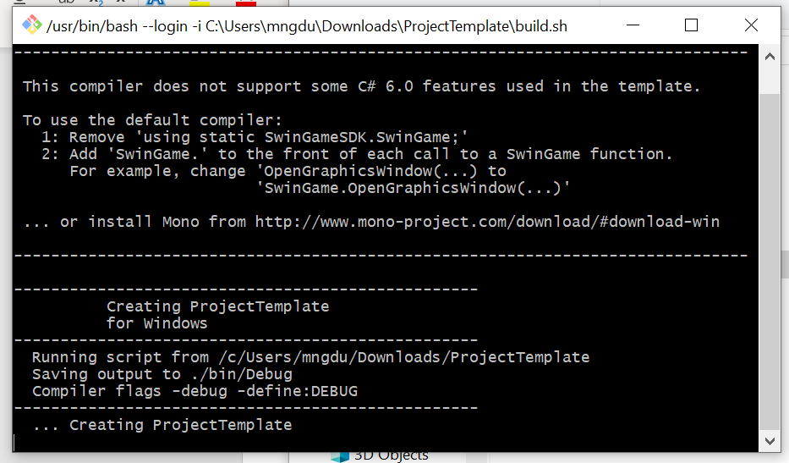

* 1. Used run.sh to run the project. However, the project is not working using this method, so our group decide to use the template from week 5 which is using visual studio as the flatform.

1. Mentioned all the errors in our code from last week iteration: I am the person who converted the VB code to C# last week, so I mention all the errors in the C# code after conversion. It helps my team member to fix the errors this week easier.

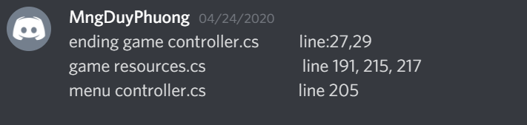

1. Finalize the group report and upload it to doubtfire.
   1. Finalized our group report on google drive

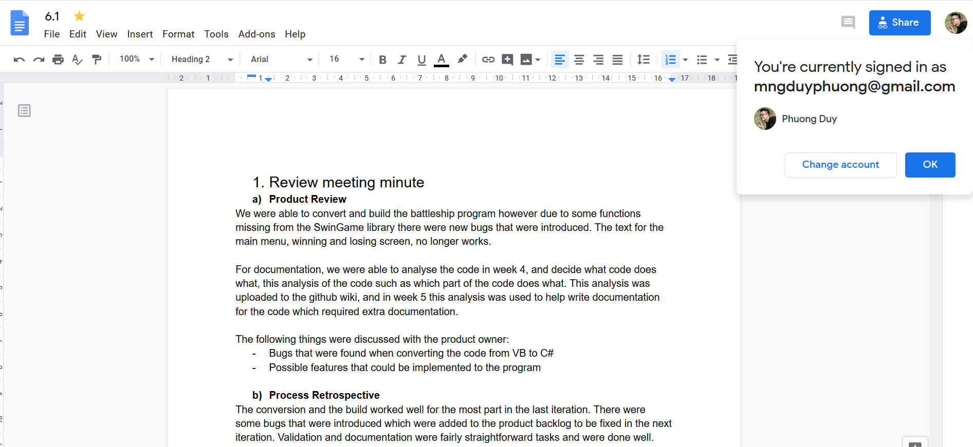

* 1. Upload the team report to DoubtFire.

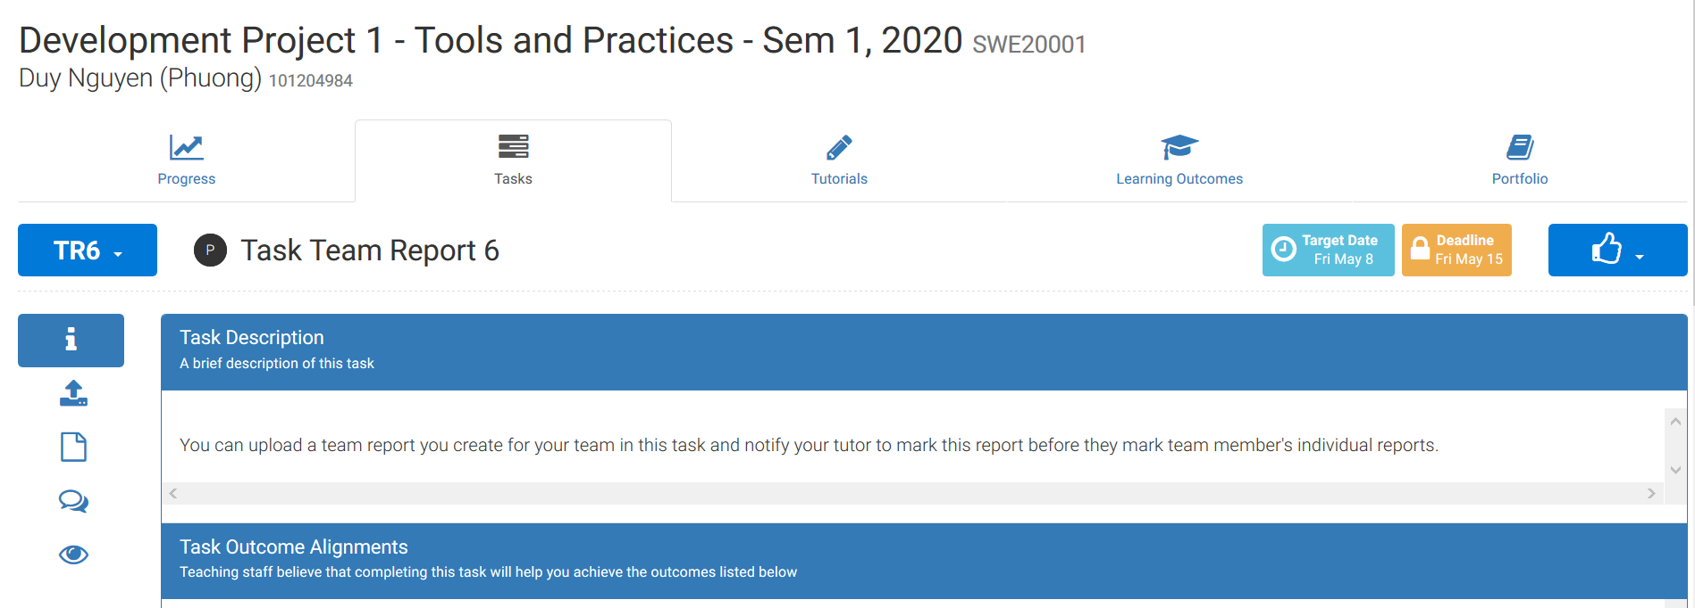

* 1. Update Trello board based on progression of team member.

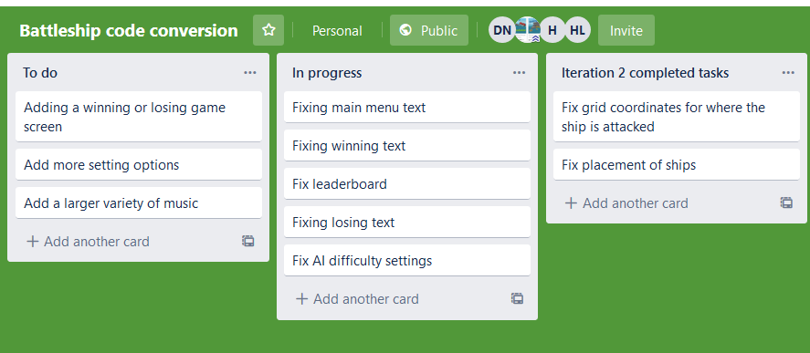

**GitHub URL:** [**https://github.com/mngduyphuong/battleship-lab03**](https://github.com/mngduyphuong/battleship-lab03)

**Trello Board URL:** [**https://trello.com/b/THQg09YT/battleship-code-conversion**](https://trello.com/b/THQg09YT/battleship-code-conversion)