SWE20001 – Development Project 1: Tools and Practices

Credit Task <6.2C>

Duy Phuong Nguyen (101204984)

Lab: Friday 2:30pm

Tutor: Huai Liu

Team number: 3

Henry Tran 102075482

Edward Knight 102700043

Duy Phuong Nguyen 101204984

**Describe agile backlogs and their good characteristics. Identify the different kinds of backlogs a project may have. Substantiate your description with examples from the software projects you were/are involved in.**

* Agile backlogs of a project are a list of tasks, requirements of a product. The product owner will maintain and update the backlog to fit with their needs. There are 3 main parts in a backlog: Story (task/requirements), Estimation, Priority. Group of developers must follow the backlog to get the expected outcomes.

Good characteristics of backlogs:

* Time estimated: Each item in a backlog have different estimated time based on their difficulties and requirements from the product owner. This helps developer team finish the final product on time.
* Prioritized: The product owner decides the Priority of an item based on the importance. Developer team can follow and determine which part of the project is vital and must finish first.
* Detailed description: Items with high priority will have more detailed description then items with low priority.

For example, in the battleship project, our group has a backlog to track everyone progress and understand which part need to be completed first.

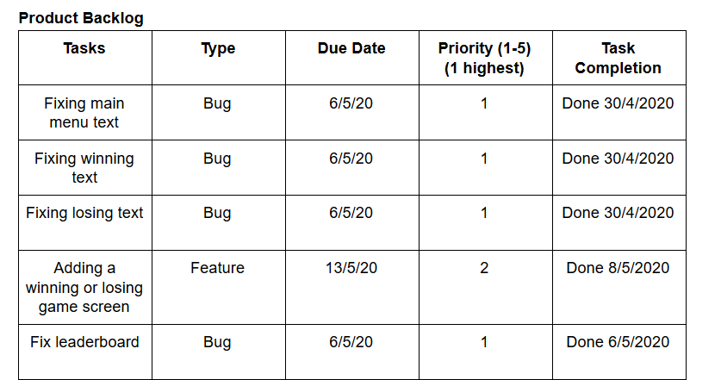

* Different kinds of product backlog a project may have: There is only one product backlog during a project. However, we can split it into smaller parts because the backlog may be oversized to be completed at first.

For example: In the battleship project, the tutor splits requirements into” iteration 1” and “iteration 2” so we can easy to manage the project and complete it in several weeks during the semester.

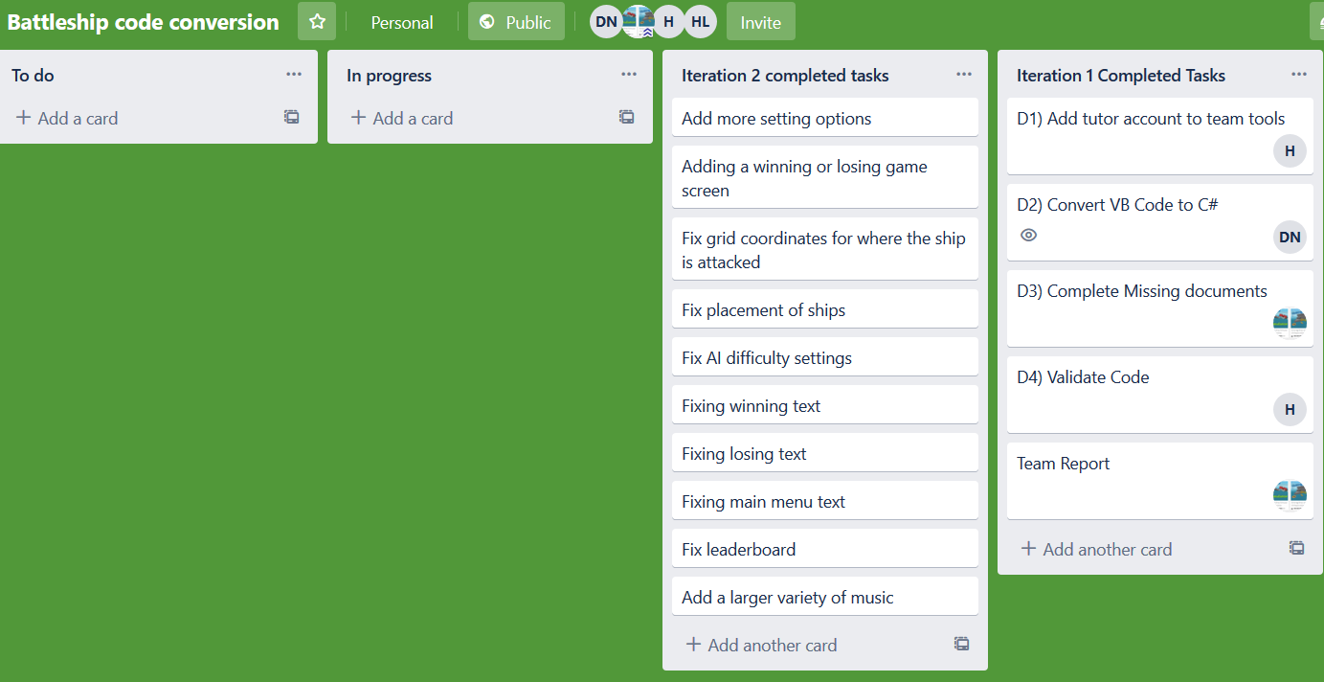

**Discuss and analyse agile backlogs in the context of software requirements. Are they different? Are they the same? Make sure that your explanation can be easily understood by a SWE20001 student.**

* Agile backlog and software requirements have some common relations. However, they are two different definition.

Product backlog is created based on “Story” expressing required functionalities of a product. It focusses more on the experience when using the product of a user. Product backlog can be changed during the progression while Software requirements cannot.

Software focuses more on the technical requirements and specific problems. This method only needed during the developing process. All of the items in Software requirements need to be completed while items in Product Backlog does not.

**Describe how agile teams carry out their work/activities around backlogs**

First, the team need to build the backlog based on customer’s requirements and expectations. After that is splitting process where the team divine backlog into smaller part for different iteration during the project. The backlog will be updated and maintenance by the product owner.

The team then move to construction phase where iterations will be completed within expected time.

After completed all the iterations and backlog, the product will be check again by product owner and ready to deploy.

**Describe how good or bad backlogs can have an impact on the work the team carries out and the project outcomes. Again, it is important to substantiate your description with evidences from the projects you have been involved in.**

A good backlog can help to reduce time consumption and improve the quality of product. It makes the project more flexible by updating the backlog regularly to avoid wasting effort on removed items. Receiving feedbacks from the customers also improve the outcome.

For example, during the battleship project our time create backlog after every meeting to track everyone progress and split the tasks for each team member

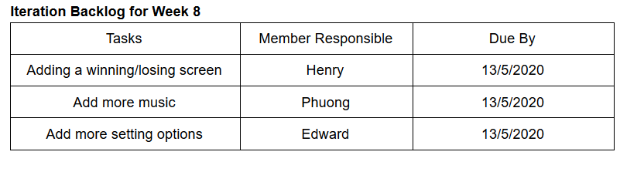

**Recommend guidelines for good agile backlog**

1. Developer team need to discuss with product owner to understand the ideas and requirements of the project. It should cover a wide range of product’s characteristic.
2. Organize these ideas and requirements into a product backlog. Decide the estimation time and priority of each item in the list.
3. Use the following format as a formal backlog:

“As a user, I want to….”

“As an authorized admin, I want to…”

1. Make the description of each item clear and easy to understand. Product owner is responsible for updating the backlog.
2. Follow the backlog and complete tasks with highest priority first.
3. Complete tasks within estimated time to ensure the final product is finished on time.