SWE20001 – Development Project 1: Tools and Practices

Pass Task <x>

Duy Phuong Nguyen (101204984)

Lab: Friday 2:30pm

Tutor: Huai Liu

Team number: 3

Henry Tran 102075482

Edward Knight 102700043

Duy Phuong Nguyen 101204984

This report summarises my contributions to the teamwork in Week <7> as well as the tasks I have performed during this week:

In this week, Henry Tran 102075482 is the team leader. He will submit the group report

# Section 1:

During this week, I have a lot of assignment and mid-term test from another subject. However, I’m still able to catch up with my allocated tasks from my team leader.

I finished to fix all the bugs in C# battleship project: AI difficult setting and Leader board.

* At first, I tried to play some battleship game to figure out why we do not have a leader board after finishing the game. After many of tries, I’m able to enter the leader board. Turn out, the leader board is still working however there is a bug in the program.

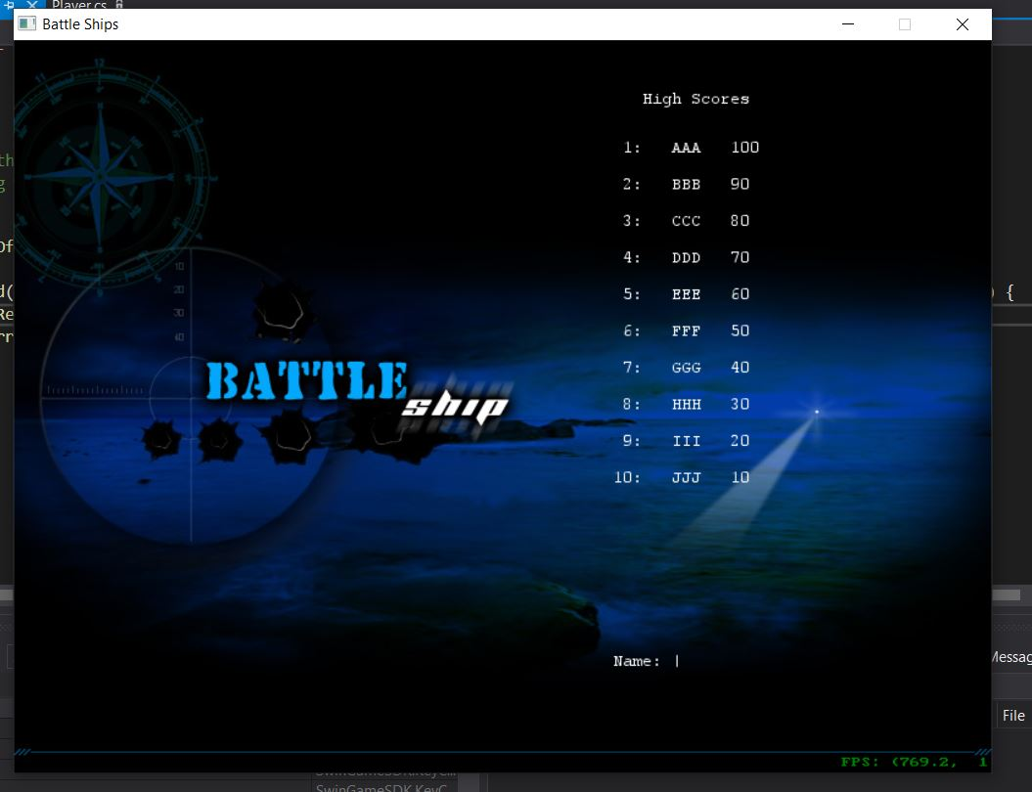

* Tried to find the error in C# code in HighScoreController.cs class and it leads to Score method in Player.cs class. In this function you can understand how the program calculate your score based on your Hits value, shots value and shipkilled.

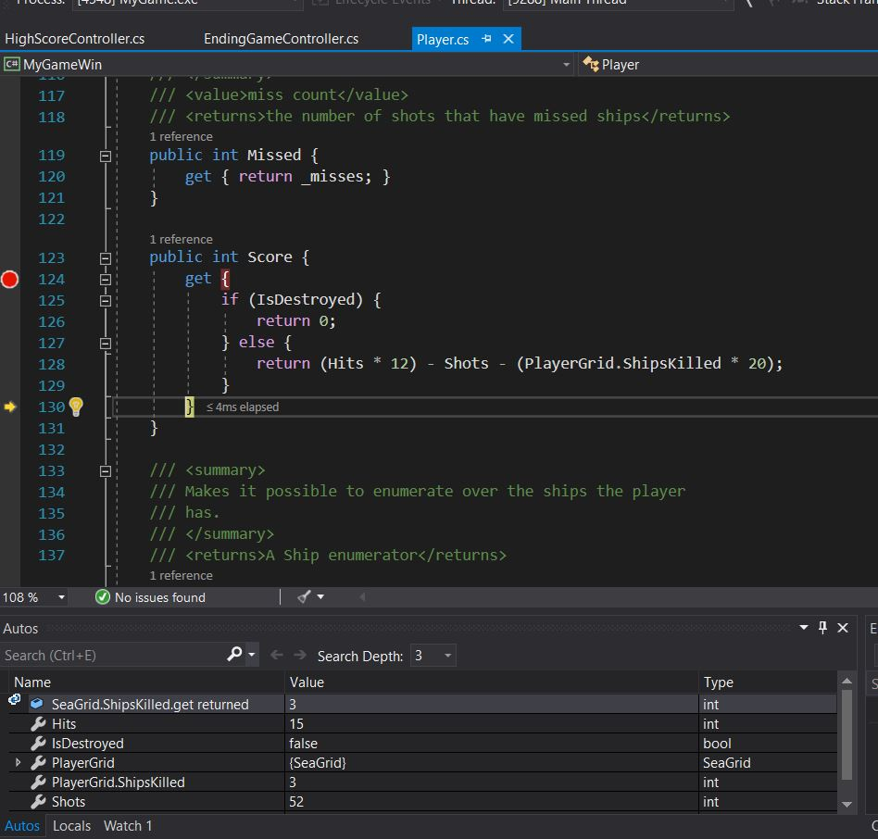

* The function is working fine, I get my score of 68 after winning the game.

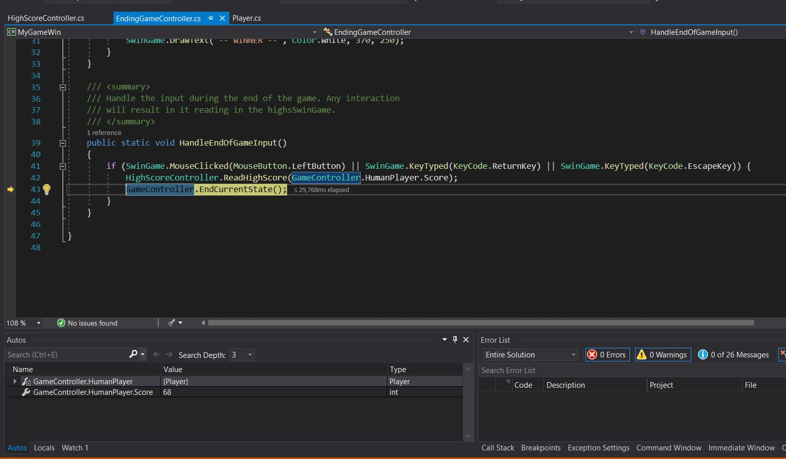

* After that, I found the bug: when we attacked in the same coordinate over and over. its increase your "shots" value so the "shots" value goes too high => your final score is negative or 0. That’s why we can’t go to the leader board. Another reminder is you must win the game otherwise your score will be 0.

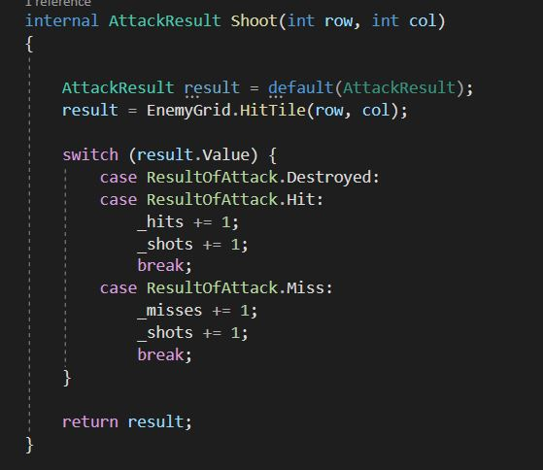

* Fixed the bug so the number of total shots = hits + splashes.

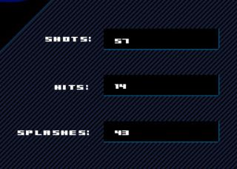

# Section 2: UnitTesting

* After followed all the step in Canvas modules. The testing result is fail because the expected value does not match with actual output

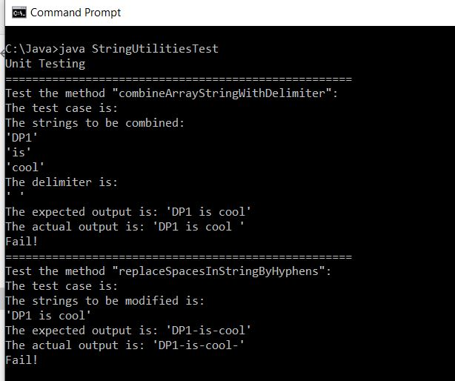

* This happened because in both methods, after going to the end of the string, the method still do the work one more time. This leads to the excess part in both cases: There is space at the end in case one, there is a ”-“ symbol at the end in case two.
* So I decided to fix the expected value to match with the actual value so its can pass the test.

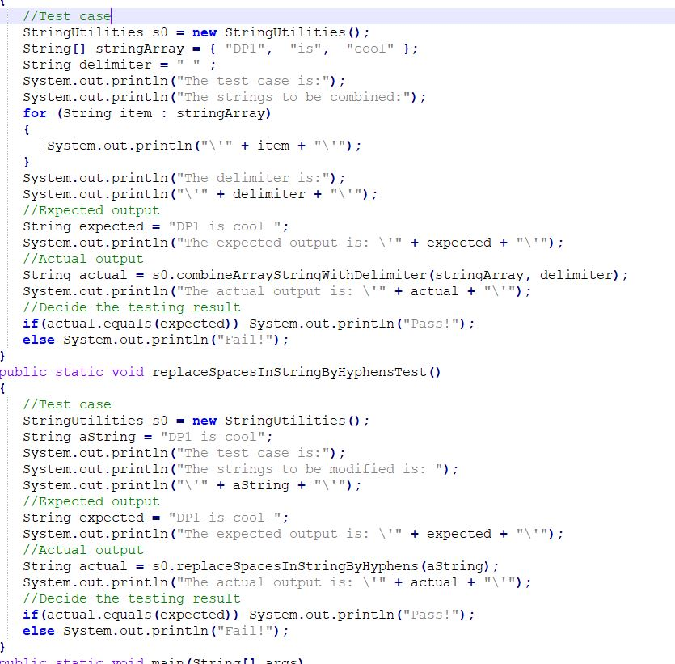

* I compile the code again using “javac StringUtilitiesTest.java” so the StringUtilities.class is up to date.
* Run the test again and both of cases are pass the test.

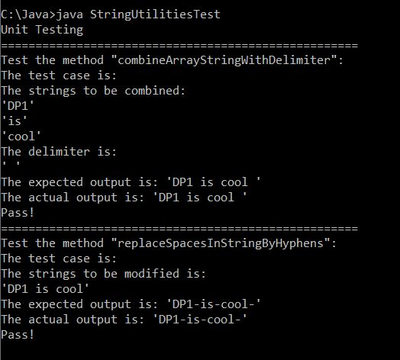

**GitHub URL:** [**https://github.com/mngduyphuong/battleship-lab03**](https://github.com/mngduyphuong/battleship-lab03)

**Trello Board URL:** [**https://trello.com/b/THQg09YT/battleship-code-conversion**](https://trello.com/b/THQg09YT/battleship-code-conversion)