SWE20001 – Development Project 1: Tools and Practices

Distinction Task <10.1D>

Duy Phuong Nguyen (101204984)

Lab: Friday 2:30pm

Tutor: Huai Liu

Team number: 3

Henry Tran 102075482

Edward Knight 102700043

Duy Phuong Nguyen 101204984

# Team presentation slides:



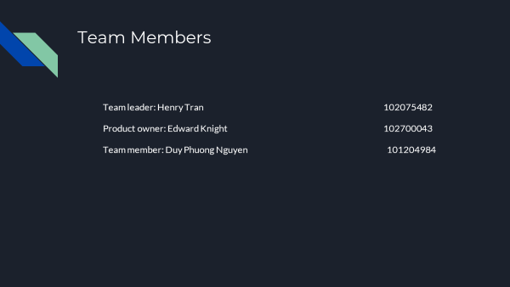

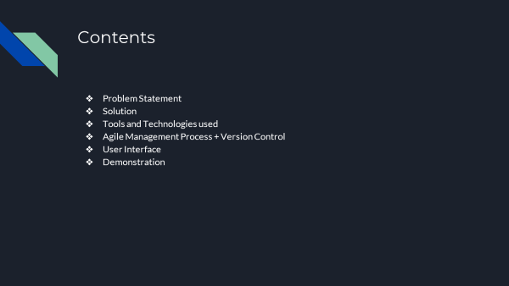

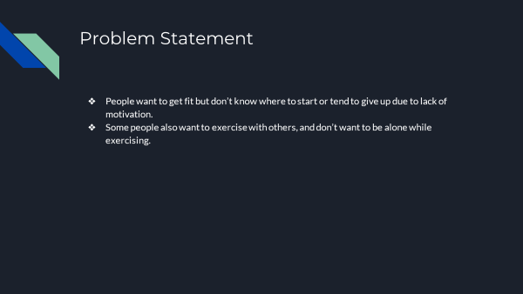

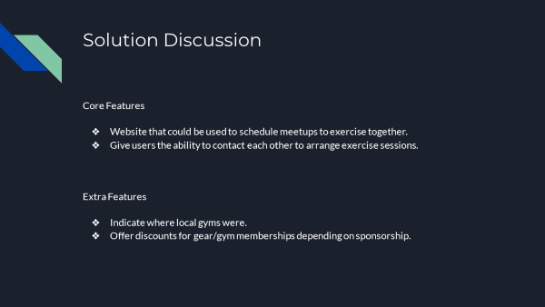

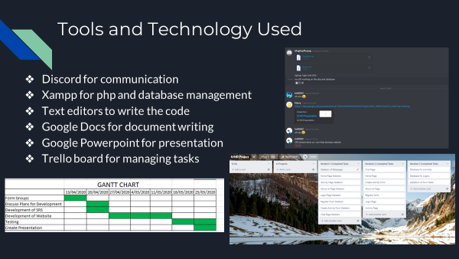

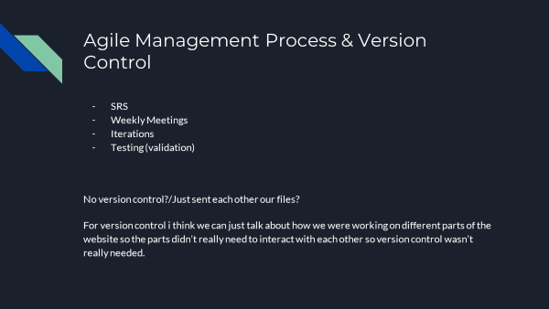

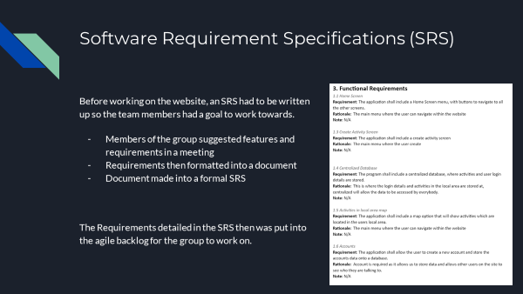

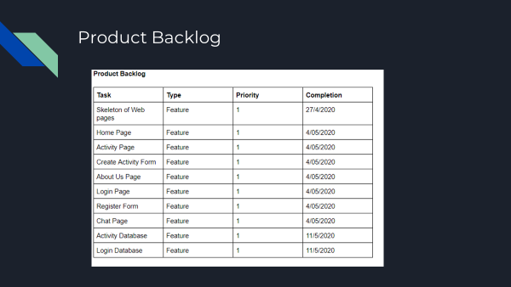

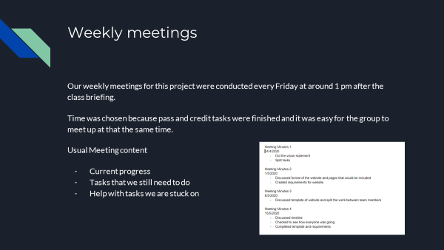

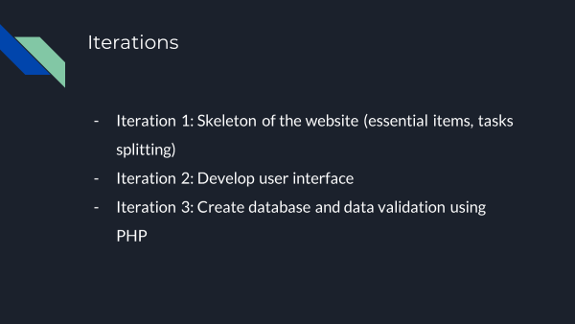

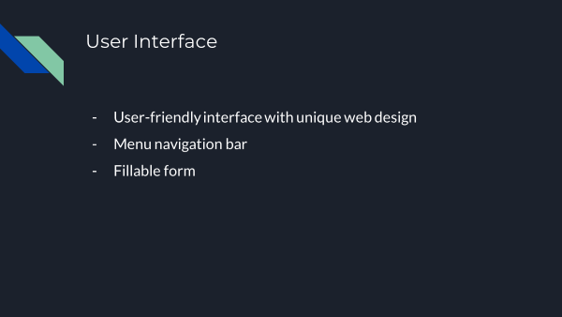

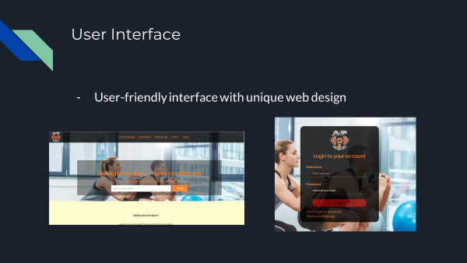

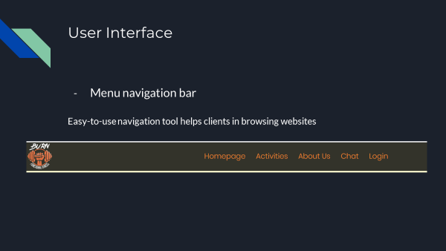

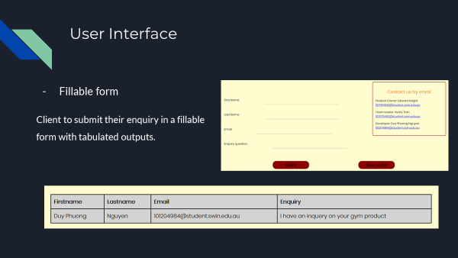

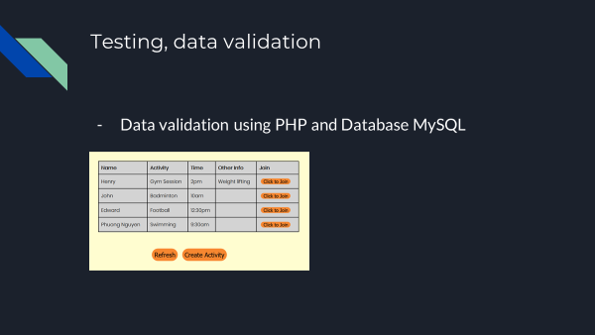



# Individual contribution

Our group has 3 members, so we decided to split the presentation into 3 parts:

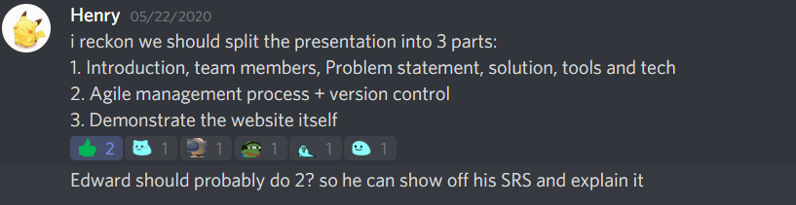

Based on our role in this project, we chose our part. For example: Henry who is Team leader will present part 1: Introduction, team members, Problem statement, solution, tools and tech. Edward is the product owner, so he understand all the SRS, agile management process and version control of our project. As a team member and developer of the group so I will demonstrate the website because I mainly focus on coding and design the web.

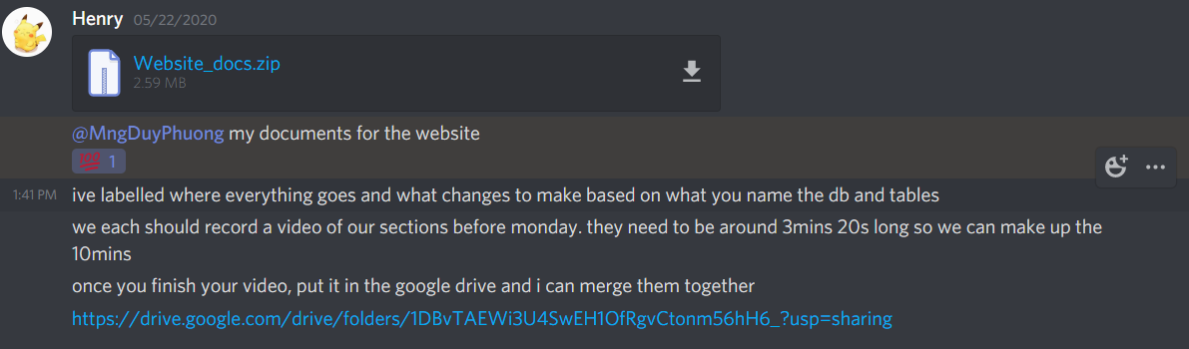

A google drive PowerPoint is created and all member can contribute their part to the final version. The total length of presentation is 10 minutes, so each member has 3 mins and 20 seconds to present their part.

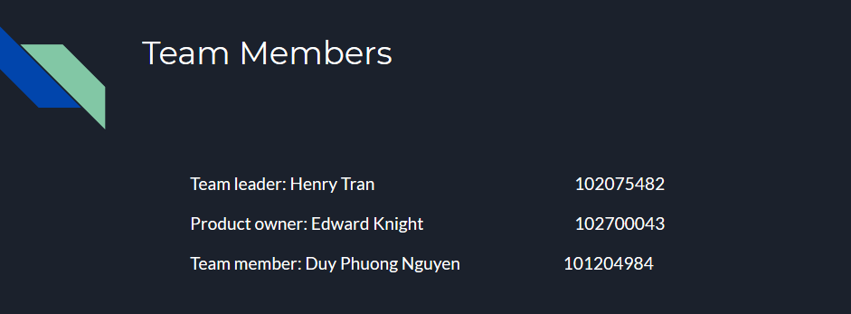

I helped Henry to create team member information slides which includes our role, name and student number.

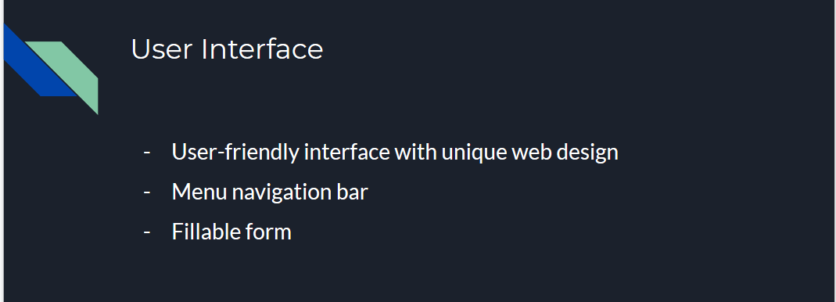

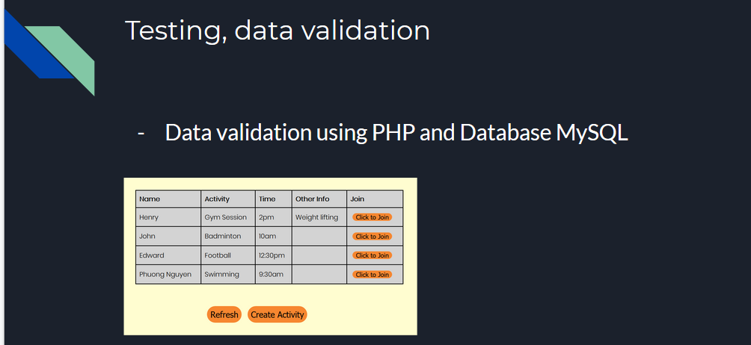

I finished my part which contains 7 slides.

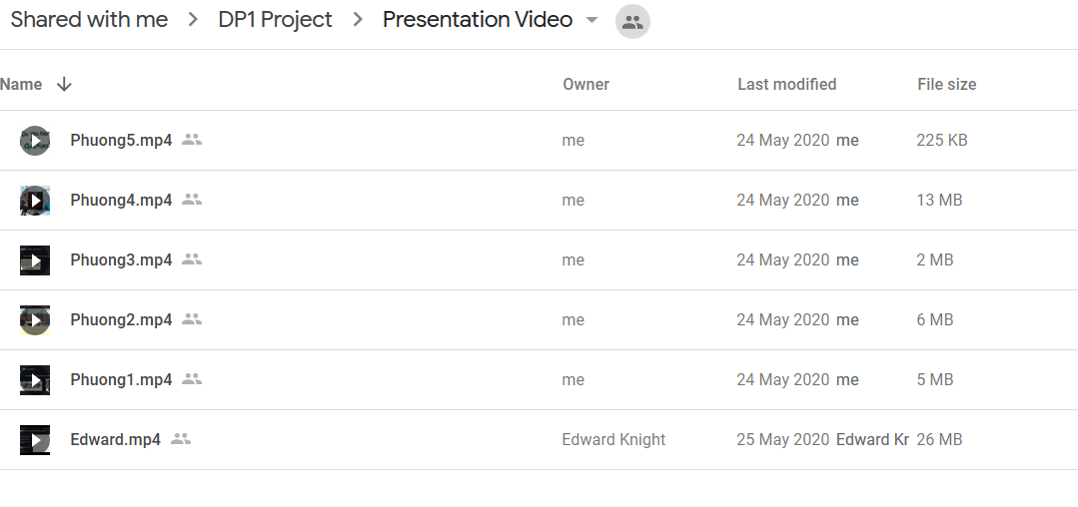

Due to Covid-19, we can’t present our project face-to-face with our tutor and classmates. A video has been recorded and our team leader Henry will merge them into one final video. I have 5 videos because I have to switch between PowerPoint slides and Website for demonstration and when I switch, the program can’t record them. My total length for the project presentation is around 4 mins. It is a bit longer than my team member. At the end, our presentation is successful.



Microsoft team session is hosted by our tutor for Question & Ask. I joined it and helped my team to answer questions from tutor and classmates.