**How to run**

Step 1: Download <https://www.wampserver.com/en/>

<https://sourceforge.net/projects/wampserver/files/WampServer%203/WampServer%203.0.0/wampserver3.2.3_x64.exe/download>

Step 2: Install it at c:\wamp64

Step 3: Run the WAMP app then you can access localhost from your web browser

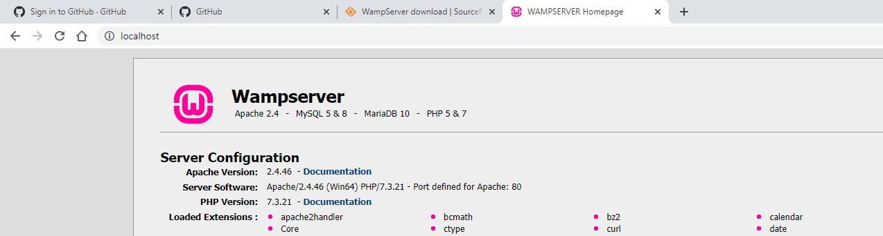

Step 4: Click on Wamp icon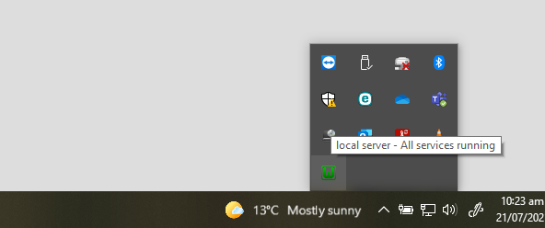

It takes you to the control panel, to access the source of the website, click www directory

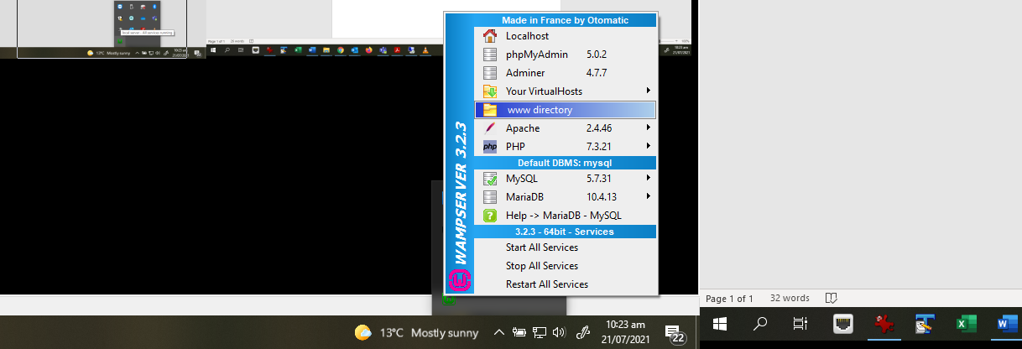

Step 5: Delete all the files and folder in that www directory and copy all the souce code from <https://github.com/mngu012/ARTag> to that folder. Once done, you can access localhost and use webcam to look at the AR Tag, and receive a random 3D model on top of that.

