- Pointer is used to store the address of data
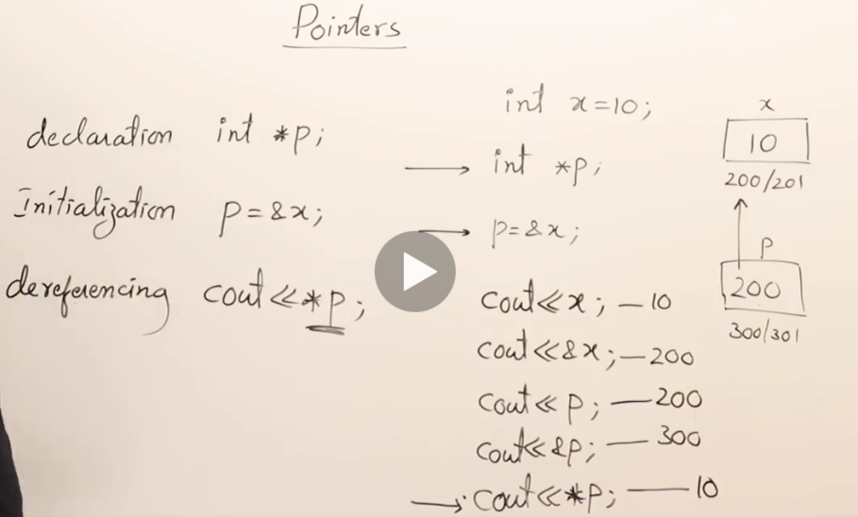
- *p = dereference = data variable value stored in that address
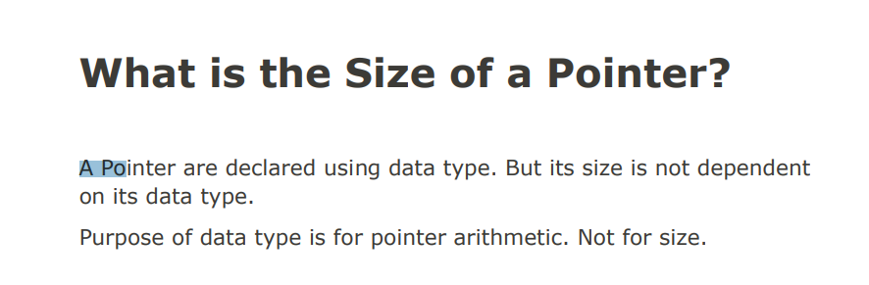
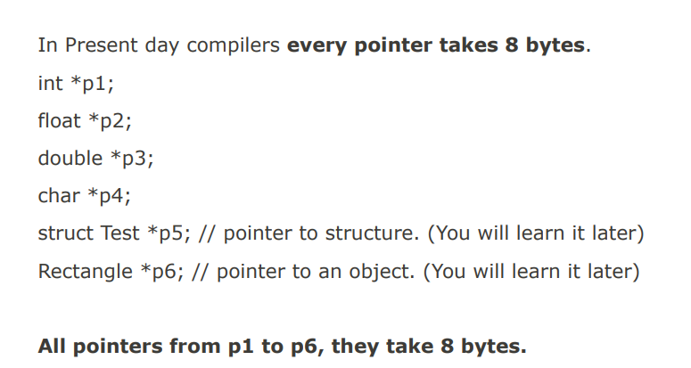
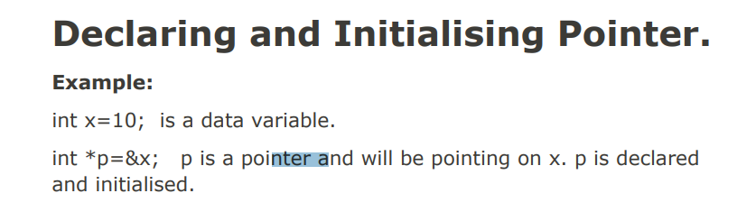
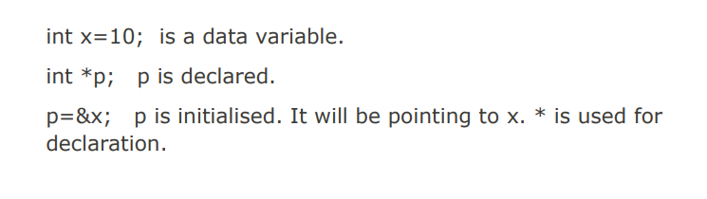
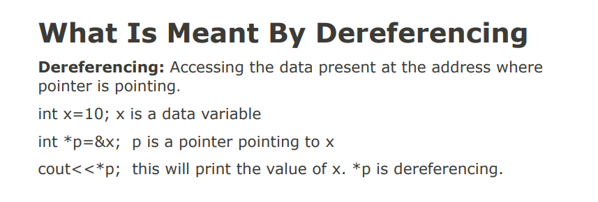
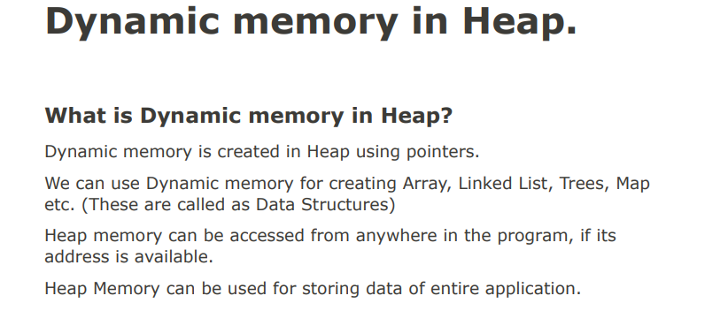
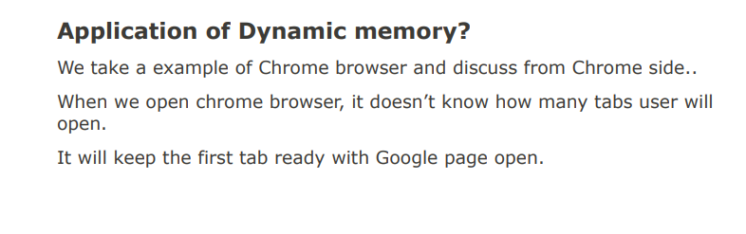
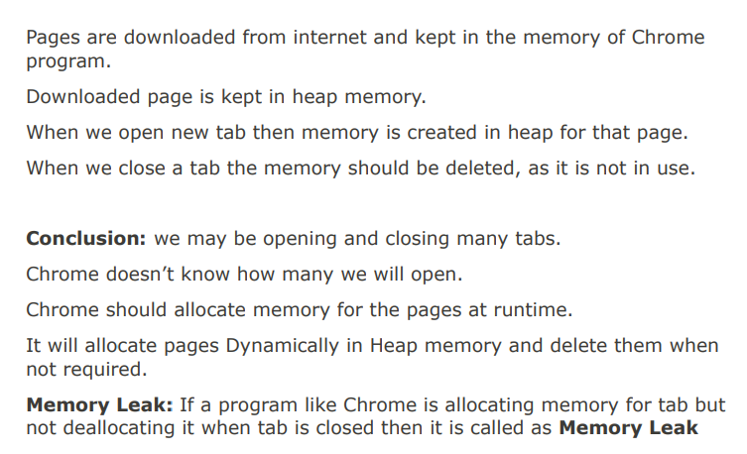
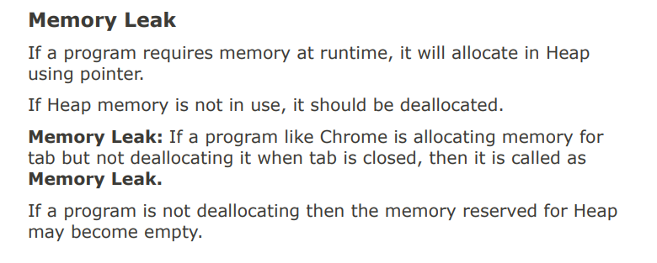

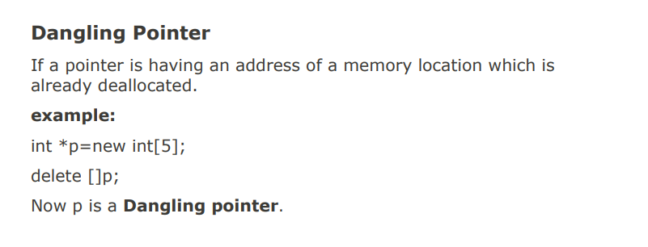
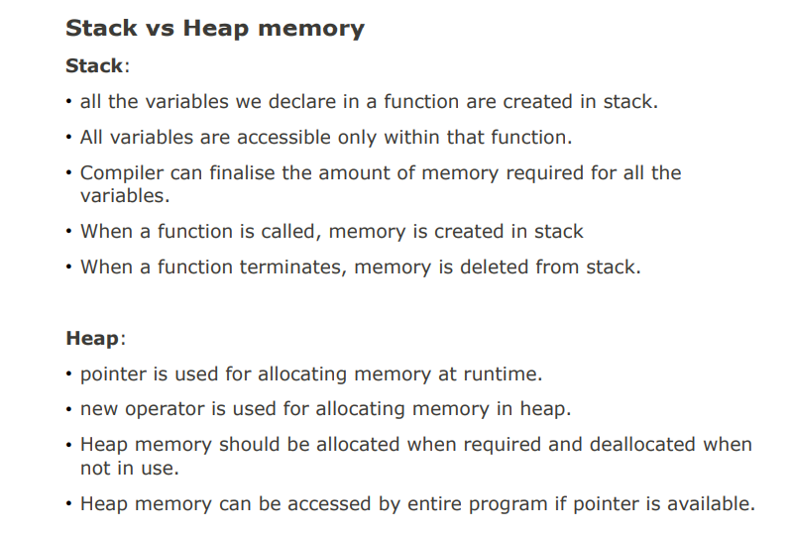
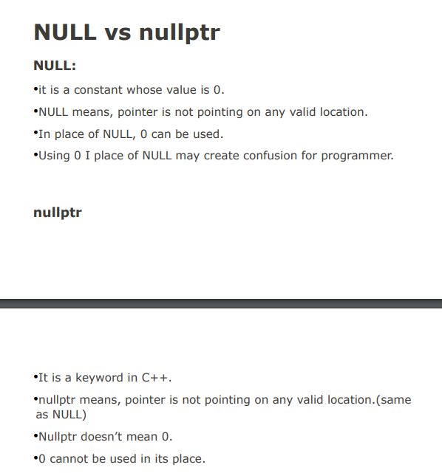
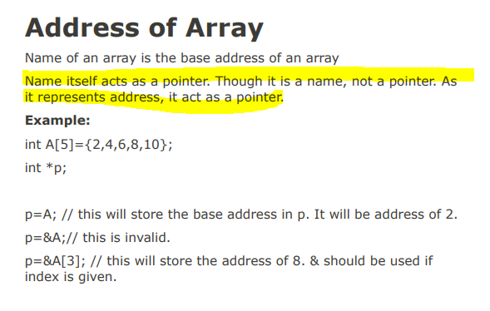

WHY POINTER?
- Function/ program main can only access stack and code section. To access heap, you have to use pointer.
- Similar, the main() program can’t access file/network connection/mouse/printer…, thus it need pointers
HEAP MEMORY ALLOCATION/ ACCESS – Dynamically – at run time not at compile time.
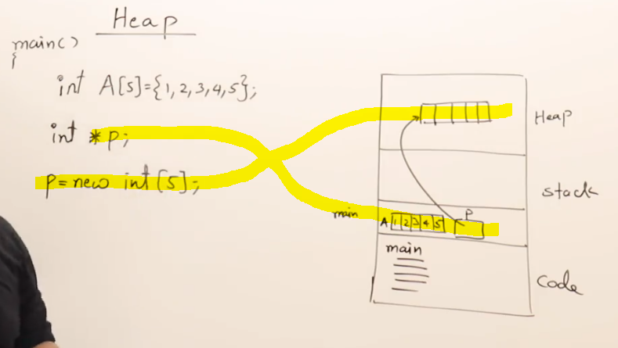
- Stack memory variable will be deleted when the program get out of scope
- Heap memory will not be deleted as long as you program still run or you not delete/deallocate it.
- Also, you have to delete/deallocate the pointer before have that point to another data variable
- Memory leak = you forgot to deallocate the memory block from a pointer and use that pointer to point to another memory block I the heap. The previous memory block will have no use and cause memory leak.
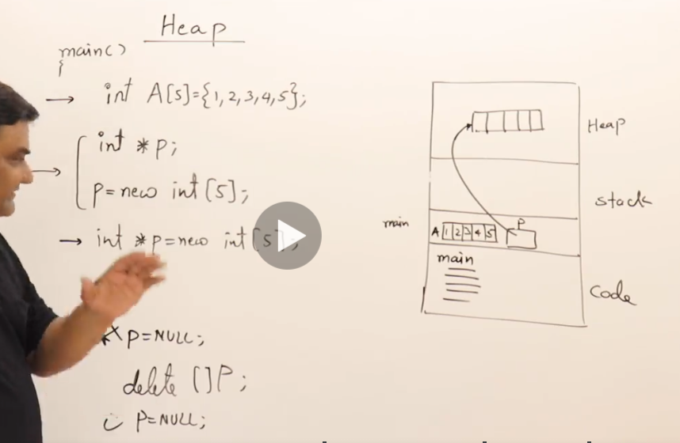
- You can modify the array in the heap via pointer and have it act as the name of the array

