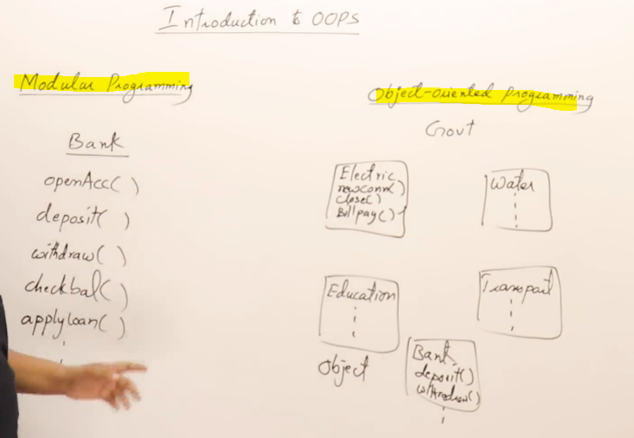
- With OOP you can design code for the whole government instead of just 1 department
1/ Principles of OOP:
- Abstraction – show the use of function
  - User does not need to know the working inside the function (internal inside).
  - We don’t want to see the implementation of function
  - Thus, we write function in class
  - The users here are programmers. No need to know how It works but just use it
  - This is how to write a library
  - Make function public
- Encapsulation: Data Hiding
  - Data is hiding inside.
  - Avoid mishandling not SECURITY. We hide data, make the function usable.
  - Make data private
- Inheritance:
  - Same class but make same change to make new class
  - Write new class that borrow all the same features
- Polymorphism:
  - Reuse function of CARs instead of rewrite it for all BWM, SUZUKI,….

2/ Pointers to Object and create Object in stack and heap
STACK:

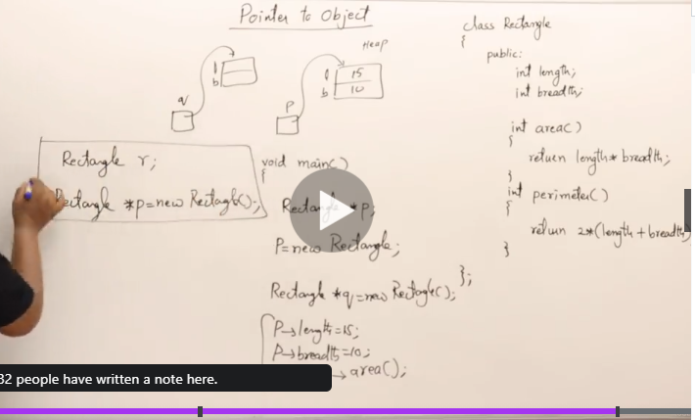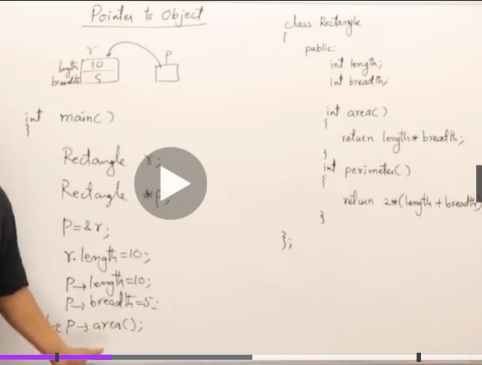

3/ The philosophy behind data hiding:
- Only functions are visible not the function.
- I want to guarantee that the function correct for the user. Not security
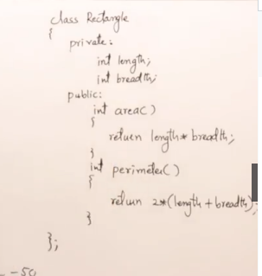
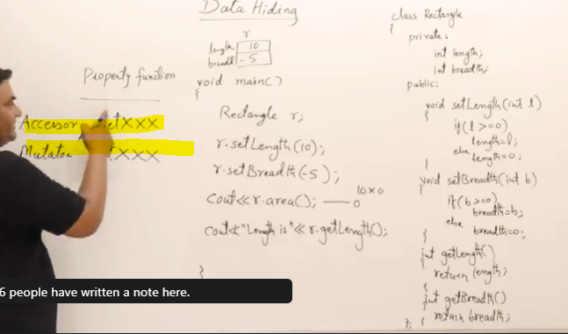
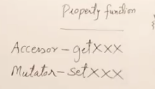

4/ Philosophy behind constructor:
- When you create an object, it should have the characteristic / data at the same time, not garbage => Just logic

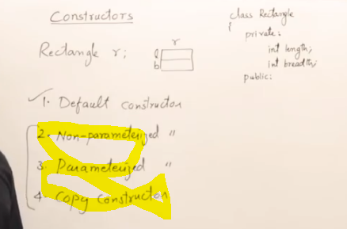
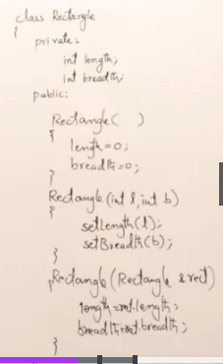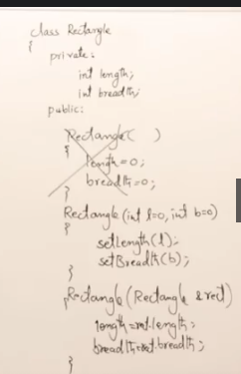
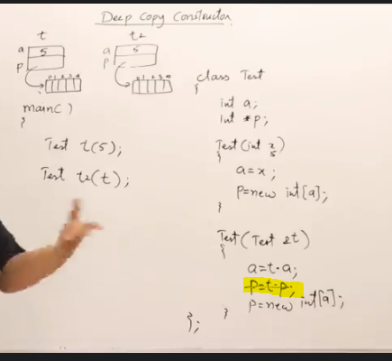
- You might want deep copy constructor instead of shallow copy constructor

5/ Types of functions in a class:
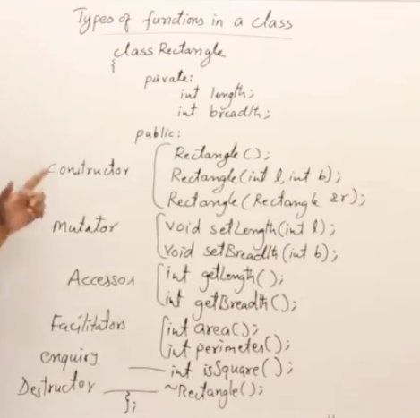
- We just write a header of the funcition not function declaration
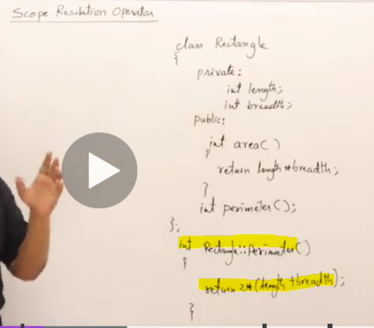
- This is how you write a function of a class outside of scope

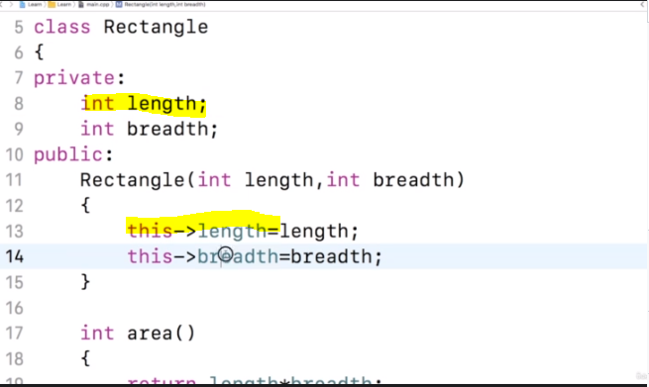
- You don’t have to do this
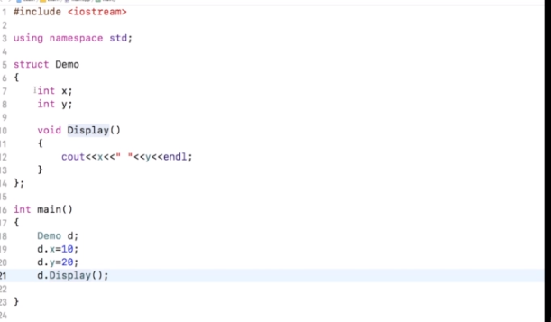
- In C++, struct is similar as class
- However, in structure, data and function is public while in class, everything is private as default

