5/30/2021

**1/ Pytorch Package:**



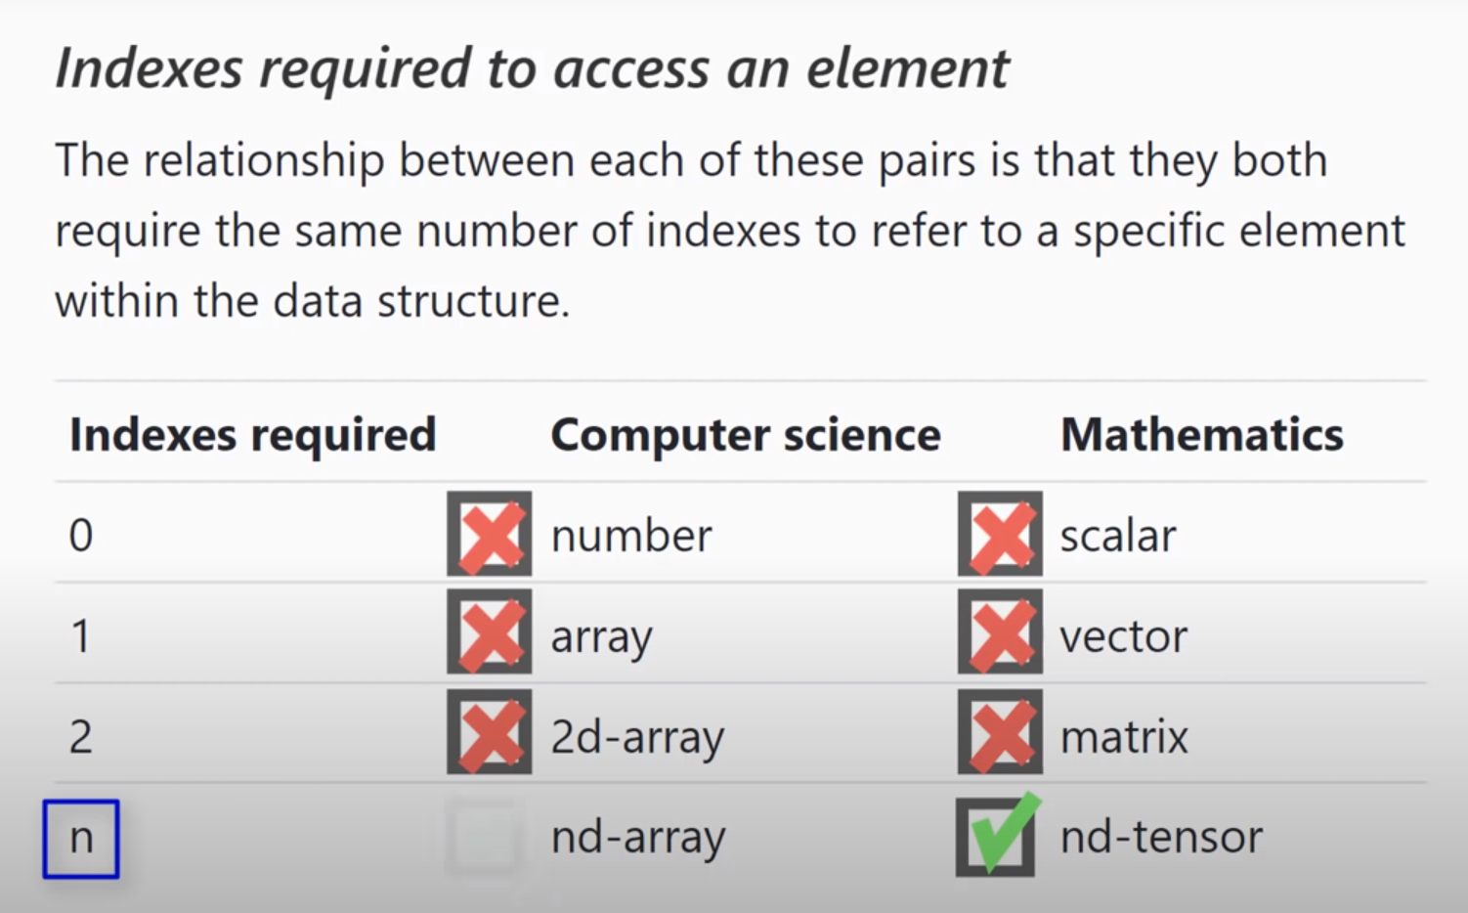

**2/ Copy and Share Tensor:**

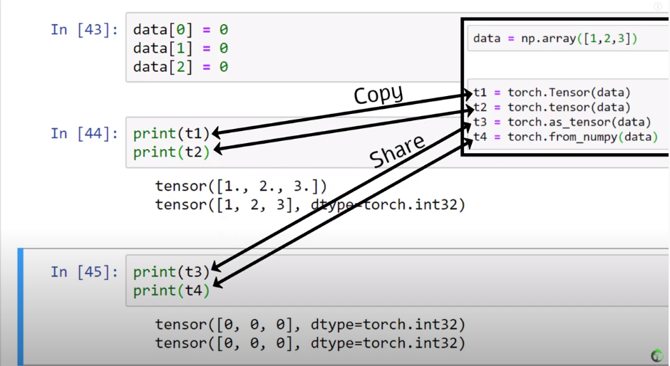

**Convolutional Neural Networks Explained**

**1/ Intro:**

* Used for pattern finding that especially use the convolutional layers.
* Convolutional layers will enable to detect patterns (edges and images) or edge detector.
* The deeper the network the more sophisticate the networks

Alex Net: Random Horizontal + cropping are the most powerful image augmentation techniques

* When initialize the conv layer, we have to notify the filter.
* Slide = convolve

Conv Demo: https://deeplizard.com/resource/pavq7noze2