7/17/2021

FAQ:

**1/ why we can not use void main instead of int main?** some compilers supports void main and some compilers int main. Mostly int main() is used.

**2/ what is the meaning or use of return 0;** here and what will happen if we don't use return 0 in our code.

when a program is ending it should return 0. It is like a standard in C++ programs, it must be written. return 0; means program has terminated successfully.

**3/ What is #include.**

# is used as preprocessor directive. #include will ask the compiler to include the header file.

**4/**

**5/**

**6/ Data Types and Variable:**

* Primitive = provided by the compiler, provided by C++:
  + Integral: int, char = no decimal point
  + Bool
  + Floating point: float, double
* Userdefined:
  + Enum
  + Structure
  + Union
  + Class
* Derived:
  + Array
  + Pointer
  + Reference
* Modifiers:
  + Unsigned
  + Long:
* Table, letter

  Description automatically generated
* Variable = name given to a data type.

**6/ Increment and Decrement Operators:**

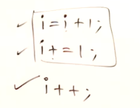

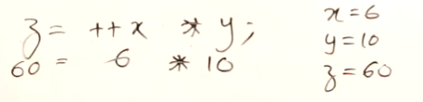

**7/ Overflow:**

* Negatives number are stores in 2’s complement

* Note that bitwise operators works only on int and char types

**8/ Bitwise Operator:**

AND, OR, XOR, NOT, >>, <<

**9/ Enum and Typedef – make the program more readable:**

* Enum is for representing constant without define them const int one by one

* Typedef allow to name the datatype

