6/5/2021

**1/ Hyper Parameter Tuning:**

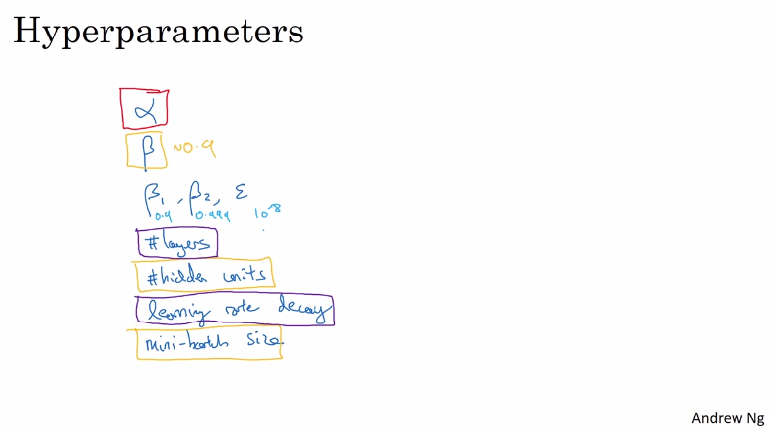

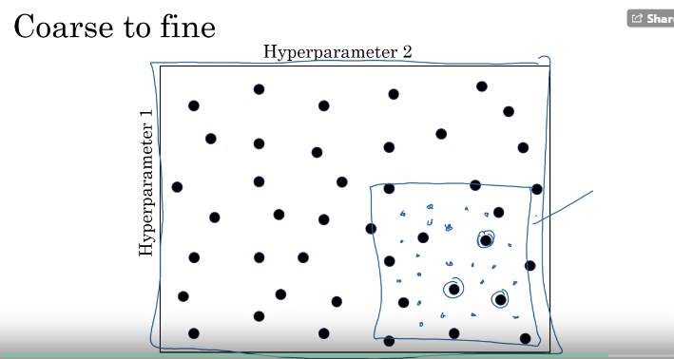

**2/ Using an appropriate scale to pick hyperparameters:**

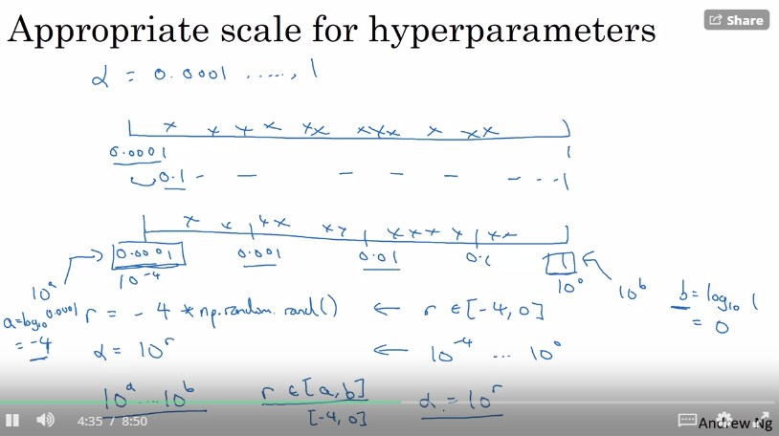

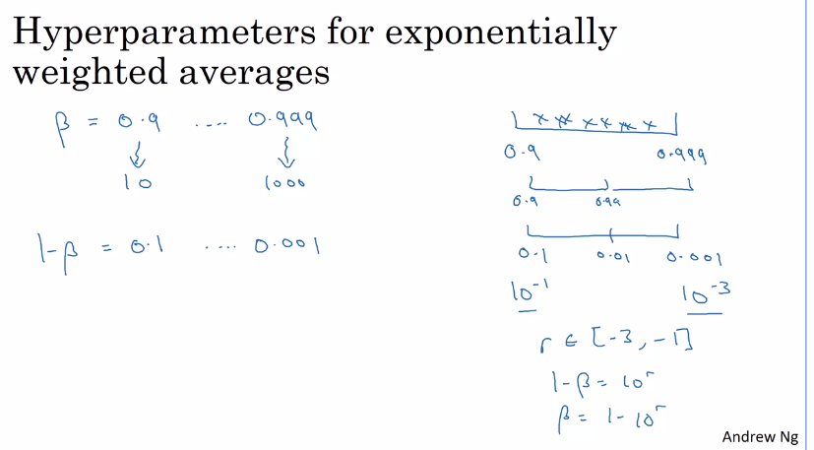

**3/ Hyperparameters tunning in practice: Pandas vs Caviar:**

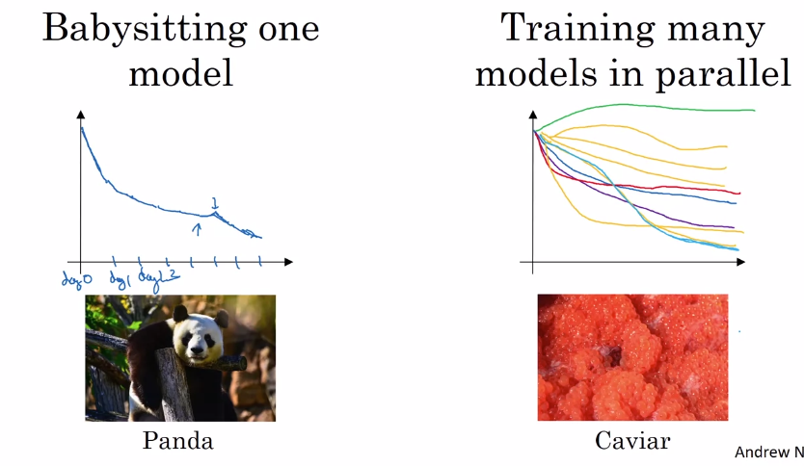

**4/ Batch Normalization:**

**a/ Normalizing Activations in a Networks**

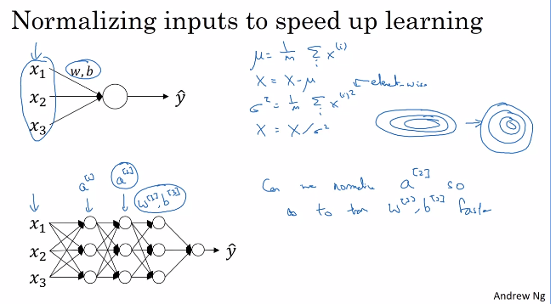

* Should normalized before putting to the activation function.

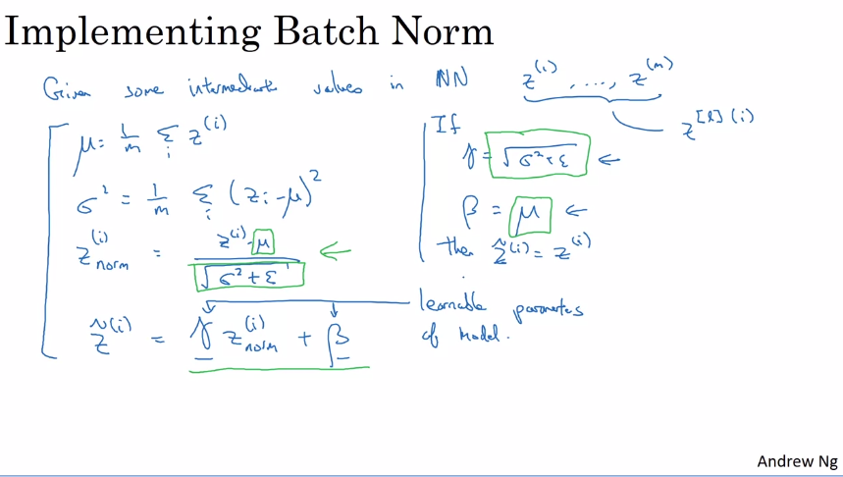

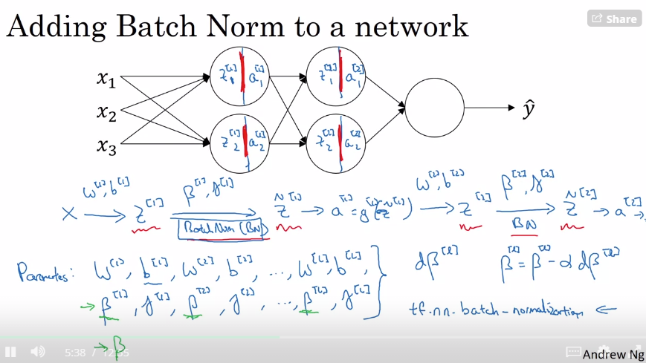

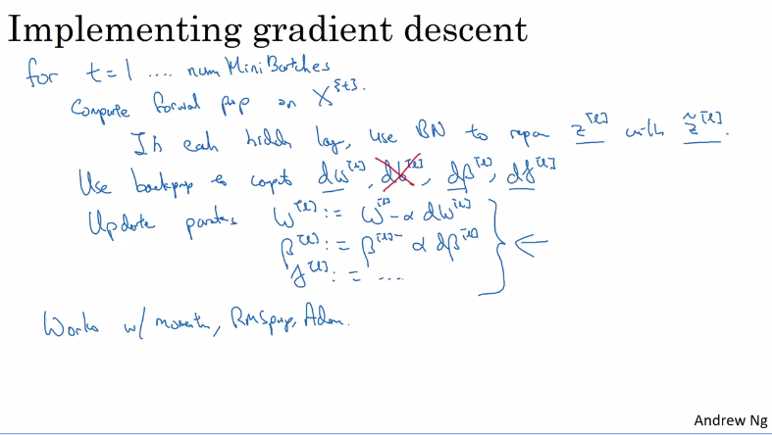

* Batch Norm make sures that the means and variance of Z for all inputs are the same

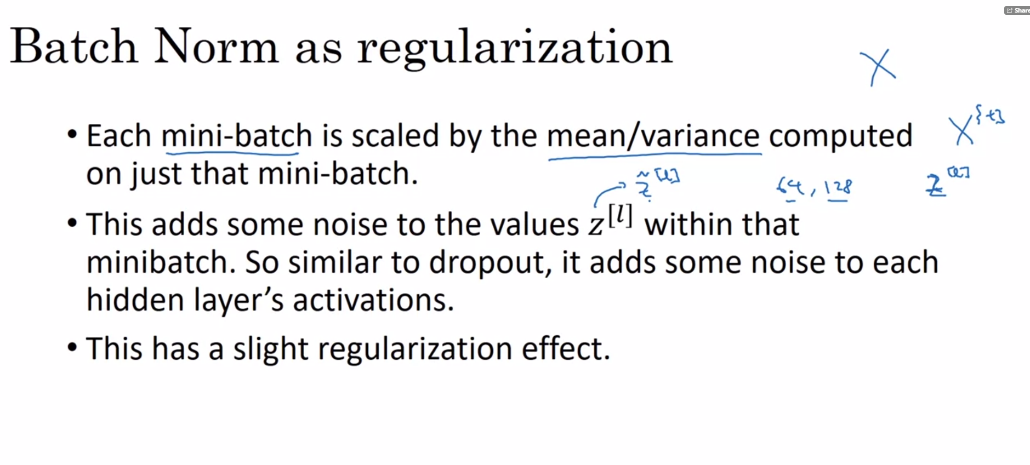

* Use BN as a way to normalize hidden unit but not as L1/L2 regularizer since it does not always work

**b/ Batch Norm in test time:**

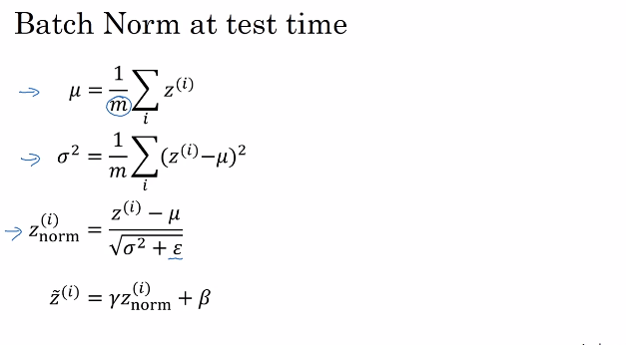

**5/ Softmax Regression => Multiclass Classification:**

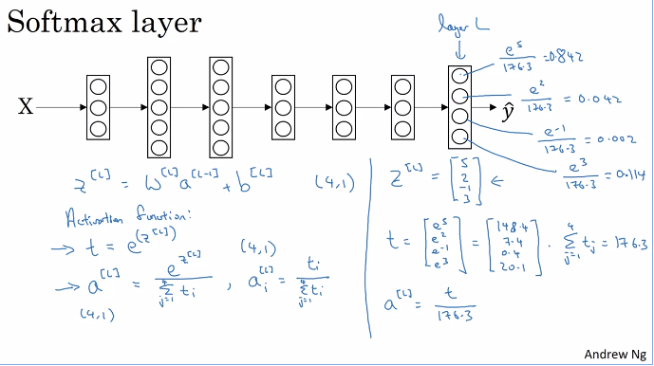

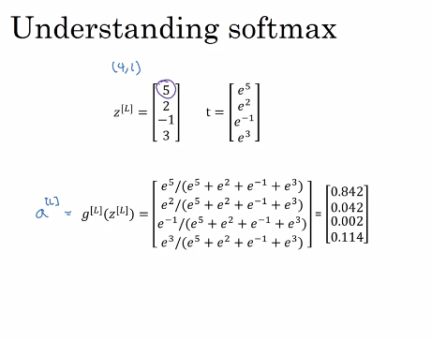

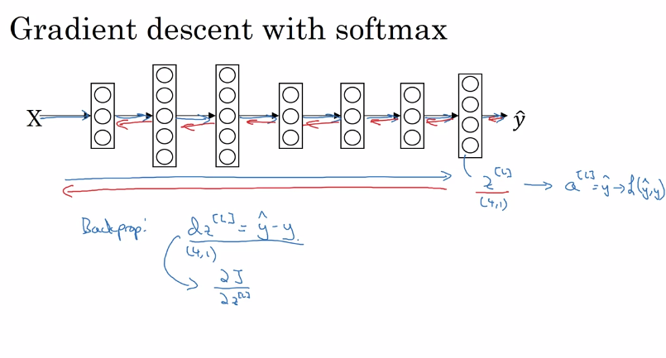

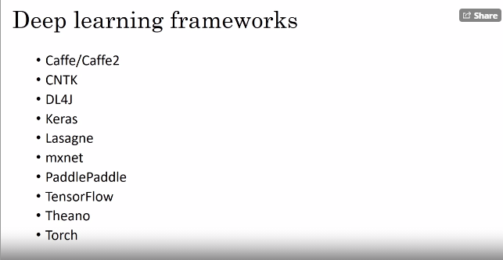

**6/ TensorFlow:**

