6/21/2021

**Introduction to Reinforcement Learning**

**1/ Characteristics of RL;**

* There is no supervisor, only reward signal. Trial and error
* Feedback is delayed by many steps after your decision, not instantaneous
* Time really matters (sequential, not iid data).
* Agent’s actions affect the subsequent data it receives.

**2/ Problems with RL:**

a/ Rewards:

* A reward is a scalar feedback signal indicating how well agent is doing at step t.
* The agent’s job is to maximize the cumulative rewards.
* Ex: Fly stunt maneuvers in helicopter

+ Add reward if following desired trajectory.

+ Deduct reward if crash.

b/ Sequential Decision Making:

* Goal: select action to maximise total future reward
* Action may have long term consequences
* Rewards may be delayed
* It may be better to sacrifice immediate reward to gain more long term rewards

At each time step t:

* The agent: Execute action A_t, Receive observation O_t, Receive scalar reward R_t
* The environment: Receive action A_t, Emits observation O_t, Emits scalar reward R_t
* The experience is the data to train the RL agent.

c/ History and State:

* The history is a sequence of observation, actions, rewards. Not very helpful in training RL agent
* State is the information used to determine what happens next.

**+ State is a function of History**

**+ Env is not helpful since the agent does not need to see the FULL env**

* 3 definitions of states:

+ **The environment state** = the environment’s private representation = whatever data the environment uses to pick the next observation/reward. The env state is not usually visible to the agent. Even if the env state is visible, it may contain irrelevant info

* Not helpful to build an agent
* **Agent state** = the agent’s internal representation = whatever info the agent uses to pick the next action = it is the info used by the RL algo.
* **The information state / MARKOV state** contains all useful info from the history.

**+** The future is independent of the past given the present

* Once the state is known, the history may be thrown away

d/ Fully Observable Environments:

* Fully observability = agent directly observes the environment state
* Agent state = environment state = information state
* THIS IS MDP

e/ Partially Observable Environments:

* Partial Observability: agent indirectly observes environment:

+ A robot with camera vision isn’t told its absolute location

* The agent state != environment state
* POMDP = Partial Observable Markov Decision process

**3/ Major Components of an RL agent:**

* An RL agent may include one or more of these components

+ Policy = agent’s behaviour function

+ Value function = how good is each state and/or action

+ Model = the agent’s representation of the environment

* **A policy = the agent’s behaviour - Agent**

+ It is a map from state to action

+ Deterministic policy: a = pi(s)

+ Stochastic policy: a = pi(a|s)

* **A value function = a prediction of the future reward – Agent, Env**

+ Why we need this? If you got to choose 2 state, you got a metric to choose between them

+ Used to evaluate the goodness/badness of the states

* **A model = Predicts what the environment will do next – Env – OPTIONAL – Model Free**

+ This is the model of the environment

+ **Transition model:** P predicts the next state

+ **Reward model:** R predicts the next (immediate) rewards

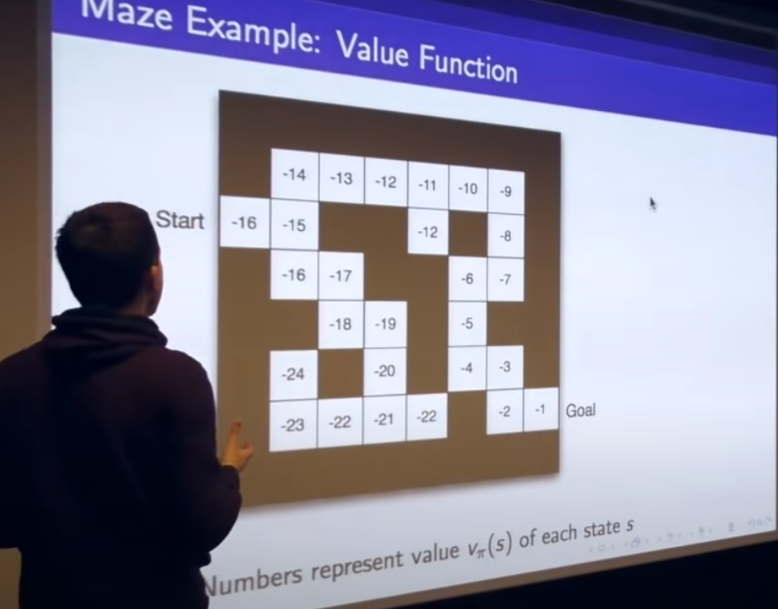

**4/ Categorizing RL Agent:**

* **Value Based Algorithms / Agent** = Value Function => Look at the value function and pick the best action.
* **Policy Based Algorithms / Agent** = Look at the arrow and adjust the arrow to the best course of action.
* **Actor Critic:**

+ Policy + Value Function

* **Model Free RL:**

+ Policy and/or Value Function no model

+ We not trying to understand the environment

* **Model Based RL:**

+ Policy and/or Value Function

+ Model

+ Build the environment model and predict what will happen to the agent if it act certain way in the environment

**5/ Problems within RL:**

a/ Learning and Planning:

* Two fundamental problems in sequential decision making:

+ **RL Problem**: The environment is initially known but the agent was not told how env work. and agent improves its policy

+ **Planning**: This is the environment with all the rule. The agent performs computations with its model (without any external interaction) and agent improves its policy

**6/ Exploration & Exploitation:**

* RL = Trials and Error learning
* The agent should discover a good policy from its experiences of the environment without losing too much reward along the way.
* Exploration = finds more info about the env
* Exploitation = exploits the known info to maximize the reward

**7/ Predictions and Control:**

* **Prediction** = evaluate the future

+ Given a policy

* **Control** = optimize the future

+ Find the best policy