Car Rental Database

Project 2 – Part 1

Kevin Phan, Michelle Nguyen, Angel Cardenas

October 29, 2021

Database System and File Structures

CSE 3330 – 004

Introduction:

This document will display the diagrams that describe the entities and relationships needed to keep track of information of a Car Rental Company’s database. The diagrams presented in this document include an EER Diagram and Relational Database Schema, along with a description of each diagram. Assumptions made about the Car Rental Company during the creation of the EER diagram are also included.

Mini-World Description:

Car Rental is a mini world environment consisting of 4 different entities including Customers, Car, Rental, and Rate. Some mini-world relationships are Customers rents Rentals, Cars are from the Rental, each Car has Rates, and each Rental is either a Weekly Rental or a Daily Rental.

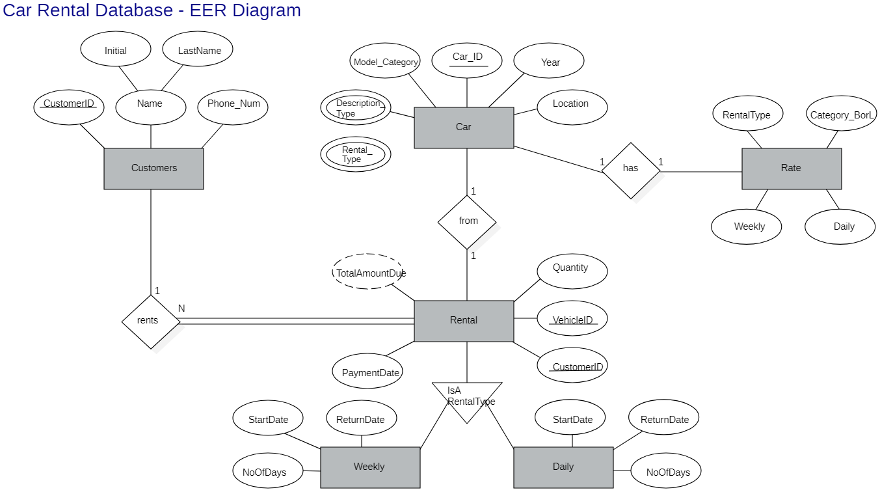

EER Diagram Explanation:

This scenario’s database contains 6 entities which are Customers, Car, Rate, Rental, Weekly, and Daily. For the first set of relationships, we have the Rental entity which serves as the connection entity between the Customers entity and the Car entity. The Rental entity uses the CustomerID attribute from Customers and Car_ID attribute from Car as a foreign key to form the connection. The Rental entity also branches into the Weekly and Daily entity through an IsA (boolean) relationship since rentals can be daily or weekly. Lastly, we also included a Rate entity which is connected to the Car entity using RentalType since different types of cars have different rates.

Relational Schema Diagram Explanation:

The relational schema consists of 4 entities which are the Customers, Car, Rental, and Rate entities. The Customers entity has the CustomerID attribute as a primary key and the Car entity has the Vehicle_ID attribute as its primary key. The Rental entity serves as a link between the Customers and Car entity and uses the CustomerID and VehicleID from each entity for foreign keys. Furthermore, the Car entity is also connected to the Rental entity through the specification of its rental type in the RentalType attribute. Each car's rental rate may be different depending on its category (basic or luxury), description type (compact, medium, large, suv, truck, and van), and rental type (daily or weekly) which affects the overall rate. Therefore, the Rate entity will use the RentalType attribute from the Rental entity to form a connection to the Car entity.

HONOR CODE

I pledge, on my honor, to uphold UT Arlington's tradition of academic integrity, a tradition that values hard work and honest effort in the pursuit of academic excellence.

I promise that I will submit only work that I personally create or that I contribute to group collaborations, and I will appropriately reference any work from other sources. I will follow the highest standards of integrity and uphold the spirit of the Honor Code.