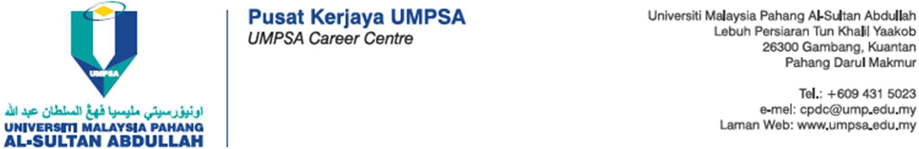

Our Reference : ${sal_reference_number} ( ${student_matric} )
Date : ${sal_release_date}


TO WHOM IT MAY CONCERN

Dear Sir/Madam,

APPLICATION FOR WORK BASED LEARNING (WBL) PLACEMENT

NAME | ${student_name:upper}
STUDENT ID | ${student_matric:upper}
FACULTY | FACULTY OF MECHANICAL AND AUTOMOTIVE ENGINEERING TECHNOLOGY
PROGRAMME | ${student_programme:upper}

I hereby confirm that the information provided herein is accurate, correct, and complete, as a student of Universiti Malaysia Pahang Al-Sultan Abdullah, Malaysia.

This is to inform you that the student will undergo WBL starting from ${group_start_date} to ${group_end_date}. For your information, our student needs to complete a Work Based Learning (WBL) programme, which includes several university-industry courses and industrial training, as one of their graduation requirements.

The student should be interviewed before an acceptance from your company and also assigned an Industrial Mentor upon the acceptance. Please find a set of REPLY FORM and the student’s resume for your perusal. Should your company offer a placement to our student, the university will send a Confirmation Letter for WBL Placement to your company with the appointment of an Industrial Coach assigned by your company.

Please do not hesitate to contact us at 09-4315023 or email to our WBL Coordinator, ${wbl_coordinator_name} for the ${student_programme}, Faculty of Mechanical and Automotive Engineering Technology at ${wbl_coordinator_email}, and via phone number at ${wbl_coordinator_phone}.

Thank you.

“MALAYSIA MADANI”

“BERKHIDMAT UNTUK NEGARA”
“Teknologi Untuk Masyarakat”

Yours Sincerely,
${director_signature}
( ${director_name:upper} )
Director
UMPSA Career Centre
Universiti Malaysia Pahang Al-Sultan Abdullah

