Openshift Kubernetes Distribution (OKD)
OKD Cluster Handbook: Design, Deployment, Operations & Troubleshooting
Document Generated: 31-01-2026

Document Revision History
Editor | Date | Description
Mirza Nehal Baig | 31-01-2026 | Initial creation with Architecture , Cluster Limitation, Costing, Installation
Mirza Nehal Baig | 21-01-2026 | User Provision OKD Cluster (Production Cluster)

Table of Contents
Document Revision History 2
Table of Contents 2
1. Introduction to OKD 3
2. Architecture 4
2.1 Custom operating system 4
2.2 Glossary of common terms for OKD architecture 5
3. OKD Cluster Limitation: 8
3.1 OKD tested cluster maximums for major releases 8
3.1.1 On Cloud: 9
3.1.2 On Prem: 9
4. OKD installation 10
4.1 Supported platforms for OKD clusters 11
4.2 Installation process details 12
4.3 Minimum Node for OKD Cluster 13
4.4 Minimum Resource Specification per Machine 13
5. Production OKD Installation 14
5.1 User-provisioned cluster on bare metal Design (HomeLab) 14
5.1.1 Systems Specification: 14
5.1.2 Network Architecture Diagram: 14
5.1.3 User-provisioned cluster on bare metal Network Table (HomeLab) 15
5.2 User-provisioned cluster on bare metal Pre-Steps (HomeLab) 16
5.2.1 Clone Repository - https://github.com/mnhomelab/OKD-BareMetal 16
5.2.2 Setup OC Installer and OC Client 16
5.2.3 Download StreamCentOS OS ISO Image and raw.tar.gz: 17
5.2.4 Make Stream CentOS OS ISO Image Bootable in USB: 17
5.3 User-provisioned cluster on bare metal Pre-Steps (HomeLab) 17
5.3.3 DHCP Server Setup (Service Node): 18
5.3.4 HAProxy Setup: 19
5.3.5 Setup Apache Web Server: 20
5.3.6 Setup NFS Server: 20
5.3.7 Static IP (Service Node): 21
5.3.8 Enable Internet on DHCP OKD Nodes - (Optional): 23
5.3.9 Setup OC Installer and OC Client 24
5.3.10 Add the ignition and SCOS files to the web server 25
5.3.9 Boot SCOS using USB and Apply Ignition File: 25
5.3.11 Boostrap Service: 25
5.4 User-provisioned cluster on bare metal Post-Steps (HomeLab) 29
5.4.1 Approve Certification Signing Request: 29
5.4.2 Configure Registry: 29
5.4.3 Configure Remote Access: 29
5.4.4 Make Master Unschedulable/Schedulable: 29
5.5 OKD Troubleshooting - User-provisioned cluster on bare metal 30
6. Single Node OKD 32
6.1 Pre-Requistes 32
6.2 Assisted Installer 32
6.3 OKD Troubleshooting 32
7. GPU Configuration with OKD Worker Node (Incomplete) 32
7.1 NVIDIA GPU Prequistes 32
7.1 Pre-Steps 33
7.2 Steps 33
7.2 Installing the NFD Operator using the CLI 35
8. Reference 35
Appendix 37

Introduction to OKD
OKD is a platform for developing and running containerized applications. It is designed to allow applications and the data centers that support them to expand from just a few machines and applications to thousands of machines that serve millions of clients.

With its foundation in Kubernetes, OKD incorporates the same technology that serves as the engine for massive telecommunications, streaming video, gaming, banking, and other applications. Its implementation in open Red Hat technologies lets you extend your containerized applications beyond a single cloud to on-premise and multi-cloud environments.

Architecture
OKD is a cloud-based Kubernetes container platform. The foundation of OKD is based on Kubernetes and therefore shares the same technology. To learn more about OKD and Kubernetes, see product architecture.

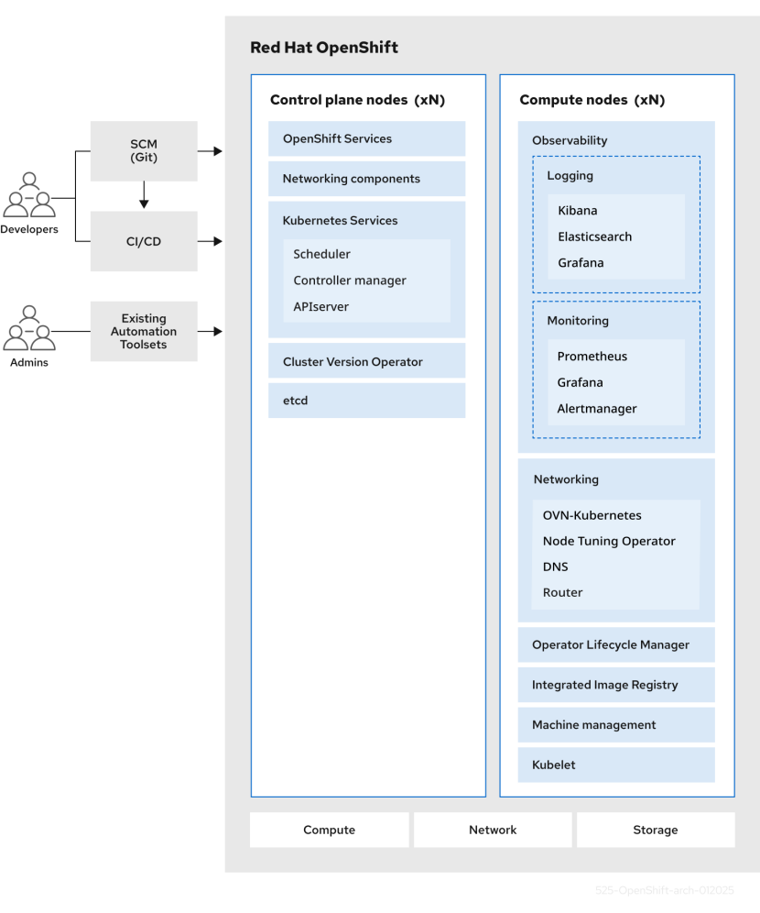

2.1 Custom operating system
OKD uses Fedora CoreOS (FCOS), a container-oriented operating system that is specifically designed for running containerized applications from OKD and works with new tools to provide fast installation, Operator-based management, and simplified upgrades.
FCOS includes:
- Ignition, which OKD uses as a firstboot system configuration for initially bringing up and configuring machines.
- CRI-O, a Kubernetes native container runtime implementation that integrates closely with the operating system to deliver an efficient and optimized Kubernetes experience. CRI-O provides facilities for running, stopping, and restarting containers. It fully replaces the Docker Container Engine, which was used in OKD 3.
- Kubelet, the primary node agent for Kubernetes that is responsible for launching and monitoring containers.
In OKD 4, you must use FCOS for all control plane machines, but you can use Red Hat Enterprise Linux (RHEL) as the operating system for compute machines, which are also known as worker machines. If you choose to use RHEL workers, you must perform more system maintenance than if you use FCOS for all of the cluster machines.

2.2 Glossary of common terms for OKD architecture
This glossary defines common terms that are used in the architecture content.
access policies
A set of roles that dictate how users, applications, and entities within a cluster interact with one another. An access policy increases cluster security.
admission plugins
Admission plugins enforce security policies, resource limitations, or configuration requirements.
authentication
To control access to an OKD cluster, a cluster administrator can configure user authentication to ensure only approved users access the cluster. To interact with an OKD cluster, you must authenticate with the OKD API. You can authenticate by providing an OAuth access token or an X.509 client certificate in your requests to the OKD API.
bootstrap
A temporary machine that runs minimal Kubernetes and deploys the OKD control plane.
certificate signing requests (CSRs)
A resource requests a denoted signer to sign a certificate. This request might get approved or denied.
Cluster Version Operator (CVO)
An Operator that checks with the OKD Update Service to see the valid updates and update paths based on current component versions and information in the graph.
compute nodes
Nodes that are responsible for executing workloads for cluster users. Compute nodes are also known as worker nodes.
configuration drift
A situation where the configuration on a node does not match what the machine config specifies.

containers
Lightweight and executable images that consist of software and all of its dependencies. Because containers virtualize the operating system, you can run containers anywhere, such as data centers, public or private clouds, and local hosts.
container orchestration engine
Software that automates the deployment, management, scaling, and networking of containers.
container workloads
Applications that are packaged and deployed in containers.
control groups (cgroups)
Partitions sets of processes into groups to manage and limit the resources processes consume.
control plane
A container orchestration layer that exposes the API and interfaces to define, deploy, and manage the life cycle of containers. Control planes are also known as control plane machines.
CRI-O
A Kubernetes native container runtime implementation that integrates with the operating system to deliver an efficient Kubernetes experience.
deployment
A Kubernetes resource object that maintains the life cycle of an application.
Dockerfile
A text file that contains the user commands to perform on a terminal to assemble the image.
hosted control planes
A OKD feature that enables hosting a control plane on the OKD cluster from its data plane and workers. This model performs the following actions:
- Optimize infrastructure costs required for the control planes.
- Improve the cluster creation time.
- Enable hosting the control plane using the Kubernetes native high level primitives. For example, deployments and stateful sets.
- Allow a strong network segmentation between the control plane and workloads.
hybrid cloud deployments
Deployments that deliver a consistent platform across bare metal, virtual, private, and public cloud environments. This offers speed, agility, and portability.
Ignition
A utility that FCOS uses to manipulate disks during initial configuration. It completes common disk tasks, including partitioning disks, formatting partitions, writing files, and configuring users.
installer-provisioned infrastructure
The installation program deploys and configures the infrastructure that the cluster runs on.
kubelet
A primary node agent that runs on each node in the cluster to ensure that containers are running in a pod.
kubernetes manifest
Specifications of a Kubernetes API object in a JSON or YAML format. A configuration file can include deployments, config maps, secrets, daemon sets.
Machine Config Daemon (MCD)
A daemon that regularly checks the nodes for configuration drift.
Machine Config Operator (MCO)
An Operator that applies the new configuration to your cluster machines.
machine config pools (MCP)
A group of machines, such as control plane components or user workloads, that are based on the resources that they handle.
metadata
Additional information about cluster deployment artifacts.
microservices
An approach to writing software. Applications can be separated into the smallest components, independent from each other by using microservices.
mirror registry
A registry that holds the mirror of OKD images.
monolithic applications
Applications that are self-contained, built, and packaged as a single piece.
namespaces
A namespace isolates specific system resources that are visible to all processes. Inside a namespace, only processes that are members of that namespace can see those resources.
networking
Network information of OKD cluster.
node
A worker machine in the OKD cluster. A node is either a virtual machine (VM) or a physical machine.
OpenShift CLI (oc)
A command-line tool to run OKD commands on the terminal.
OpenShift Dedicated
A managed Fedora OKD offering on Amazon Web Services (AWS) and Google Cloud. OpenShift Dedicated focuses on building and scaling applications.
OpenShift Update Service (OSUS)
For clusters with internet access, Fedora provides over-the-air updates by using an OpenShift update service as a hosted service located behind public APIs.
OpenShift image registry
A registry provided by OKD to manage images.
Operator
The preferred method of packaging, deploying, and managing a Kubernetes application in an OKD cluster. An Operator takes human operational knowledge and encodes it into software that is packaged and shared with customers.
OperatorHub
A platform that contains various OKD Operators to install.
Operator Lifecycle Manager (OLM)
OLM helps you to install, update, and manage the lifecycle of Kubernetes native applications. OLM is an open source toolkit designed to manage Operators in an effective, automated, and scalable way.

OSTree
An upgrade system for Linux-based operating systems that performs atomic upgrades of complete file system trees. OSTree tracks meaningful changes to the file system tree using an addressable object store, and is designed to complement existing package management systems.
over-the-air (OTA) updates
The OKD Update Service (OSUS) provides over-the-air updates to OKD, including Fedora CoreOS (FCOS).
pod
One or more containers with shared resources, such as volume and IP addresses, running in your OKD cluster. A pod is the smallest compute unit defined, deployed, and managed.
private registry
OKD can use any server implementing the container image registry API as a source of the image which allows the developers to push and pull their private container images.
public registry
OKD can use any server implementing the container image registry API as a source of the image which allows the developers to push and pull their public container images.
Fedora OKD Cluster Manager
A managed service where you can install, modify, operate, and upgrade your OKD clusters.
Fedora Quay Container Registry
A Quay.io container registry that serves most of the container images and Operators to OKD clusters.
replication controllers
An asset that indicates how many pod replicas are required to run at a time.
role-based access control (RBAC)
A key security control to ensure that cluster users and workloads have only access to resources required to execute their roles.
route
Routes expose a service to allow for network access to pods from users and applications outside the OKD instance.
scaling
The increasing or decreasing of resource capacity.
service
A service exposes a running application on a set of pods.
Source-to-Image (S2I) image
An image created based on the programming language of the application source code in OKD to deploy applications.
storage
OKD supports many types of storage, both for on-premise and cloud providers. You can manage container storage for persistent and non-persistent data in an OKD cluster.
Telemetry
A component to collect information such as size, health, and status of OKD.
template
A template describes a set of objects that can be parameterized and processed to produce a list of objects for creation by OKD.

user-provisioned infrastructure
You can install OKD on the infrastructure that you provide. You can use the installation program to generate the assets required to provision the cluster infrastructure, create the cluster infrastructure, and then deploy the cluster to the infrastructure that you provided.
web console
A user interface (UI) to manage OKD.
worker node
Nodes that are responsible for executing workloads for cluster users. Worker nodes are also known as compute nodes.

OKD Cluster Limitation:

3.1 OKD tested cluster maximums for major releases

3.1.1 On Cloud:
to do cost estimation and resource calculation required for cloud regarding OCP, we have caclulator to estimate
https://access.redhat.com/labs/ocplimitscalculator/

3.1.2 On Prem:
Maximum Tested Cluster Scale (4.x)

Resource Type | Maximum Tested Value | Notes / Conditions
Number of Nodes | 2,000 | Tested cluster size
Number of Pods | 150,000 | Total across cluster
Pods per Node | 2,500 | Upper tested scheduling density
Namespaces | 10,000 | Logical isolation units
Builds | 10,000 | S2I strategy with default pod RAM 512 Mi
Pods per Namespace | 25,000 | High multi-tenant workload
Routes (2 default routers) | 9,000 | Ingress capacity
Secrets | 80,000 | Includes service + application secrets
ConfigMaps | 90,000 | Application configuration objects
Services | 10,000 | Cluster-wide services
Services per Namespace | 5,000 | Per tenant/app space
Backends per Service | 5,000 | Large-scale load balancing
Deployments per Namespace | 2,000 | Application rollout objects
BuildConfigs | 12,000 | OpenShift build definitions
Custom Resource Definitions (CRDs) | 1,024 | API extensions limit

Pause pods were deployed to stress the control plane components of OKD at 2000 node scale. The ability to scale to similar numbers will vary depending upon specific deployment and workload parameters.

The pod count displayed here is the number of test pods. The actual number of pods depends on the application’s memory, CPU, and storage requirements.

This was tested on a cluster with 31 servers: 3 control planes, 2 infrastructure nodes, and 26 worker nodes. If you need 2,500 user pods, you need both a hostPrefix of 20, which allocates a network large enough for each node to contain more than 2000 pods, and a custom kubelet config with maxPods set to 2500. For more information, see Running 2500 pods per node on OCP 4.13.

When there are a large number of active projects, etcd might suffer from poor performance if the keyspace grows excessively large and exceeds the space quota. Periodic maintenance of etcd, including defragmentation, is highly recommended to free etcd storage.

There are several control loops in the system that must iterate over all objects in a given namespace as a reaction to some changes in state. Having a large number of objects of a given type in a single namespace can make those loops expensive and slow down processing given state changes. The limit assumes that the system has enough CPU, memory, and disk to satisfy the application requirements.

Each service port and each service back-end has a corresponding entry in iptables. The number of back-ends of a given service impact the size of the Endpoints objects, which impacts the size of data that is being sent all over the system.

Tested on a cluster with 29 servers: 3 control planes, 2 infrastructure nodes, and 24 worker nodes. The cluster had 500 namespaces. OKD has a limit of 1,024 total custom resource definitions (CRD), including those installed by OKD, products integrating with OKD and user-created CRDs. If there are more than 1,024 CRDs created, then there is a possibility that oc command requests might be throttled.

Read more at https://docs.okd.io/latest/scalability_and_performance/planning-your-environment-according-to-object-maximums.html#planning-your-environment-according-to-object-maximums

OKD installation
The OKD installation program offers four methods for deploying a cluster which are detailed in the following list:
- Interactive: You can deploy a cluster with the web-based Assisted Installer. This is an ideal approach for clusters with networks connected to the internet. The Assisted Installer is the easiest way to install OKD, it provides smart defaults, and it performs pre-flight validations before installing the cluster. It also provides a RESTful API for automation and advanced configuration scenarios.
- Local Agent-based: You can deploy a cluster locally with the Agent-based Installer for disconnected environments or restricted networks. It provides many of the benefits of the Assisted Installer, but you must download and configure the Agent-based Installer first. Configuration is done with a command-line interface. This approach is ideal for disconnected environments.
  - Additionally, you can deploy a cluster without an external registry, using self-contained installation media that also provides a simplified user interface similar to the Assisted Installer during on-premise installations. For more information, see "Installing a cluster without an external registry".
- Automated: You can deploy a cluster on installer-provisioned infrastructure. The installation program uses each cluster host’s baseboard management controller (BMC) for provisioning. You can deploy clusters in connected or disconnected environments.
- Full control: You can deploy a cluster on infrastructure that you prepare and maintain, which provides maximum customizability. You can deploy clusters in connected or disconnected environments.
  - Each method deploys a cluster with the following characteristics:
  - Highly available infrastructure with no single points of failure, which is available by default.
  - Administrators can control what updates are applied and when.

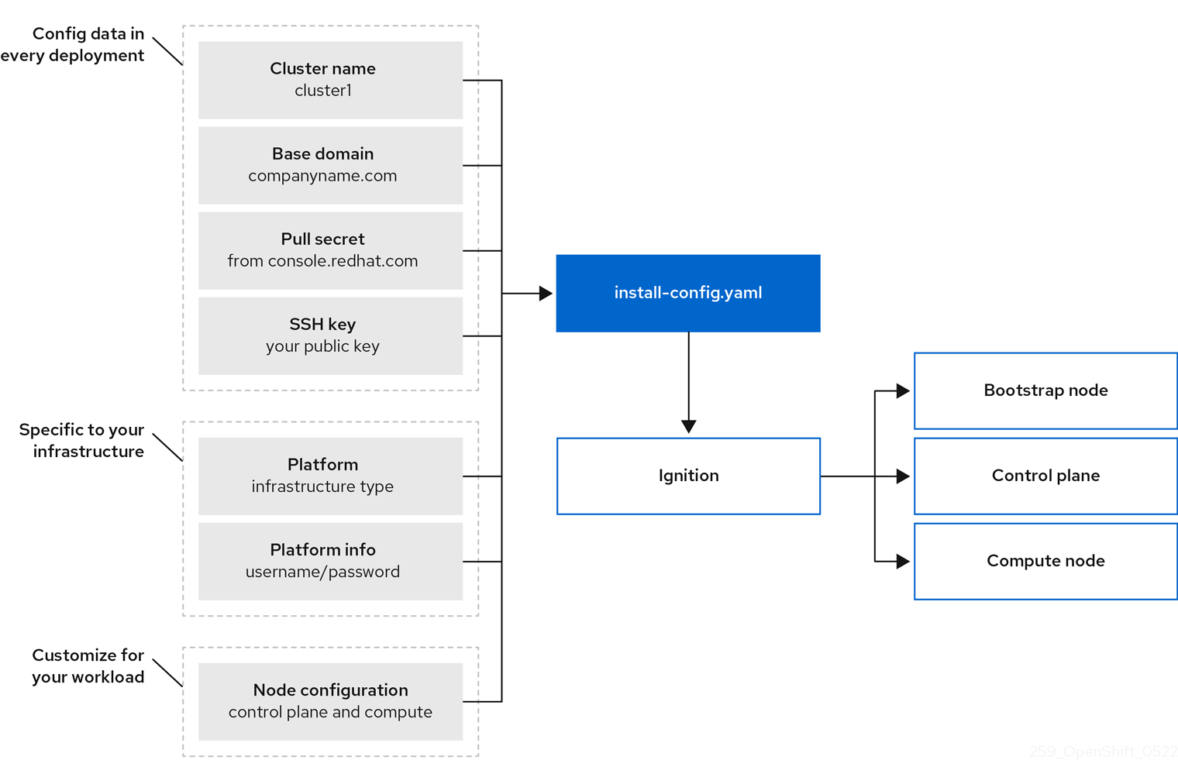

4.1 Supported platforms for OKD clusters
read more at https://docs.okd.io/latest/architecture/architecture-installation.html#supported-platforms-for-openshift-clusters_architecture-installation
Platform | Installer-provisioned infrastructure | User-provisioned infrastructure | Agent-based dcxxInstaller | Assisted Installer
Amazon Web Services (AWS) | ❌ | ✅ | ❌ | ✅
Bare metal | ❌ | ✅ | ✅ | ✅
External | ❌ | ✅ | ❌ | ✅
Google Cloud | ❌ | ✅ | ❌ | ✅
IBM Cloud® Classic | ❌ | ✅ | ❌ | ❌
IBM Cloud® Virtual Private Cloud (VPC) | ❌ | ✅ | ❌ | ❌
IBM Power® | ❌ | ✅ | ✅ | ❌
IBM Z® / IBM® LinuxONE | ❌ | ✅ | ✅ | ❌
Microsoft Azure | ❌ | ✅ | ❌ | ❌
Microsoft Azure Stack Hub | ❌ | ✅ | ❌ | ❌
None (existing infrastructure) | ❌ | ✅ | ❌ | ❌
Nutanix | ❌ | ✅ | ❌ | ❌
Oracle Cloud Infrastructure (OCI) | ❌ | ✅ | ❌ | ❌
OpenStack | ❌ | ✅ | ❌ | ❌
VMware vSphere | ❌ | ✅ | ✅ | ✅

- For installer-provisioned infrastructure: All machines, including the computer that you run the installation process on, must have direct internet access to pull images for platform containers and provide telemetry data to Red Hat.

- For user-provisioned infrastructure: Depending on the supported cases for the platform, you can perform installations on user-provisioned infrastructure so that you can run machines with full internet access, place your cluster behind a proxy, or perform a disconnected installation.
In a disconnected installation, you can download the images that are required to install a cluster, place them in a mirror registry, and use that data to install your cluster. While you require internet access to pull images for platform containers, with a disconnected installation on vSphere or bare-metal infrastructure, your cluster machines do not require direct internet access.
- For OpenStack: The latest OKD release supports both the latest OpenStack long-life release and intermediate release. For complete OpenStack release compatibility, see the OKD on OpenStack support matrix.

Except for the Assisted Installer, when you install an OKD cluster, you must download the installation program from https://github.com/openshift/okd/releases.

4.2 Installation process details
Bootstrapping a cluster involves the following steps:
- The bootstrap machine boots and starts hosting the remote resources required for the control plane machines to boot. If you provision the infrastructure, this step requires manual intervention.
- The bootstrap machine starts a single-node etcd cluster and a temporary Kubernetes control plane.
- The control plane machines fetch the remote resources from the bootstrap machine and finish booting. If you provision the infrastructure, this step requires manual intervention.
- The temporary control plane schedules the production control plane to the production control plane machines.
- The Cluster Version Operator (CVO) comes online and installs the etcd Operator. The etcd Operator scales up etcd on all control plane nodes.
- The temporary control plane shuts down and passes control to the production control plane.
- The bootstrap machine injects OKD components into the production control plane.
- The installation program shuts down the bootstrap machine. If you provision the infrastructure, this step requires manual intervention.
- The control plane sets up the compute nodes.
- The control plane installs additional services in the form of a set of Operators.
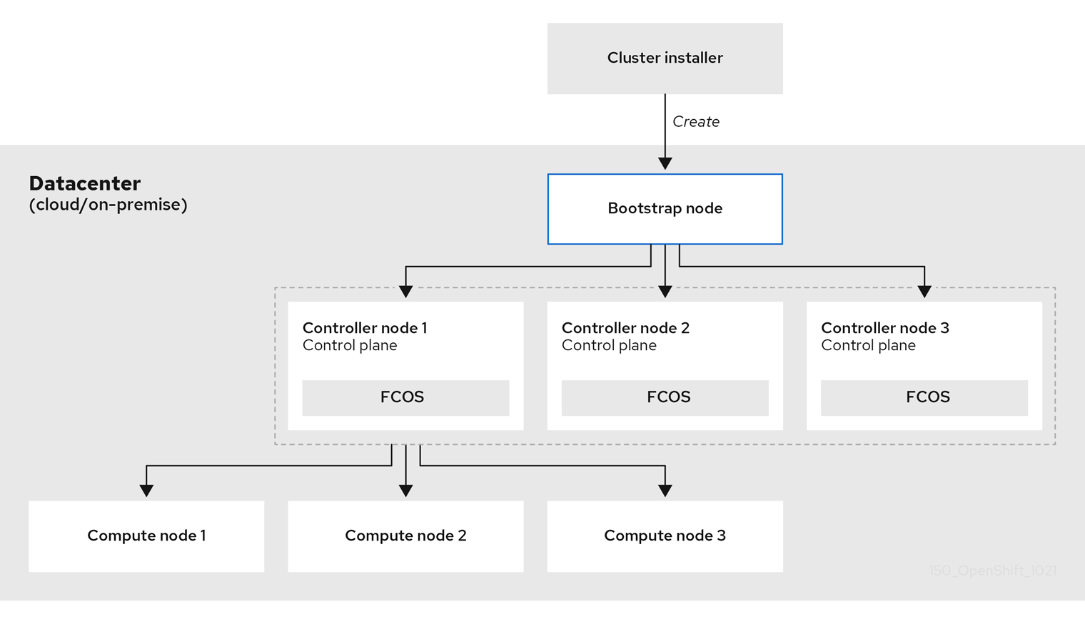
Read more about update at https://docs.okd.io/latest/architecture/architecture-installation.html#update-service-about_architecture-installation

4.3 Minimum Node for OKD Cluster
The bootstrap and control plane machines must use Fedora CoreOS (FCOS) as the operating system. However, the compute machines can choose between Fedora CoreOS (FCOS), Fedora 8.6 and later.

Hosts | Description
One temporary bootstrap machine | The cluster requires a bootstrap machine to initialize and deploy the OKD cluster on the control plane nodes. This machine is only needed during installation and can be safely removed after the cluster is fully operational.
Three control plane machines | These machines run the core Kubernetes and OKD services, including API server, scheduler, controller manager, and etcd, forming the cluster’s control plane and managing overall cluster state.
At least two compute (worker) machines | Worker machines run application workloads, pods, and services requested by OKD users. They provide the compute capacity and scale horizontally based on workload demand.

4.4 Minimum Resource Specification per Machine
Machine | Operating System | CPU (vCPU) | RAM | Storage | IOPS
Bootstrap | FCOS (Fedora CoreOS) | 4 | 16 GB | 100 GB | 300
Control Plane | FCOS (Fedora CoreOS) | 4 | 16 GB | 100 GB | 300
Compute (Worker) | FCOS (Fedora CoreOS) | 2 | 8 GB | 100 GB | 300

- One CPU is equivalent to one physical core when simultaneous multithreading (SMT), or Hyper-Threading, is not enabled. When enabled, use the following formula to calculate the corresponding ratio: (threads per core × cores) × sockets = CPUs.

- OKD and Kubernetes are sensitive to disk performance, and faster storage is recommended, particularly for etcd on the control plane nodes which require a 10 ms p99 fsync duration. Note that on many cloud platforms, storage size and IOPS scale together, so you might need to over-allocate storage volume to obtain sufficient performance

- As with all user-provisioned installations, if you choose to use Fedora compute machines in your cluster, you take responsibility for all operating system life cycle management and maintenance, including performing system updates, applying patches, and completing all other required tasks. Use of Fedora 7 compute machines is deprecated and has been removed in OKD 4.10 and later.

read more at https://docs.okd.io/latest/installing/installing_bare_metal/upi/installing-bare-metal.html#installing-bare-metal

Production OKD Installation

User-provisioned cluster on bare metal Design (HomeLab)

5.1.1 Systems Specification:
Sr# | Name | Machine Model | Purpose | Architecture | *vCPU | **Memory | ***Storage (SSD/NVME)
1 | Intel NUC | NUC7i5BNH | Service | Intel i5-7260 CPU @ 2.20GHz | 4vcpu | 8GB DDR4 | 250GB
2 | JPYXKM | DAD600 / DLL600D | Bootstrap | Intel N100 CPU @ 3.4GHz | 4vcpu | 12GB DDR5 | 512GB
3 | GMKtec NucBox | K9 Mini | Control Plane | Intel Ultra 125H @ 5.10 GHz | 18vcpu | 32GB DDR5 | 250GB+1TB
4 | HP EliteDesk | 705 G4 35W (396) | Control Plane | ryzen 5 pro 2400ge @ 3.2 GHz | 8vcpu | 32GB DDR4 | 250GB
5 | HP EliteDesk | 705 G4 36W (215) | Control Plane | ryzen 5 pro 2400ge @ 3.2 GHz | 8vcpu | 32GB DDR5 | 250GB
6 | GMKtec NucBox | K8 Plus Mini | Worker Node | AMD Ryzen™ 7 8845HS @ 5.1Ghz | 16vcpu | 96GB DDR5 | 128gb +1 TB
7 | GMKtec NucBox | K12 Mini | Worker Node | AMD Ryzen™ 7 H 255 @ 3.8 GHz | 16vcpu | 32GB DDR5 | 128gb +1 TB

*For CPU, use following command:
lscpu
** For Memory, use following command:
free -h
***For Storage, use following command:
lsblk
****To calculateIOPS, use following command:
sudo mkdir -p /var/tmp/fio
sudo fio --name=etcd-okd-test \ --directory=/var/tmp/fio \ --rw=randwrite \ --bs=4k \ --iodepth=1 \ --numjobs=1 \ --size=5G \ --runtime=60 \ --time_based \ --direct=1 \ --ioengine=libaio \ --fsync=1 \ --group_reporting

5.1.2 Network Architecture Diagram:
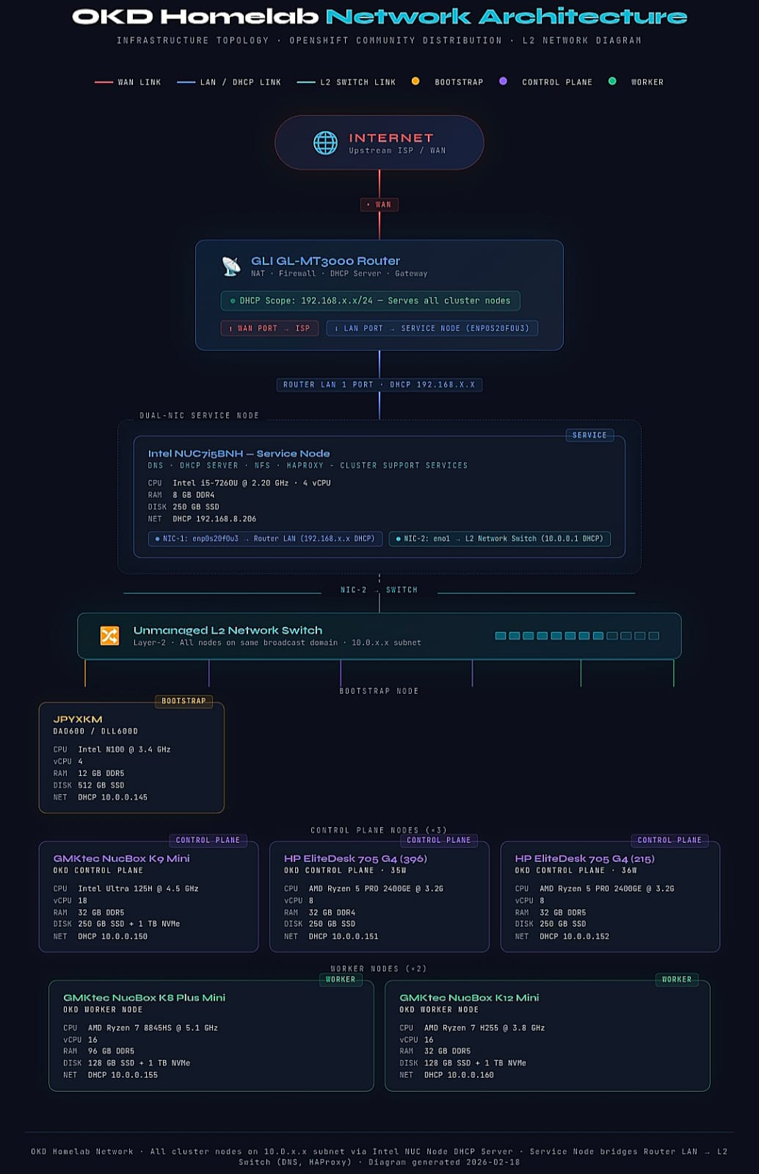

Preview at fullscale: https://mnhomelab.github.io/OKD-BareMetal/

5.1.3 User-provisioned cluster on bare metal Network Table (HomeLab)
# | Name | Machine Model | Purpose | Linux | IP Address | Hostname | MAC Address | Image
1 | Intel NUC | NUC7i5BNH | Service | Omarchy Linux | 192.168.8.206  10.0.0.1 | okd.mnhomelabs.com | EC:9A:0C:1B:17:84  F4:4D:30:6F:39:A3
2 | JPYXKM | DAD600 / DLL600D | Bootstrap | Fedora Core | 10.0.0.145 | bootstrap.okd.mnhomelabs.com | E0:51:D8:17:54:FC | 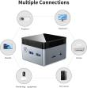
3 | GMKtec NucBox | K12 Mini | Worker Node | Fedora Core | 10.0.0.150 | control-plane1.okd.mnhomelabs.com | 84:47:09:71:F4:4B
4 | HP EliteDesk | 705 G4 35W (396) | Control Plane | Fedora Core | 10.0.0.151 | control-plane2.okd.mnhomelabs.com | 80:E8:2C:2A:36:0D | 
5 | HP EliteDesk | 705 G4 36W (215) | Control Plane | Fedora Core | 10.0.0.152 | control-plane3.okd.mnhomelabs.com | 04:0E:3C:89:12:2F
6 | GMKtec NucBox | K8 Plus Mini | Worker Node | Fedora Core | 10.0.0.155 | compute1.okd.mnhomelabs.com | C8:FF:BF:0F:7C:43
7 | GMKtec NucBox | K9 Mini | Worker Plane | Fedora Core | 10.0.0.160 | compute2.okd.mnhomelabs.com | 84:47:09:54:7D:C9

User-provisioned cluster on bare metal Pre-Steps (HomeLab)
we have disabled firewall for testing purpose, but if you want to enable them, find out about it here https://docs.okd.io/latest/installing/installing_bare_metal/upi/installing-bare-metal.html#installation-network-connectivity-user-infra_installing-bare-metal

5.2.1 Clone Repository - https://github.com/mnhomelab/OKD-BareMetal
git clone https://github.com/mnhomelab/OKD-BareMetal.git

5.2.2 Setup OC Installer and OC Client
1) Install Openshift-installer
link: https://github.com/okd-project/okd/releases/tag/4.20.0-okd-scos.11
wget https://github.com/okd-project/okd/releases/download/4.20.0-okd-scos.11/openshift-install-linux-4.20.0-okd-scos.11.tar.gz
tar -xvzf openshift-install-linux-4.21.0-okd-scos.6.tar.gz
sudo mv openshift-install /usr/bin/
- Install Openshift-Client
wget https://github.com/okd-project/okd/releases/download/4.20.0-okd-scos.11/openshift-client-linux-4.20.0-okd-scos.11.tar.gz
tar -xvzf openshift-client-linux-4.20.0-okd-scos.11.tar.gz

sudo cp kubectl oc /usr/bin
- a Quick OKD Installer and Client Sanity Check
oc version
Client Version: 4.20.0-okd-scos.11
Kustomize Version: v5.6.0

openshift-install version
openshift-install 4.20.0-okd-scos.11
built from commit 5b017f5fa073c7979416a3ce02715e34d2213da6
release image quay.io/okd/scos-release@sha256:f9deda679ec53ad95d5d6b7471daea9dc76b57a12f68fa5ea4040507cf615418
release architecture multi
default architecture amd64
Note: release image should be quay.io/openshift-release-dev/okd-release....

5.2.3 Download StreamCentOS OS ISO Image and raw.tar.gz:
In Service Node, Download the ISO Image and the raw.xz file
mkdir ~/okd-images

cd ~/okd-images/
For ISO:
curl -O $(openshift-install coreos print-stream-json | jq -r '.architectures.x86_64.artifacts.metal.formats.iso.disk.location')

FOR RAW.GZ:
curl -O $(openshift-install coreos print-stream-json | jq -r '.architectures.x86_64.artifacts.metal.formats["raw.gz"].disk.location')

5.2.4 Make Stream CentOS OS ISO Image Bootable in USB:
For Window User:
Attach usb and Open Rufus Software (https://github.com/pbatard/rufus/releases/download/v4.13/rufus-4.13.exe)
Partition Scheme: MBR 
Target System: BIOS or UEFI 
File System: Large FAT32 
Cluster Size: 32 kilobytes (Default) 
Write in DD Mode

For Linux:

Attach usb and check which block is usb, in our case it is /dev/sda
cd ~/okd-images
- Identify your USB device:
lsblk

- write the image:
sudo dd if=scos-10.0.20251103-0-metal.x86_64.iso of=/dev/sda bs=4M status=progress
sync

User-provisioned cluster on bare metal Pre-Steps (HomeLab)

5.3.1 DNS Server Setup (Service Node):
1) Install DNS on service machine (Arch Linux)
sudo pacman -S bind -y

- Take backup of main DNS configuration file

cp /etc/named.conf /etc/named.conf-original!

- make modification of ip and copy the file named.conf
cd <repository-location>
cp scripts/DNS-Server/named.conf /etc/named.conf
sudo chown root:named /etc/named.conf
sudo chmod 640 /etc/named.conf

- Check for Syntax Error
named-checkconf

- Create the required directory for logs with appropriate permission and ownership

mkdir /var/named/log/
chown named:named /var/named/log/
chmod 700 /var/named/log/

- Define Forward Zone
change Ip address in okd.mnhomelabs.com.zone file and then copy it to /var/named/
cp scripts/DNS-Server/okd.mnhomelabs.com.zone /var/named/

- Define Reverse Zone
cp scripts/DNS-Server/0.0.10.in-addr.arpa.zone /var/named/

- Set Permission
chown root:named /var/named/okd.mnhomelabs.com.zone
chown root:named /var/named/0.0.10.in-addr.arpa.zone

chmod 640 /var/named/okd.mnhomelabs.com.zone
chmod 640 /var/named/0.0.10.in-addr.arpa.zone

sudo chmod 640 /var/named /var/named/dynamic
sudo chown -R named:named /var/named
sudo chmod 750 /var/named
sudo find /var/named -type d -exec chmod 750 {} \;
sudo find /var/named -type f -exec chmod 640 {} \;

Run named-checkzone file for any errors.

named-checkzone okd.mnhomelabs.com /var/named/okd.mnhomelabs.com.zone
named-checkzone 0.0.10.in-addr.arpa /var/named/0.0.10.in-addr.arpa.zone

- Start Service
Start and enable the service persistently

systemctl enable --now named
systemctl restart named.service

systemctl status named.service

- Check DNS Resolution
dig -4 +short @127.0.0.1 A ns1.okd.mnhomelabs.com
dig -4 +short @127.0.0.1 A api.okd.mnhomelabs.com
dig -4 +short @10.0.0.1 A api.okd.mnhomelabs.com
dig -4 +short @10.0.0.1 -x 10.0.0.1
- Firewall
sudo ufw status
sudo ufw allow dns

5.3.2 DHCP Server Setup (Service Node):
1) Install DHCP Server on service machine (Arch Linux):
sudo pacman -S dhcp

- Copy dhcpd.conf configuration
cd <repository-location>
cp scripts/DHCP-Server/dhcpd.conf /etc/dhcpd.conf

- Firewall
sudo ufw status
sudo ufw allow 67/udp
sudo ufw allow 68/udp

- Enable and Start the Service:
sudo systemctl enable --now dhcpd4.service

- Verify Status:
systemctl status dhcpd4.service

5.3.3 HAProxy Setup:
1) Install HAProxy on service machine (Arch Linux)
sudo pacman -S haproxy -y

- make modification of ip and copy the file named.conf
cd <repository-location>
cp scripts/HAProxy/haproxy.cfg /etc/haproxy/
sudo chown root:named /etc/haproxy/haproxy.cfg
sudo chmod 640 /etc/haproxy/haproxy.cfg

sudo mkdir -p /var/lib/haproxy
sudo chown -R haproxy:haproxy /var/lib/haproxy
sudo chmod 750 /var/lib/haproxy

- firewall
sudo ufw allow proto tcp to any port 6443,22623,443,80
sudo ufw reload
sudo ufw status verbose
- Enable and start the service
systemctl enable --now haproxy.service
systemctl start haproxy.service

systemctl restart haproxy.service
systemctl status haproxy.service

- Test
Before proceeding with further steps make sure to verify all DNS are resolvable.

Command:
dig +noall +answer 10.0.0.1 api.okd.mnhomelabs.com
dig +noall +answer 10.0.0.1 api-int.okd.mnhomelabs.com
dig +noall +answer 10.0.0.1 console-openshift-console.apps.okd.ms1.la
dig +noall +answer 10.0.0.1 someapp.apps.okd.mnhomelabs.com
dig +noall +answer 10.0.0.145 bootstrap.okd.mnhomelabs.com

dig +noall +answer 10.0.0.1 -x 10.0.0.145
dig +noall +answer 10.0.0.1 -x 10.0.0.150
dig +noall +answer 10.0.0.1 -x 10.0.0.151
dig +noall +answer 10.0.0.1 -x 10.0.0.152
dig +noall +answer 10.0.0.1 -x 10.0.0.155
dig +noall +answer 10.0.0.1 -x 10.0.0.160

Output:
api.okd.mnhomelabs.com. 6125 IN A 10.0.0.1
api-int.okd.mnhomelabs.com. 6125 IN A 10.0.0.1
someapp.apps.okd.mnhomelabs.com. 6125 IN A 10.0.0.1
bootstrap.okd.mnhomelabs.com. 6126 IN A 10.0.0.145
145.0.0.10.in-addr.arpa. 6135 IN PTR bootstrap.okd.mnhomelabs.com.
150.0.0.10.in-addr.arpa. 6135 IN PTR control-plane1.okd.mnhomelabs.com.
151.0.0.10.in-addr.arpa. 6135 IN PTR control-plane2.okd.mnhomelabs.com.
152.0.0.10.in-addr.arpa. 6135 IN PTR control-plane3.okd.mnhomelabs.com.
155.0.0.10.in-addr.arpa. 6135 IN PTR compute1.okd.mnhomelabs.com.
160.0.0.10.in-addr.arpa. 6135 IN PTR compute2.okd.mnhomelabs.com.

5.3.4 Setup Apache Web Server:
1) Install Apache Web Server on service machine (Arch Linux)

sudo pacman -Syu apache

- change default listen port to 8080 in httpd.conf

sed -i 's/Listen 80/Listen 0.0.0.0:8080/' /etc/httpd/conf/httpd.conf

- enable and start the service
systemctl enable httpd
systemctl start httpd
systemctl status httpd

- test
curl http://localhost:8080

5.3.5 Setup NFS Server:
1) Update system + install NFS utilities on Arch Linux
sudo pacman -Syu nfs-utils

(Optional) Verify package is installed:

pacman -Qs nfs-utils

2) Create the export directory
sudo mkdir -p /shares/registry

- Set ownership (common for NFS exports):

sudo chown nobody:nobody /shares/registry

- Set permissions:

sudo chmod 755 /shares/registry

5) Configure NFS exports (/etc/exports)

Edit exports file:

sudo vi /etc/exports

Add this line (recommended format):

/shares/registry 10.0.0.0/24(rw,sync,no_subtree_check,root_squash,no_wdelay)

✅ Note: Use normal double-quotes in shell commands. Your pasted command had smart quotes “ ” which will break in Linux.

If you want to write it using echo safely:

echo "/shares/registry 10.0.0.0/24(rw,sync,no_subtree_check,root_squash,no_wdelay)" | sudo tee /etc/exports

6) Apply the export configuration
sudo exportfs -rv

Confirm exports:

sudo exportfs -v

7) Enable and start NFS services

Enable + start:

sudo systemctl enable --now rpcbind nfs-server

Start remaining components (usually not necessary separately, but okay):

sudo systemctl start nfs-mountd nfs-server rpcbind

Check status:

systemctl status nfs-server

5.3.6 Static IP (Service Node):
For enp0s20f0u2 Port, I have configured static ip for NIC-1 192.168.8.206 from the router DHCP Server

To Check:
ip a
...
2: enp0s20f0u2: <BROADCAST,MULTICAST,UP,LOWER_UP> mtu 1500 qdisc fq_codel state UNKNOWN group default qlen 1000
link/ether ec:9a:0c:1b:17:84 brd ff:ff:ff:ff:ff:ff
altname enxec9a0c1b1784
inet 192.168.8.206/24 metric 1024 brd 192.168.8.255 scope global dynamic enp0s20f0u3
valid_lft 42674sec preferred_lft 42674sec
inet6 fe80::ee9a:cff:fe1b:1784/64 scope link proto kernel_ll
valid_lft forever preferred_lft forever
...
- Check Status of Interface

networkctl status eno1
- If Offline / Degraded,
create a file /etc/systemd/network/10-wan.network

[Match]
# Matching with "Type=ether" causes issues with containers because it also matches virtual Ethernet interfaces (veth*).
# See https://bugs.archlinux.org/task/70892
# Instead match by globbing the network interface name.
Name=eno1

[Link]
RequiredForOnline=routable

[Network]
Address=10.0.0.1/24
DNS=10.0.0.1

# systemd-networkd does not set per-interface-type default route metrics
# https://github.com/systemd/systemd/issues/17698
# Explicitly set route metric, so that Ethernet is preferred over Wi-Fi and Wi-Fi is preferred over mobile broadband.
# Use values from NetworkManager. From nm_device_get_route_metric_default in
# https://gitlab.freedesktop.org/NetworkManager/NetworkManager/-/blob/main/src/core/devices/nm-device.c
[DHCPv4]
RouteMetric=100

[IPv6AcceptRA]
RouteMetric=100

then edit the network file
/etc/systemd/network/20-ethernet.network
[Match]
# Matching with "Type=ether" causes issues with containers because it also matches virtual Ethernet interfaces (veth*).
# See https://bugs.archlinux.org/task/70892
# Instead match by globbing the network interface name.
Name=enp*
[Link]
RequiredForOnline=routable

[Network]
DHCP=yes
MulticastDNS=yes

# systemd-networkd does not set per-interface-type default route metrics
# https://github.com/systemd/systemd/issues/17698
# Explicitly set route metric, so that Ethernet is preferred over Wi-Fi and Wi-Fi is preferred over mobile broadband.
# Use values from NetworkManager. From nm_device_get_route_metric_default in
# https://gitlab.freedesktop.org/NetworkManager/NetworkManager/-/blob/main/src/core/devices/nm-device.c
[DHCPv4]
RouteMetric=100

[IPv6AcceptRA]
RouteMetric=100

- Enable networkd
sudo systemctl enable --now systemd-networkd

- Check and if Service Found,Disable NetworkManager (Optional but recommended)

sudo systemctl status NetworkManager

sudo systemctl disable NetworkManager

- Check and if Service Not Started,Enable Systemd Networkd

Check if Active or not by following command:
systemctl is-active systemd-networkd

Start by following command:
sudo systemctl enable --now systemd-networkd

restart by following command:
sudo systemctl restart systemd-networkd

- Check Status
networkctl status eno1
● 3: eno1
Link File: /usr/lib/systemd/network/99-default.link
Network File: /etc/systemd/network/20-ethernet.network
State: routable (configured)
Online state: online

ip a
...
3: eno1: <BROADCAST,MULTICAST,UP,LOWER_UP> mtu 1500 qdisc fq_codel state UP group default qlen 1000
link/ether f4:4d:30:6f:39:a3 brd ff:ff:ff:ff:ff:ff
altname enp0s31f6
altname enxf44d306f39a3
inet 10.0.0.1/24 brd 10.0.0.255 scope global eno1
valid_lft forever preferred_lft forever
inet6 fe80::f64d:30ff:fe6f:39a3/64 scope link proto kernel_ll
valid_lft forever preferred_lft forever
...

5.3.7 Enable Internet on DHCP OKD Nodes - (Optional):
Enable Internet from Service Node to All other nodes

1) Enable IP Forwarding (MANDATORY)
Temporary (for testing)
sudo sysctl -w net.ipv4.ip_forward=1

Permanent
echo "net.ipv4.ip_forward = 1" | sudo tee /etc/sysctl.d/99-ipforward.conf
sudo sysctl --system
✅ Without this, routing will never work.

- Configure NAT (MASQUERADE)
sudo iptables -t nat -A POSTROUTING -o enp0s20f0u2 -j MASQUERADE
sudo iptables -A FORWARD -i eno1 -o enp0s20f0u2 -j ACCEPT
sudo iptables -A FORWARD -i enp0s20f0u2 -o eno1 -m state --state RELATED,ESTABLISHED -j ACCEPT

- Enable Firewall
sudo firewall-cmd --permanent --add-masquerade
sudo firewall-cmd --permanent --add-forward
sudo firewall-cmd --reload

- DHCP Must Point Nodes to Service Node as Gateway

Your DHCP config (/etc/dhcpd.conf) must already have this:

option routers 10.0.0.1; # service node LAN IP
option domain-name-servers 10.0.0.1;

After renew, nodes should show:

ip route
default via 10.0.0.1

- DNS on Service Node

Your service node:

BIND / dnsmasq → internal DNS

Forwards queries upstream (e.g. 8.8.8.8,10.0.0.1)

This is perfect.

- Verify From a Worker / Control Plane Node
Routing
ip route

Expected:

default via 10.0.0.1 dev eth0

Internet test
ping -c 3 8.8.8.8
curl https://google.com

DNS test
dig google.com

5.3.8 Setup OC Installer and OC Client

- Create an cluster's install directory
rm -rf ~/okd-install

TIP: If you need to reuse the "~/okd-install" folder, make sure it is empty. Hidden files are created after generating the configs and they should be removed before you use the same folder on a new attempt.
mkdir -p ~/okd-install

- create/modify and copy the "install-config.yaml" file

In the install-config.yaml, you can either use a pull-secret from RedHat
Specifies the pull secret from Red Hat OpenShift Cluster Manager.
This pull secret allows you to authenticate with the services that are provided by the included authorities, including Quay.io, which serves the container images for OKD components.

To generate a ssh-key, use following command:
ssh-keygen -t rsa -C "bastion-cluster-access"

Then add the SSH private keys into the SSH authentication agent to implementing single sign-on with SSH...

eval "$(ssh-agent -s)"
ssh-add ~/.ssh/id_rsa

Copy the ssh-key public key from .ssh/id_rsa.pub to sshKey.

Either Create and modify, use following command:
openshift-install create install-config --dir ~/okd-install

but we will use already existed install-config.yaml and modify it and copy from repository:
cd <repository-location>
cp scripts/Openshift/install-config.yaml ~/okd-install

- Generate the Openshift Kubernetes manifest
openshift-install create manifests --dir ~/okd-install/

sed -i 's/mastersSchedulable: true/mastersSchedulable: false/g' ~/okd-install/manifests/cluster-scheduler-02-config.yml

- Create the ignition configuration files
openshift-install create ignition-configs --dir ~/okd-install/

5.3.10 Add the ignition and SCOS files to the web server
sudo rm -rf /srv/http/okd

sudo mkdir -p /srv/http/okd
sudo cp -r ~/okd-install/* /srv/http/okd

Copy the Downloaded files to /var/www/html/
sudo cp ~/okd-images/scos-*metal.x86_64.raw.gz /srv/http/scos.raw.gz

sudo chown -R http:http /srv/http
sudo chmod -R 755 /srv/http

Restart the Web Server
sudo systemctl restart httpd.service

5.3.9 Boot SCOS using USB and Apply Ignition File:
Note: Ventoy will failed as this os need to be booted directly to the usb
Make sure that there is no partiontion in the disk and it is empty/clean

check disk:
lsblk
wipe:
sudo wipefs -a /dev/sda1

Step 1) On Bootstrap Node:
sudo coreos-installer install /dev/sda --ignition-url http://10.0.0.1:8080/okd/bootstrap.ign --image-url http://10.0.0.1:8080/scos.raw.gz --insecure-ignition --insecure

Step 2) On All Master Node:
sudo coreos-installer install /dev/nvme0n1 --ignition-url http://10.0.0.1:8080/okd/master.ign --image-url http://10.0.0.1:8080/okd/scos.raw.gz --insecure-ignition --insecure

5.3.11 Boostrap Service:
Step 3) Wait for boostrap process to be completed (on Service node)

ssh core@10.0.0.145
Ignore following error
Last login: Fri Feb 20 18:18:08 2026 from 10.0.0.1
[systemd]
Failed Units: 1
node-image-pull.service

journalctl -b -f -u release-image.service -u bootkube.service -u node-image-pull.service
...
Feb 20 18:46:25 bootstrap.okd.mnhomelabs.com podman[36679]: 2026-02-20 18:46:25.724695412 +0000 UTC m=+0.108083286 container attach 5de720daa8e9e8b56e2ccf6be56b7c68b04d6d2b39966c34392f64fc1ee10c79 (image=quay.io/okd/scos-content@sha256:5ea0c021c4fe73ba35c36185d04ead9e88fa73f41ca93fccc2b889a4d6938446, name=wait-for-ceo, License=GPLv2+, vcs-ref=f488d674be371d6746611b89544dc558bed24bc6, architecture=x86_64, org.label-schema.name=CentOS Stream 9 Base Image, vcs-type=git, io.openshift.build.commit.id=d584457479db6980f9b4bdfac86b42531651015f, build-date=2026-02-09T12:45:46Z, io.openshift.build.commit.url=https://github.com/openshift/cluster-etcd-operator/commit/d584457479db6980f9b4bdfac86b42531651015f, org.label-schema.build-date=20260202, com.redhat.component=cluster-etcd-operator-container, io.k8s.description=Empty, io.openshift.release.operator=true, name=openshift/ose-cluster-etcd-rhel9-operator, io.openshift.tags=Empty, io.openshift.build.source-location=https://github.com/openshift/cluster-etcd-operator, version=v4.21.0, io.openshift.maintainer.component=Etcd, vendor=Red Hat, Inc., org.label-schema.vendor=CentOS, description=Empty, summary=Empty, org.label-schema.schema-version=1.0, release=202602091142.p2.gd584457.assembly.stream.scos9, io.k8s.display-name=Empty, org.opencontainers.image.created=2026-02-09T12:45:46Z, io.buildah.version=1.42.2, org.opencontainers.image.revision=f488d674be371d6746611b89544dc558bed24bc6, org.label-schema.license=GPLv2)
Feb 20 18:46:25 bootstrap.okd.mnhomelabs.com podman[36679]: 2026-02-20 18:46:25.638249239 +0000 UTC m=+0.021637112 image pull 4b4bea0c798ba2f871a4414c98809bfd04fd433bb5a7faa9a999fcc3b5db0cdb quay.io/okd/scos-content@sha256:5ea0c021c4fe73ba35c36185d04ead9e88fa73f41ca93fccc2b889a4d6938446
Feb 20 18:46:25 bootstrap.okd.mnhomelabs.com bootkube.sh[36679]: I0220 18:46:25.758653 1 waitforceo.go:66] Cluster etcd operator bootstrapped successfully
Feb 20 18:46:25 bootstrap.okd.mnhomelabs.com bootkube.sh[36679]: E0220 18:46:25.759048 1 reflector.go:205] "Failed to watch" err="Get \"https://api-int.okd.mnhomelabs.com:6443/apis/operator.openshift.io/v1/etcds?allowWatchBookmarks=true&fieldSelector=metadata.name%3Dcluster&resourceVersion=43630&timeoutSeconds=459&watch=true\": context canceled" reflector="k8s.io/client-go@v0.34.1/tools/cache/reflector.go:290" type="*v1.Etcd"
Feb 20 18:46:25 bootstrap.okd.mnhomelabs.com bootkube.sh[36679]: I0220 18:46:25.759069 1 waitforceo.go:60] cluster-etcd-operator bootstrap etcd
Feb 20 18:46:25 bootstrap.okd.mnhomelabs.com podman[36679]: 2026-02-20 18:46:25.762951838 +0000 UTC m=+0.146339696 container died 5de720daa8e9e8b56e2ccf6be56b7c68b04d6d2b39966c34392f64fc1ee10c79 (image=quay.io/okd/scos-content@sha256:5ea0c021c4fe73ba35c36185d04ead9e88fa73f41ca93fccc2b889a4d6938446, name=wait-for-ceo, org.label-schema.license=GPLv2, vcs-ref=f488d674be371d6746611b89544dc558bed24bc6, architecture=x86_64, version=v4.21.0, org.label-schema.name=CentOS Stream 9 Base Image, io.k8s.display-name=Empty, vcs-type=git, org.opencontainers.image.revision=f488d674be371d6746611b89544dc558bed24bc6, io.openshift.build.commit.id=d584457479db6980f9b4bdfac86b42531651015f, org.label-schema.vendor=CentOS, io.openshift.build.source-location=https://github.com/openshift/cluster-etcd-operator, summary=Empty, io.openshift.release.operator=true, name=openshift/ose-cluster-etcd-rhel9-operator, io.openshift.maintainer.component=Etcd, io.openshift.tags=Empty, vendor=Red Hat, Inc., release=202602091142.p2.gd584457.assembly.stream.scos9, org.opencontainers.image.created=2026-02-09T12:45:46Z, io.k8s.description=Empty, build-date=2026-02-09T12:45:46Z, description=Empty, org.label-schema.schema-version=1.0, License=GPLv2+, io.openshift.build.commit.url=https://github.com/openshift/cluster-etcd-operator/commit/d584457479db6980f9b4bdfac86b42531651015f, org.label-schema.build-date=20260202, com.redhat.component=cluster-etcd-operator-container, io.buildah.version=1.42.2)
Feb 20 18:46:25 bootstrap.okd.mnhomelabs.com podman[36679]: 2026-02-20 18:46:25.787401528 +0000 UTC m=+0.170789381 container remove 5de720daa8e9e8b56e2ccf6be56b7c68b04d6d2b39966c34392f64fc1ee10c79 (image=quay.io/okd/scos-content@sha256:5ea0c021c4fe73ba35c36185d04ead9e88fa73f41ca93fccc2b889a4d6938446, name=wait-for-ceo, org.label-schema.vendor=CentOS, io.openshift.build.source-location=https://github.com/openshift/cluster-etcd-operator, io.openshift.release.operator=true, io.openshift.build.commit.id=d584457479db6980f9b4bdfac86b42531651015f, io.openshift.build.commit.url=https://github.com/openshift/cluster-etcd-operator/commit/d584457479db6980f9b4bdfac86b42531651015f, io.k8s.display-name=Empty, org.label-schema.license=GPLv2, build-date=2026-02-09T12:45:46Z, org.label-schema.name=CentOS Stream 9 Base Image, io.openshift.tags=Empty, description=Empty, com.redhat.component=cluster-etcd-operator-container, org.opencontainers.image.created=2026-02-09T12:45:46Z, License=GPLv2+, architecture=x86_64, org.label-schema.schema-version=1.0, vcs-ref=f488d674be371d6746611b89544dc558bed24bc6, summary=Empty, vcs-type=git, version=v4.21.0, name=openshift/ose-cluster-etcd-rhel9-operator, io.k8s.description=Empty, org.opencontainers.image.revision=f488d674be371d6746611b89544dc558bed24bc6, vendor=Red Hat, Inc., org.label-schema.build-date=20260202, release=202602091142.p2.gd584457.assembly.stream.scos9, io.buildah.version=1.42.2, io.openshift.maintainer.component=Etcd)
Feb 20 18:46:25 bootstrap.okd.mnhomelabs.com bootkube.sh[34690]: Check if API URL is reachable during bootstrap
Feb 20 18:46:25 bootstrap.okd.mnhomelabs.com bootkube.sh[34690]: Checking if api.okd.mnhomelabs.com of type API_URL reachable
Feb 20 18:46:25 bootstrap.okd.mnhomelabs.com bootkube.sh[34690]: Success while trying to reach API_URL's https endpoint at https://api.okd.mnhomelabs.com:6443/readyz
Feb 20 18:46:25 bootstrap.okd.mnhomelabs.com bootkube.sh[34690]: Check if API-Int URL is reachable during bootstrap
Feb 20 18:46:25 bootstrap.okd.mnhomelabs.com bootkube.sh[34690]: Checking if api-int.okd.mnhomelabs.com of type API_INT_URL reachable
Feb 20 18:46:25 bootstrap.okd.mnhomelabs.com bootkube.sh[34690]: Success while trying to reach API_INT_URL's https endpoint at https://api-int.okd.mnhomelabs.com:6443/readyz
Feb 20 18:46:25 bootstrap.okd.mnhomelabs.com bootkube.sh[34690]: bootkube.service complete
Feb 20 18:46:25 bootstrap.okd.mnhomelabs.com systemd[1]: bootkube.service: Deactivated successfully.
Feb 20 18:46:25 bootstrap.okd.mnhomelabs.com systemd[1]: bootkube.service: Consumed 3.732s CPU time, 54M memory peak.

openshift-install wait-for bootstrap-complete --dir ~/okd-install --log-level=debug

It going to take almost 1-2 hours, once it is completed it will show these output

openshift-install wait-for bootstrap-complete --dir ~/okd-install/--log-level=debug
DEBUG OpenShift Installer 4.21.0-okd-scos.6
DEBUG Built from commit e973ac44d6883540dc4ac32b3a02ad05565feefa
INFO Waiting up to 20m0s (until 11:39PM PKT) for the Kubernetes API at https://api.okd.mnhomelabs.com:6443...
DEBUG Loading Agent Config...
INFO API v1.34.2 up
DEBUG Loading Install Config...
DEBUG Loading SSH Key...
DEBUG Loading Base Domain...
DEBUG Loading Platform...
DEBUG Loading Cluster Name...
DEBUG Loading Base Domain...
DEBUG Loading Platform...
DEBUG Loading Pull Secret...
DEBUG Loading Platform...
INFO Waiting up to 45m0s (until 12:04AM PKT) for bootstrapping to complete...
DEBUG Bootstrap status: complete
INFO Waiting for the bootstrap etcd member to be removed...
DEBUG Error getting etcd operator singleton, retrying: the server was unable to return a response in the time allotted, but may still be processing the request (get etcds.operator.openshift.io cluster)
DEBUG Error getting etcd operator singleton, retrying: the server was unable to return a response in the time allotted, but may still be processing the request (get etcds.operator.openshift.io cluster)
INFO Bootstrap etcd member has been removed
INFO It is now safe to remove the bootstrap resources
DEBUG Time elapsed per stage:
DEBUG Bootstrap Complete: 28m50s
INFO Time elapsed: 28m50s

Step 4) Remove all references to the okp-bootstrap host from the /etc/haproxy/haproxy.cfg file
# Two entries
vim /etc/haproxy/haproxy.cfg
# Restart HAProxy - If you are still watching HAProxy stats console you will see that the ocp-boostrap host has been removed from the backends.

and restart the haproxy service

sudo systemctl restart haproxy

Step 5) On Worker Node (Both Node):
sudo coreos-installer install /dev/sda --ignition-url http://10.0.0.1:8080/okd/worker.ign --image-url http://10.0.0.1:8080/okd/scos.raw.gz --insecure-ignition --insecure

Then debug if it’s kubelet working fine in following node:
ssh core@10.0.0.155
ssh core@10.0.0.160

wait for few minutes to load and then write down following command
sudo journalctl -u kubelet -f

if no entries found then try,
sudo journalctl -b --no-pager | egrep -i 'ignition|mco|machine-config|kubelet|bootkube|oauth|api-int|22623|6443' | tail -200

and see if following ouput exists
Feb 20 19:59:53 compute1.okd.mnhomelabs.com kubenswrapper[4803]: E0220 19:59:53.785859 4803 kubelet_node_status.go:116] "Unable to register node with API server, error getting existing node" err="nodes \"compute1.okd.mnhomelabs.com\" is forbidden: User \"system:anonymous\" cannot get resource \"nodes\" in API group \"\" at the cluster scope" node="compute1.okd.mnhomelabs.com"

5.4 User-provisioned cluster on bare metal Post-Steps (HomeLab)

5.4.1 Approve Certification Signing Request:
In Service node, write down following command:
oc get csr
find “pending” condition in openshift and approve one-by-one:
oc adm certificate approve <Name-of-csr|ID>
Example:
oc adm certificate approve csr-xwvfp

or approve/reapprove all in one flow:
oc get csr -oname | xargs oc adm certificate approve
Validate:
oc get csr,node -A
NAME STATUS ROLES AGE VERSION
node/compute1.okd.mnhomelabs.com NotReady worker 4m50s v1.34.2
Wait 10 minutes for okd to provision pods,configuration and change the status from notReady to Ready

5.4.2 Configure Registry:
1 - Update the Image Registry operator config:
oc edit configs.imageregistry.operator.openshift.io
managementState: Managed

storage:
pvc:
claim: # leave the claim blank

2 - Confirm the 'image-registry-storage' pvc has been created:
oc get pvc -n openshift-image-registry
It should be in a 'Pending' state

3 - Create the persistent volume for the 'image-registry-storage' pvc to bind to:
oc create -f ~/<repository-path>/manifest/registry-pv.yaml
4 - Validate the 'image-registry-storage' pvc
After a short wait the 'image-registry-storage' pvc should now be bound
oc get pvc -n openshift-image-registry

5.4.3 Configure Remote Access:
edit /etc/hosts:
10.0.0.1 *.apps.okd.mnhomelabs.com

and try to access from service node
https://console-openshift-console.apps.okd.mnhomelabs.com/

5.4.4 Make Master Unschedulable/Schedulable:
To view:
oc get schedulers.config.openshift.io cluster -o yaml | grep -i mastersSchedulable

Make masters schedulable (allow workloads on control-plane)
oc patch schedulers.config.openshift.io cluster --type=merge -p '{"spec":{"mastersSchedulable":true}}'

Make masters unschedulable (allow workloads on control-plane)
oc patch schedulers.config.openshift.io cluster --type=merge -p '{"spec":{"mastersSchedulable":false}}'

5.5 OKD Troubleshooting - User-provisioned cluster on bare metal
- Problem- #1 :
  - invalid managed-keys-directory /var/named/dynamic: file not found
- Reference:

- Solution:
  - sudo mkdir -p /var/named/dynamic
  - sudo chown -R named:named /var/named
  - sudo chmod 750 /var/named /var/named/dynamic
  - sudo systemctl restart named
  - sudo systemctl status named --no-pager

- Problem- #2 :
  - parsing [/etc/haproxy/haproxy.cfg:25] : 'option httplog' not usable with proxy 'api-server-6443' (needs 'mode http'). Falling back to 'option tcplog'.
  - [/etc/haproxy/haproxy.cfg:49] : 'server api-server-6443/bootstrap' : unable to set SSL cipher list to 'PROFILE=SYSTEM'.
  - parsing [/etc/haproxy/haproxy.cfg:25] : 'option httplog' not usable with proxy 'machine-config-server-22623' (needs 'mode http'). Falling back to 'option tcplog'.
- Reference:

- Solution:
Remove option httplog from TCP-mode proxies.Since these services are not HTTP, option tcplog is the correct and intended logging method.
- Problem- #3 :
  - dig +noall +answer 10.0.0.1 -x 10.0.0.145
  - ;; communications error to 127.0.0.53#53: timed out
- Reference:
  - N/A
- Solution:
  - Go to server 10.0.0.145, and open port 53 in firewall
  - sudo ufw allow 53/tcp

- Problem- #4:

  - While booting using USB, Fedora CoreOS bare-metal boot fails to mount /run/media/iso
- Reference:
  - https://github.com/coreos/fedora-coreos-tracker/issues/554

- Solution:
  - Boot using Rufus
    - Partition Scheme: MBR
    - Target System: BIOS or UEFI
    - File System: Large FAT32
    - Cluster Size: 32 kilobytes (Default)
      - Write in DD Mode

- Problem- #5:
  - cannot bind UNIX socket (No such file or directory) [/var/lib/haproxy/stats] at /etc/haproxy/haproxy.cfg:12
- Reference:
  - N/A
- Solution:
    - sudo install -d -o haproxy -g haproxy -m 0755 /var/lib/haproxy
    - sudo systemctl reset-failed haproxy
    - sudo systemctl restart haproxy
    - sudo systemctl status haproxy --no-pager

- Problem- #6:

On Bootstrap Node, when write this command

journalctl -b -f -u release-image.service -u bootkube.service -u node-image-pull.service

we get following error:

node-image-pull.sh[3553]: error: Preparing import: Fetching manifest: failed to invoke method OpenImage: reading manifest sha256:532f7eec684df4f01feda2e6113634f77781cee226bca1304c1ddad211181475 in quay.io/openshift-release-dev/ocp-v4.0-art-dev: unauthorized: access to the requested resource is not authorized in bootstrap
- Reference:
  - N/A
- Solution:
  - download correct version from https://github.com/okd-project/okd/releases/tag/4.21.0-okd-scos.6 and recreate the ignition and kubernetes manifest files

- Problem- #7:

On Bootstrap Node, when write this command

journalctl -b -f -u release-image.service -u bootkube.service -u node-image-pull.service

we get following error:
Feb 20 08:24:08 bootstrap.okd.mnhomelabs.com systemd[1]: node-image-pull.service: Main process exited, code=exited, status=1/FAILURE
Feb 20 08:24:08 bootstrap.okd.mnhomelabs.com systemd[1]: node-image-pull.service: Failed with result 'exit-code'.
Feb 20 08:24:08 bootstrap.okd.mnhomelabs.com systemd[1]: Failed to start node-image-pull.service - Node Image Pull.
Feb 20 08:24:08 bootstrap.okd.mnhomelabs.com systemd[1]: node-image-pull.service: Consumed 1min 20.752s CPU time, 2G memory peak.
- Reference:
  - N/A
- Solution:
Reignite the bootstrap, resolve this issue.

- Problem- #8:
  - openshift-install wait-for bootstrap-complete --dir ~/okd-install --log-level=debug
  - DEBUG OpenShift Installer 4.21.0-okd-scos.6
  - DEBUG Built from commit e973ac44d6883540dc4ac32b3a02ad05565feefa
  - INFO Waiting up to 20m0s (until 3:44PM PKT) for the Kubernetes API at https://api.okd.mnhomelabs.com:6443...
  - DEBUG Loading Agent Config...
  - DEBUG Still waiting for the Kubernetes API: Get "https://api.okd.mnhomelabs.com:6443/version": EOF

- Reference:
  - N/A
- Solution:
  - Issue was because of OCP API was not able to communicate with tls enabled, changing the haproxy help us resolve it. remove ssl-check and verify and all of ssl related thing help us resolve it.
  - Few steps to debug in bootstrap/control-plane:
  - sudo crictl ps

Single Node OKD

Pre-Requistes
Administration host: You must have a computer to prepare the ISO, to create the USB boot drive, and to monitor the installation.

CPU Architecture: Installing OKD on a single node supports x86_64, arm64,ppc64le, and s390x CPU architectures.

Production-grade server: Installing OKD on a single node requires a server with sufficient resources to run OKD services and a production workload.
Table 1. Minimum resource requirements
Profile | Compute | Memory | Storage
Minimum | 8 vCPUs | 16 GB of RAM | 120 GB

One vCPU generally equals one physical core. However, if you enable simultaneous multithreading (SMT), or Hyper-Threading, each CPU thread counts as a vCPU.

Assisted Installer

OKD Troubleshooting

GPU Configuration with OKD Worker Node (Incomplete)

NVIDIA GPU Prequistes
- A working OpenShift cluster with at least one GPU worker node.

- Access to the OpenShift cluster as a cluster-admin to perform the required steps.

- OpenShift CLI (oc) is installed.

7.1 Pre-Steps
ssh to worker nodes, in our case it is 10.0.0.145 node,
ssh core@10.0.0.145

Check if gpu is integrated with node by executing following ocmmand:
lspci | grep -E "VGA|3D"

Example:
lspci | grep -E "VGA|3D"
01:00.0 VGA compatible controller: NVIDIA Corporation GA102 [GeForce RTX 3080 Lite Hash Rate] (rev a1)
c7:00.0 VGA compatible controller: Advanced Micro Devices, Inc. [AMD/ATI] HawkPoint1 (rev c5)

7.2 Steps
Openshift-installer version: 4.21.0-okd-scos.6
Image Version: CentOS Stream CoreOS 10.0.20260211-0

I tried to deploy with following command:
helm install --generate-name nvidia/gpu-operator \
-n gpu-operator \
--set platform.openshift=true \
--set operator.defaultRuntime=crio

oc adm policy add-scc-to-group privileged system:serviceaccounts:gpu-operator

But it was failing on nvidia-driver-daemonset-xxx with error ImagePullBackOff error:

3m27s Warning Failed pod/nvidia-driver-daemonset-d4kwv Failed to pull image "nvcr.io/nvidia/driver:580.105.08-centos10": unable to pull image or OCI artifact: pull image err: initializing source docker://nvcr.io/nvidia/driver:580.105.08-centos10: reading manifest 580.105.08-centos10 in nvcr.io/nvidia/driver: manifest unknown; artifact err: get manifest: build image source: reading manifest 580.105.08-centos10 in nvcr.io/nvidia/driver: manifest unknown

Following images was not found on nvcr.io/nvidia/driver:580.105.08-centos10
in following nvidia catalog registry:
https://catalog.ngc.nvidia.com/orgs/nvidia/containers/driver/tags?version=580.105.08-rhcos4.18

I manually edit the images and try to see if that’s resolve it, but no luck:
nvcr.io/nvidia/driver:580.105.08-rhel9.6

Mostly container stuck on InitState
Failed to create pod sandbox: rpc error: code = Unknown desc = failed to find runtime handler nvidia from runtime list map[crun:0xc000102fc0]

and it was failing with CrashLookBackOff Error

I uninstall it using following command:
helm list -A
helm uninstall <release-name> -n <namespace>

Confirm the node kernel version

oc debug node/compute1.okd.mnhomelabs.com -- chroot /host uname -r

Temporary namespace openshift-debug-rq6zg is created for debugging node...
Starting pod/compute1okdms1lan-debug-b6pv9 ...
To use host binaries, run `chroot /host`. Instead, if you need to access host namespaces, run `nsenter -a -t 1`.
6.12.0-202.el10.x86_64

Removing debug pod ...
Temporary namespace openshift-debug-rq6zg was removed.

OKD release:
oc get clusterversion -o jsonpath='{.items[0].status.desired.version}{"\n"}'

RELEASE_IMAGE="$(oc get clusterversion version -o jsonpath='{.status.desired.image}')"
echo "$RELEASE_IMAGE"

4.21.0-okd-scos.6

Get DTK (Driver Toolkit) Image:
DTK_IMAGE="$(oc adm release info "$RELEASE_IMAGE" --image-for=driver-toolkit)"
echo "$DTK_IMAGE"

quay.io/okd/scos-content@sha256:059c26e192dbbc959c9f010d930110720d6d611758333288d02203deaa98f283

~ ❯ oc run -it --rm dtk-check --restart=Never --image="$DTK_IMAGE" -- bash -lc '
echo "DTK kernel pkgs:"
rpm -qa | egrep "kernel-(core|devel|headers)|kernel-devel|kernel-headers" | sort || true
echo
echo "DTK uname -r (container):"
uname -r || true
'
Warning: would violate PodSecurity "restricted:latest": allowPrivilegeEscalation != false (container "dtk-check" must set securityContext.allowPrivilegeEscalation=false), unrestricted capabilities (container "dtk-check" must set securityContext.capabilities.drop=["ALL"]), runAsNonRoot != true (pod or container "dtk-check" must set securityContext.runAsNonRoot=true), seccompProfile (pod or container "dtk-check" must set securityContext.seccompProfile.type to "RuntimeDefault" or "Localhost")
DTK kernel pkgs:
egrep: warning: egrep is obsolescent; using grep -E
kernel-core-6.12.0-201.el10.x86_64
kernel-devel-6.12.0-201.el10.x86_64
kernel-devel-matched-6.12.0-201.el10.x86_64
kernel-headers-6.12.0-201.el10.x86_64

DTK uname -r (container):
6.12.0-202.el10.x86_64
pod "dtk-check" deleted from openshift-nfd namespace

Installing the NFD Operator using the CLI

Reference
- ocp4-metal-install (GitHub Repository) – A community UPI installer for OKD on bare-metal platforms.
https://github.com/ryanhay/ocp4-metal-install

- Installing OKD on Bare Metal (Official Docs) – Guide for bare-metal UPI installation, including machine creation details.
https://docs.okd.io/latest/installing/installing_bare_metal/upi/installing-bare-metal.html#creating-machines-bare-metal_installing-bare-metal

- okd_bare_metal (GitHub Repository) – Example bare-metal OKD installation repository with configurations and automation.
https://github.com/eduardolucioac/okd_bare_metal

- OKD SNO UPI Guide (OKD Project Docs) – Single Node OpenShift (SNO) installation guide.
https://okd.io/docs/project/guides/upi-sno

- YouTube: OKD Bare Metal Install Tutorial – Video walkthrough for OKD bare-metal installation.
https://youtu.be/10w6sJ0hbhI?si=E4HKggpFKGeoE7Ge

- OKD Cluster OpenShift Installation (LinuxSysAdmins.com) – Detailed OKD cluster installation tutorial with explanations.
https://www.linuxsysadmins.com/okd-cluster-openshift-installation/

- Setting BIND DNS Server for OKD HA Clusters (LinuxSysAdmins.com) – Guide on configuring BIND DNS server for OKD.
https://www.linuxsysadmins.com/setting-bind-dns-server-for-okd-ha-clusters/

- Configuring DHCP Server for OKD HA Clusters (LinuxSysAdmins.com) – DHCP setup instructions tailored for OKD installs.
https://www.linuxsysadmins.com/configuring-dhcp-server-for-okd-ha-clusters/

- Configuring HAProxy Load Balancer for OKD HA Cluster (LinuxSysAdmins.com) – HAProxy LB setup for OKD high-availability.
https://www.linuxsysadmins.com/configuring-haproxy-lb-for-okd-ha-cluster/

Appendix
Quick Reference, Assumptions & Operational Guardrails

Scope & Intent
This appendix provides a concise operational reference for OKD (Openshift Kubernetes Distribution) clusters deployed using User‑Provided Infrastructure (UPI) on bare‑metal or homelab environments. It captures design assumptions, constraints, validated patterns, and common failure domains.

Deployment Assumptions
• Fully user-managed infrastructure
• Static IP addressing preferred
• Fedora CoreOS / SCOS mandatory for bootstrap and control-plane
• External DNS, DHCP, HAProxy, HTTP, and NFS services required
• Internet access required during install unless mirrored

Mandatory External Dependencies
DNS (BIND): Forward & reverse DNS must be correct
DHCP: Static reservations recommended
HAProxy: TCP mode for API (6443) and MCS (22623)
HTTP Server: Hosts ignition & OS artifacts
NFS: Persistent registry storage

Minimum & Recommended Sizing
Control Plane: 4 vCPU, 16 GB RAM, 100 GB SSD/NVMe, ≤10 ms disk latency
Compute: 2+ vCPU, 8+ GB RAM, 100 GB storage

Bootstrap Lifecycle
Bootstrap is temporary and expected to show node-image-pull.service failure after completion.
Bootstrap references must be removed from HAProxy after bootstrap-complete.

Network & Port Contract
6443 – Kubernetes API
22623 – Machine Config Server
80/443 – Ingress
53 – DNS
67/68 – DHCP

Ignition & OS Boot Constraints
Ventoy unsupported. Use DD mode.
Disks must be wiped before install.
Ignition URLs must remain reachable until first reboot.

Common Failure Domains
DNS misconfiguration
HAProxy TLS / EOF errors
Invalid pull-secret
Slow disk I/O (etcd)
Firewall blocking required ports

Operational Best Practices
Approve CSRs in batches
Keep masters unschedulable unless required
Use clean install directories per attempt
Enable debug logging during bootstrap

Supported Variants
HA OKD
Single Node OKD (SNO)
Disconnected installs with mirror registry
Homelab / lab environments

Final Notes
UPI offers maximum control with maximum responsibility.
Correct DNS and HAProxy configuration determine majority of success.

