M4 Competency Assessment: Multitier Architecture

Nikki Leonard-Walker
Purdue Global University
IN350: Advanced Software Development Including Web and Mobility Using Python
Professor Brian Myers
March 17, 2026

Design Document and Development Summary
For this project, I created a small Django web application connected to an SQLite3 database to manage and display student grades. The app follows a three-tier design:
- Presentation tier: HTML templates and CSS styling form the user interface.
- Logic tier: Django views handle operations like form submissions and data calculation.
- Data tier: The SQLite3 database stores student information and grades.
I started with this wireframe for the elements of the UI that I built:
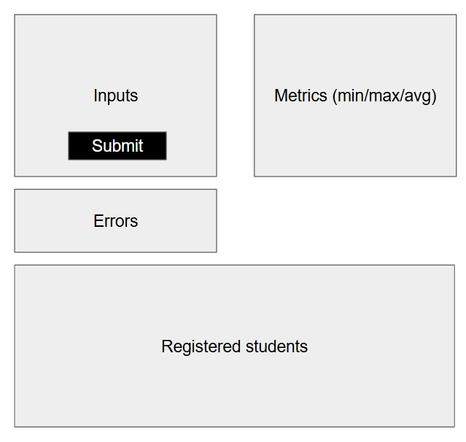
Setup Process
I started by reviewing the requirements and setting up my development environment in VS Code. After watching a few tutorials, I installed the Live Server extension for quick browser previews and connected it to a local SQLite3 database. I learned how to create a connection and cursor to interact with the data and prepared to build an Entity Relationship Diagram (ERD).
Next, I set up Django. PowerShell wouldn’t let me install it directly due to an "externally-managed-environment" issue, so I solved it by creating a Python virtual environment using uv venv and activating it. I installed Django inside the virtual environment, created a project called school_proj, and added an app called students to handle student data. I found these graphics that helped determine the concepts of the django framework:

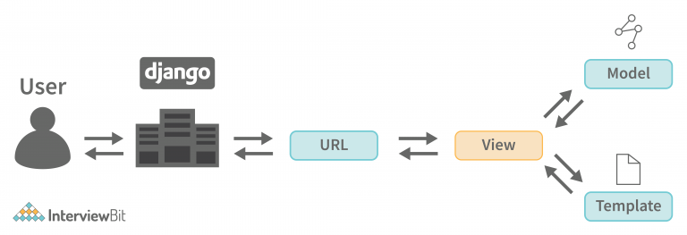
(InterviewBit, 2022)

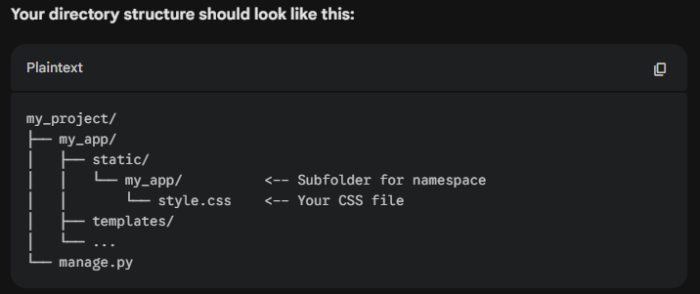
(Google, 2026)

Database and Django Models
In the models.py file, I defined a Student model with the fields FirstName, LastName, and Grade. I then ran makemigrations and migrate to create the corresponding tables in SQLite3. This established the data structure for storing 24 student grades ranging from 50 to 100.
Front-End and Server
For the interface, I created the templates folder with an index.html file and linked a style.css file for basic design. I initially used VS Code Live Server, but it displayed Django template tags ({% load static %}) as plain text, so I switched to Django’s built-in local server. I added URL paths and a views.py function to handle routing and form submissions.
Debugging and Issues
One major issue was duplicate paths in urls.py—the home view and submit view both used '', which broke variable passing. After some trial and error, fixing the path names solved it. Another challenge was preventing data duplication on page refresh; I handled this by redirecting back to the home page after form submission.
Validation and Results
The final app validates that each record has both first and last names and ensures that grades are integers between 50 and 100. The page reads data from the module4 table, calculates the lowest, highest, and average grades, and displays them cleanly on the web page.

References
Coder Coder. (2025, December 22). VS Code for absolute beginners [Video]. YouTube. http://www.youtube.com/watch?v=lWEKiak0WVU
Google. (2026). Gemini (March 9 version) [Large language model]. https://gemini.google.com
InterviewBit. (2022, June 17). Django Architecture - Detailed explanation. InterviewBit. https://www.interviewbit.com/blog/django-architecture/
Python.org. (n.d.). sqlite3 — DB-API 2.0 interface for SQLite databases. Python Documentation. https://docs.python.org/3/library/sqlite3.html

