1. Class Diagram for the Game app

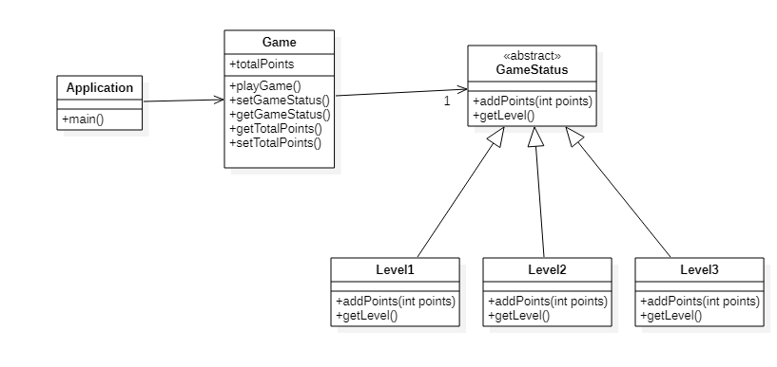

1. Sequence Diagram for the Game app changing levels from 1 to 2

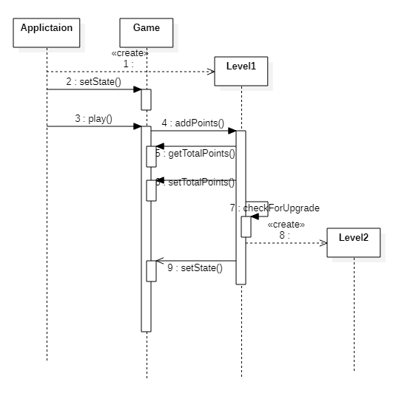

1. Code attached
2. Modified class Diagram for the counter Application

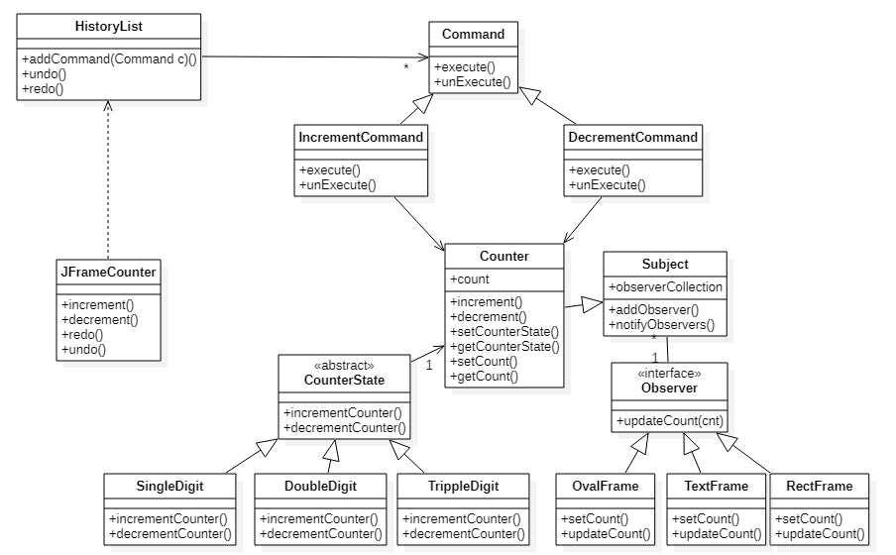

1. Sequence diagram of increment and undo operations

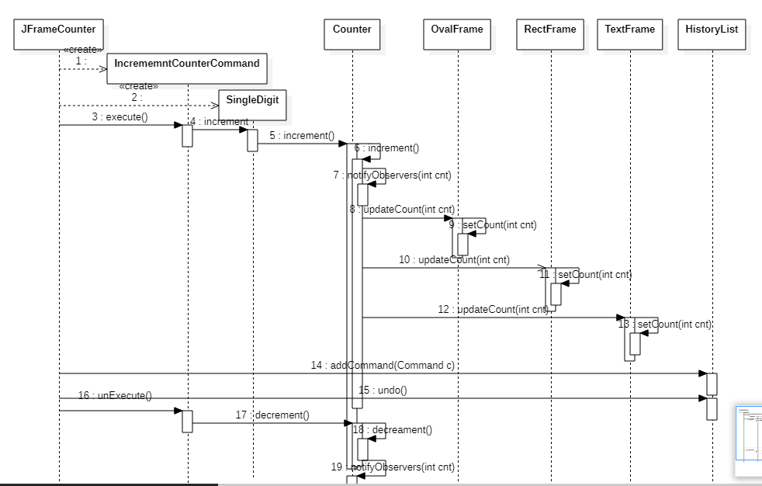

1. Code Attached