**1. Briefly describe the mold oscillation testbed and its resonance excitation problem, and explain why the latter takes place.**

The mold oscillation testbed is a physical mockup of the mold oscillation system on which they could run experiments and test changes to their control system. Like the caster mold oscillator, the testbed is driven by a hydraulic piston attached to one end of the beam, and the goal is to attain a sinusoidal motion of the other side, where a mass is mounted to mimic the effect of the mold. The testbed exhibited similar profile distortions, allowing hands-on problem investigation.

Since the beam is poorly damped, it provides about 40 times amplification of the excitation signal magnitude at its resonance frequency 9.2 Hz. Therefore, when the reference signal frequency is moved to 4.6 Hz, the small magnitude 9.2 Hz second harmonic multiple in the hydraulic piston displacement excites the beam main resonance mode, scaling up the small 9.2 Hz sinusoidal distortion in the piston displacement to a large distortion of mold displacement at this frequency. The distortion in the mold oscillator motion then becomes prohibitively large and disrupts production. This problem is called the resonance excitation problem.

**2. Using Beam_simulation.slx, simulate the response of the coupled beam system (without hydraulic valve) to two input sine waves: (a) one with frequency 4.6 Hz and (b) another with frequency 9.2 Hz. Draw excitation and response graphs and explain why the system acts as a motion amplifier when periodically excited at resonance frequency.**

The plots of (a) and (b) are shown below. The reason why the resonance excitation takes place is answered in the previous question.

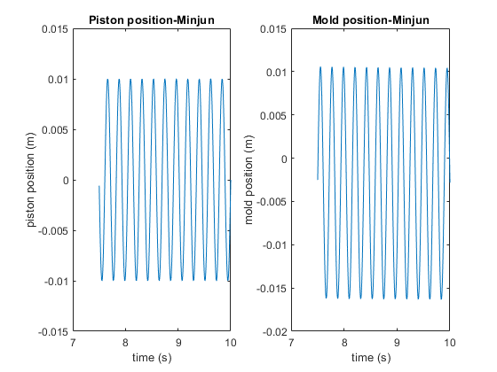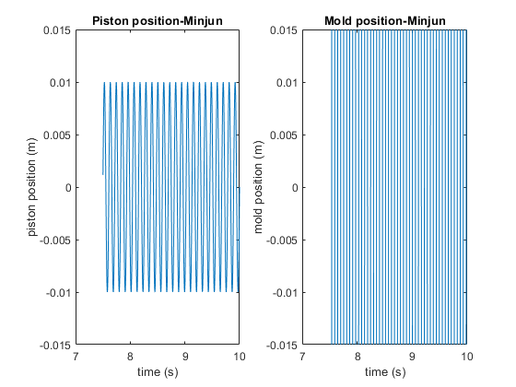

**3. Using Testbed_simulation.slx, simulate the system with hydraulic valve and feedback with P-controller only (matching the controller setup to a particular task is described in the detailed procedure below), responding to a 4.6 Hz reference input sine wave. Draw excitation and response graphs and indicate what is the problem with system performance based on the mold displacement and velocity response to periodic input excitation.**

The plots are shown below. We can observe the distortions in the velocity profile. This means that the negative strip time was no longer provided as the process needed to guarantee breakouts. Thus, the need appeared for controlling the mold oscillator to attain a clean sinusoidal oscillation in a broader frequency range.

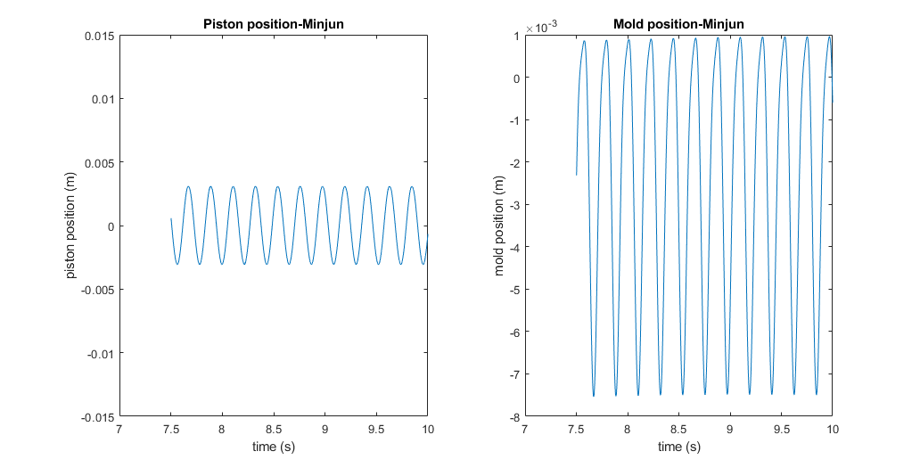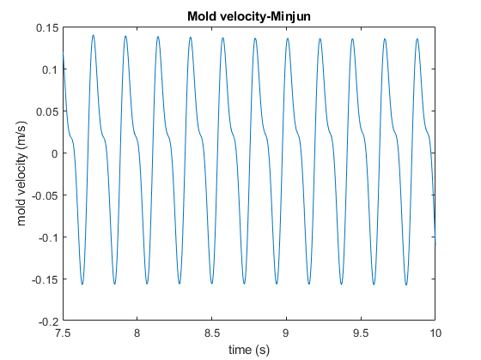

**4. Simulate the system with hydraulic valve and feedback P-controller with “tracking controller” algorithm from [1], [2], responding to a 4.6 Hz reference input sine wave. Draw excitation and response graphs, examine them, and indicate how well the mold displacement tracks the reference input and how close the velocity response is to a pure sinusoid. Compare system performance (the degree to which the plant response resembles the reference input) with that in task 3 and comment on any performance improvement attained.**

Clearly, the mold velocity follows the sinusoidal wave without its profile getting distorted. This provides the negative strip time, suggesting mold breakouts, which is a desired property.

