**National Institute of Technology, Tiruchirappalli**

**Lab Report - 1**

**CA – 709 Artificial Intelligence Lab**

|  |  |
| --- | --- |
| **Submitted To** | **Submitted By** |
| Mr. Purushottam Kumar | Manish Kumar Pandey (205120049) |
|  |  |

Objective

# Fundamentals of Python Programming

1. Write a program that needs to ask the user for her or his email address in the format firstname.lastname@ xyz.edu OR firstname.lastname@gmail.com. The application takes as input this email address, parses the email and replies to the user with first name, last name and host name
2. Write a program that converts a positive integer into the Roman number system. Your program should take an input, such as 1978, and convert it to Roman numerals, MCMLXXVIII
3. Write a program that calculates the user's body mass index (BMI) and categorizes it as underweight, normal, overweight, or obese, based on the table from the United States Centres for Disease Control.

**Explanation –** To achieve the goal of this exercise, A menu-based program was used which included all the programs as a subtask, controlled by a single driver function.

**Email Parser -**  The method takes input a string, which is an email id. We split the string based on the separators such as dot (.) and at (@). The format is [firstname.lastname@host.domain](mailto:firstname.lastname@host.domain) , so the appropriate credentials were parsed in the same way.

**Code**

**def** **email_parser**(email):

'''

Receive the email as input in form of firstname.lastname@domain and return first name, last name and domain.

'''

name, host = email.split('@')

first_name, last_name = name.split('.')

host, domain_name = host.split('.')

**return** first_name, last_name, host

**Output –**

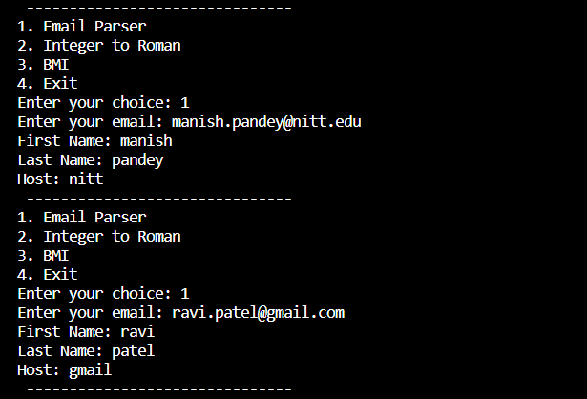

**Integer to Roman –** This program required us to feed into it an positive integer (Zero and Negative numbers were not invented in Roman Times, Romans never used these numerals in arithmetic) and convert it into a Roman numeral (A string). Since Roman numerals were only available upto 1000, the biggest number we can represent in roman numerals is 3999, and similar constraints were used in this program.

**Code**

**def** **integer_to_roman**(num:int) -> str:

'''

Given a Positive Intger, return the Roman numeral representation

'''

**if** **not** (**0** < num < **4000**):

**return** 'Invalid Input'

roman_numeral_map = (('M', **1000**),

('CM', **900**),

('D', **500**),

('CD', **400**),

('C', **100**),

('XC', **90**),

('L', **50**),

('XL', **40**),

('X', **10**),

('IX', **9**),

('V', **5**),

('IV', **4**),

('I', **1**))

result = ''

**for** numeral, value **in** roman_numeral_map:

**while** num >= value:

result += numeral

num -= value

**return** result

**Output**

**BMI Calculator** – BMI (Body Mass Index) is metric used to categorize people into weight categories. It takes height and weight as inputs and returns the result. The Metric System is used for the inputs. The table that was used for reference is taken from United States Centre for Disease Control and can be found at <https://www.cdc.gov/healthyweight/assessing/bmi/adult_bmi/index.html#Interpreted>

**Code**

**def** **bmi**(height:int, weight: int) -> str:

'''

Given Height and Weight, calculate the BMI and categorize the result in Underweight, Normal, Overweight or Obese.

'''

bmi = weight / (height / **100**) ** **2**

**if** bmi < **18.5**:

**return** 'Underweight'

**elif** bmi < **25**:

**return** 'Normal'

**elif** bmi < **30**:

**return** 'Overweight'

**else**:

**return** 'Obese'

**Output**

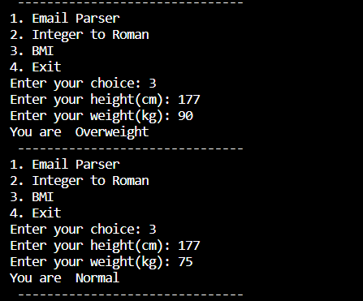

**Driver Code**

**def** **email_parser_runner**():

email = input('Enter your email: ')

first_name, last_name, host = email_parser(email)

**print**(f'First Name: {first_name}')

**print**(f'Last Name: {last_name}')

**print**(f'Host: {host}')

**def** **integer_to_roman_runner**():

num = int(input('Enter a number: '))

**print**(f"Roman Representation of {num} is {integer_to_roman(num)}")

**def** **bmi_runner**():

height = int(input('Enter your height(cm): '))

weight = int(input('Enter your weight(kg): '))

**print**("You are ",bmi(height, weight))

**def** **main**():

'''

Create A menu based runner for the above functions.

'''

**while** True:

**print**(" ------------------------------- ")

**print**('1. Email Parser')

**print**('2. Integer to Roman')

**print**('3. BMI')

**print**('4. Exit')

choice = int(input('Enter your choice: '))

**if** choice == **1**:

email_parser_runner()

**elif** choice == **2**:

integer_to_roman_runner()

**elif** choice == **3**:

bmi_runner()

**elif** choice == **4**:

**break**

**else**:

**print**('Invalid Choice')

**if** __name__ == "__main__":

main()